Report 2 Refractory High Entropy Alloys
Nivedita
IIT Madras- December ‘17
Introduction
There is no universally accepted definition in scientific literature of elements that should be considered refractory. But, in general refractory metals are considered to be those with melting temperature more than that of iron (1535 °C). These are expected to have high heat and wear resistance. The refractory metal HEA family consists of alloys containing at least 4 of the 9 refractory elements: Cr, Hf, Mo,Nb, Ta, Ti, V, W, and Zr. Refractory metal high entropy alloys were developed with the objective to design and create new high temperature structural metals.
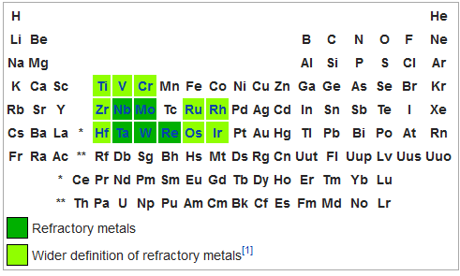
Fig. 1 Refractory metals in the Periodic table.
The refractory metals offer a very wide range in elemental properties such as melting temperature (T_{m} : 2128K-3695K); density (4.5-19.4 g/cc); elastic modulus (68-411 GPa for Young's modulus) and so on.
Ir, Os, Re, Rh and Ru have not yet been used in HEAs and therefore offer many new possibilities.
Alloy: MoNbTaVW
Literature:
W–Nb–Mo–Ta–V alloy was first prepared at Pittsburgh Materials Technology, Inc. (Jefferson Hills, PA) by vacuum arc melting of equimolar mixtures of the corresponding elements.The microstructure and properties of the alloys were studied in the as-cast condition.[1]
This alloy is reported to have exceptional mechanical properties such greater yield strength than any of its individual constituents. It is expected to have excellent yield strength sustained to ultrahigh temperatures which has been usually attributed to solid solute strengthening mechanism and/or associated lattice strains.
Computational studies have been recently conducted predicting the short range order based on binary elements interactions ( ∆H_{mix} and Solubility ).[2]
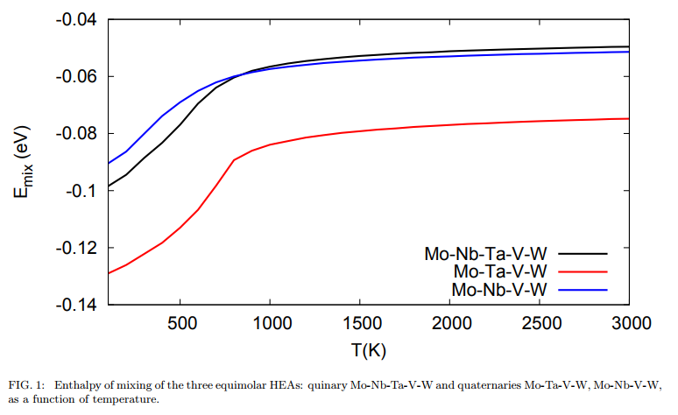
Fig. 2 Enthalpy of mixing of HEAs quinary MoNbTaVW and quaternaries MoNbVW, MoTaVW
Inflection points from the temperature curve of enthalpy of mixing indicate order-disorder phase transformations fromdifferent non-random configurations intosolid solution phase at higher temperatures.
From Fig.2, at temperatures below 750 K, a partially ordered phase is thermodynamically more stable than the equimolar solid-solution random configuration. For the two sub-system alloys, it is found that the enthalpy of mixing for HEAs in the presence of Mo-Ta binaries, namely Mo-Ta-V-W, is significantly lower not only than the those for the Mo-Nb-V-W where Ta element is absent, but also in a comparison with quinary Mo-Nb-Ta-V-W system
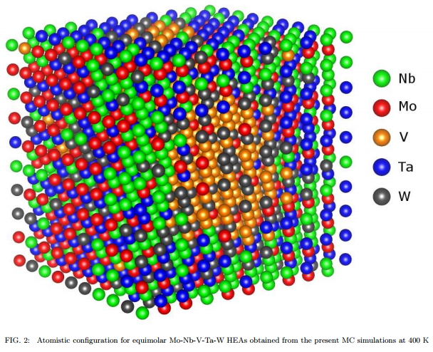
Fig. 3 Atomic Configuration for equimolar MoNbTaVW HEA simulated at 400K
Phase segregation of Nb (in green) around the edges of the atomic cell and of V (in yellow) around the center of the cell can be seen clearly from the presented configuration implying that there are no chemical attractive interactions between Nb and V atoms further confirmed from their positive enthalpies of mixing .
On the contrary the chemical ordering of Mo-Ta (red and blue) can be appreciated on the left hand side face of the cubic cell that is in a full agreement with the strong negative enthalpy of mixing for the bcc binary Mo-Ta system.
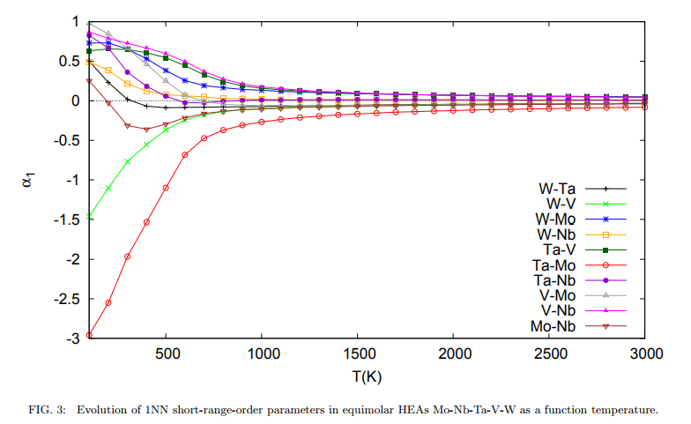
Fig. 4 Short range order parameter with binary interactions in equimolar MoNbTaVW as a function of temperature

Composition:
Table 1
Element | Properties | Challenges
Mo | High melting point, high modulus of elasticity, low coefficient of linear thermal expansion, good hear resistance, high electrical conductivity and thermal conductivity, small cross section of capture of thermal neutrons, high creep and stress rupture strength | High ductile-brittle transition temperature, increase in temperature and impairment of ductility on alloying, poor weldability and strong oxidisability
Nb | High strength, ductility, weldability, low cross section of thermal neutron capture, low ductile-brittle transition temperature, less sensitive to interstitial impurities and retains its ductility on alloying | High oxidisability at elevated temperatures
Ta | High ductility (even down to liquid helium temperatures), high melting, excellent workability (easy rolling, stamping, welding etc.) | Very small natural resources
V | Considerable natural resources, high melting point, resistance to oxidation when heated to 600°C, relatively low specific gravity, high corrosion resistance | Has to made completely free from interstitial impurities by processes like vacuum electron-beam melting
W | Exceptional refractory and high strength properties, considerable heat resistance at temperature as high as 0.7 T_{m} | Low ductility and high oxidisability/ chemical activity at high temperatures

MoNbTaVW is expected to have best of all, overcoming the shortcomings of individual elements.
Processing:
Ball milling is done of the powdered components for 5 hours.
Vacuum Hot Pressing is done following this proposed cycle.

Table 2
Segment no. | Segment | Time (min) | Temperature(°C) | Pressure (MPa)
1 | Start vacuum | 5 | RT | 0
2 | Powder control + Pr. increase | 3 | 400 | 2
3 | Power control | 60 | 600 | 2
4 | Power control | 20+40 | 600 | 2
5 | Pyro control | 40 | 1000 | 5
6 | Pyro control | 30 | 1000 | 5
7 | Pyro control | 30 | 1250 | 5
8 | Pyro control | 45 | 1500 | 20
9 | Pyro control | 40 | 1500 | 30
10 | Pyro control & Cooling | 60 | 1250 | 30
11 | Cooling Control and pressure release | 30 | 1000 | 5
12 | Natural cooling | `~ 4 hours | RT | 5
13 | Pr. Release | 2 | RT | -
At the end of the last segment temp. remains around 150°C ( depending on the mould). When it has dropped to 80-90°C, vessel is opened & it takes ~ 60 min |  | ~60
Density:
Table 3
Rule of mixtures ( Theoretical ) | 12.12 g/cc
Current analysis | 10.78 g/cc
Expected after VHP | 12.21 g/cc
Reported in Literature[1] | 12.36 g/cc

ρ_{rel}= $\frac{ρ_{experimental}}{ρ_{theoretical}}$ = 0.886
Melting Temperature: T_{m} calculated from rule of mixtures is 2962.8 K
Vickers Hardness Text
Hardness is a measure of how resistant the material is to permanent shape change when a compressive force is applied. The behavior of materials under load is complex and depends on ductility, elastic stiffness, plasticity, strength, toughness, viscoelasticity and viscosity.
Hardness tests can be used to measure scratch hardness, indentation hardness and rebound hardness.To metallurgical field Indentation hardness is most relevant and informative. .
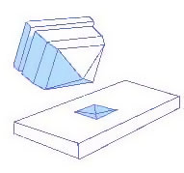
Fig. 5 Schematic illustration of the Vickers Indenter
The Vickers micro-hardness H_{v} of the alloy was measured on a polished surfacein15 randomly selected locations and the results are tabulated in Table
The load used was 1000g with dwell time of 10 seconds.
The average diameters of the indent were 41.59 μm and 39.16 μm.
Table 4
S.No | Hardness ( in HV )
1 | 918
2 | 1094
3 | 923
4 | 1078
5 | 1070
6 | 1051
7 | 1096
8 | 1100
9 | 1069
10 | 1086
11 | 1073
12 | 1061
13 | 1102
14 | 1111
15 | 1128
Average | 1064

The average hardness value = 1064 HV = 10.43 GPa
The standard deviation = 61.6 HV= 0.6 GPa
Vickers Hardness = 10.4± 0.6 GPa
Table 5
Processing | Load | Dwell Time | Micro-Hardness value | Reference
Vacuum Arc Melting of buttons of highly pure elements | 500 g | 30 s | 5.25 GPa | [1]
Vacuum Hot Press of Ball milled powered mixture | 1000g | 10s | 10.4 GPa | Current Ananlysis

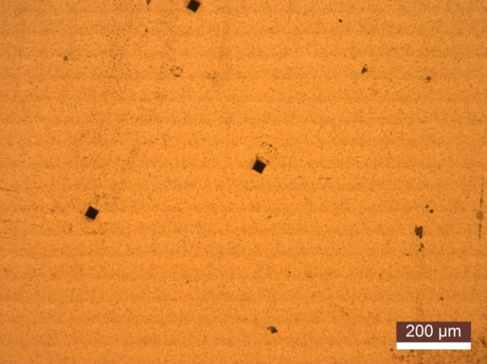
Fig. 6 Optical microscope image of surface of sample after Vickers indentation
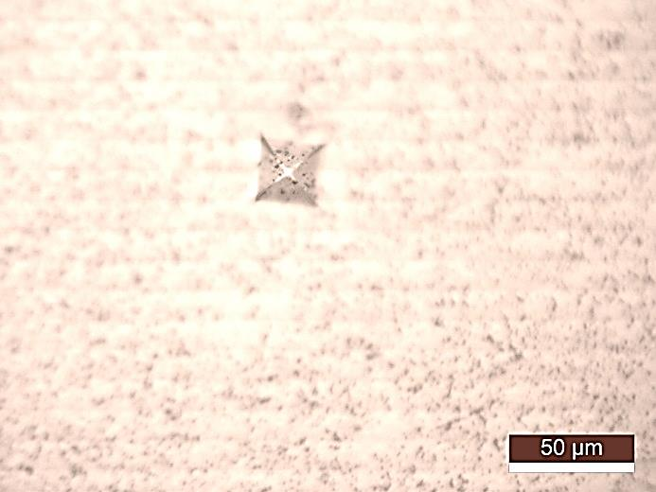
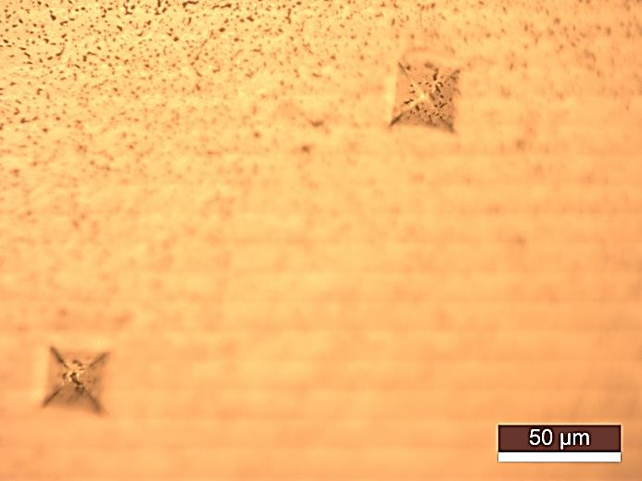
D₂
D₁
Fig. 7 Optical microscope images of the Vickers indents on sample surface higher magnification
Nano-Indentation[3], [4]
The method was developed to measure the hardness and elastic modulus of a material from indentation load–displacement data. It used in the characterization of mechanical behavior at small scales where properties vary from grain to grain and grain size is smaller than the area of the micro indenter.
32 indents in a matrix near center
2 indent in the darker phase

Fig. 8 Schematic of the Nano-Indentation layout
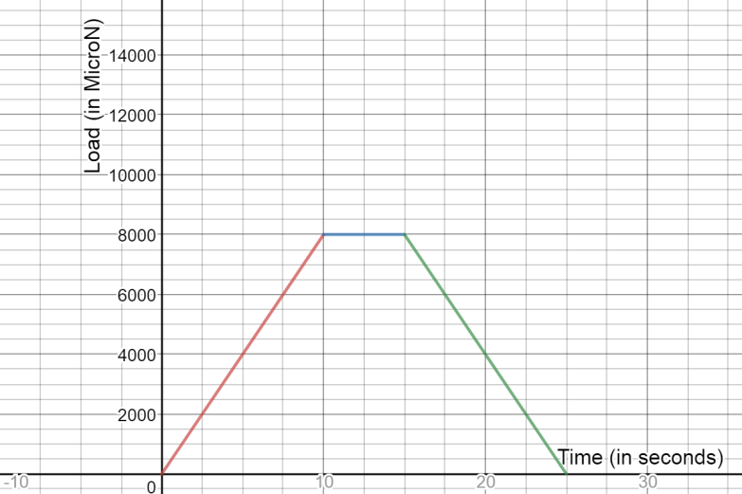The load used was 8000 μN for 5seconds. The total cycle for one indent was of 25 seconds.
10s
10s
Fig. 9 Loading Profile vs. time of a single indent

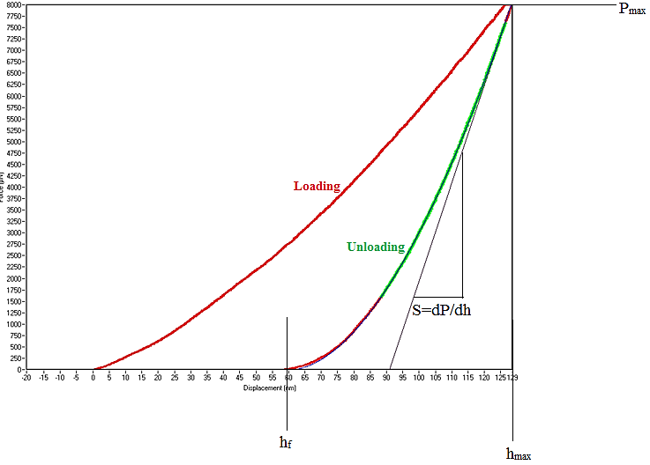
Fig. 10 Force/Load (P) vs. Displacement (h) profile of a single indent made in the sample

There are three important quantities that must be measured from the P–h curves:
- Maximum load, P_{max}
- Maximum displacement, h_{max}
- Elastic unloading stiffness, S =dP/dh, defined as the slope of the upper portion of the unloading curve during the initial stages of unloading (also called the contact stiffness).

Another important quantity is the final depth h_{f}, the permanent depth of penetration after the indenter is fully unloaded.

The accuracy of hardness and modulus measurement depends inherently on how well these parameters can be measured experimentally.
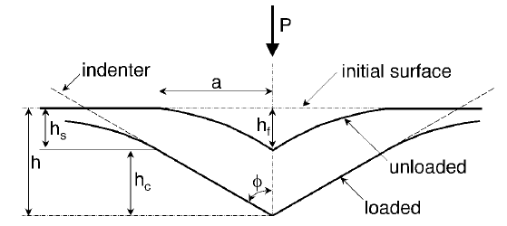
Fig.11 Schematic illustration of the unloading process showing parameters characterizing the contact geometry
The following equations are used to calculate Hardness and Elastic Modulus:
$$S=\frac{dP}{dh}$$
$$P=α{\left(h-h_{f}\right)}^{m}; α,m are power fitting constants$$
$$h_{s}=ε\frac{P_{max}}{S}; h_{s} is the sink-in and ε is a costant depending on contact geometry$$
$$h_{c}=h_{max}-h_{s}; h_{c} is approx. vertical displacement of contact periphery$$
$$A=f\left(h_{c}\right); A is the area,$$
$$f\left(d\right)is area function that describes the projevted or crosssectional area of$$
$$indenter at disctance d from tip$$
$$H=\frac{P_{max}}{A}$$
$$S= 2βE_{eff }\sqrt{\frac{A}{π}}; β is a dimentionaless parameter close to unity$$
$$\frac{1}{E_{eff}}=\frac{1-ν^{2}}{E}+\frac{1-ν_{i}^{2}}{E_{i}};$$

$$\left(E,ν\right)and\left(E_{i},ν_{i}\right) are Elastic Modulus and Poissions ration of$$
$$the specimen and the indenter respectively$$
$$E=\frac{1-ν^{2}}{\frac{2β}{S}\sqrt{\frac{A}{π}}-\frac{1-ν_{i}^{2}}{E_{i}}}$$

Elastic modulus is calculated by the given formula;
For Berkovich diamond indenter,
$β$=1.034,A=f(d)= 24.56 d², ν for sample is calculated from rule of mixtures=0.34 (~ 0.3 for
most solids), E_{i} and ν_{i} for diamond are 1220 GPa and 0.2.
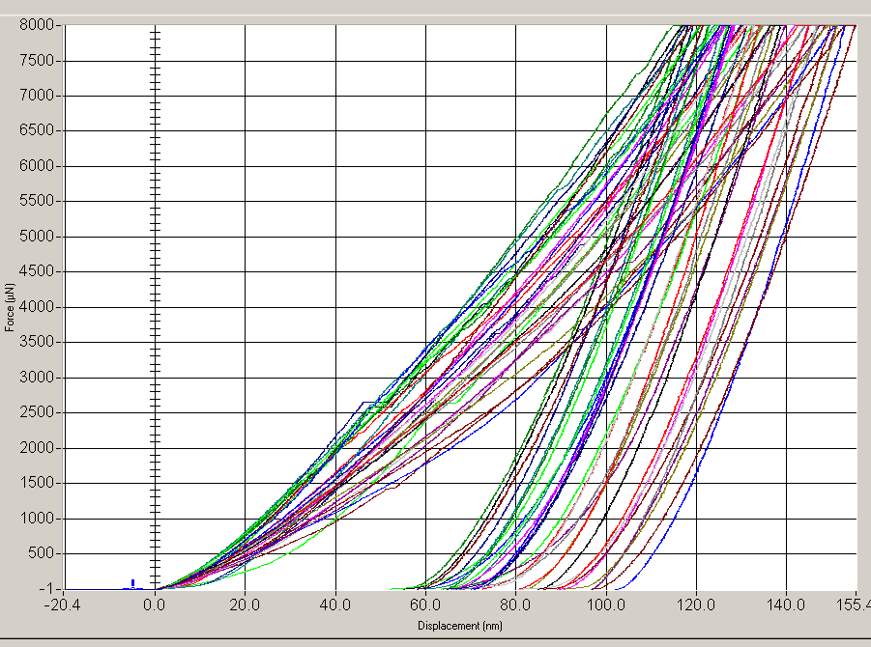
Fig. 12 P vs. h curves for multiple indents, also showing pop-in at places
A pop-in (event) is a sudden (load or displacement) burst during the loading of an indenter on a sample. If the nano-indentation experiment is load-controlled (as in our case), an horizontal plateau is also observed on the load-displacement curve.
The pop-in event is often explained by on of the following mechanisms as a function of the indented specimen and the experimental conditions (time, temperature, geometry of the indenter):
- Dislocations nucleation (= sudden yielding of a material under load) ;
- Strain transfer across grain boundaries in metals ;
- Crack(s) formation ;
- phase transformation
It is really important to mention that pop-in events are function of the indenter shape, the temperature and the strain rate.
Results:
The hardness value at the dark spots was found to be higher than the average hardness of the matrix.
Hardness value Average: 13 ± 2 GPa( Hardness at the dark phase ~ 19.2 GPa )
Elastic Modulus Average: 236 ±16 GPa
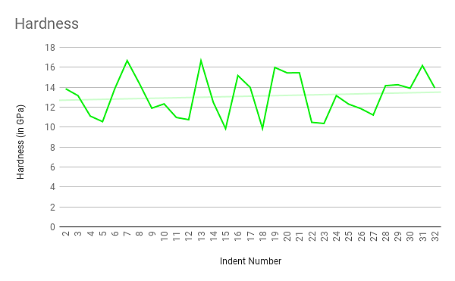
Fig. 13 Variation of Hardness values for different indents in the central matrix
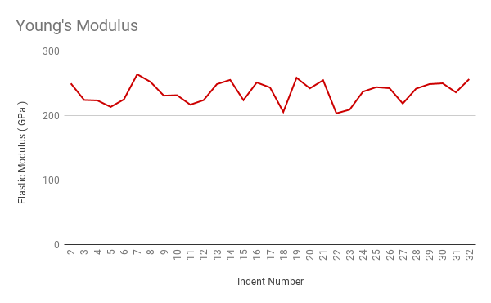
Fig. 14 Variation of Elastic Modulus for different indents in the central matrix

- Comparison between Nano-Indentation hardness value and Vickers Micro-hardness
- For micro-indentation, the contact Area is the surface area of the tip-faces that are in contact with the sample. While, for nano-indentation, the contact Area is defined as the projected area of contact between the sample and tip. Since projected area is smaller than the actual area in contact, the hardness value for nano indentation is more.
- The difference in the Vicker's hardness and the nano-indentation hardness is also often ascribed to load effect (i.e., the hardness reduces with increase in load). The load applied in Vicker's hardness is greater than that applied in nano-indentation.
- Nano indentation measures the surface hardness as the penetration depth is very low. Vickers on the other hand measures the bulk hardness value.

Table 6
S. No | Elastic Modulus (in GPa) | Hardness  (in GPa)
1 | 245.1677 | 13.00838
2 | 249.6976 | 13.84577
3 | 224.1656 | 13.15586
4 | 223.4475 | 11.10764
5 | 213.4017 | 10.5493
6 | 225.1336 | 13.87463
7 | 263.8829 | 16.66383
8 | 252.1061 | 14.35329
9 | 230.8615 | 11.89749
10 | 231.518 | 12.32851
11 | 216.8195 | 10.96449
12 | 223.9291 | 10.74726
13 | 248.651 | 16.64669
14 | 255.2361 | 12.48329
15 | 223.9027 | 9.850089
16 | 251.225 | 15.16762
17 | 243.4786 | 13.97887
18 | 205.5894 | 9.868972
19 | 258.5082 | 15.98115
20 | 242.1202 | 15.4391
21 | 254.6861 | 15.44212
22 | 203.4692 | 10.4808
23 | 209.1903 | 10.36631
24 | 237.0094 | 13.15568
25 | 243.9565 | 12.3057
26 | 242.3828 | 11.84913
27 | 218.6156 | 11.21023
28 | 241.615 | 14.15504
29 | 248.672 | 14.24909
30 | 249.9684 | 13.89889
31 | 235.9761 | 16.1711
32 | 256.314 | 13.93045
Average | 236.58 | 13.098
StdDev |  | 2.044775
  16.60787

Microstructural analysis:
SEM: Alloy microstructures were analyzed with the use of a scanning electron microscope (SEM) equipped with both backscatter electron (BSE) and energy dispersive spectroscopy (EDS) detectors. Two complete compositions were evaluated and 18 Spot EDS were taken at different phases.
Some critical observations included, presence of three different phases.EDS data showed considerable impurity Fe which would have added while ball-milling. The presence of Iron in such amount alters the expected order and simple BCC solid solution does not form. Carbon is also detected with traces of Chromium and Oxygen. Carbon impurity cannot be quantitatively justified via EDS data due to smaller atomic mass. Carbon is plausibly added while sintering.
From literature it was expected that the alloy forms single solid solution BCC, also from phase diagram analysis Mo and Ta should be completely miscible, but it is not found so in EDS analysis discussed further.
Fe and W are completely immiscible and their dense regions occur mutually exclusively.
The structure is very fine grained and the grains are not resolvable in simple optical microscope.
In SEM. It is seen that Phase segregations are < 1 μm in size. 6 spot EDS were taken in each of the three phases

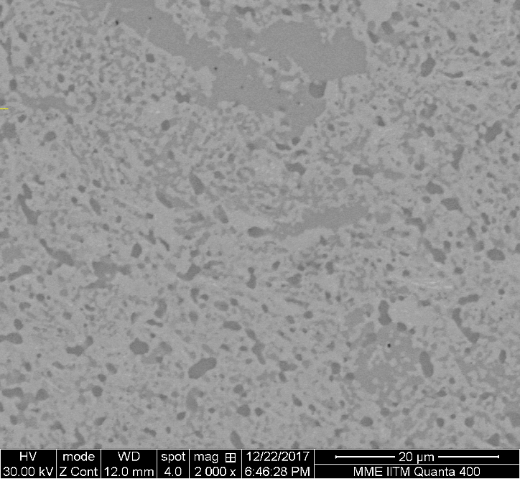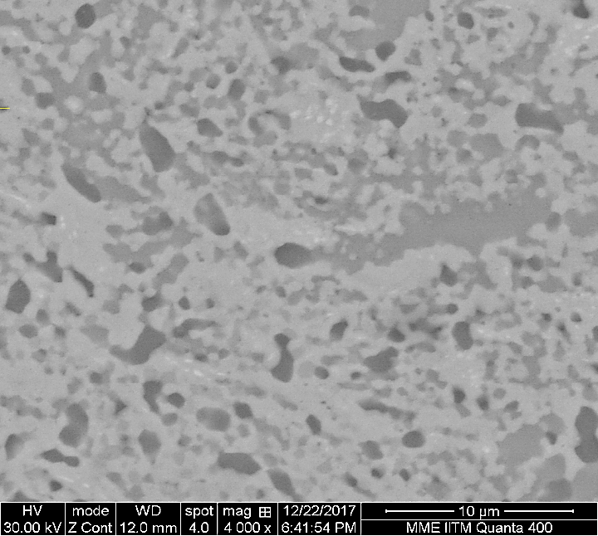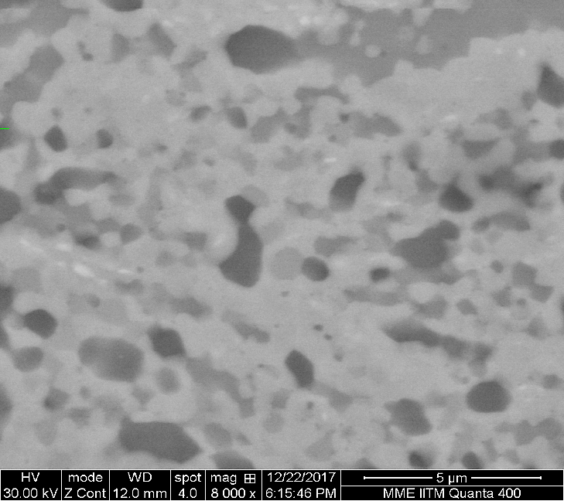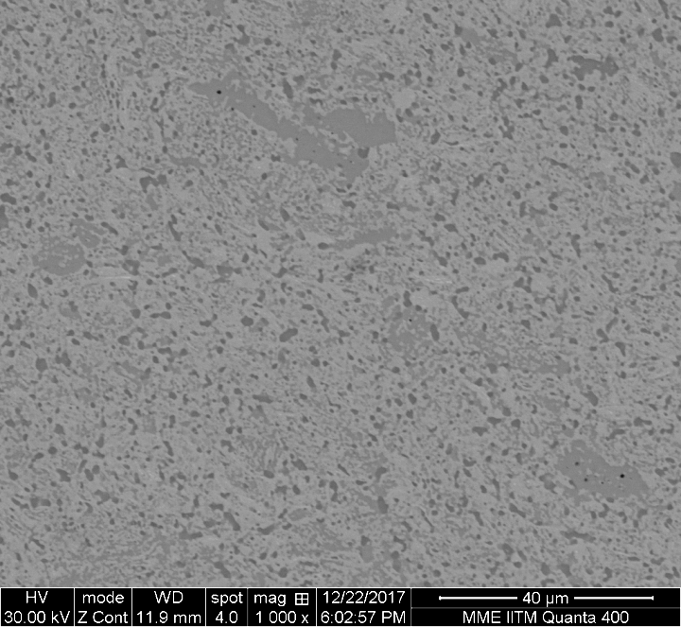Three different phases were identified, classifies as white, light grey and dark grey. The white phase forms the matrix, whereas the other two are somewhat localized. The dark grey being most localized.
Fig. 15 SEM micrograph of the sample in increasing order of magnification, with clear contrast distinction between three phases.

Light Grey
White
Dark Grey
Fig. 16 BSE image of the sample, for contrat in phases
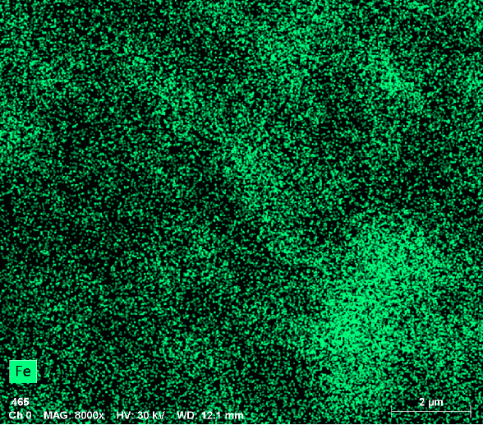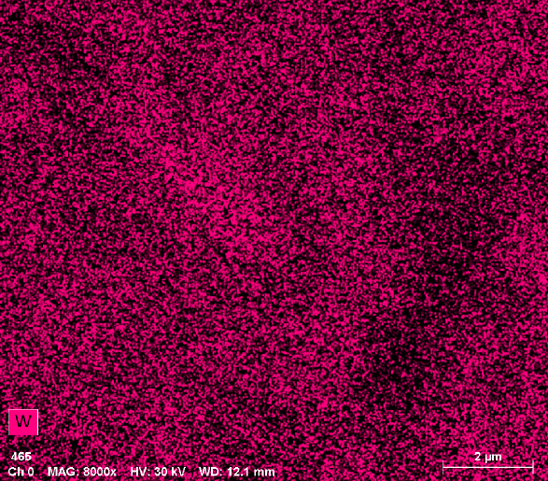

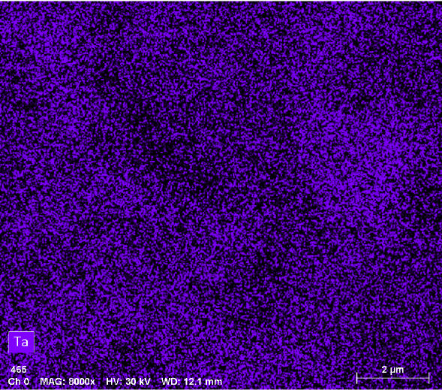
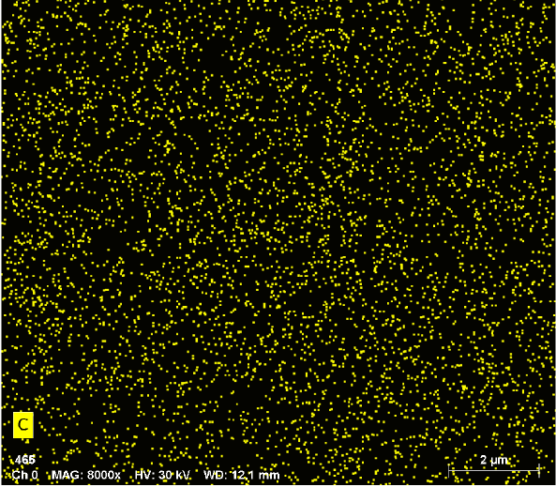
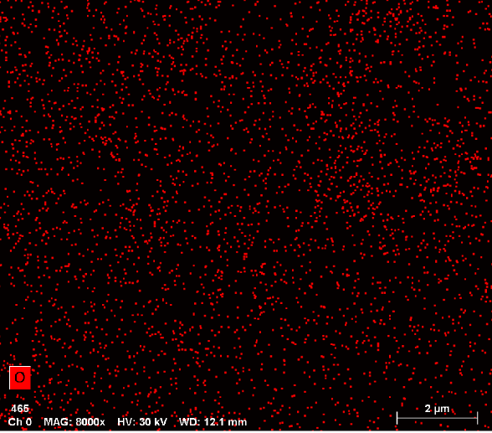
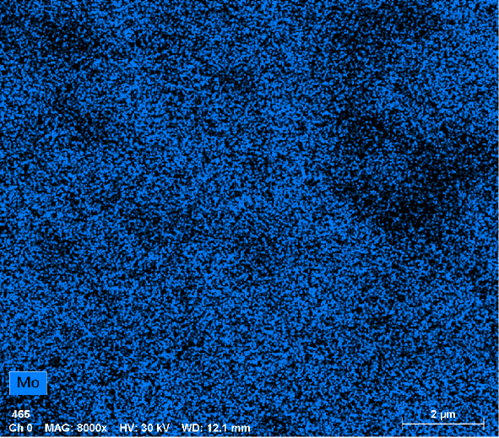
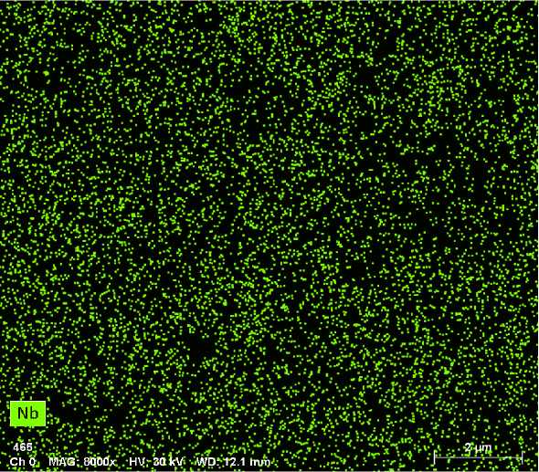
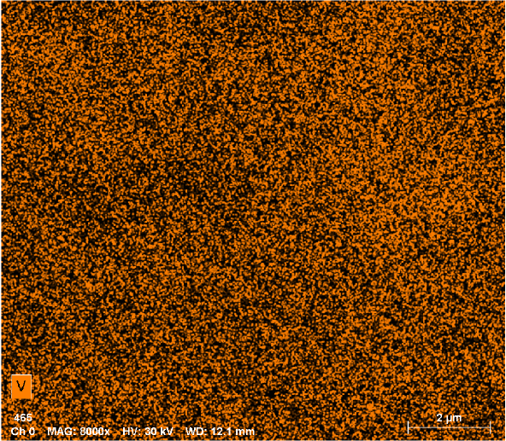

Fig. 17Energy Dispersive Spectroscopy of the sample. The relative intensity of each element map gives a qualitative sense for the segregation characteristics of that constituent

Analysis:
Table 7
Phase | WHITE | LIGHT GREY | DARK GREY
Predicted Components | W,Nb,V,Ta | Fe, Mo, V | Ta, V


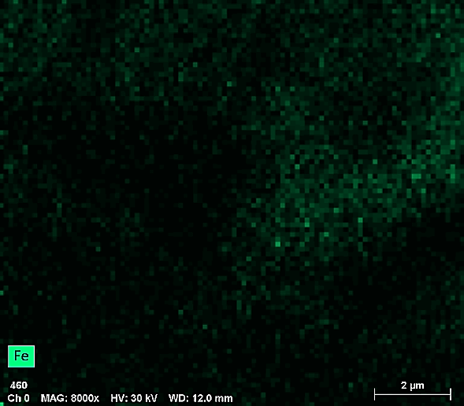
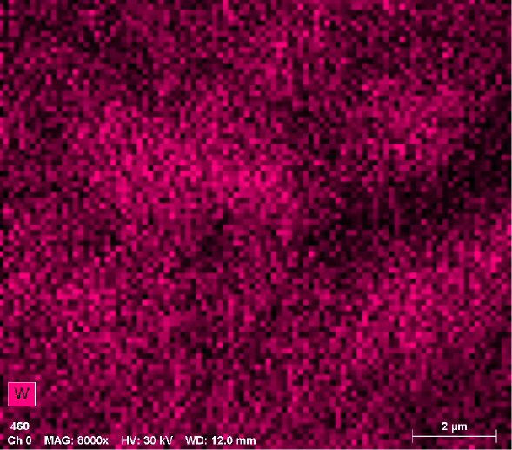

Fig. 18 EDS map to show immisibility of Fe and W forming grey and white phase respectively showing immiscibility.
Element-wise analysis:
Vanadium: Homogeneously present, no ordering or phase segregation observed.
Molybdenum, Iron: Although Mo is expected to form solid solution with Ta, due to presence of Fe impurity in considerable amounts, partition of their phases takes place and Mo forms a phase with Fe instead of Ta. This is the light grey phase.
Niobium: Nb occurs in the white phase forming solid solution in W. It is depleted in Mo rich regions.
Tantalum: Tantalum forms solution with vanadium and it is present in high density in dark grey phase; it is also present in white phase matrix.
Tungsten: W rich white phase exists which also has Nb. W is depleted in Fe rich regions.
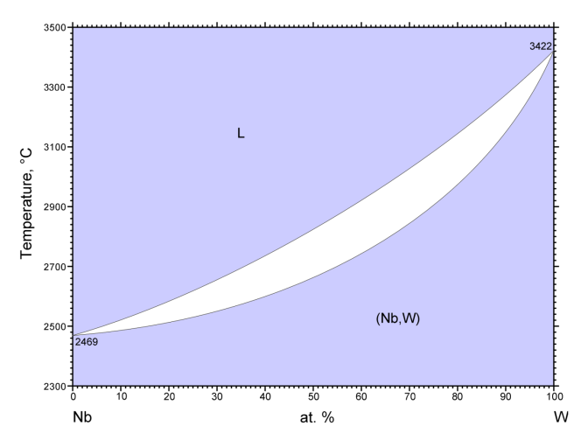
- Nb-W forming complete solid solution 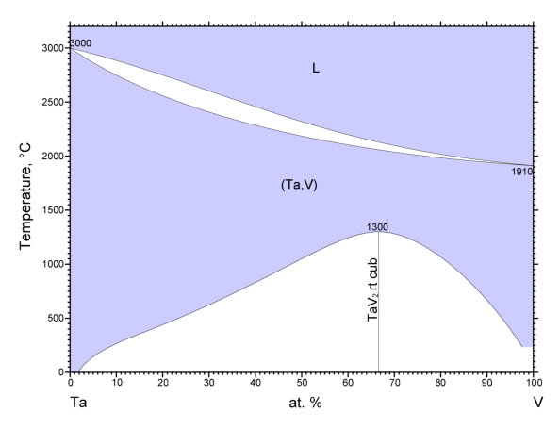
- Ta-V forming intermetallic at < 1300°C and solid solution above it
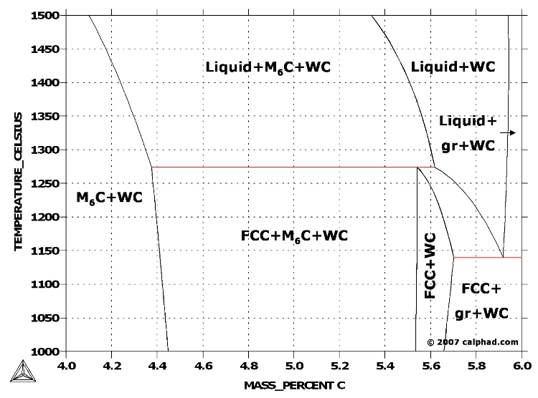
- Vertical section (isopleth) of the tungsten-iron-carbon (W-Fe-C) ternary system. The iron content is kept constant at 10 wt. %.
Fig. 19 Equilibrium Phase Diagram to justify solubility of predicted components in phases
Table 8
Element | At. % Overall from EDS
Mo | 23.2± 0.5
Nb | 15.4± 0.3
Ta | 17.6± 0.6
V | 19.2± 0.2
W | 18.1±0.7
Fe | 6.5±0.1

Due to drifting of beam during spot EDS, the At. % obtained for different phases are not reliable quantitatively but we get an idea about how individual elements are distributed.
Mo is absent in White phase, Nb is absent in Grey phases and Dark grey phase is rich in Ta.

Further, another SEM analysis followed by TEM and XRD can be used to give precise information regarding phases.
Further Work:
Temperature dependent mechanical properties are to be studied and quantified for this RHEA to be used as potential reactor/ turbines/ re-entry tip materials by replacing super alloys and ceramics.
References
[1] O.N. Senkov, G.B. Wilks, D.B. Miracle, C.P. Chuang, P.K. Liaw, Refractory high-entropy alloys, Intermetallics. 18 (2010) 1758–1765. doi:10.1016/j.intermet.2010.05.014.
[2] A. Fernandez-Caballero, J.S. Wrobel, P.M. Mummery, D. Nguyen-Manh, Short-range order in high entropy alloys:Theoretical formulation and application to Mo-Nb-Ta-V-W system, (2017). http://arxiv.org/abs/1705.01844.
[3] W.C. Oliver, G.M. Pharr, G.M. Pharr, W.C. Oliver, Nanoindentation in materials research : Past , present , and future The original nanoindenter, MRS Bull. 35 (2010).
[4] J. Menk, Uncertainties and Errors in Nanoindentation, Nanoindentation Mater. Sci. (2012). doi:10.5772/50002.

