**Summarize each of the proposed projects listed above using a simple table format suitable for presentation to top management. Include the name of each project, identify how each one supports business strategies, assess the potential financial benefits and other benefits of each project, and provide your initial assessment of the value of each project. Write your results in a one- to two-page memo to top management, including appropriate back-up information and calculations.**

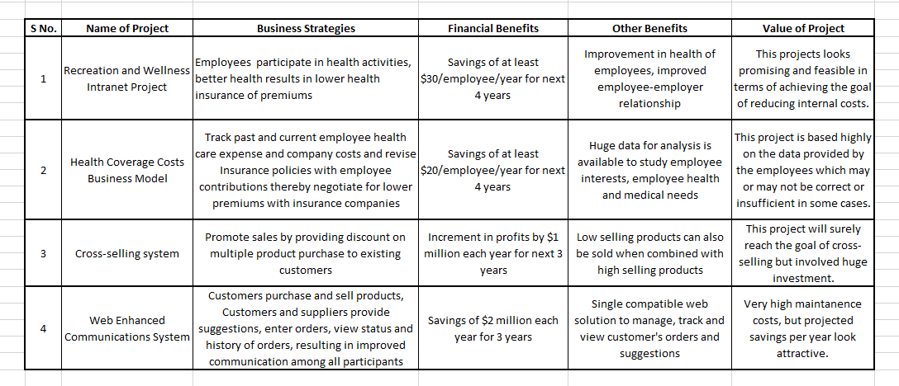

The four projects described by MHM address at least one of the three strategic goals of the company.

**Recreation and Wellness Project:** The first project proposes to address the cost reduction goal. Poor health of employees results in higher insurance premiums paid by the company. In this approach, employee will be facing a web application interface in which he will be able to register himself for sports programs, competitions or classes according to his interest. This will gradually reduce any health risks posed in a sitting working environment. Assumption is made that indulging in such events and activities will improve employee’s health and there will be lesser medical attention needed. The company in turn can lower the contribution it pays for employee’s health insurance. This looks like a feasible solution as it promotes an overall good work place environment which is an organizational goal too. The return on investment is at least three times in the form of savings as shown below in the figure.

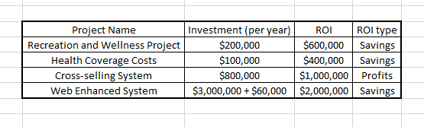

**Health Coverage Costs Business Model:** The second project does not involve employee’s direct participation in the process of lowering the employer premium contribution. Employee will be entering all details of his ailments, his bills, medicines and other relevant information on the web application. The system will then read the data from the employee and create various business models considering various scenarios. It will also study the difference between employer’s contribution and employee submissions. Data analysts will also study these models and there by company will negotiate with insurance companies for lower premiums. This solution is largely based on the assumption that the employee is submitting all bills, is keeping record of all ailments he has, all doctor visits, is genuinely storing his information in the web application which poses a risk to the implementation and success of this project. Even though the investment is very less, the outcome of this project is based on many assumptions and hence not recommended.

**Cross-selling System:** The third project addresses the goal of cross-selling of products. It proposes a solution to sell the highest selling items bundled with lowest selling items at a discounted price to existing customers. This approach is tried and tested and works most of the times. The return on investment is high so is the cost to develop and maintain. Tailoring the products into specific groups for specific customers is the key of this project. The customer may or may not be interested in the bundled version even if the discounts are offered. This is a huge risk to the project and should be taken into consideration before investment.

**Web-Enhanced Communications System**: The fourth project is focused on the last strategic goal of MHM, it provides a common platform for all kinds of stakeholders, customer, vendors, suppliers etc. to collaborate with the company as well as with themselves. The participants can give suggestions, reviews and can also place orders. Since this will be a common platform for a huge set of activities, this system needs to be stable every time and would require proper backup features and scheduled maintenance, which is why the developmental and maintenance costs are high. This project surely cannot complete within a year’s timeframe and would need multiple customer, user and employee interactions to arrive at a useful product.