Project Charter©
For Recreation and Wellness Project

Document Control

Document Information
© | Information
Document Id | Project_Charter #1
Document Owner | Nivedita Hari
Issue Date | 09/29/2017
Last Saved Date | 09/29/2017
File Name | Task_4_Project_Charter

Document History
Version | Issue Date | Changes
1.0 | 09/29/2017 | Initial Draft

Document Approvals
Role | Name | Signature© | Date
Project Sponsor | Joseph M
Project Review Group | Business case review group
Project Manager© | TBD
Quality Manager  (if applicable) | TBD
Procurement Manager  (if applicable) | TBD
Communications Manager  (if applicable) | N/A
Project Office Manager  (if applicable) | N/A

Table of Contents

1 Executive Summary 2
2 Project Definition 2
2.1 Vision 2
2.2 Objectives 2
2.3 Scope 2
2.4 Deliverables 2
3 Project Organisation 3
3.1 Customers 3
3.2 Stakeholders 3
3.3 Roles 3
3.4 Responsibilities 3
4 Project Plan 4
4.1 Approach 4
4.2 Overall Plan 4
4.3 Resource Plan 5
4.4 Financial Plan 5
4.5 Quality Plan 5
5 Project Considerations 5
5.1 Risks 5
5.2 Issues 5
5.3 Assumptions 6
5.4 Constraints 6
6 Appendix 6
6.1 Supporting Documentation 6

Executive Summary

The project is designed for employees to register to various health related activities organized by MHM. Participation by employees will result in better health and thereby reduce the premium costs to company. Certain risks such as employee involvement and consistent employee participation in the program are eminent to the project. A budget of $200,000 and six months’ time to complete is estimated.

Project Definition

The project aims at reducing the premiums of health insurance of employees paid by the company. Reduction in premiums will result in overall reduction in the internal costs of the company.

Vision
To successfully implement a solution which will improve the health of employees and help MHM reduce its employees’ health premium costs.

Objectives
Business Objectives
- To build a web application which can be used by 100% of full-time employees to register various health related activities.
- To encourage employees to enrol into programs which might help reduce their health premiums by 10% within one year of roll out of website.
- To reduce MHM’s employee premium contribution to at least 20% from what it is now, to meet industry standards.

Technology Objectives
- To build a cloud based system for enrolling employees to all kinds of activities offered by MHM.
- To build a new website which can be learnt and understood without formal training.

Scope
The management team will have more data about an employee’s interests.
This website will be rolled out throughout MHM over all locations.
New website will be available for use on the company’s intranet.

Deliverables
Item | Components© | Description
New website on intranet | New website.  Common platform to register for activities. | All employees will be eligible to enrol into the programs and activities organized by MHM. Employees can login anytime and can check and enrol into programs as per their convenience.
Incentives program | Identify top employees who have reached milestone in their set goals.  Award top employees with perks. | The website will allow user/employee to set a goal each month and monitor the progress they made. At the end of the month, rewards will be given to employees who reach specific milestones.
Reduction in Premiums | Employees become fit and less trips to physician  Lower medical bills by employees | More healthy employees resulting in less trips to the doctor. Employees happy with lesser premium provided by MHM as they are in good health.

Project Organisation

Customers
Customer | Representative©
Employees | Manager from each team
Higher Management Team | Senior Manager/ CTO

Stakeholders
Stakeholder© | Interested in
CEO | Alignment with company vision and strategy
Financial Controller | Alignment with company budget
CTO | Alignment with project completion timelines and website compliance
Employee | Using the fully functional product to register and monitor health progress.

Roles
Role | Organisation© | Resource Name | Assignment Status | Assignment Date
Sponsor | MHM | X | Assigned | 09/22/2017
Manager | MHM | Y | Assigned | 09/25/2017
Team Leader | MHM | K | Assigned | 09/26/2017
Team Member | MHM | Z, B, D | Unassigned | 09/29/2017

Responsibilities

Project Sponsor

- Defining the vision and high-level objectives for the project.
- Approving the requirements, timetable, resources and budget.
- Approving the project plan.
- Ensuring that major business risks are identified and managed.
- Approving any major changes in scope.
- Providing final acceptance of the solution upon project completion. ©

Project Manager

- Documenting the detailed Project Plan and Quality Plan
- Monitoring and reporting on project performance (re: schedule, cost, quality and risk)
- Reporting and escalating project risks and issues

Project Leader

- Ensuring that all required resources are assigned to the project and clearly tasked
- Managing assigned resources according to the defined scope of the project

Project Team Member

- Undertaking all tasks allocated by the Team Leader (as per the Project Plan)
- Reporting progress of the execution of tasks to the Project Manager on a frequent basis
- Maintaining all documentation relating to the execution of allocated tasks
- Escalating risks and issues to be resolved by the Project Manager. ©

Project Plan

Approach

Phase | Approach©
Initiation | Probable options will be presented to the stakeholders in the form of memos, weighted scoring models. Feasibility will be studied and one of the options will be selected. Business case and project charter will be created.
Planning | TBD
Execution | TBD
Closure | TBD

Overall Plan
A more detailed Project Plan will be drawn up during the “Planning” phase of the project.

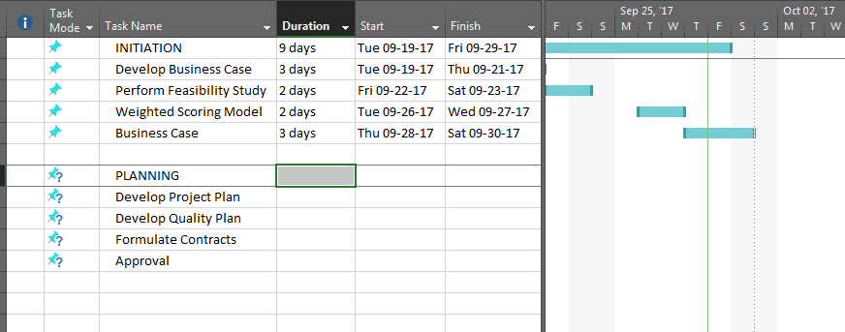

Milestones

Milestone | Date© | Description
Feasibility Study | 09/23/2017 | This will show the management and stake holders what is required to make the project successful.
Project Plan | TBD | TBD
Launch | TBD

Resource Plan
A detailed Resource Plan will be drawn up during the “Planning” phase of this project.

Financial Plan
Category | Cost© | Value
TBD | TBD | TBD

A detailed Financial Plan will be drawn up during the “Planning” phase of this project.

Quality Plan
Process© | Description
Risk Management | Risks will be mitigated using strategies as described in Business case document.
Issue Management | Ad hoc issues will be handled by the respective team manager.
Acceptance Management | Project plan and developed product will be accepted by higher management.
Procurement Management | The necessary memberships, equipment, instructors will be sought out by the procurement team.
Financial Management | Cost over runs and budgeting will be monitored by finance team.
Project Reporting | Team manager will report weekly progress to stakeholders.
Project Communications | Team will communicate with each other via share point.

Project Considerations

Risks
Description | Likelihood | Impact© | Mitigating Actions
Project not completed within time-frame | Low | Medium | Assessment of completion regularly, roll out of key features of product
Employees do not show interest in health activities | High | Critical | Create small campaigns on health benefits before product launch and encourage employees to join the initiative.
Initial investment amount over run | Medium | High | Plan for lesser activities in the quarters succeeding the implementation

Issues
Description© | Priority | Resolution Actions
Internal resources not available to work full-time on the project | High | Hire new contractors for the project, find employees from job pool in other locations for availability
Management skeptical on the prospects of the initiative and employee engagement after a year or two of implementation | Medium | New incentives to be launched every month to attract more employees.

Assumptions
The project will take six months to complete.

Constraints
The financial budget allocated is fixed and does not allow for over-spending. There are limited technical resource available for the project and no new hiring can be done.

Appendix

Supporting Documentation

- Proposed Business Case
- Proposed Weighted Scoring Model Study.

