Special Numbers – Python Program

10 Special numbers logic with examples explained.

1. **Palindrome Number**

A **Palindrome Number** is a number that remains the same when its digits are reversed.

In short —  
if the number reads the same forward and backward, it’s a palindrome.

**Examples**

| **Number** | **Reversed** | **Result** |
| --- | --- | --- |
| **121** | **121** | **✅ Palindrome** |
| **1331** | **1331** | **✅ Palindrome** |
| **12321** | **12321** | **✅ Palindrome** |
| **123** | **321** | **❌ Not Palindrome** |

**Some Palindrome Numbers**

| **Range** | **Palindromes** |
| --- | --- |
| **1–1000** | **1, 2, 3, 4, 5, 6, 7, 8, 9, 11, 22, 33, 44, 55, 66, 77, 88, 99, 101, 111, 121, 131, 141, 151, ... 999** |
| **1000–10000** | **1221, 1331, 1441, 1551, … 9999** |

1. **Armstrong Number** (also called **Narcissistic Number**).

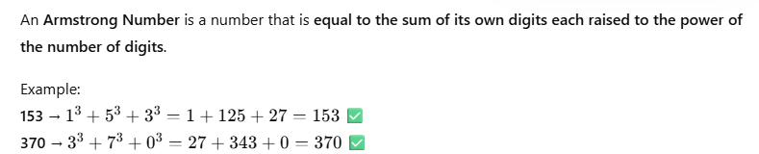

**🧩 Some Known Armstrong Numbers**

| **Digits** | **Armstrong Numbers** |
| --- | --- |
| 1-digit | 0, 1, 2, 3, 4, 5, 6, 7, 8, 9 |
| 3-digit | 153, 370, 371, 407 |
| 4-digit | 1634, 8208, 9474 |
| 5-digit | 54748, 92727, 93084 |
| 7-digit | 548834 |

1. **Perfect Number**

A **Perfect Number** is a number that is **equal to the sum of its proper divisors** (excluding itself).  
Example:  
6=1+2+3 = 6 - Perfect Number  
28=1+2+4+7+14 = 28 – Perfect Number

Here are the **first few Perfect Numbers** (they’re quite rare too):

| **Number** | **Divisors (excluding itself)** | **Sum** | **Check** |
| --- | --- | --- | --- |
| **6** | 1, 2, 3 | 1 + 2 + 3 = 6 | ✅ Perfect |
| **28** | 1, 2, 4, 7, 14 | 1 + 2 + 4 + 7 + 14 = 28 | ✅ Perfect |
| **496** | 1, 2, 4, 8, 16, 31, 62, 124, 248 | sum = 496 | ✅ Perfect |
| **8128** | 1, 2, 4, 8, 16, 32, 64, 127, 254, 508, 1016, 2032, 4064 | sum = 8128 | ✅ Perfect |
| **33550336** | (many divisors) | sum = 33550336 | ✅ Perfect |

**🧠 Fun Fact**

All **known even perfect numbers** come from this formula:

Perfect Number=2p−1(2p−1)\text{Perfect Number} = 2^{p-1}(2^p - 1)Perfect Number=2p−1(2p−1)

where (2p−1)(2^p - 1)(2p−1) is a **Mersenne prime**.

For example:

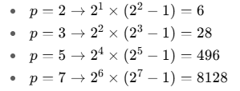

1. **Strong Number**

A **Strong Number** (also called a Krishnamurthy Number) is a **number equal to the sum of the factorials of its digits.**

Example:

145 → 1!+4!+5!=1+24+120=145 so it’s a **Strong Number**

**✅ List of Strong Numbers (within 1–100000)**

| **Number** | **Explanation** |
| --- | --- |
| **1** | 1! = 1 ✅ |
| **2** | 2! = 2 ✅ |
| **145** | 1! + 4! + 5! = 1 + 24 + 120 = **145** ✅ |
| **40585** | 4! + 0! + 5! + 8! + 5! = 24 + 1 + 120 + 40320 + 120 = **40585** ✅ |

So, **Strong Numbers up to 100000** are:  
👉 1, 2, 145, 40585

**🧩 Quick Tip**

These numbers are **very rare** because factorial values grow extremely fast.  
That’s why you’ll find only a few of them within a large range.

1. **Automorphic Number**

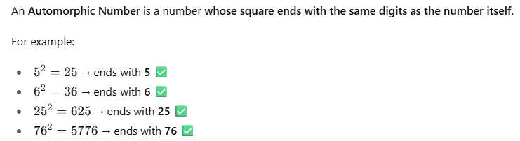

**🧩 Some Known Automorphic Numbers**

| **Range** | **Automorphic Numbers** |
| --- | --- |
| 1–100 | 1, 5, 6, 25, 76 |
| 1–10000 | 376, 625, 9376 |
| 1–1000000 | 90625, 109376, 890625 |

1. **Harshad Number (also known as the Niven Number)**

A **Harshad Number** is a number that is **divisible by the sum of its digits**.

**Formula:**

If num % (sum of its digits) == 0, then it’s a Harshad Number.

**🧩 Some Harshad Numbers**

1 → 1 ÷ 1 = 1 ✅  
12 → 12 ÷ (1+2) = 4 ✅  
18 → 18 ÷ (1+8) = 2 ✅  
20 → 20 ÷ (2+0) = 10 ✅  
21 → 21 ÷ (2+1) = 7 ✅  
24, 27, 30 … ✅

In fact, **many numbers** are Harshad numbers — especially smaller ones.

1. **Neon Number**

**Known Neon Numbers (in small range)**

| **Number** | **Square** | **Sum of Digits** | **Result** |
| --- | --- | --- | --- |
| **0** | 0 | 0 | ✅ |
| **1** | 1 | 1 | ✅ |
| **9** | 81 | 9 | ✅ |

So, **0, 1, and 9** are Neon Numbers.

1. **Spy Number**

A **Spy Number** is a number **whose sum of digits is equal to the product of its digits**.

If (sum of digits)=(product of digits), then it’s a Spy Number.

**Example**

**123 :**

Sum = 1 + 2 + 3 = 6

* Product = 1 × 2 × 3 = 6  
  Sum of digits = product of digits
* So 123 is a **Spy Number**
* **Some Spy Numbers**

| **Number** | **Sum of Digits** | **Product of Digits** | **Result** |
| --- | --- | --- | --- |
| **22** | 2 + 2 = 4 | 2 × 2 = 4 | ✅ |
| **123** | 1 + 2 + 3 = 6 | 1 × 2 × 3 = 6 | ✅ |
| **132** | 1 + 3 + 2 = 6 | 1 × 3 × 2 = 6 | ✅ |
| **1124** | 1 + 1 + 2 + 4 = 8 | 1. × 1 × 2 × 4 = 8 | ✅ |

1. **Kaprekar Number**

A **Kaprekar Number** is a number whose **square can be split into two parts that add up to the original number.** 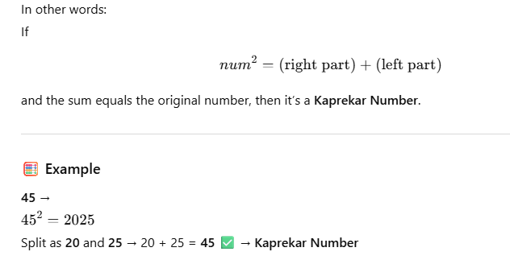

**Some Known Kaprekar Numbers**

| **Range** | **Kaprekar Numbers** |
| --- | --- |
| **1–100** | **1, 9, 45, 55, 99** |
| **1–1000** | **297** |
| **1–10000** | **703, 999** |
| **1–100000** | **2223, 2728, 4879, 4950, 5050, 5292, 7272, 7777, 9999** |

1. **Magic Number**

A **Magic Number** is a number in which **the sum of its digits** (repeatedly summed until a single digit) **becomes 1.**

That means —  
keep adding the digits again and again until only one digit remains.  
If that digit is 1, it’s a Magic Number.

Example

Example 1:  
19→1+9=10→1+0=1 ✅ → Magic Number

Example 2:  
28→2+8=10→1+0=1 ✅ → Magic Number

**Example 3:  
123→1+2+3=6123 → 1 + 2 + 3 = 6123→1+2+3=6 ❌ (not 1) → Not Magic**

**Some Magic Numbers**

| **Magic Numbers** | **Explanation** |
| --- | --- |
| **1** | **Single digit 1 → ✅** |
| **10** | **1 + 0 = 1 → ✅** |
| **19** | **1 + 9 = 10 → 1 + 0 = 1 ✅** |
| **28** | **2 + 8 = 10 → 1 ✅** |
| **37** | **3 + 7 = 10 → 1 ✅** |
| **46** | **4 + 6 = 10 → 1 ✅** |
| **55** | **5 + 5 = 10 → 1 ✅** |
| **64** | **6 + 4 = 10 → 1 ✅** |