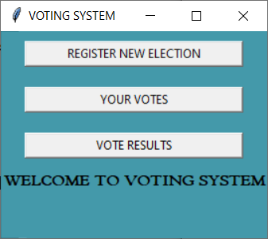 =>home page

#SELECTING THE BUTTON “REGISTER NEW ELECTION” IN HOME PAGE

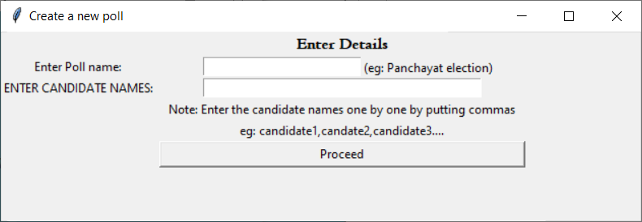

ENTRING NEW POLL DETAILS

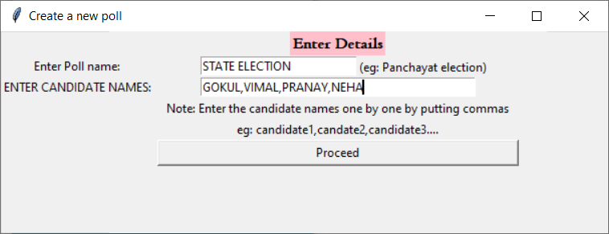

#PROCEEDING AFTER ENTERING POLL DETAILS

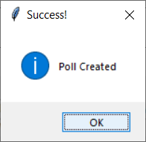

O/P IN IDLE

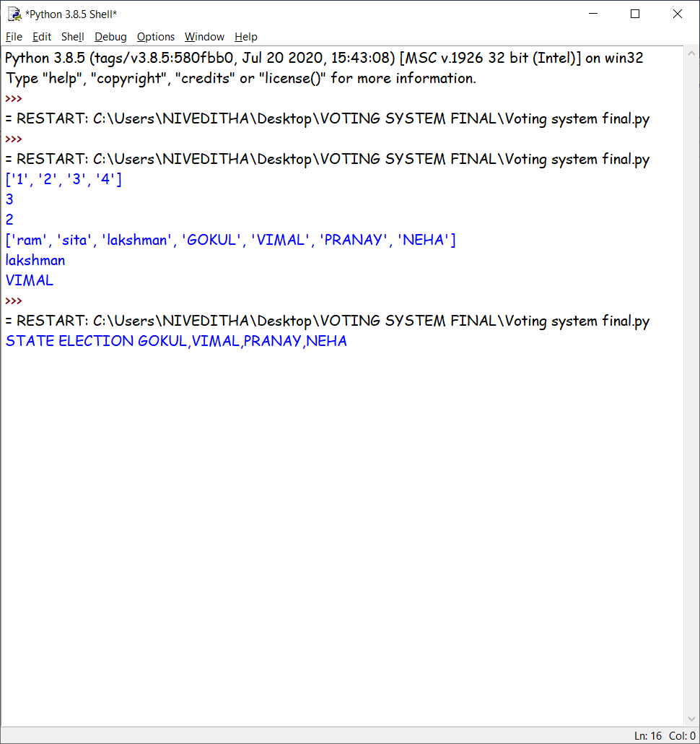

#AUTOMATICALLY RETURNED TO THE HOME SCREEN

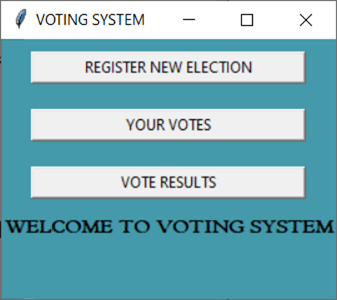

#PAGE AFTER CLIKING ‘YOUR VOTES’ BUTTON

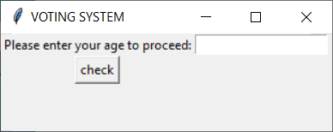

#ENTRING AGE LESS THAN 18(MINIMUM AGE TO VOTE)

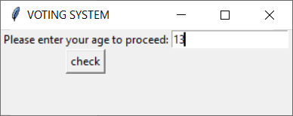

ERROR DISPLAYED

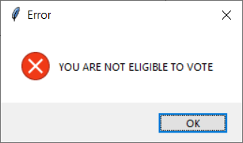

#ENTRING AGE ELIGIBLE FOR CASTING VOTE

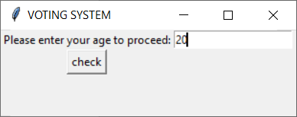

#SELECTING POLL AND PROCEEDING

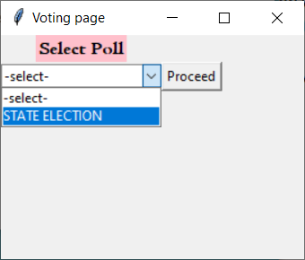

CASTING VOTE

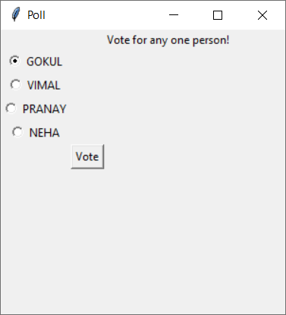

#CASTING 2ND AND FINAL VOTE

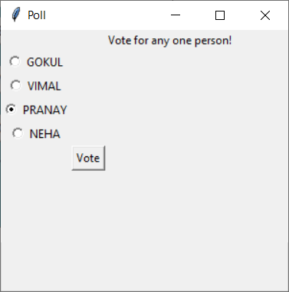

AFTER CASTING VOTES

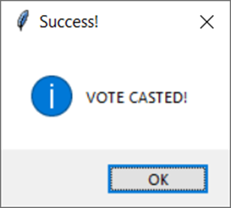

# AFTER CASTING AUTOMATICALLY RETURNED TO THE HOME SCREEN

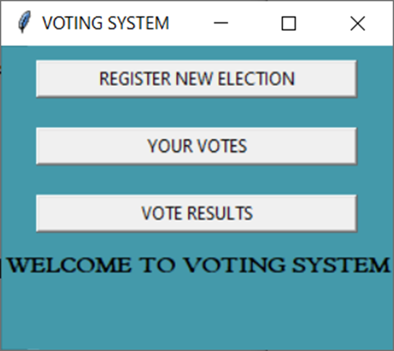

#O/P IN IDLE

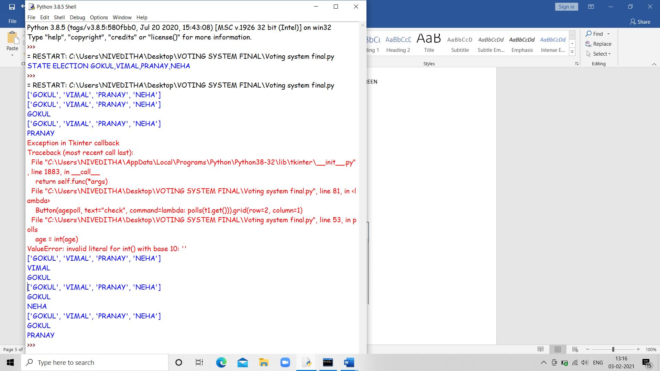

#VOTER 2 CASTING VOTE

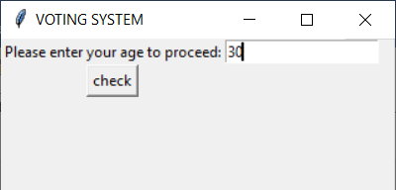

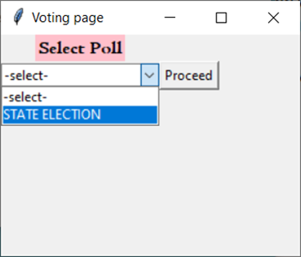

1ST VOTE

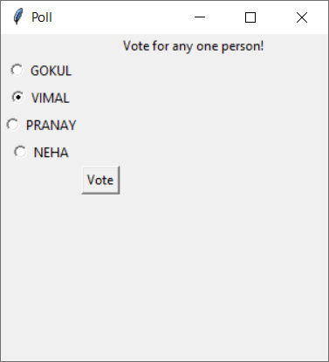

2ND VOTE





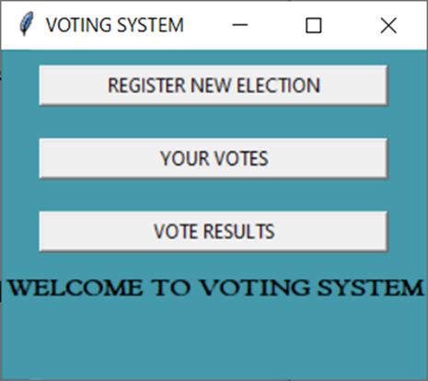

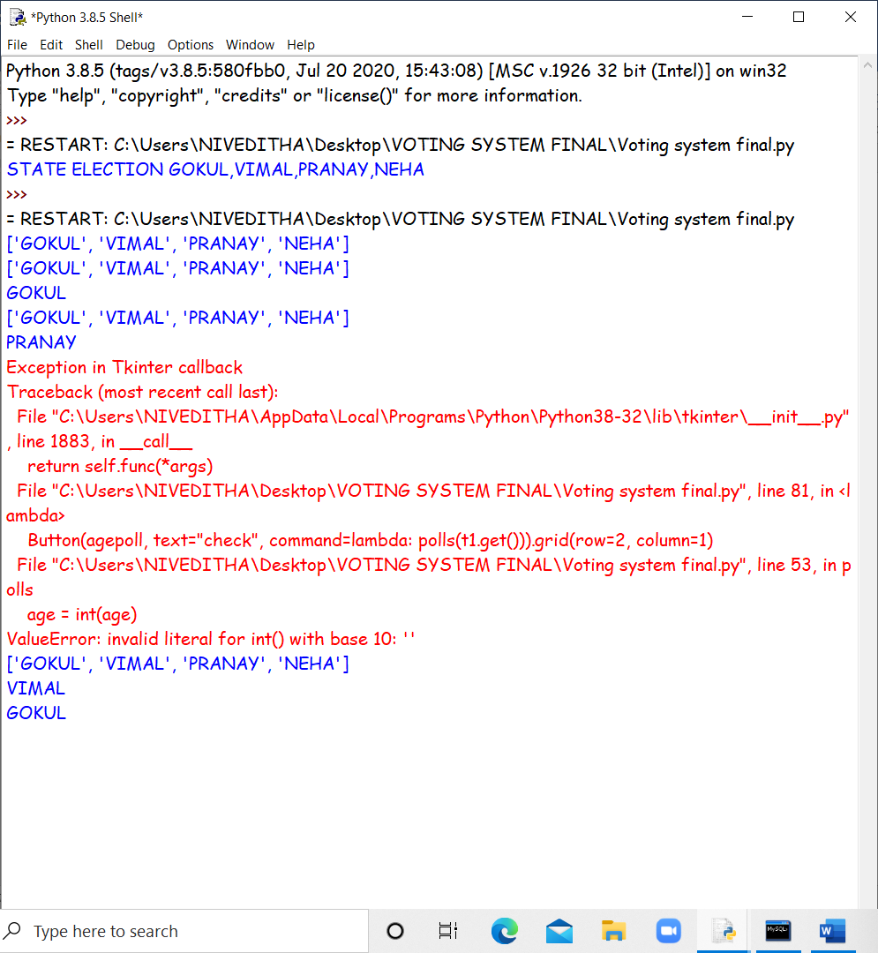

VOTER 3 CASTING VOTE

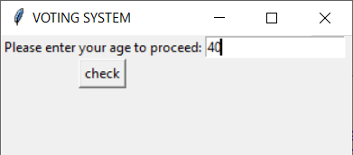



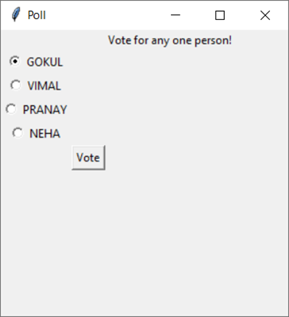

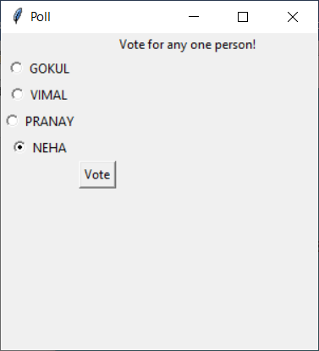





O/P IN IDLE

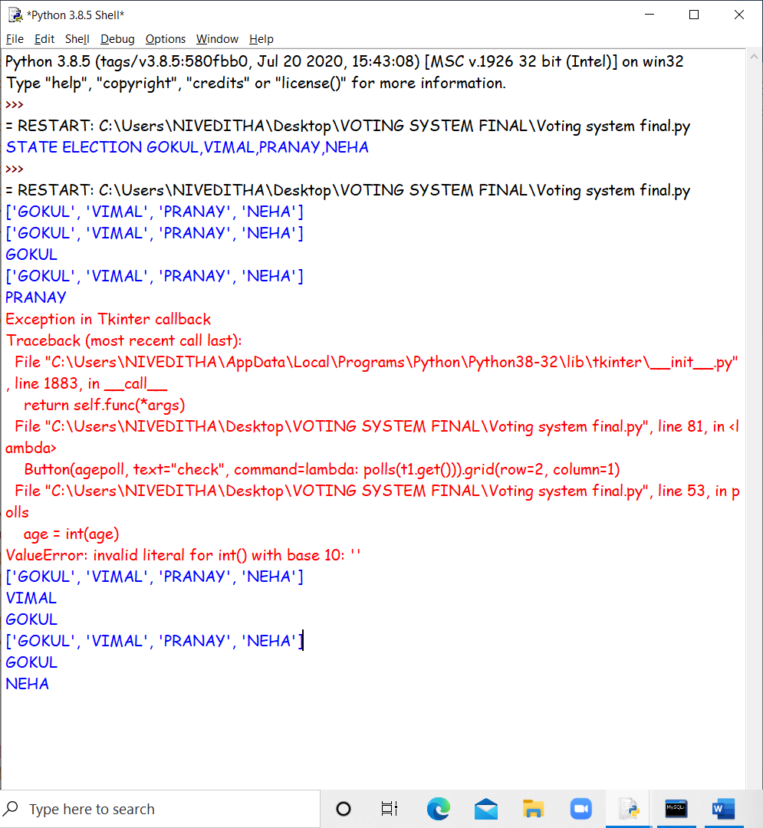

#RESUTLS

#AFTER SELECTING “VOTE RESULTS” IN HOME PAGE

#SELECTING POLL AND PRESSING THE BUTTON “GET RESULTS”

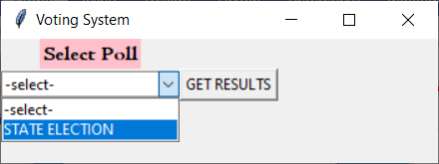

#DIPLAYING RESULTS

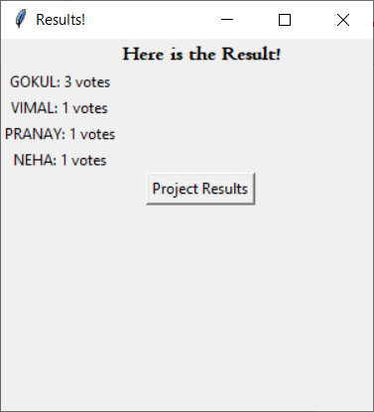

#SELECTING “ PROJECT RESUTLS “

