**USING RAPTOR – CHECK GIVEN NUMBER PALINDROME OR NOT**

**R.NIVEDITHA**

**192110054**

**FLOWCHART**

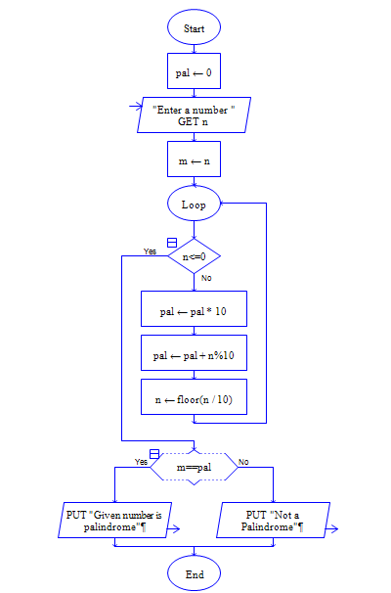

**OUTPUT**

INPUT IS 1234321

