SCHOOL MANAGEMENT SYSTEM

PROJECT REPORT

TABLE OF CONTENTS

 | PAGE NO.
SYSTEM SPECIFICATION | 3
DATA FLOW DIAGRAM | 4
PROJECT OVERVIEW | 5
DATA FILE DESIGN | 8
FLOWCHART | 10
PROGRAM SOURCE CODE | 11
OUTPUT SCREENSHOTS | 19
BIBLIOGRAPHY | 28

SYSTEM SPECIFICATION
- Hardware Requirement
Device specification:
-Processor: Intel(R) Core(TM) i5-6200UCPU@ 2.30GHz 2.40GHZ
-Memory: 16.0 GB
-System type: 64-bit operating system
Windows specification:
-Edition: Windows 10 Pro
-Version: 22H2
- Software requirement
Python 3.11 64-bit
MySQL 5.7

DATA FLOW DIAGRAM
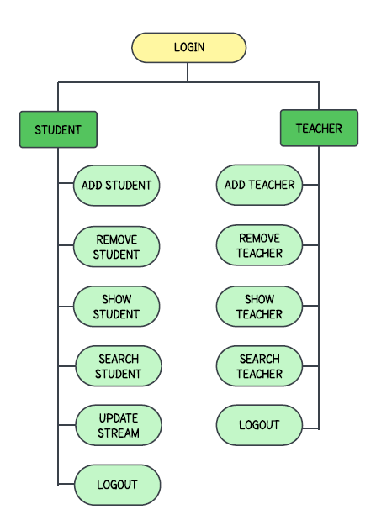

PROJECT OVERVIEW
This Python script implements a basic School Management System using MySQL for database interactions.
Components:
- Connection: Connecting the python script to a MySQL database named school_management. The connection object ‘db’ is used to interact with the database, and cursor is used to execute SQL queries.
- Connection check: Checking if the connection is successful.
- Login() function: Asks for the username and password to ensure that only the correct user uses the system. If it matches with the one given, it allows access else denies access.
- Main menu: It calls the corresponding function based on the user's choice and continues to display the menu until the user selects the option to log out.
- School management choices:
- addstudent(): Takes details of the student and add new record in the ‘student’ table.
- removestudent(): Asks the user to enter a student ID and the student will be deleted from the ‘student’ table.
- addteacher(): Takes details of the teacher and add new record in the ‘teacher’ table.
- removeteacher(): Asks the user to enter a teacher ID and the teacher will be deleted from the ‘teacher’ table.
- showstudent(): Displays all student records from the table.
- showteacher(): Displays all teacher records from the ‘teacher’ table.
- searchstudent(): Searches for a student by ID and displays the record if found.
- searchteacher(): Searches for a teacher by ID and displays the record if found.
- updatestream(): Function to search a student by ID and changes the stream if found

DATA FILE DESIGN
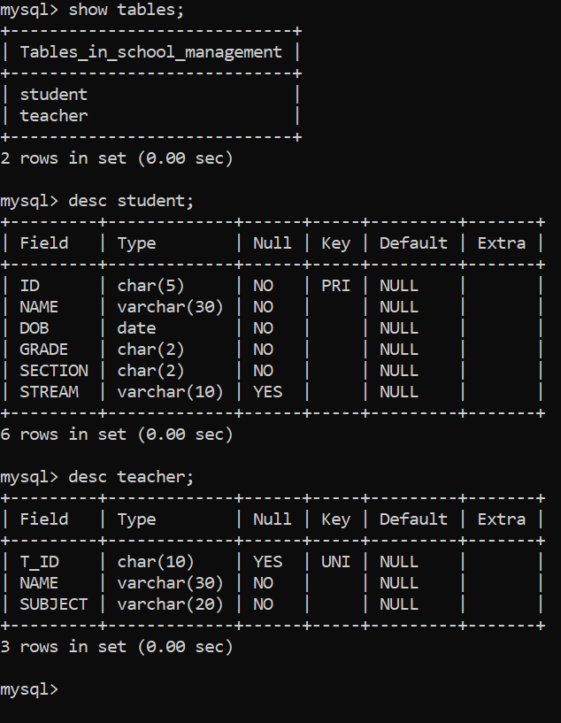
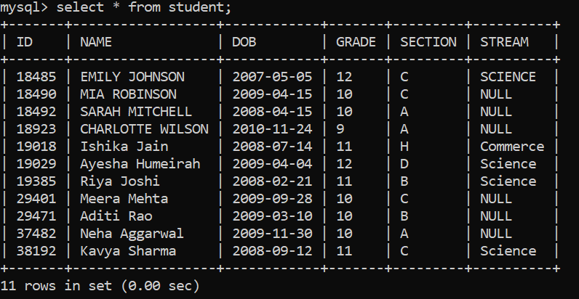
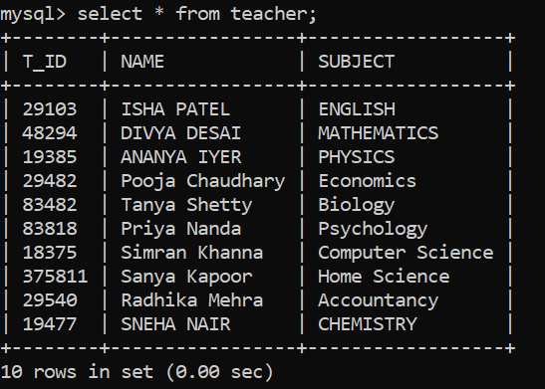

FLOWCHART
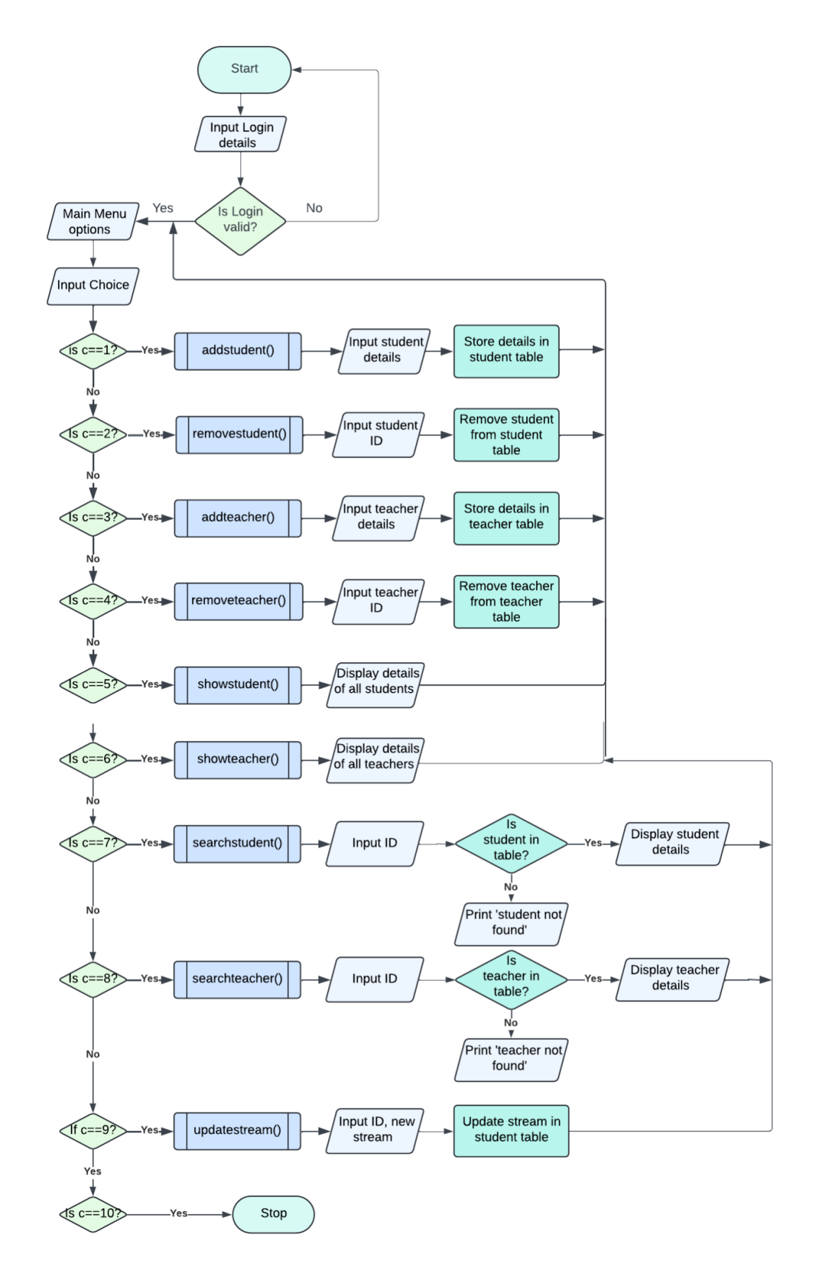
PROGRAM SOURCE CODE

import mysql.connector
db=mysql.connector.connect(host='localhost',user='root',password='*********',database='school_management')
cursor=db.cursor()

def addstudent():
ID=int(input("Enter Student's ID:"))
name=input("Enter Student's name:")
DOB=input("Enter DOB of the student:")
grade=input("Enter grade:")
section=input("Enter section:")
if grade=="11" or grade=="12":
stream=input("Enter stream:")
cursor.execute('Insert into student (ID,NAME,DOB,GRADE,SECTION,STREAM) VALUES (%s,%s,%s,%s,%s,%s)',(ID,name,DOB,grade,section,stream))
else:
cursor.execute('Insert into student (ID,NAME,DOB,GRADE,SECTION) VALUES (%s,%s,%s,%s,%s)',(ID,name,DOB,grade,section))
db.commit()
print('STUDENT ADDED SUCCESSFULLY')

def removestudent():
ID= int(input("Enter Student's ID:"))
cursor.execute('DELETE FROM student WHERE ID = %s', (ID,))
db.commit()
print('STUDENT REMOVED SUCCESSFULLY')

def addteacher():
ID=int(input("Enter Teacher's ID:"))
name=input("Enter Teacher's name:")
sub= input("Enter Teacher's subject:")
cursor.execute('INSERT INTO teacher (T_ID,NAME,SUBJECT) VALUES (%s,%s,%s)',(ID,name,sub))
db.commit()
print('TEACHER ADDED SUCCESSFULLY')

def removeteacher():
ID=int(input("Teacher's ID: "))
cursor.execute('DELETE FROM teacher WHERE T_ID = %s', (ID,))
db.commit()
print('TEACHER REMOVED SUCCESSFULLY')

def showstudent():
cursor.execute("SELECT * FROM student")
student=cursor.fetchall()
if student:
print("List of students:")
for i in student:
if i[3]=="11" or i[3]=="12":
print(f"ID:{i[0]},Name:{i[1]},DOB:{i[2]},Grade:{i[3]},Section:{i[4]},Stream:{i[5]}")
else:
print(f"ID:{i[0]},Name:{i[1]},DOB:{i[2]},Grade:{i[3]},Section:{i[4]}")
else:
print("NO STUDENTS ENTERED")

def showteacher():
cursor.execute("SELECT T_ID,NAME,SUBJECT FROM teacher")
teacher=cursor.fetchall()
if teacher:
print("List of teachers:")
for i in teacher:
print(f"ID:{i[0]},Name:{i[1]},Subject:{i[2]}")
else:
print("NO TEACHERS ENTERED")

def searchstudent():
ID=int(input("Enter student's ID: "))
cursor.execute("SELECT GRADE FROM student WHERE ID=%s"%(ID,))
grade=cursor.fetchone()
if grade:
gr=int(grade[0])
if gr==11 or gr==12:
cursor.execute("SELECT ID,NAME,DOB,GRADE,SECTION,STREAM FROM student WHERE ID=%s"%(ID,))
else:
cursor.execute("SELECT ID,NAME,DOB,GRADE,SECTION FROM student WHERE ID=%s"%(ID,))
student=cursor.fetchone()
if gr==11 or gr==12:
print(f"ID: {student[0]}, Name: {student[1]}, DOB: {student[2]}, GRADE: {student[3]}, SECTION: {student[4]}, STREAM: {student[5]}")
else:
print(f"ID: {student[0]}, Name: {student[1]}, DOB: {student[2]}, GRADE: {student[3]}, SECTION: {student[4]}")
else:
print("STUDENT NOT FOUND")
def searchteacher():
ID=int(input("Enter teacher's ID: "))
cursor.execute("SELECT T_ID,NAME,SUBJECT FROM teacher WHERE T_ID=%s", (ID,))
teacher=cursor.fetchone()
if teacher:
print(f"ID: {teacher[0]}, Name: {teacher[1]}, Subject: {teacher[2]}")
else:
print("TEACHER NOT FOUND")

def updatestream():
ID=int(input("Enter student's ID:"))
cursor.execute("SELECT ID,NAME,DOB,GRADE,SECTION,STREAM FROM student WHERE ID=%s"%(ID,))
student=cursor.fetchone()
if student:
stream=input("Enter new stream chosen:")
cursor.execute("Update student set stream='%s' where ID=%d"% (stream,ID))
db.commit()
print("STREAM UPDATED")
else:
print("STUDENT NOT FOUND")
def login():
print('Login')
for i in range(3):
c=0
username = input("Enter username: ")
password = input("Enter password: ")
if username=='sql123pyt' and password=='123':
print("Login successful\n")
return True
else:
print("Invalid Username and password\n")
c+=1
if c>3:
return False

def menu():
while True:
print("""
---------------------------------------------------
( )
( .. .. .. .. .. .. .. )
(..............SCHOOL MANAGEMENT SYSTEM.............)
( .. .. .. .. .. .. .. )
( )
---------------------------------------------------
^^^^^^^^^^^^^^^^^^^^^^^^^^^^^^^^^^^^^^^^^^^^^^^^^^^
===================================================
***************************************************
MAIN MENU

1.Add new student 6.Show list of teachers

2.Remove a student 7.Search student

3.Add new teacher 8.Search teacher

4.Remove a teacher 9.Update stream

5.Show list of students 10.Logout
***************************************************
===================================================
^^^^^^^^^^^^^^^^^^^^^^^^^^^^^^^^^^^^^^^^^^^^^^^^^^^
""")
c=int(input("Enter your choice:"))
if c==1:
addstudent()
elif c==2:
removestudent()
elif c==3:
addteacher()
elif c==4:
removeteacher()
elif c==5:
showstudent()
elif c==6:
showteacher()
elif c==7:
searchstudent()
elif c==8:
searchteacher()
elif c==9:
updatestream()
elif c==10:
print("Successfully logged out")
break
else:
print("Invalid choice, please try again.\n")
r=login()
if r==True:
menu()
else:
print("Login attempt failed")

OUTPUT SCREENSHOTS
Login Attempt Failed:
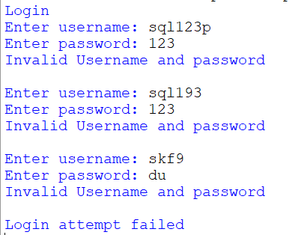
Login Attempt Successful:
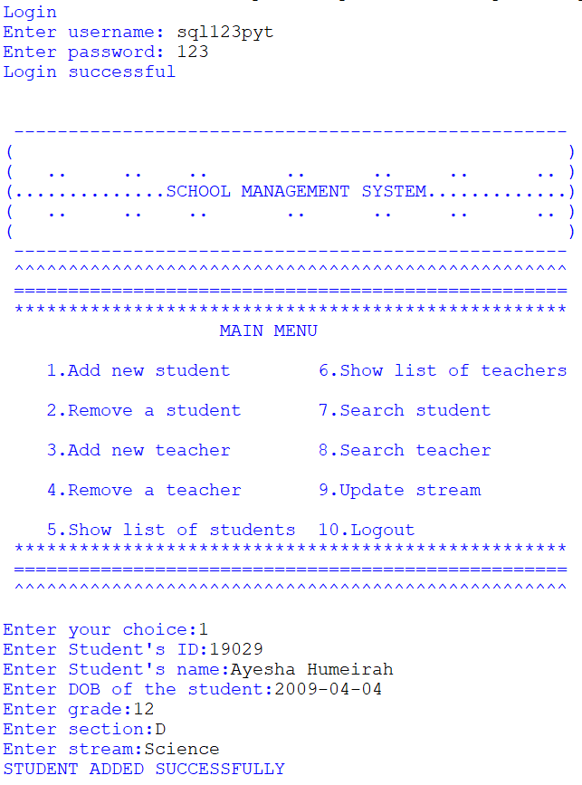
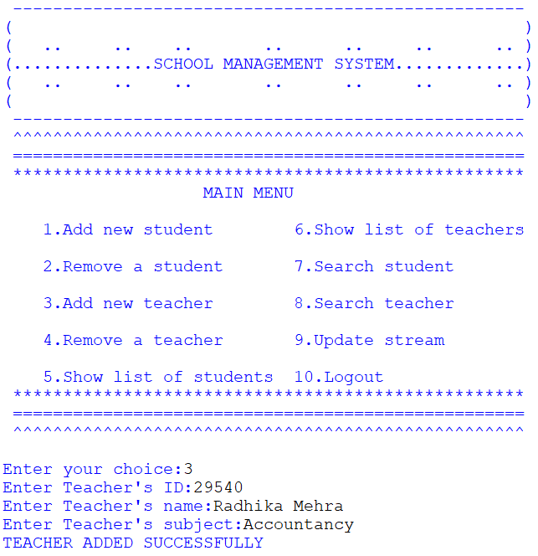
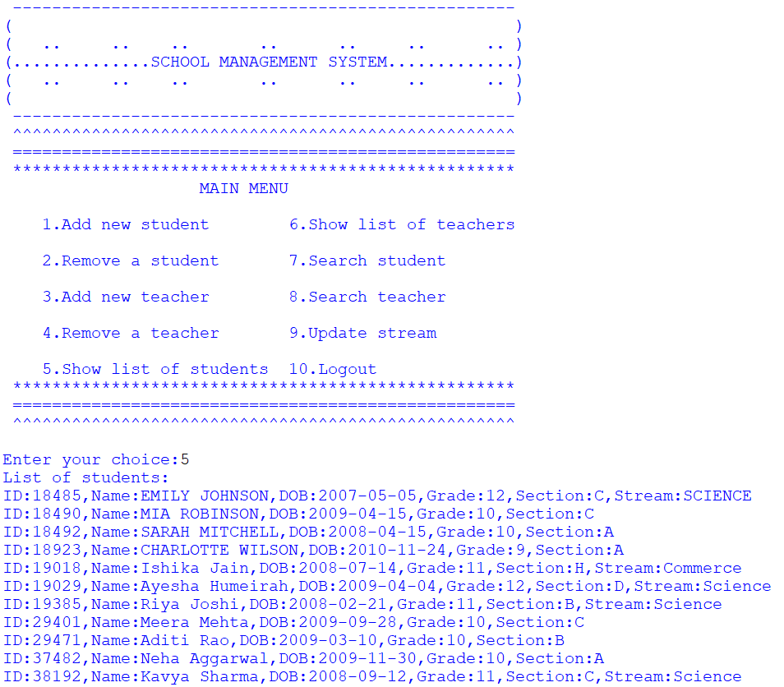
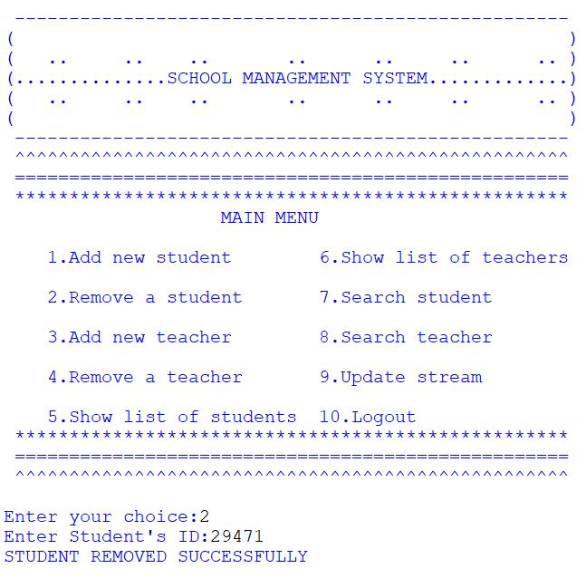
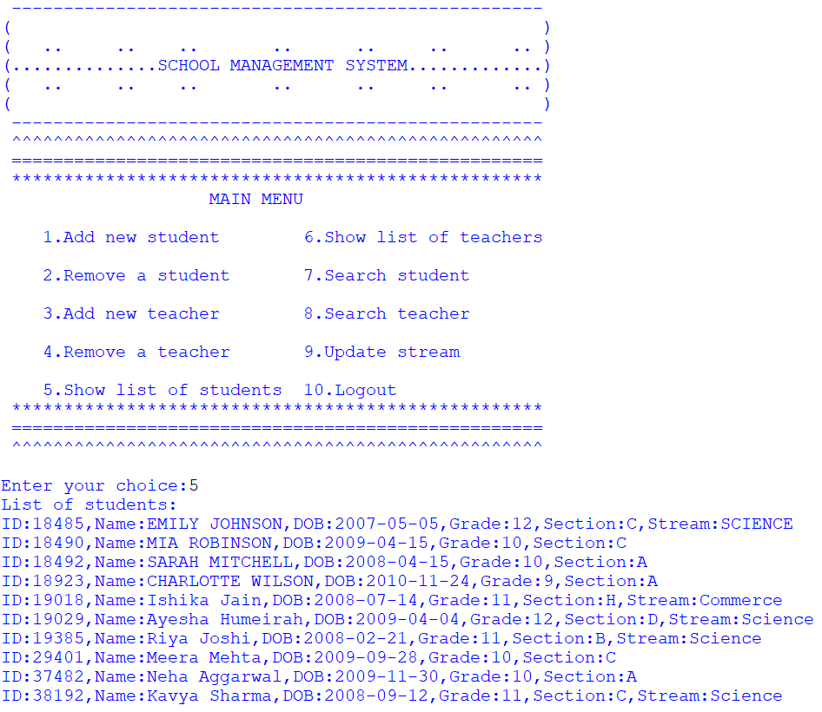
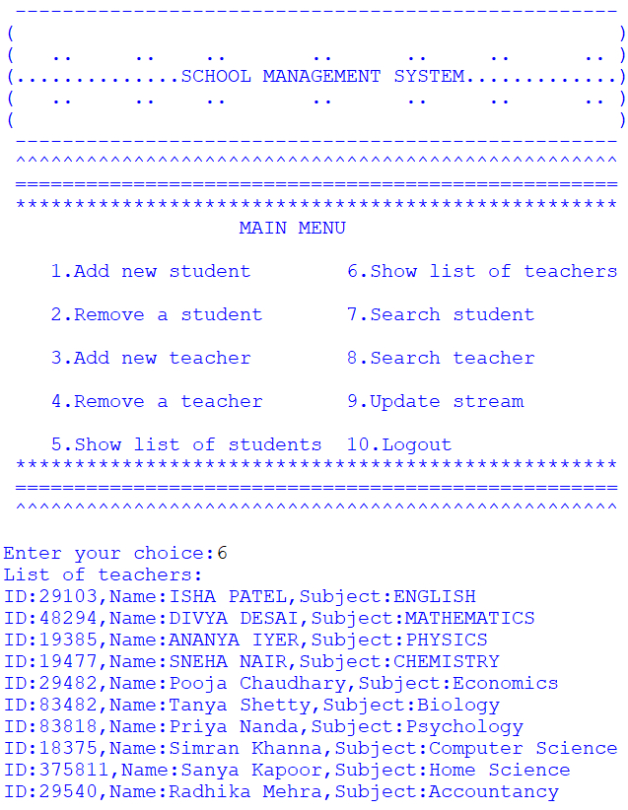
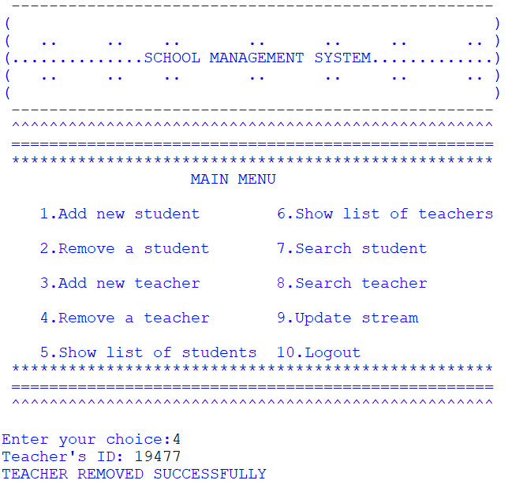
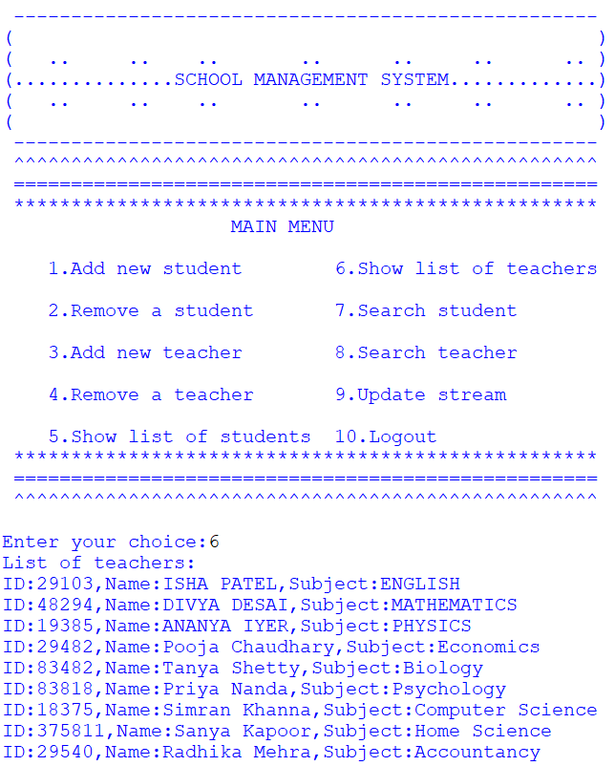
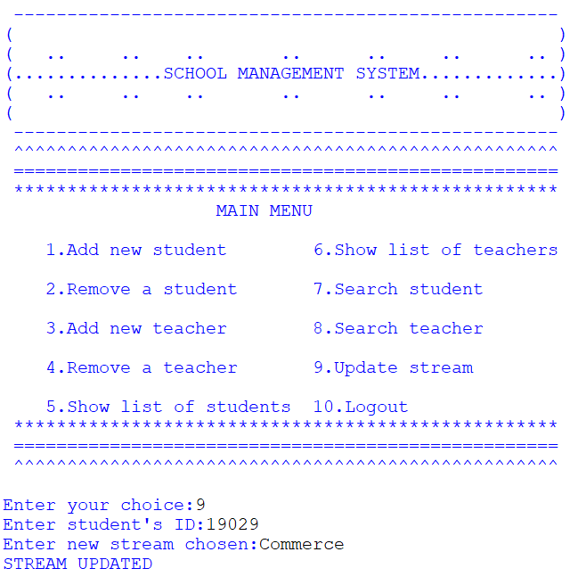
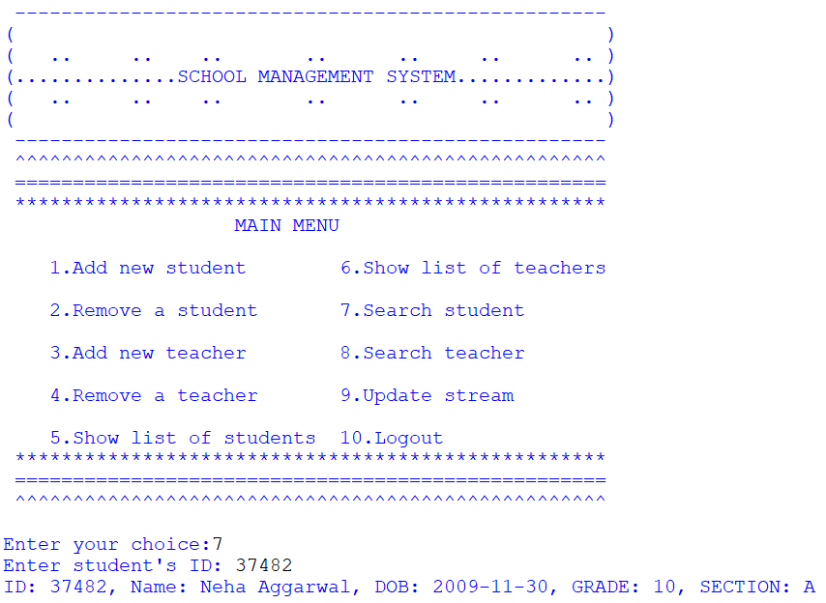
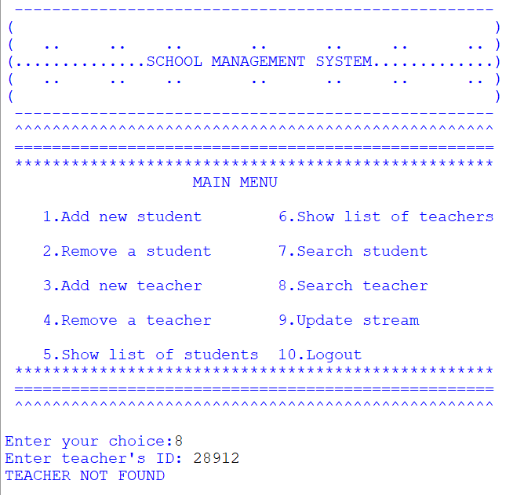
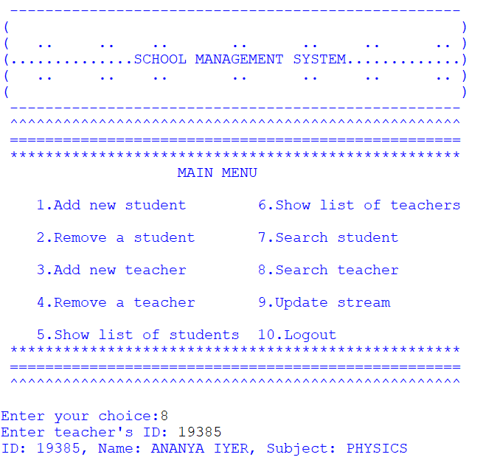
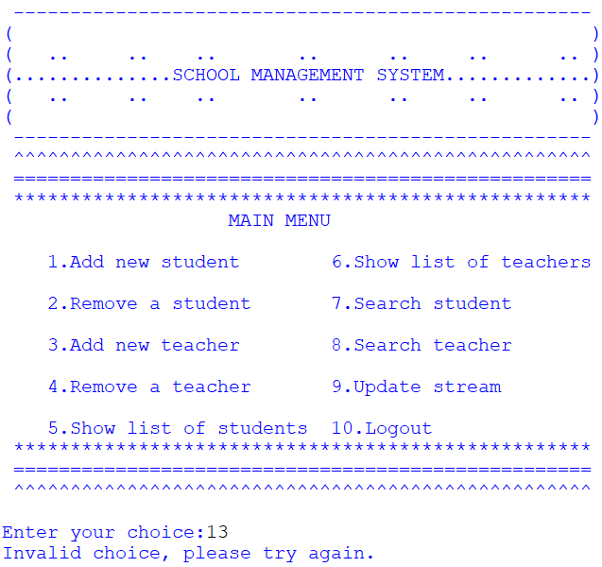
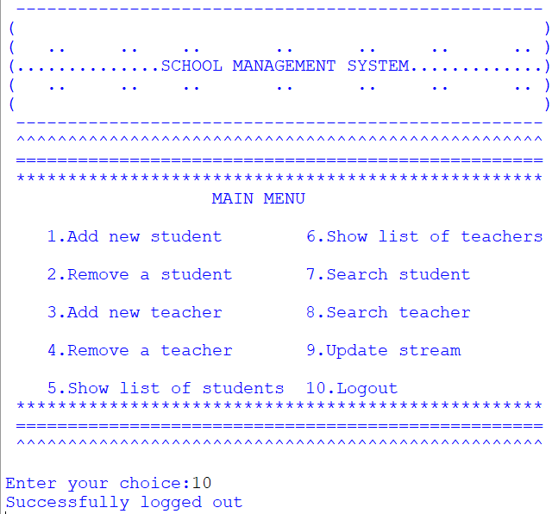

BIBLIOGRAPHY

- Sumita Arora (2021), Computer Science With Python- Class XI, Dhanpat Rai & Co.

- Sumita Arora (2021), Computer Science With Python- Class XII, Dhanpat Rai & Co.

- http://www.realpython.com

- http://google.com/

- https://www.w3schools.com/python/

