NAME : NIVETHA G

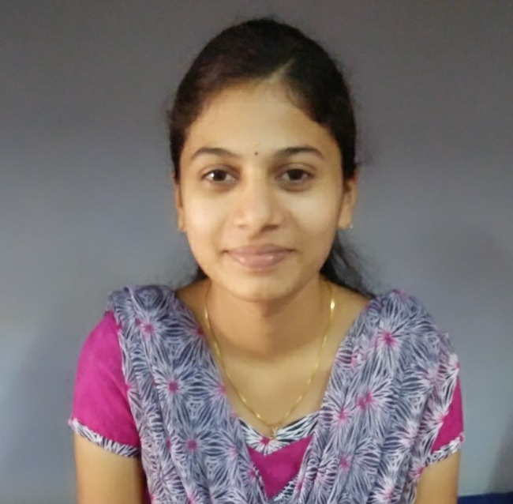
DEGREE : Bachelor of Engineering
BRANCH : Electronics and Communication Engineering

OBJECTIVE:

To be a part of your Organization that provides an atmosphere of mutual growth and benefits, Where I can show my talent and potential.

PERSONAL DETAILS:

PERMANENT ADDRESS:
D/O P.Ganesan,
4/23 Kadakkalpudhur,
Veesanam,Namakkal(DT)-637 405.
 +919443186611
E-Mail: nivethaganesh1997@gmail.com

DATE OF BIRTH : 06.10.1997
AGE : 19
GENDER : Female
FATHER'S NAME : Mr.P.Ganesan
MOTHER TONGUE : Tamil
LANGUAGES KNOWN : English,Tamil

ACADEMIC RECORDS:

Course | Institution | University /  Board | Year of  Completion | CGPA /  Marks %
B.E.  XII  X | Karpagam College of Engineering, Coimbatore.  Sri Mahabharathi. Hr. Sec School,  Namakkal.  Sri Mahabharathi. Hr. Sec School,  Namakkal. | Anna University  State Board  State Board | 2018  2014  2012 | 8.45  92.25  89.8

COMPUTER PROFICIENCY:
- Turbo C 3.0, Turbo C++ 3.0.
- Microsoft Windows and Linux Mint.
FIELD OF INTEREST:
- Digital Electronics, SQL.
PROJECT WORKS DONE:
- LOCATION TRACKING SYSTEM –An embedded Systems project.
- HAZARDOUS WASTE MANAGEMENT SYSTEM.
CO- CURRICULAR ACTIVITIES:
- Participated in “Bit N Byte” contest conducted by ES Academy in KCE.
- Participated in “Code Guerriero” event of Yugam 2016 conducted by Kumaraguru College of Technology.
- Certified in “Infosys Campus Connect Programs” conducted by Karpagam College of Engineering.
- Participated in “National Programming Aptitude Test”(NPAT) on August-13-2017.
EXTRA- CURRICULAR ACTIVITIES:
- National Service Scheme Volunteer in Karpagam College of Engineering.
- Vice President of “Food And Nutrition Club” in Karpagam College of Engineering.
- Volunteer in Dhruva Fest-2K17 in Karpagam College of Engineering.
- Volunteer in world record attempt “Largest Human Image Of A Music Instrument” in Karpagam College Of Engineering at Coimbatore.
HOBBIES/INTERESTS:
- Playing games
- Cycling

DECLARATION:
I, hereby confirm that the information given above is true to the best of my knowledge.

PLACE:
DATE : SIGNATURE

