EXPERIMENT 2-CLI, GUI AND VUI

🔹 CLI (Command Line Interface)
CLI allows users to interact with the system using text commands typed in the terminal. It is fast, lightweight, and suitable for experienced users.

CODE:
import os import sys

def rename_file(old_name, new_name): try:
os.rename(old_name, new_name) print(f"File renamed from {old_name} to {new_name}") except FileNotFoundError:
print(f"Error: {old_name} not found.") except Exception as e: print(f"An error occurred: {e}")

if __name__ == "__main__": if len(sys.argv) != 3:
print("Usage: python rename_file_cli.py <old_filename>
<new_filename>") else:
rename_file(sys.argv[1], sys.argv[2])
OUTPUT:

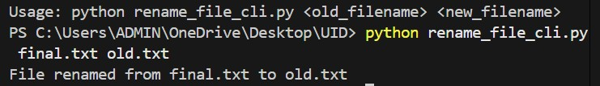

HOW IT WORKS:
- User selects create / rename / exit from menu
- Program performs file operation using Python functions
- Output displayed in terminal

🔹 GUI (Graphical User Interface)
GUI allows users to interact using graphical elements like buttons, text boxes, and windows. It is user-friendly and easy to use.

CODE:
import tkinter as tk from tkinter import messagebox import os

def rename_file():
old_name = old_entry.get() new_name = new_entry.get() try:
os.rename(old_name, new_name) messagebox.showinfo("Success", f"Renamed {old_name} to
{new_name}") except FileNotFoundError:
messagebox.showerror("Error", "File not found")

root = tk.Tk() root.title("File Renamer")

tk.Label(root, text="Old Filename").grid(row=0, column=0) tk.Label(root, text="New Filename").grid(row=1, column=0)

old_entry = tk.Entry(root) new_entry = tk.Entry(root) old_entry.grid(row=0, column=1) new_entry.grid(row=1, column=1)

tk.Button(root, text="Rename File", command=rename_file).grid(row=2, columnspan=2)

root.mainloop()

OUTPUT:

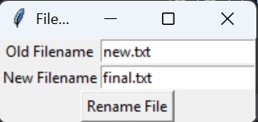
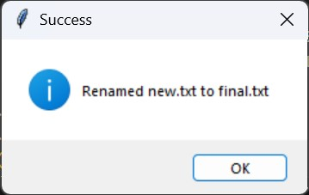

HOW IT WORKS:
- User enters file name in text box
- Click buttons (Create, Rename, Delete)
- Files shown in listbox
- Status bar shows result

🔹 VUI (Voice User Interface)
VUI allows users to interact with the system using voice commands. It improves accessibility and provides hands-free operation.

CODE:
import speech_recognition as sr import os
import sounddevice as sd from scipy.io.wavfile import write

samplerate = 44100

def record(seconds=4): print("Speak now...")
audio = sd.rec(int(seconds * samplerate), samplerate=samplerate, channels=1, dtype='int16') sd.wait() write("temp.wav", samplerate, audio)

def listen(prompt): print(prompt) record()

r = sr.Recognizer() with sr.AudioFile("temp.wav") as source:
audio_data = r.record(source)
try:
text = r.recognize_google(audio_data) print("You said:", text) return text.lower() except:
print("Could not understand. Try again.") return None

def rename_file(): print("Welcome to the Voice-Controlled File Renamer!") old_name = listen("Say the name of the file you want to rename
(without .txt)") if not old_name:
return

new_name = listen("Say the new name for the file (without .txt)") if not new_name: return

old_file = old_name + ".txt" new_file = new_name + ".txt"

if not os.path.exists(old_file):
print(f"Error: '{old_file}' not found.") return

os.rename(old_file, new_file)

# GREEN SUCCESS LINE WITH TICK
print(f"\033[92m✅ File successfully renamed from '{old_file}' to '{new_file}'\033[0m")

rename_file()

OUTPUT:
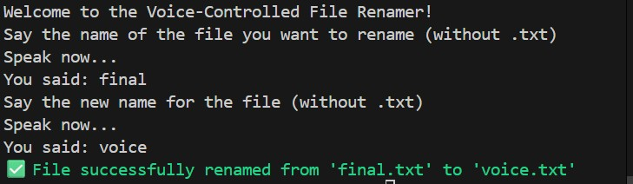

HOW IT WORKS:
- System listens to voice command
- User says create or rename
- Program performs operation
- System speaks result

