33332. MICROSOFT AZURE

2.1 INTRODUCTION

Azure was announced in October 2008 and released on 1 February 2010 as Windows Azure, before being renamed to Microsoft Azure on 25 March 2014. Along with Amazon Web Services Azure is considered a leader in the IAAS field.

Microsoft Azure is an open and flexible cloud platform that enables you to quickly build, deploy, and manage applications across a global network of Microsoft-managed datacenters. You can build applications using any language, tool, or framework. And you can integrate your public cloud applications with your existing IT environment.

This definition tells us that Microsoft Azure is a cloud platform, which means you can use it for running your business applications, services, and workloads in the cloud. But it also includes some key words that tell us even more:

Open Microsoft Azure provides a set of cloud services that allow you to build and deploy cloud-based applications using almost any programming language, framework, or tool.

Flexible Microsoft Azure provides a wide range of cloud services that can let you do everything from hosting your company’s website to running big SQL databases in the cloud. It also includes different features that can help deliver high performance and low latency for cloudbased applications. Microsoft-managed Microsoft Azure services are currently hosted in several datacenters spread across the United States, Europe, and Asia. These datacenters are managed by Microsoft and provide expert global support on a 24x7x365 basis. Compatible Cloud applications running on Microsoft Azure can easily be integrated with on-premises IT environments that utilize the Microsoft Windows Server platform. It provides both PAAS and IAAS services and supports many different programming languages, tools and frameworks, including both Microsoft-specific and third-party software and systems.

MICROSOFT AZURE: CLOUD COMPUTING PLATFORM AND SERVICES

7 | P a g e

2.2 AZURE AS PAAS (PLATFORM AS A SERVICE)

As the name suggests, a platform is provided to clients to develop and deploy software.

The clients can focus on the application development rather than having to worry about hardware

and infrastructure. It also takes care of most of the operating systems, servers and networking

issues.

Pros

➢ The overall cost is low as the resources are allocated on demand and servers are

automatically updated.

➢ It is less vulnerable as servers are automatically updated and being checked for all known

security issues. The whole process is not visible to developer and thus does not pose a risk

of data breach.

➢ Since new versions of development tools are tested by the Azure team, it becomes easy for

developers to move on to new tools. This also helps the developers to meet the customer’s

demand by quickly adapting to new versions.

Cons

➢ There are portability issues with using PAAS. There can be a different environment at

Azure, thus the application might have to be adapted accordingly.

MICROSOFT AZURE: CLOUD COMPUTING PLATFORM AND SERVICES

8 | P a g e

2.3 Azure as IAAS (Infrastructure as a Service)

It is a managed compute service that gives complete control of the operating systems and

the application platform stack to the application developers. It lets the user to access, manage and

monitor the data centers by themselves.

Pros

➢ This is ideal for the application where complete control is required. The virtual machine

can be completely adapted to the requirements of the organization or business.

➢ IAAS facilitates very efficient design time portability. This means application can be

migrated to Windows Azure without rework. All the application dependencies such as

database can also be migrated to Azure.

➢ IAAS allows quick transition of services to clouds, which helps the vendors to offer

services to their clients easily. This also helps the vendors to expand their business by

selling the existing software or services in new markets.

Cons

➢ Since users are given complete control they are tempted to stick to a particular version for

the dependencies of applications. It might become difficult for them to migrate the

application to future versions.

➢ There are many factors which increases the cost of its operation. For example, higher server

maintenance for patching and upgrading software.

MICROSOFT AZURE: CLOUD COMPUTING PLATFORM AND SERVICES

9 | P a g e

➢ There are lots of security risks from unpatched servers. Some companies have well-defined

processes for testing and updating on-premise servers for security vulnerabilities. These

processes need to be extended to the cloud-hosted IAAS VMs to mitigate hacking risks.

➢ The unpatched servers pose a great security risk. Unlike PAAS, there is no provision of

automatic server patching in IAAS. An unpatched server with sensitive information can be

very vulnerable affecting the entire business of an organization.

➢ It is difficult to maintain legacy apps in IAAS. It can be stuck with the older version of the

operating systems and application stacks. Thus, resulting in applications that are difficult

to maintain and add new functionality over the period of time.

It becomes necessary to understand the pros and cons of both services in order to choose

the right one according your requirements. In conclusion it can be said that, PAAS has definite

economic advantages for operations over IAAS for commodity applications. In PAAS, the cost of

operations breaks the business model. Whereas, IAAS gives complete control of the OS and

application platform stack.

MICROSOFT AZURE: CLOUD COMPUTING PLATFORM AND SERVICES

10 | P a g e

2.4 AZURE MANAGEMENT PORTAL

Azure Management Portal is an interface to manage the services and infrastructure

launched in 2012. All the services and applications are displayed in it and it lets the user manage

them.

Getting started

A free trial account can be created on Azure management portal by visiting the following link -

manage.windowsazure.com

The screen that pops up is as shown in the following image. The account can be created

using our existing Gmail, Hotmail or Yahoo account.

Figure4: Sign in to Microsoft Azure

MICROSOFT AZURE: CLOUD COMPUTING PLATFORM AND SERVICES

11 | P a g e

Once logged in, you will be redirected to the following screen, where there is a list of

services and applications on the left panel.

Figure5: Services and application of Microsoft Azure

When you click on a category, its details are displayed on the screen. You can see the number of

applications, virtual machine, mobile services and so on by clicking on the menu item.

\

MICROSOFT AZURE: CLOUD COMPUTING PLATFORM AND SERVICES

12 | P a g e

3. SERVICES OF MICROSOFT AZURE

➢ Windows Azure provides businesses with four basic categories of cloud-based services: 1. Compute services 2. Network services 3. Data services 4. App services

Figure6: Services of Microsoft Azure

MICROSOFT AZURE: CLOUD COMPUTING PLATFORM AND SERVICES

13 | P a g e

1. Compute services

Windows Azure compute services provide the processing power required for cloud applications to be able to run. Windows Azure currently offers four different compute services:

➢ Virtual Machines: This service provides you with a general-purpose computing environment that lets you create, deploy, and manage virtual machines running in the Windows Azure cloud.

➢ Web Sites: This service provides you with a managed web environment you can use to create new websites or migrate your existing business website into the cloud.

➢ Cloud Services This service allows you to build and deploy highly available and almost infinitely scalable applications with low administration costs using almost any programming language.

➢ Mobile Services This service provides a turnkey solution for building and deploying apps and storing data for mobile devices.

MICROSOFT AZURE: CLOUD COMPUTING PLATFORM AND SERVICES

14 | P a g e

2. Network services

Windows Azure network services provide you with different options for how Windows Azure applications can be delivered to users and datacenters. Windows Azure currently offers two different network services:

➢ Virtual Network This service allows you to treat the Windows Azure public cloud as if it is an extension of your on-premises datacenter. ➢ Traffic Manager This service allows you to route application traffic for the user who is using the application to Windows Azure datacenters in three ways: for best performance, in round robin fashion, or using an Active/Passive failover configuration.

ADVANTAGES:

Azure allows you to build, deploy, and manage apps more quickly and easily without having to buy and/or maintain the underlying infrastructure. Azure's integrated cloud **resources** meet all your **security** and compliance requirements while being easily customizable for a company's unique needs.

MICROSOFT AZURE: CLOUD COMPUTING PLATFORM AND SERVICES

15 | P a g e

3. Data services

Windows Azure data services provide you with different ways of storing, managing, safeguarding, analyzing, and reporting business data. Windows Azure currently offers five different data services:

➢ Data Management This service lets you store your business data in SQL databases, either with dedicated Microsoft SQL Server virtual machines, using Windows Azure SQL Database, using NoSQL Tables via REST, or using BLOB storage. ➢ Business Analytics This service enables ease of discovery and data enrichment using Microsoft SQL Server Reporting and Analysis Services or Microsoft SharePoint Server running in a virtual machine, Windows Azure SQL Reporting, the Windows Azure Marketplace, or HDInsight, a Hadoop implementation for Big Data.

➢ HDInsight This is Microsoft’s Hadoop-based service which brings a 100 percent Apache Hadoop solution to the cloud. ➢ Cache This service provides a distributed caching solution that can help speed up your cloud-based applications and reduce database load.

➢ Backup This service helps you protect your server data offsite by using automated and manual backups to Windows Azure. ➢ Recovery Manager Windows Azure Hyper-V Recovery Manager helps you protect business critical services by coordinating the replication and recovery of System Center 2012 private clouds at a secondary location.

MICROSOFT AZURE: CLOUD COMPUTING PLATFORM AND SERVICES

16 | P a g e

4. App services

Windows Azure app services provide you with ways of enhancing the performance, security, discoverability, and integration of your cloud apps that are running. Windows Azure currently offers seven different app services:

➢ Media Services This service allows you to build workflows for the creation, management, and distribution of media using the Windows Azure public cloud.

➢ Messaging This consists of two services (Windows Azure Service Bus and Windows Azure Queue) that allow you to keep your apps connected across your private cloud environment and the Windows Azure public cloud.

➢ Notification Hubs This service provides a highly scalable, cross-platform push notification infrastructure for applications running on mobile devices.

➢ BizTalk Services This service provides Business-to-Business (B2B) and Enterprise Application Integration (EAI) capabilities for delivering cloud and hybrid integration solutions.

➢ Active Directory This service provides you with identity management and access control capabilities for your cloud applications.

➢ Multifactor Authentication This service provides an extra layer of authentication, in addition to the user’s account credentials, in order to better secure access for both onpremises and cloud applications.

MICROSOFT AZURE: CLOUD COMPUTING PLATFORM AND SERVICES

17 | P a g e

9. APPLICATIONS OF MICROSOFT AZURE

Windows Azure is usually misinterpreted as just a hosting solution, but there is a lot more that can be done using Windows Azure. It provides a platform to develop applications using a range of available technologies and programming languages. It offers to create and deploy applications using .net platform, which is Microsoft’s own application development technology. In addition to .net, there are many more technologies and languages supported. For example, Java, PHP, Ruby, Oracle, Linux, MySQL, Python.

Windows Azure applications are scaled by creating multiple instances of the application. The number of instances needed by the application is specified by the developer while hosting the applications. If traffic is increased or decreased on the website or web application it can be managed easily by logging in to Windows Azure management portal and specifying the instances. Load balancing can also be automated which would allow Azure to make the decision itself as when to assign more resources to application.

Web applications support .net, java, python, php and node.js. Tasks such as scaling and backups can be easily automated. A new feature called ‘web jobs’ is available, which is a kind of batch processing service. Web jobs can also be scaled and scheduled. The mobile application platforms supported are Xamarin iOS, Xamarin Android and IOS. Azure platform is developed in such a way that developers need to concentrate on only the development part and need not worry about other technical stuff outside their domain. Thus most of the administrative work is done by Azure itself.

A marketplace is also set by Azure where its customers can buy applications and services. It is a platform where customers can search applications and deploy them in an easier way. Azure marketplace is available in 88 countries at present. An application purchased from the marketplace can be easily connected to the local development environment by the application developers. The pricing is done using 5 different models, which includes usage-based and monthly fee. Some of the applications are even free of charge.

MICROSOFT AZURE: CLOUD COMPUTING PLATFORM AND SERVICES

18 | P a g e

5. DATACENTERS

When we think of cloud, we imagine a place with large number of machines in big rooms. There must be a place where all the data is stored. Microsoft has datacenters all over the world from where Windows Azure services are managed. Datacenters are divided in regions. The exact location of these datacenters is not revealed by Microsoft for obvious security reasons. Following are the 19 listed regions as can also be seen in the image. 1. Central US

2. East US

3. East US 2

4. US Gov Iowa

5. US Gov Virginia

6. North Central US

7. South Central US

8. West US

9. North Europe

10. West Europe

11. East Asia

12. Southeast Asia

13. Japan East

14. Japan West

15. Brazil South

16. Australia East

17. Australia Southeast

18. Central India

MICROSOFT AZURE: CLOUD COMPUTING PLATFORM AND SERVICES

19 | P a g e

19. South India

Figure7: Datacenters of Microsoft Azure

MICROSOFT AZURE: CLOUD COMPUTING PLATFORM AND SERVICES

20 | P a g e

5.1 HOW TO CHOOSE THE RIGHT DATA CENTER FOR YOUR APPLICATION

When creating Windows Azure application, whether it is mobile application, web application or database storage it asks to specify the region. Region here specifies a regional datacenter.

Performance: You should select the nearest datacenter to the users of your application. The performance can be affected by the relative location of the users who want to access the application. If a user is closer to the datacenter, the performance will be better. Cost: The price of hosting the application may also increase or decrease depending upon the datacenter you choose. Price actually can vary according to the database hosting location or any other service being used by the application. You should choose the same location for all the services that are being used by your application. For example, database or any media service. If they are kept in separate datacenter there will be charges per transaction, but anything extra won’t be charged if they are kept at the same datacenter.

Legal Aspect: Laws vary from country to country and restrictions could be enforced in some regions on what information can be shared and what cannot.

MICROSOFT AZURE: CLOUD COMPUTING PLATFORM AND SERVICES

21 | P a g e

6. ADVANTAGE MICROSOFT AZURE

The Microsoft Azure Platform offers a range of businesses flexibility, control, and an affordable solution for running Web-scale applications. The services reduce tedious and expensive infrastructure management and planning and are built with security and reliability in mind, along with the option of a pay-as-you-go model.

➢ Pay as you grow – Match usage needs with the option of pay-as-you-go pricing - paying for the services you use and reducing the capital costs associated with purchasing hardware and infrastructure. ➢ Reduce operational costs – Azure reduces the need for up-front technology purchases and by running applications in the cloud you decrease the need for maintaining on-premise infrastructure. ➢ Increase business efficiency and agility – by dynamically adding and subtracting capacity in real time. Azure simplifies maintaining and operating applications by providing ondemand compute and storage to host, scale, and manage web and connected applications. ➢ Build and deploy software quickly and easily by capitalising on the same personnel, development tools and investments, and knowledge that already powers your IT organisation. ➢ Easy developer on-ramp to the cloud – Millions of developers worldwide already use the .NET Framework and the Visual Studio development environment. Utilize those same skills to create cloud-enabled applications that can be written, tested, and deployed all from Visual Studio. Azure will support more programming languages and development environments in the future, such as Eclipse, Ruby, PHP, and Python. ➢ Enables Agile & Rapid Results – Applications can be deployed to the Platform with the click of a button. Changes can be made quickly and without downtime, making it an ideal platform for affordably experimenting and trying new ideas. ➢ Imagine and Create New User Experiences – The Platform enables you to create web, mobile, or hybrid applications that use the cloud with on-premises applications. Combined with Live Services ability to reach over 400 million live users, new opportunities exist to interact and reach users in new ways.

MICROSOFT AZURE: CLOUD COMPUTING PLATFORM AND SERVICES

22 | P a g e

➢ Offers choice –The open architecture gives developers the choice to build web applications, applications running on connected devices, PCs, servers, or hybrid solutions offering the best of online and on-premises. ➢ Standards-Based Compatibility – The services platform supports industry-standard protocols, including HTTP,REST, SOAP, RSS, and AtomPub, for consuming, exposing, and integrating with third-party services. You can easily integrate applications built on a variety of different technologies and operating systems.

MICROSOFT AZURE: CLOUD COMPUTING PLATFORM AND SERVICES

23 | P a g e

7. CONCLUSION

Executing applications in the clouds offer many advantages over the traditional way of running programs. Firstly, using cloud computing allows rapid service deployment and massive Savings upfront because not having to invest in infrastructure. Secondly, cloud computing model allows computing power and storage to scale up with business growth. In addition to this, it’s also easy to dynamically adjust computing power up or down. As a customer, you end up paying for the actual usage of resources. The advantages of using the Azure cloud platform relate to the fact that Microsoft has tried to minimize the changes involved in migrating applications to the cloud. Effort required from developers already familiar with Microsoft’s technologies to utilize the Azure is minimal. In addition to this, upcoming releases of Azure are going to support applications written in languages such as Python and PHP. Another advantage in Microsoft’s solution is that the services provided can be used in a very flexible fashion. Not only are Azure services available to cloud applications, but also traditional on-premises applications are free to exploit them. What’s Even better, Microsoft seems to be improving in terms of interoperability. Because all of the services are accessible via industry standard protocols, it is guaranteed exploiting them doesn’t force customers to use Microsoft’s operating systems on-premises. Although there are many advantages in cloud computing, there are also disadvantages that shouldn’t be ignored. The First and most obvious disadvantage is the fact that by running applications in the cloud you have to hand over your private data. Privacy and security concerns are direct consequences of this. Secondly, although cloud computing relieves customers from the burden of infrastructure management, it also takes away the possibility to be in total control of that infrastructure. In addition to losing control on hardware, using compute clouds also ties the customer very tightly to the cloud service provider. Data, for example, is usually stored in a proprietary format which makes porting applications to competitors’ systems hard. As customers are locked in, they are also at the mercy of that certain service provider’s future pricing strategy.

MICROSOFT AZURE: CLOUD COMPUTING PLATFORM AND SERVICES

24 | P a g e

8. REFERENCES

[1] D. Chappell. Introducing the Azure Services Platform - an early look at Windows Azure, .NET services, SQL services and Live services, October 2008. http://download. microsoft.com/download/e/4/3/e43bb484-3b52-4fa8-a9f9-ec60a32954bc/ Azure_Services_Platform.pdf. [2] H. Erdogmus. Cloud computing: Does Nirvana hide behind the Nebula? IEEE Software, 26(2):4–6, 2009. [3] M. Fitzgerald. When the forecast calls for clouds. Inc.Boston, 31(1):100–102, 2009. [4] B. Hayes. Cloud computing. Commune. ACM, 51(7):9–11, 2008. [5] J. N. Hoover. A stake in the cloud. InformationWeek, 26(1209):22–24, 2008. [6] Microsoft Azure Services Platform documentation, October 2008. http://www.microsoft.com/ Azure/default.mspx. [7] A. Weiss. Computing in the clouds. Net Worker, 11(4):16–25, 2007.

Microsoft is the leading provider of cloud infrastructure as a service (IaaS) and platform as a service (PaaS) solutions sold under the Azure umbrella. Azure allows you to build, deploy, and manage apps more quickly and easily without having to buy and/or maintain the underlying infrastructure. Azure’s integrated cloud resources meet all your security and compliance requirements while being easily customizable for a company’s unique needs.

Estimated to be the second-largest IaaS and PaaS service provider worldwide, Azure has the additional advantage of being fully integrated with all Microsoft products. For those with an existing Microsoft infrastructure, Azure perfectly complements your existing software and applications. Flexible, cost-effective, and at the cutting edge of technology, Azure is the preferred solution for businesses looking to grow and stay ahead of the competition. it integrates with other Microsoft products.

**5 Key Benefits of Microsoft Azure**

Azure provides a number of benefits for businesses. For example:

1. **Perfect for small businesses and established enterprises** — Azure is designed for every business regardless of size, from the local bakery to multi-national corporations. It’s easily scalable and operates on a pay-as-you-go pricing model to meet any budget. Since businesses can launch and store internal and external applications in the cloud, it also saves on in-house IT costs, including hardware and maintenance.
2. **Complements and expands our current IT infrastructure** — The platform makes it fast and easy to deploy your current apps with little to no downtime. An integrated development environment reduces the learning curve, allowing teams to master the platform quickly. Additionally, the platform has a footprint in more countries than Google or Amazon, providing faster content delivery while optimizing the user experience. Azure is scalable to grow with your company, and you pay for only what you need.
3. **Leading the way with IaaS and PaaS** — At the forefront of IaaS and PaaS, Azure offers rapid deployments. The hybrid cloud environment allows companies to select whether they operate autonomously or utilize a public cloud. You are also able to decide the level at which you are connected to the internet, if at all. Meet all your IT and service needs without having to maintain the underlying infrastructure.
4. **Security, compliance, and disaster recovery** — Microsoft understands the importance of security and has designed Azure to stay ahead of the competition when it comes to protecting your data. Azure has many compliance certifications and is a top choice of high-risk industries such as health care and government to provide cloud services. Both the platform and end users are protected. Additional services such as multi-factor authentication and sophisticated disaster recovery abilities that can restore data in a matter of hours further address business needs.
5. **Industry-specific applications** — Due to the high-risk and sensitive nature of certain industries, Azure has designed specific applications to address unique needs. Government, health care, manufacturing, and financial services benefit greatly from Azure’s many features, including offline cloud services, individualized security needs, simplified compliance, and modernized customer apps.

**Microsoft Azure expertise**

At ProTech, we’ve designed multiple courses to assist businesses in accomplishing their goals and objectives. Our classes can be taken in a variety of delivery formats to best suit your needs. Our experts know Microsoft Azure inside and out and understand how it integrates with other Microsoft products. We can assist you in taking your business to the next level regardless of your knowledge and experience with the platform.

## Why are people trusting their workloads to Microsoft Azure?

It’s been said that the on-premise data center has no future. Like mainframes and dial-up modems before them, self-hosted data centers are becoming obsolete, being replaced by increasingly available and affordable cloud solutions. Several important players have emerged in the cloud service sphere, including Amazon Web Services (AWS), perennial computing giant IBM, and Apple’s ubiquitous iCloud, which holds the picture memories and song preferences of hundreds of millions of smartphone users, among other data. With so many options, why are companies like 3M, BMW, and GE moving workloads to Microsoft Azure? Just some of the reasons:

### Flexibility

With Microsoft Azure you can spin up new services and geometrically scale your data storage capabilities on the fly. Compare this to a static data center, which would require new hardware and OS purchasing, provisioning, and deployment before additional power could be brought to bear against your IT challenges. This modern flexibility makes Azure a tempting solution for organizations of any size.

### Cost

Azure solutions don’t just make it faster and easier to add and scale infrastructure, they make it cheaper. Physical services and infrastructure devices like routers, load balancers and more quickly add up to thousands or even hundreds of thousands of dollars. Then there’s the IT expertise required to run this equipment, which amounts to major payroll overhead. By leveraging Microsoft’s massive infrastructure and expertise, Azure can trim our annual IT budget by head-turning percentages.

### Applications

With a la carte service offerings like Visual Studio Team Services, Visual Studio Application Insights, and Azure’s scalable, on-demand storage for both frequently accessed and ‘cold’ data, Microsoft makes developing and testing mission-critical apps a snap. Move an application from test to production mode on the fly across a globally distributed network. Microsoft also offers substantial licensing discounts for migrating their existing apps to Azure, which represents even more opportunity for savings.

### Disaster recovery

Sometimes the unthinkable becomes the very immediate reality. Another advantage of Microsoft Azure lay in its high-speed and geographically decentralized infrastructure, which creates limitless options for disaster recovery plans. Ensure that your critical application and data can run from redundant sites during recovery periods that last minutes or hours instead of days. Lost time is lost business, and with Azure you can guarantee continuous service delivery even when disaster strikes.

The combination of Microsoft’s vast infrastructure, constant application and services development, and powerful presence in the global IT marketplace has made Microsoft Azure solutions the choice of two-thirds of the world’s Fortune 500 companies. But the infinite scalability of Azure can make it just as right for your small personal business

|  |  |  |
| --- | --- | --- |
| **AWS** | **Microsoft Azure** | **Google Cloud Platform** |
| 12 years old | 7 years old | 6 years old |
| Amazon S3 is mostly used for secondary backup | Backup is built into Azure | Does not provide any backup |
| Gives managed virtual tape infrastructure across hybrid environments | Enterprise-grade hybrid cloud storage | It relies on partners like Egnyte |
| Dominant market position | Second largest provider | Recently launched and new |
| Pricing is per hour | Pricing is per minute | Pricing is per minute |

## Microsoft Azure Login

Moving along in this ‘what is Microsoft Azure’ blog, let us see, how you can create a free account in Microsoft Azure. On successful signup, you get Rs.13,300 credit in your Microsoft Azure free-tier account, and 25+ free services for a lifetime.

Below are the steps of creating your own Azure free trial account:

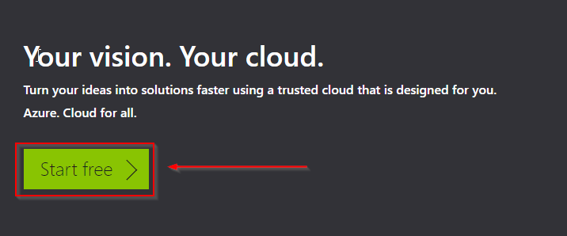

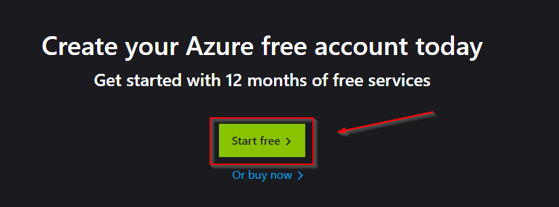

**Step 2**: Again, click on the **Start free** button

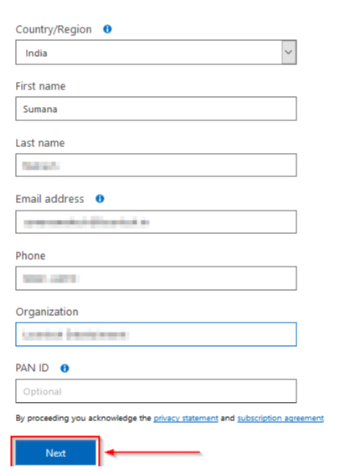

**Step 3**: If you already have a Microsoft account, enter your credentials and log in

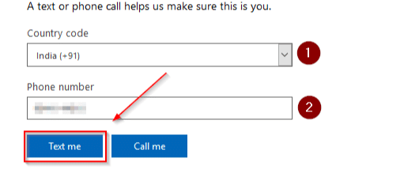

**Step 4**: You will need to verify your account via phone SMS



**Step 5**: Provide your valid credit/debit card details, but you won’t be charged

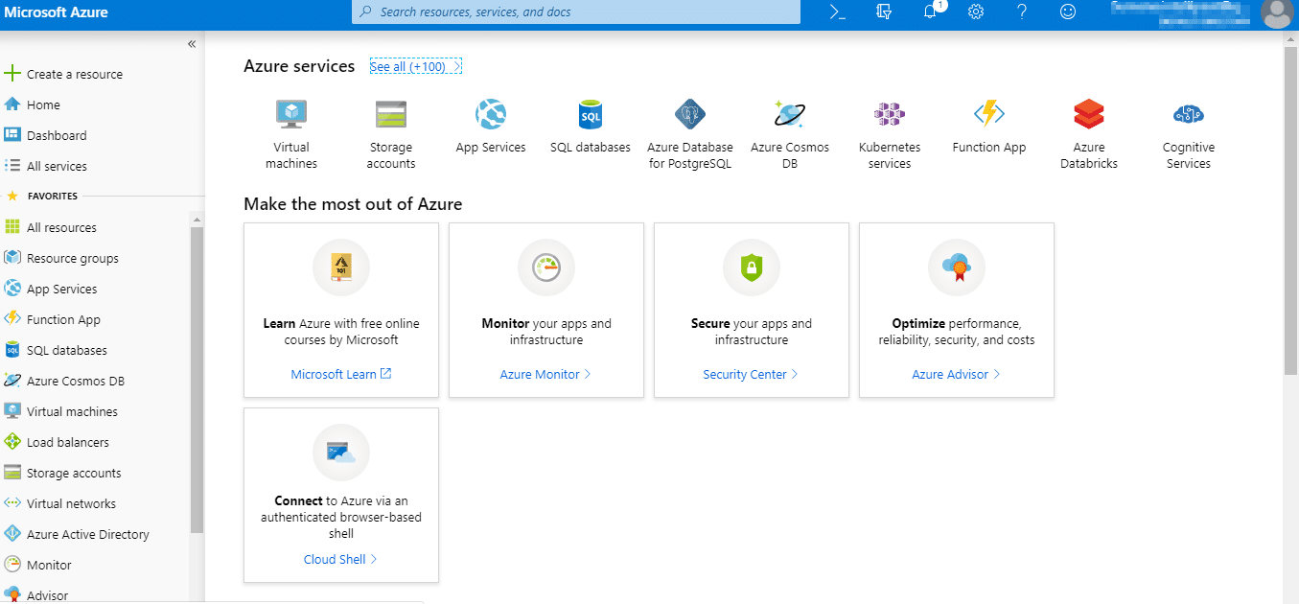

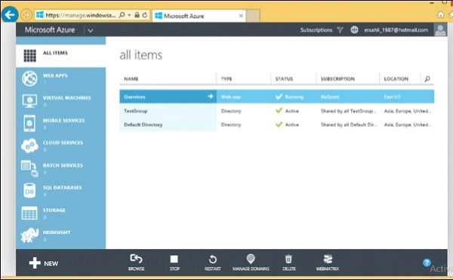

**Step 6**: Next, tick on **I agree** and click on **Sign Up**. Within a few seconds, your account will be ready. Here is your dashboard

And that’s how simple it is!  
Now, talking about the pricing of Azure, here is what you must know.

## Azure Pricing

Azure gives the most amazing pocket-friendly plans for your Infrastructure on Azure.

Azure Pricing is offered in the following three forms:

1. Pay as you go
2. Spot Pricing or Low Priority VM
3. Azure Reserved Instances

Let us understand them one by one:

**Pay as you go:** It is as simple as it sounds, you pay only for what you use. For example: Let’s say you use a 64GB RAM machine with 8 CPU cores for 45 minutes. You will just be charged for 45 minutes, nothing more nothing less. Want to hear something cool? The pricing for the machine similar to this spec is as low as, 61 rupees or 0.8 US dollars an hour. Isn’t that amazing! Not impressed with this pricing? Read on.

**Spot Pricing or Low Priority VM:** You can avail up to 70% discount on the standard pricing of Azure by using this pricing option. How? Azure has a lot of servers under the hood, sometimes because of low demand these servers can go idle, and for this very reason, Azure gives them at discount to users, which can up to 70%. Seems too good to be true? There is a catch though, the moment demand goes up for these servers, they will be taken away from you i.e let’s say you took a Low Priority VM for 0.2 dollars an hour. The moment somebody bids a higher amount on that VM, it will be taken away from you. This kind of pricing is helpful when you are working on tasks that require processing, but they are not urgent. Therefore you do not mind, them being taken away from you.

**Azure Reserved Instances:** With Azure Reserved Instances you can avail a discount of up to 70% on standard Azure pricing. How? Well, unlike Low Priority VMs, this kind of pricing is for workloads, which are extremely important and require constant processing. The way it works is, you commit to Azure that you will be using a particular VM for let’s say 2 years. This way, Azure gives you an upfront discount up to 70% which can vary based on the commitment time. But, you cannot withdraw the VM mid-term. Once you have committed you will use the VM for a particular amount of time, you will be billed for the time that you committed for, even though you are not using it.

The Storage component of Windows Azure represents a durable store in the cloud. Windows Azure allows developers to store tables, blobs, and message queues. The storage can be accessed through HTTP. You can also create our own client; although Windows Azure SDK provides a client library for accessing the Storage.

In this chapter, we will learn how to create a Windows Azure Storage account and use it for storing data.

## **Creating Azure Storage Account**

**Step 1** − When you login into your Azure account, you can find ‘Storage’ under ‘Data Services’.

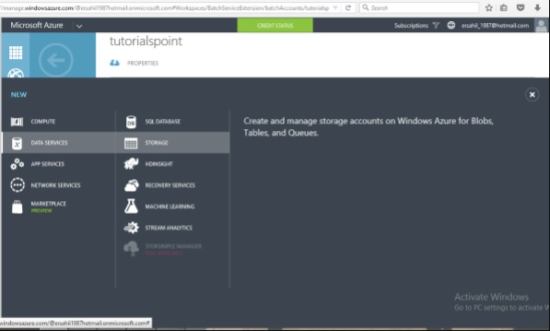

**Step 2** − Click on ‘Quick Create’ and it will ask for ‘Account Name’.

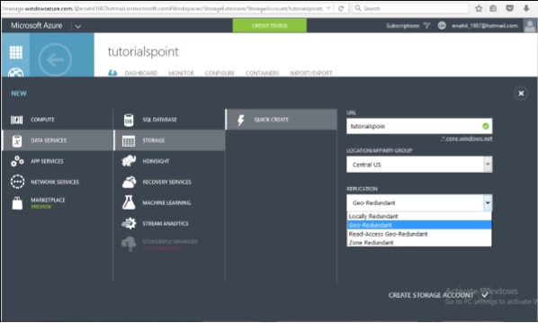

You can see there are four options in the ‘Replication’ dropdown. A copy of the data is kept so that it is durable and available at high speed. It is retained even in case of hardware failure. Let’s see what these options mean −

* **Locally redundant storage** − Copy of the data is created in the same region where storage account is created. There are 3 copies of each request made against the data that resides on separate domains.
* **Zone-redundant storage (available for blobs only)** − Copy of the data is created on separate facilities either in the same region or across two regions. The advantage is that even if there is failure on one facility, the data still can be retained. Three copies of data are created. One more advantage is that data can be read from a secondary location.
* **Geo-redundant storage** − `Copy is created in a different region which means data is retained even if there is a failure in the complete region. The numbers of copies of data created are 6 in this case.
* **Read-access geo-redundant storage** − This option allows reading of data from a secondary location when data on the primary location is not available. The number of copies created is 6. The main advantage here is that availability of data can be maximized.

There are different price plans for each replication option and the ‘Local Redundant’ is the cheapest of them all. So, choosing the replication of data depends on the cost and individual requirements.

## **Storage Account Endpoints**

**Step 1** − Click on the ‘Storage Account’ it will take you to the next screen.

**Step 2** − Click on ‘Dashboard’ from top horizontal menu.

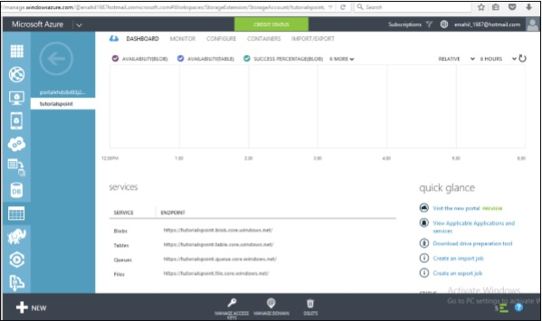

Here you can see four items under services. You can create blobs, tables, queues and files in this storage account.

There will a unique URL for each object. For example, here account name is ‘tutorialspoint’ then the default URL for blob is **https://tutorialspoint.blob.core.windows.net** Similarly, replace blob with table, queue and file in the URL to get the respective URLs. To access an object in the location is appended in the URL. For example, **http://tutorialspoint.blob.core.windows.net/container1/blob1**

## **Generating an Access Key**

Access key is used to authenticate the access to the storage account. Two access keys are provided in order to access the account without interrupting it, in case, one key has to be regenerated.

To get the Access Keys, click on ‘Manage Access Keys’ in your storage account. The following screen will come up.

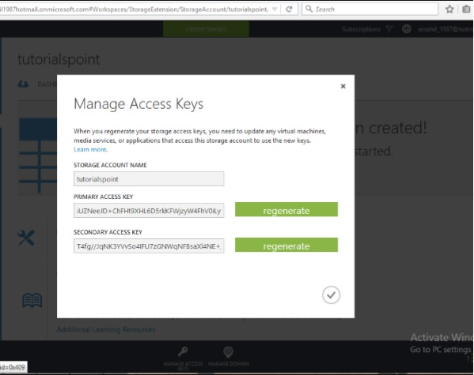

Regenerating the key at regular intervals is advised for security reasons.

## **Managing Data to Azure Storage**

How can you upload or download data to Azure store? There are many ways to do it, but it can’t be done within the Azure portal itself. You will have to either create your own application or use an already built tool.

There are many tools available for accessing the data in an explorer that can be accessed by clicking on ‘Storage Explorer’ under ‘Get the Tools’ in your Azure storage account. Alternatively, an application can also be built using Software Development Kit (SDK) available in Windows Azure Portal. Using the PowerShell commands is also an option to upload data. PowerShell is a command line application that facilitates administering and managing the Azure storage. Preset commands are used for different tasks to manage the storage.

You can install PowerShell by going to ‘Downloads’ on the following screen in your account. You will find it under Command-Line tools.

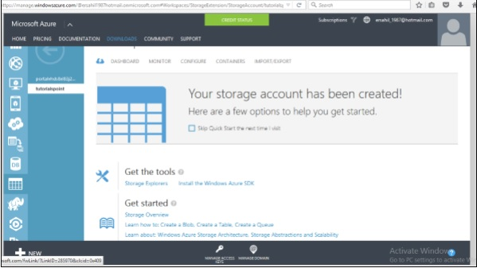

There are specific commands for each task. You can manage you storage account, create a new account, and create a container. Additionally, blobs, tables, queues messages can also be managed using PowerShell.

APPLICATIONS:

Windows Azure is usually misinterpreted as just a hosting solution, but there is a lot more that can be done using Windows Azure. It provides a platform to develop applications using a range of available technologies and programming languages. It offers to create and deploy applications using .net platform, which is Microsoft’s own application development technology. In addition to .net, there are many more technologies and languages supported. For example, Java, PHP, Ruby, Oracle, Linux, MySQL, Python.

Windows Azure applications are scaled by creating multiple instances of the application. The number of instances needed by the application is specified by the developer while hosting the applications. If traffic is increased or decreased on the website or web application it can be managed easily by logging in to Windows Azure management portal and specifying the instances. Load balancing can also be automated which would allow Azure to make the decision itself as when to assign more resources to application.

Web applications support .net, java, python, php and node.js. Tasks such as scaling and backups can be easily automated. A new feature called ‘webjobs’ is available, which is a kind of batch processing service. Webjobs can also be scaled and scheduled. The mobile application platforms supported are Xamarin iOS, Xamarin Android and IOS.

Azure platform is developed in such a way that developers need to concentrate on only the development part and need not worry about other technical stuff outside their domain. Thus most of the administrative work is done by Azure itself.

A marketplace is also set by Azure where its customers can buy applications and services. It is a platform where customers can search applications and deploy them in an easier way. Azure marketplace is available in 88 countries at present. An application purchased from the marketplace can be easily connected to the local development environment by the application developers. The pricing is done using 5 different models, which includes usage-based and monthly fee. Some of the applications are even free of charge.

