HotelRevAI - AI Driven Revenue Analysis for Hotels

Milestone 2: Data Loading & Modelling

Mentor : Submitted By:

Selciya Nivetha L

HotelRevAI - AI Driven Revenue Analysis for

Hotels

Milestone 2: Data Loading & Modelling

Project Abstract
This project analyses hotel bookings data using Power BI to identify trends, meaningful insights in revenue generation and performance. The dataset includes booking details such as room type, booking channel, customer type, revenue, cancellation status, and stay duration. Data cleaning and preprocessing were performed to remove inconsistencies and handle missing values before importing the dataset into Power BI. Various interactive dashboards were created using Power BI to visualize important metrics such as total revenue, monthly revenue trends, occupancy percentage, average daily rate (ADR) and cancellation rate. The project demonstrates how data visualization can help hotel management make informed business decisions and improve revenue performance.

Problem statement
Hotels face challenges in understanding revenue fluctuations, booking patterns, and customer segments due to large volumes of raw booking data. Without proper visualization and analysis, it becomes difficult to identify peak seasons, high-revenue sources, and the impact of cancellations. This project aims to solve this problem by using Power BI to analyze hotel booking data and create interactive dashboards for effective business insights.

Objectives
  - Analyse overall revenue performance and identify growth trends over time
  - Analyse hotel performance using ADR, cancellation rate, total booking nights, total guests.

  - Analyse customer behaviour booking patterns by customer type, room type, repeated customers.
  - Create interactive dashboards using Power BI that includes filtering by year, customer behaviour charts, booking patterns that provide meaningful visual insights.
  - By all these to support data driven decision making that is useful to business.

Dataset Overview
This is hotel booking dataset collected from Kaggle. This data set contains booking information for a city hotel and a resort hotel, and includes information such as when the booking was made, length of stay, the number of adults, children, and/or babies, and the number of available parking spaces, among other things.

Data loading and cleaning
  - The dataset was imported into Power BI from a CSV file containing hotel booking records. Power BI’s Power Query Editor was used to preview, transform, and prepare the data before loading it into the data model.
  - Data preprocessing was performed using Power Query to ensure accuracy and consistency. The following general cleaning operations were carried out:
    - Handled missing or null values in important columns.
    - Verified and corrected data types (date, numeric, text).
    - Removed duplicate records.
    - Removed columns that are not participating in revenue analysis
  - Created new calculated columns such as:
    - Total Stay Duration (weekend nights + weekday nights)
    - Total guests (adults + children + babies)
    - Revenue-related measures using ADR and stay duration.
    - Converted arrival date columns into single column.

Data Modelling
Data modelling is a crucial step in Power BI that defines the logical relationships between different tables and ensures efficient filtering and aggregation across visualizations. In this project, a structured relational data model was developed to support multi-dimensional analysis of hotel booking and revenue data.
The data model consists of the following primary components:

Fact Table (Hotel_Data):
This table contains transactional booking-level data such as customer type, ADR, reserved room type, booking changes, country, and arrival date.

Dimension Table (Calendar):
This table includes:
    - Date
    - Month
    - Month Number
    - Year

Measures Table (d3_measures):
A dedicated measures table was created to store calculated metrics using DAX (Data Analysis Expressions). These measures include:
Total Revenue
Total Revenue = SUM(Hotel_data[Revenue])
Total Bookings
Total Bookings = COUNTROWS(Hotel_data)

Total Customers
Total Customers = COUNTROWS(Hotel_data)

Total Guests Count
Total Guests Count = SUM(Hotel_data[Total Guests])

Total Nights Stayed Total Nights Stayed =
SUM(Hotel_data[Total Nights])

Revenue per Night
Revenue per Night = DIVIDE(
[Total Revenue], [Total Nights Stayed], 0
)

Rev_per_Night
Rev_per_Night = DIVIDE(
SUM(Hotel_data[Revenue]), SUM(Hotel_data[Total Nights]), 0
)

Cancelled Bookings
Cancelled Bookings = COUNTROWS(
FILTER(
Hotel_data, Hotel_data[is_canceled] = 1
)
) + 0

Cancellation Rate
Cancellation Rate = DIVIDE(
[Cancelled Bookings], [Total Bookings],

0
)
Revenue Loss
Revenue Loss = CALCULATE(
SUM(Hotel_data[Revenue]), Hotel_data[is_canceled] = 1
)

Cancellation Impact
Cancellation Impact = DIVIDE(
[Revenue Loss], [Total Revenue], 0
)

Bookings_New
Bookings_New = CALCULATE(
COUNTROWS(Hotel_data), Hotel_data[is_repeated_guest] = 0
)

Bookings_Repeated
Bookings_Repeated = CALCULATE(
COUNTROWS(Hotel_data), Hotel_data[is_repeated_guest] = 1
)

Repeated Guests
Repeated Guests = CALCULATE(
SUM(Hotel_data[Total Guests]), Hotel_data[is_repeated_guest] = 1
)

Repeat %
Repeat % = DIVIDE(
[Bookings_Repeated], [Total Bookings],
0
)

Occupancy Proxy
Occupancy_Proxy = DIVIDE(
[Total Guests Count], [Total Nights Stayed], 0
)

Revenue_Repeated
Revenue_Repeated = CALCULATE(
SUM(Hotel_data[Revenue]), Hotel_data[is_repeated_guest] = 1
)
The above DAX queries are used to create calculated columns, measures, and calculated tables in Power BI.
A one-to-many relationship was established between: Calendar[Date] → Hotel_Data[Arrival Date]
This relationship allows accurate time-based filtering and aggregation across dashboards.

Dashboard Implementation
Three interactive dashboards were developed using Power BI to present insights related to hotel booking performance, customer behaviour, and revenue optimization.

Dashboard 1: Hotel Revenue Performance Dashboard
This dashboard provides a consolidated overview of overall hotel performance through key performance indicators (KPI) such as Total Revenue, Total Bookings, Average Daily Rate (ADR), and Total Guest Count. Additionally, it includes visualizations that represent:
  - Monthly Revenue Trends
  - Booking Distribution by Market Segment
  - Distribution Channel Analysis
  - Room Type Demand
  - Revenue Trend Over Time
  - Customer Type Booking Distribution
These visualizations assist in identifying seasonal demand patterns and revenue-generating customer segments.
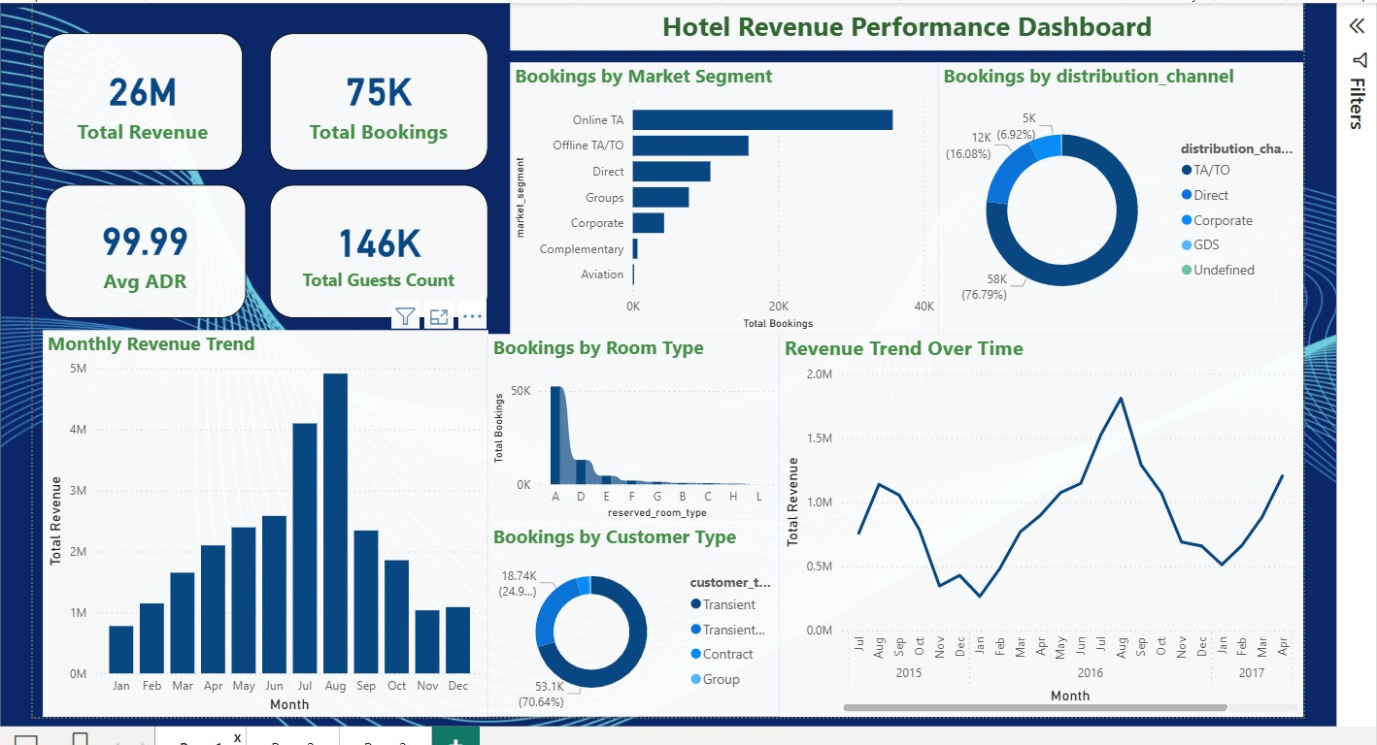

The integrated analysis reveals:
  - Strong reliance on online booking channels.
  - Seasonal demand patterns affecting revenue.
  - High contribution from transient customers.
  - Concentrated demand for specific room types.
  - Stable pricing strategy reflected in ADR.

Dashboard 2: Customer and Booking Behaviour Dashboard
This dashboard focuses on analysing customer booking behaviour and engagement patterns. It includes KPI cards such as Total customers, Average lead lite, Total repeated customers, Repeated guests percentage. It provides insights into:
  - Booking Distribution by Customer Type
  - Top 10 Booking Countries
  - Revenue Contribution from Repeated vs New Guests
  - Booking Trends based on Lead Time Group
The analysis helps in understanding customer loyalty patterns and booking preferences across different regions.
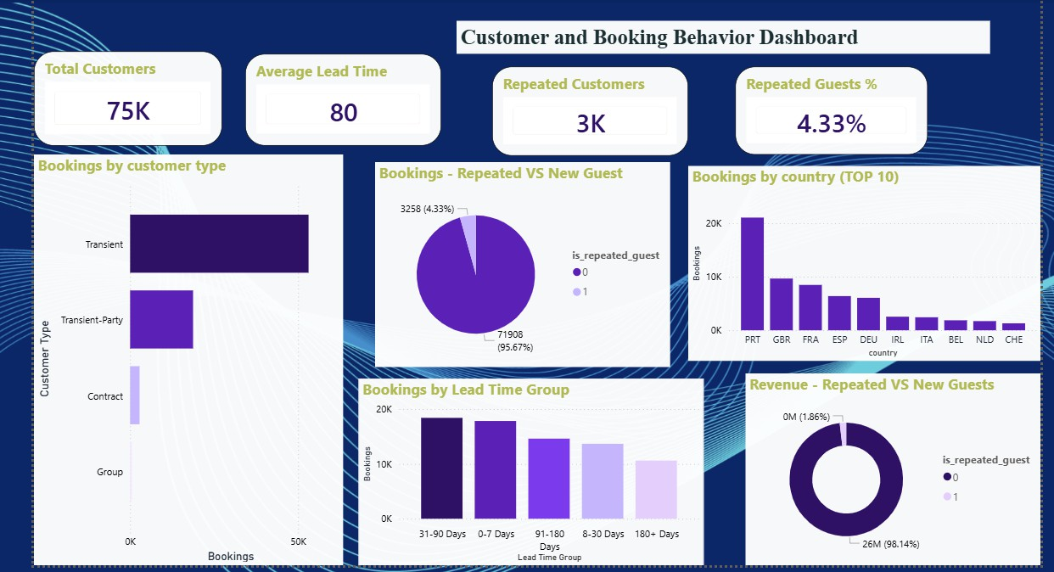
The dashboard reveals:
  - Strong customer inflow.
  - Low repeat guest ratio.
  - High early booking behavior.
  - Demand concentrated in selected countries.
  - Dominance of transient travelers.

Dashboard 3: Revenue Optimization and AI Insights Dashboard
This dashboard focuses on Revenue Optimization & AI Insights. It includes KPI cards such as Revenue per Night, Cancellation Impact, Occupancy Proxy, Estimated Revenue Loss. It provides insights into:
  - Total Revenue by Year
  - Average ADR by Year
  - Revenue Variation with Lead Time
  - Demand Distribution by Room Type
These insights support strategic decision-making related to pricing policies and booking management.
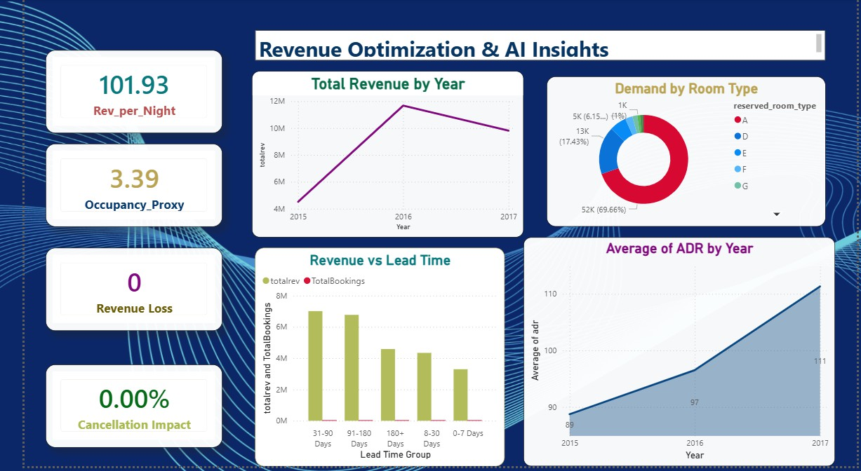
The Revenue Optimization dashboard reveals:
  - Stable nightly revenue performance
  - Increasing pricing strategy effectiveness
  - Strong early booking contribution
  - Efficient room utilization
  - Balanced revenue growth trend

Conclusion
This project successfully demonstrates the application of Power BI in analysing hotel booking data to generate meaningful insights related to revenue performance and customer behaviour. Through effective data loading, preprocessing, and structured data modelling, a reliable analytical foundation was established for visualization and decision-making.
The developed dashboards provide a comprehensive overview of key performance indicators such as total revenue, ADR, booking trends, customer segmentation, and cancellation impact. Time-based analysis using the calendar model enabled identification of seasonal demand patterns and revenue fluctuations. Furthermore, customer behaviour analysis highlighted booking preferences and loyalty trends across different customer segments. The revenue optimization dashboard supported the evaluation of factors influencing pricing and occupancy.
Overall, the project illustrates how data-driven insights can assist hotel management in improving operational efficiency and maximizing revenue performance.

