Predicting Learner Success and Dropout Risk at LearnSphere
A Data-Driven Early-Warning System for Proactive Student Success
Course: | Advanced Certification Programme in Gen AI, ML & LLM for Business Applications | Batch: | 02
Mentor: | Prof. Babji Srinivasan (IITM) | Team Size: | 4 Members
Domain: | EdTech Analytics – Student Retention & Engagement Intelligence | Duration: | ~3 Months

1. Business Problem Understanding and Objective Formulation

1.1 Domain and Business Context
LearnSphere Education Technologies is a fast-growing online learning platform offering professional certifications, university partnerships, corporate training, and skill-development courses. Despite strong enrollment growth, leadership is concerned about declining course completion rates and inconsistent learner engagement. Interventions today are largely reactive, applied only after a learner has already fallen behind. The dataset provided (50,500 learner records, 37 attributes spanning demographics, engagement, attendance, assessments, and platform usage) gives the analytics team an opportunity to move toward a proactive, early-warning approach to student success.

1.2 Business Problems Identified in the Dataset
- Reactive interventions: At-risk learners are identified only after underperformance is visible, missing the early window for support.
- Disengagement signals go unused: Forum participation, login frequency, and attendance carry early-warning signals not currently tracked systematically.
- Enterprise impact: Corporate clients have flagged low completion rates among employee learners, creating a B2B retention risk.

1.3 Business and Analytical Objectives
Business Objectives:
- Reduce dropout by identifying at-risk learners early enough for meaningful intervention.
- Increase completion and certification rates across self-paced, instructor-led, and bootcamp formats.
- Strengthen enterprise trust by improving completion metrics reported to corporate training clients.
Analytical Objectives:
- Diagnose: Quantify how attendance, study time, video/assignment completion, and engagement relate to learner outcomes.
- Predict: Build a classification model that estimates dropout/non-completion risk per learner, early in the course lifecycle (student_success_flag).
- Prescribe: Translate risk scores into a prioritised, actionable early-warning dashboard with risk tiers for student-success teams.

1.4 Preliminary Evidence from the Dataset (n = 50,000 after de-duplication)
- Behavioural gap between completers and non-completers: completers show 20–32% higher values across every core behavioural metric — quiz scores (+32.3%), video completion (+32.1%), assignment completion (+26.6%), study hours (+20.6%), attendance (+20.2%), and engagement score (+20.4%).
- Non-linear, threshold-driven risk: success rate is flat at ~45–50% across the bottom 7 attendance/engagement deciles, then jumps to ~70–78% in the top 3 deciles — risk concentrates at a clear behavioural cliff rather than rising gradually.
- Compounding risk: learners in the bottom 3 deciles of both attendance and engagement (9.1% of learners) succeed at only 37.8%, versus 88.8% for learners in the top 3 deciles of both — a >50-point swing, making this the highest-value intervention segment.
- No meaningful signal in demographics or course design: success rates are flat (54.5–55.6%) across course category, difficulty, and enrollment type — confirming behaviour, not background, drives outcome.

2. Challenges and Constraints

2.1 Data Quality Challenges (identified during initial inspection)
- Target leakage: certificate_issued_flag is mathematically identical to the target student_success_flag (Pearson r = 1.00, 0 mismatches across 50,000 rows) and must be excluded from modelling — it is an outcome, not a predictor.
- Duplicate records: 500 of 50,500 rows (0.99%) are exact duplicates and were removed prior to all analysis above.
- Inconsistent categorical labels: employment_status encodes “Professional” as three case variants — “Professional”, “professional”, “PROFESSIONAL” — fragmenting roughly 2.6% of records into duplicate categories that must be merged before use.
- Missing values: mentor_interaction_count is missing in 9.93% of rows and feedback_score in 10.02%, both requiring an explicit imputation strategy (e.g., median or model-based) rather than row deletion, given the volume affected.
- Logical inconsistencies: ~11% of records show a learning streak (in days) longer than the entire course duration, indicating possible data entry or generation errors that need rule-based correction.
- Legacy administrative fields (legacy_student_reference, administrative_code, batch_reference, learning_cluster_id) show correlation with the target below |r| = 0.006 — statistically indistinguishable from noise — and appear to be inherited administrative artifacts.

2.2 Implementation and Adoption Constraints
- Class balance is moderate (55% successful vs. 45% at-risk), which is manageable but still requires care in model evaluation (precision/recall, not accuracy alone).
- As a 4-member team new to applied ML, the timeline must balance learning curve with delivery; modelling choices will favour interpretable algorithms over complex ones.
- Model adoption depends on trust: student success teams will need transparent, explainable risk indicators (e.g., via SHAP or feature importance) rather than a black-box score.
- Risk scores must avoid encoding bias against specific demographic or course-category cohorts, given fairness expectations and adoption concerns for corporate clients — basic fairness checks across groups are planned at the evaluation stage.
- Engagement metrics are static snapshots rather than week-by-week trajectories; without timestamps, true early-course prediction (vs. end-of-course hindsight) is harder to validate.
- Assumption: the dataset is representative of LearnSphere's actual learner base across course categories and time periods, since no timestamp/cohort field is available to verify recency.

3. Background Study / Literature Review
Student dropout prediction is a well-studied problem in educational data mining (EDM) and learning analytics. Prior work consistently shows that behavioural and engagement signals captured early in a course are more predictive of completion than static demographic attributes.
- Engagement-based early warning systems: Research on MOOCs (e.g., Coursera- and edX-scale studies) shows that login frequency, video-watching behaviour, and forum activity in the first few weeks are strong predictors of eventual dropout, often outperforming demographic features.
- Classical ML for dropout prediction: Industry and academic studies commonly apply Logistic Regression, Random Forest, Gradient Boosting (XGBoost/LightGBM) for tabular learner data, balancing interpretability with predictive performance.
- Risk-tiering over binary flags: Several university and corporate-LMS case studies (e.g., Purdue's Course Signals, Georgia State's predictive analytics initiative) favour multi-tier risk scores over binary pass/fail predictions, since they map more naturally to intervention intensity.
- Survival/time-to-event analysis: Some academic studies model when a learner is likely to drop rather than just whether, enabling timed interventions — noted here as a possible future extension beyond this project's initial scope.
- Explainability for adoption: Literature on learning analytics adoption consistently notes that academic and student-success staff are more likely to act on model output when paired with interpretable feature explanations rather than opaque scores.
These findings directly inform our approach: prioritising engagement and behavioural features over static administrative fields, favouring interpretable models, and designing for risk-tier outputs rather than a single binary prediction.

4. Proposed Methodology / Solution Approach
The proposed solution follows a standard applied ML lifecycle, adapted to the specific data quality issues identified above:
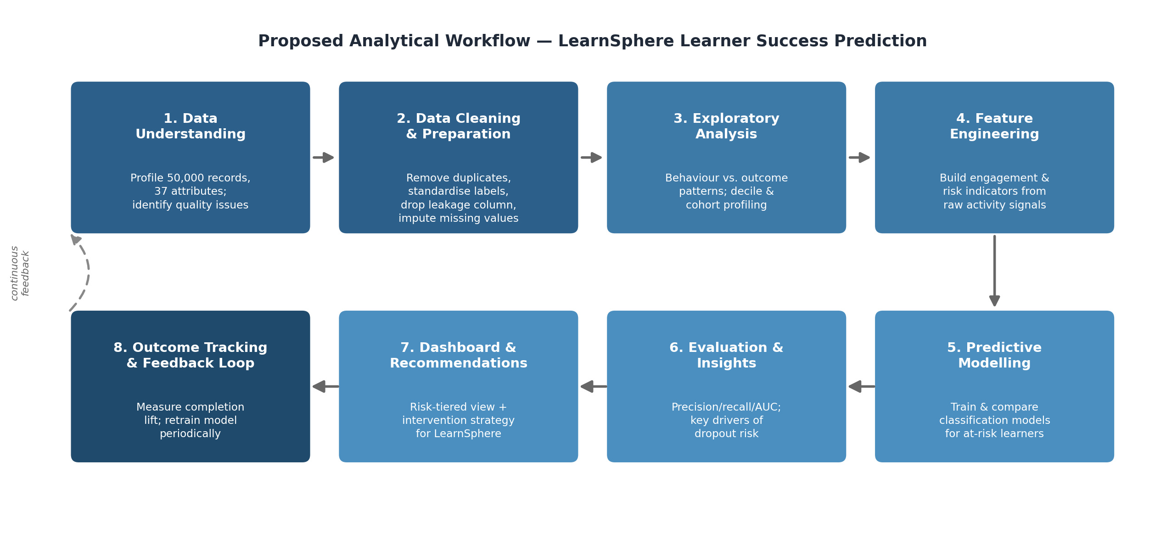

4.1 Workflow Summary
- Data Understanding: Profile all 37 attributes; quantify missingness, duplication, and leakage (already initiated).
- Data Cleaning: Remove duplicates, standardise categorical text, drop certificate_issued_flag and non-predictive legacy ID fields, treat missing values and inconsistent streak values.
- Exploratory Analysis: Compare engagement, attendance, and assessment patterns between successful and at-risk learners; decile and cohort profiling to surface behavioural drivers.
- Feature Engineering: Derive composite indicators such as an overall engagement index, consistency-of-effort measures, and risk-relevant interaction ratios.
- Predictive Modelling: Train and compare Logistic Regression (baseline/interpretable), Random Forest, and Gradient Boosting classifiers to predict student_success_flag.
- Evaluation: Assess using precision, recall, F1-score, and ROC-AUC (prioritising recall on the at-risk class, since missed at-risk learners are costlier than false alarms), plus basic fairness checks across demographic groups.
- Dashboard & Recommendations: Present risk-tiered learner segments and behavioural drivers through a visual dashboard, paired with concrete intervention recommendations for academic and student-success teams.
- Outcome Tracking & Feedback Loop: Measure post-intervention completion lift and periodically retrain the model — closing the loop from reactive to genuinely proactive management.

4.2 Why This Approach Fits the Problem
The preliminary evidence above confirms the approach: behavioural signals show a 20–32% gap between completers and non-completers and a sharp non-linear risk cliff in the bottom attendance/engagement deciles, while course category and enrollment type show almost no variation (54.5–55.6%) — confirming that behavioural signals, not course attributes or demographics, are the right modelling focus. The interpretable-model-first approach ensures LearnSphere's teams can trust and act on the output, while the risk-tier framing and feedback loop support proportionate, genuinely proactive interventions rather than reactive ones.

5. Proposed Timeline (Approx. 3 Months)
Phase | Duration | Key Activities
Data Understanding  & Cleaning | Weeks 1–2 | Profile dataset, fix data quality issues, finalise problem scope with mentor
Exploratory Analysis | Weeks 3–4 | Univariate/bivariate analysis, engagement vs. outcome patterns, visualisation
Feature Engineering | Weeks 5–6 | Build derived engagement/risk features; prepare train-test splits
Model Development | Weeks 7–8 | Train & tune Logistic Regression, Random Forest, Gradient Boosting models
Evaluation & Insight  Generation | Weeks 9–10 | Compare models, interpret feature importance, validate business relevance
Dashboard & Reporting | Weeks 11–12 | Build dashboard, finalise recommendations, prepare report and final presentation
Note: Timeline is indicative and may shift with team bandwidth and findings during cleaning.

6. Expected Deliverables / Outputs
Deliverable | Description
Data Analysis Report | Documented findings from data cleaning and exploratory analysis
Predictive ML Model | Trained classification model predicting learner success/at-risk status with evaluation metrics
Risk Dashboard /  Visualization | Visual summary of at-risk learner segments and key behavioural drivers
Business Recommendations | Actionable intervention strategies for academic, learning experience, and student success teams
Final Presentation | Summary presentation of approach, findings, and recommendations for evaluation
Technical Documentation | Methodology, assumptions, and model documentation for reproducibility
Deployment Proposal | Outline for integrating the risk-scoring engine into LearnSphere's existing LMS workflow

