**Feedback Management Screenshot:**

1)Login Page

URL: http://localhost:4200

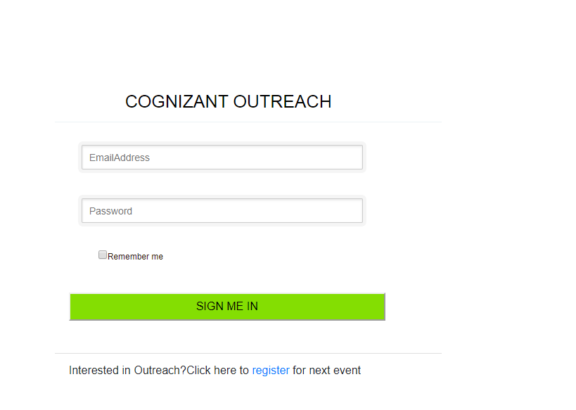

2)Login Page with Valid Credentials:

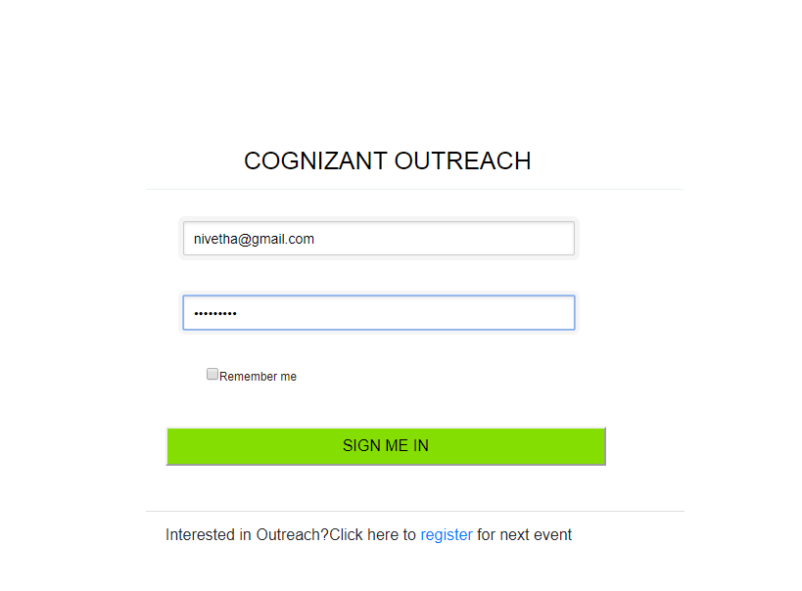URL: http://localhost:4200

If it is a Invalid User Credentials, we will get an error message as ‘Invalid User’.

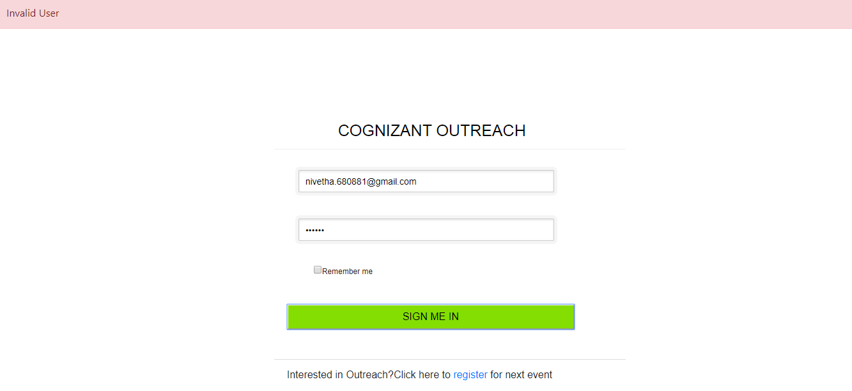

If Valid credential is given it gets redirected to Dashboard page.

2)DashboardPage

[URL: http://localhost:4200/dashboard](URL:%20http://localhost:4200/dashboard)

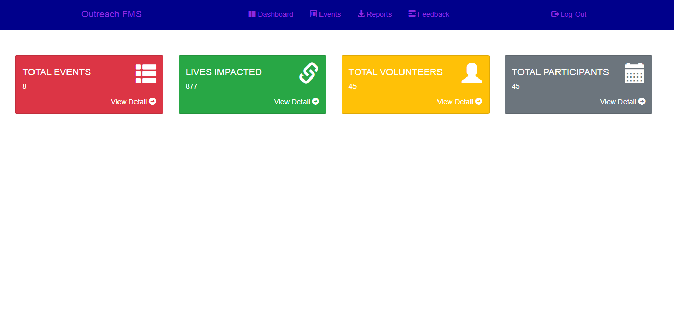

3)EventPage

URL : <http://localhost:4200/event>

In the event page, Onload event details are fetched from the database.

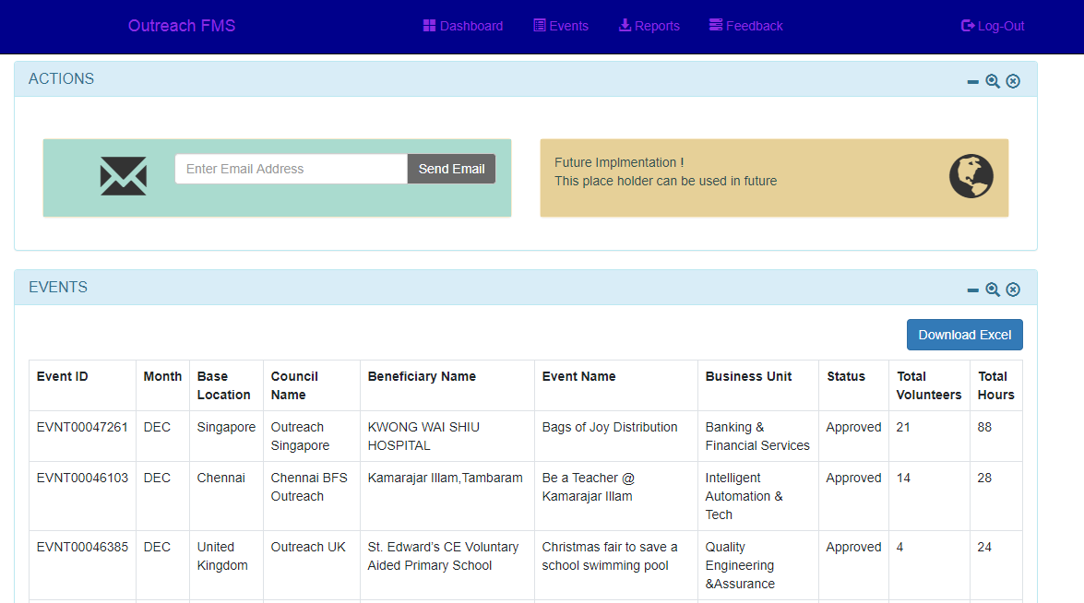

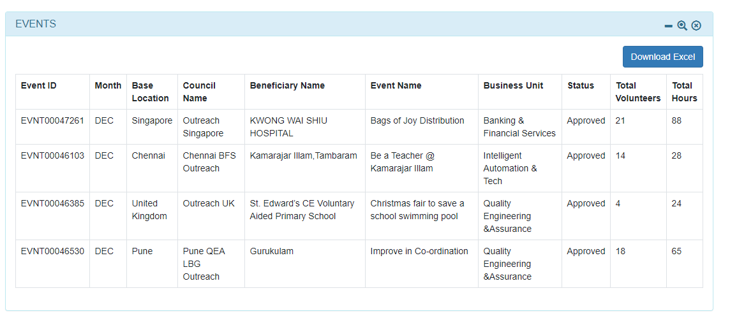

Event Details has been sent as mail to the specified mail id.

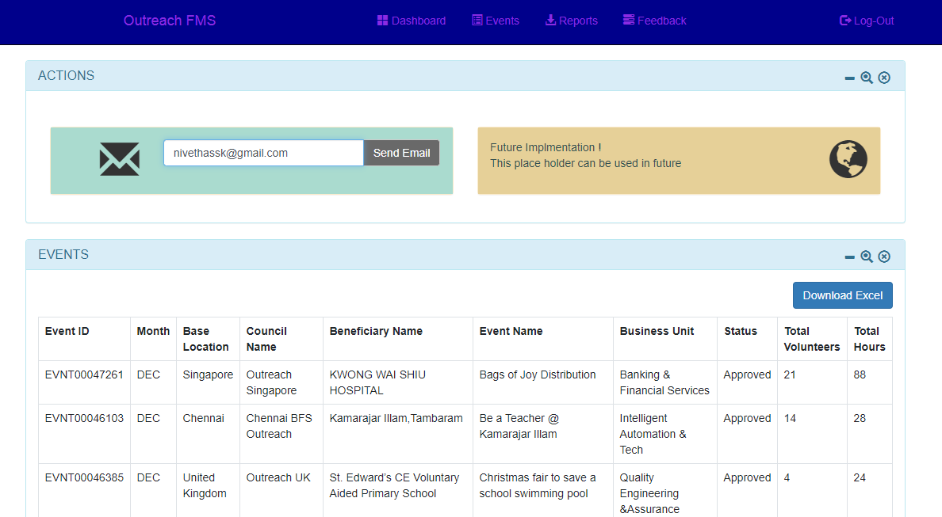

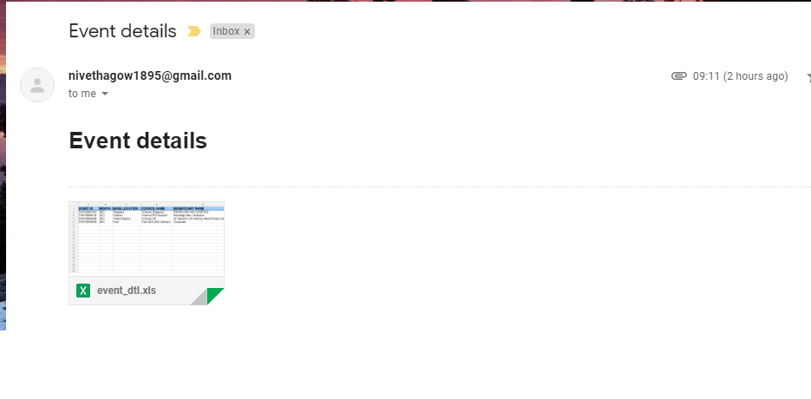

In Event page when download button has been clicked , event excel file will be downloaded, File has been attached here.





4)Report Page

URL : <http://localhost:4200/report>

In the report page, Onload report details are fetched from the database.

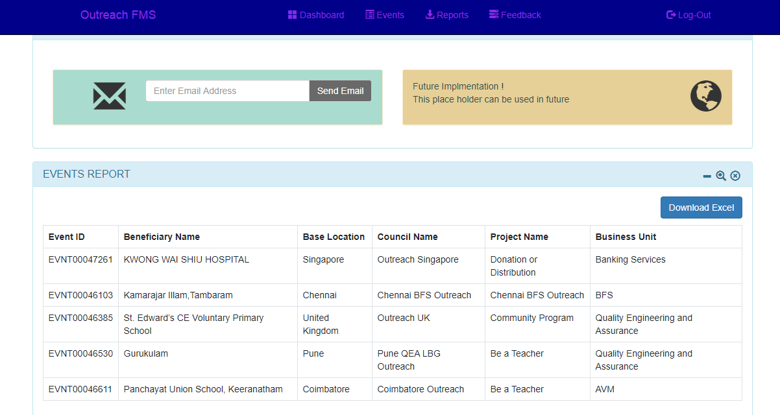

Report Details has been sent as mail to the specified mail id.

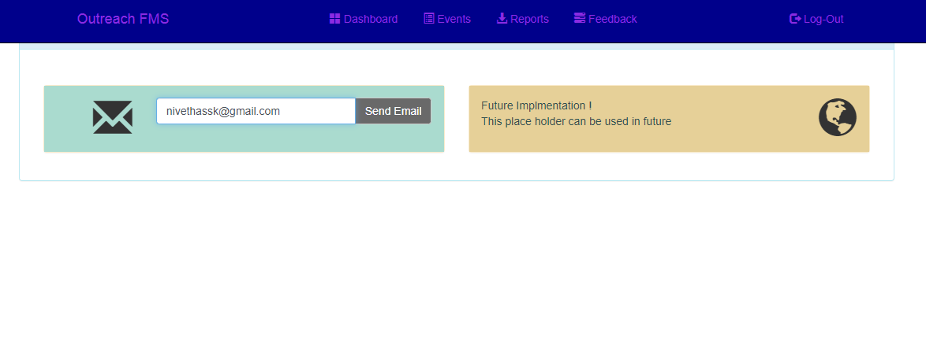

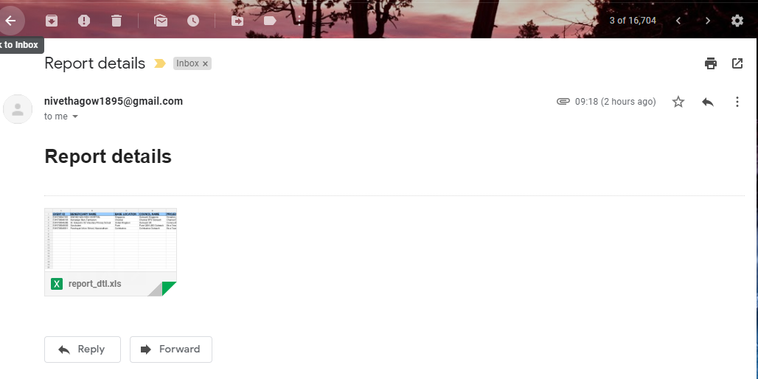

In Report page when download button has been clicked , event excel file will be downloaded, File has been attached here.

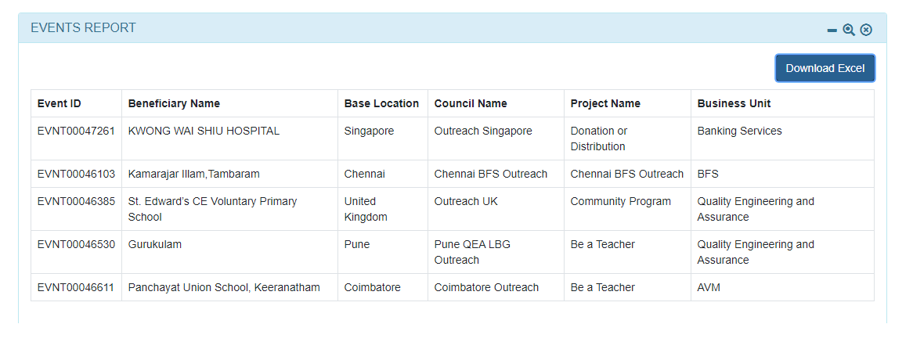



5)Feedback Page

URL : http://localhost:4200/feedback

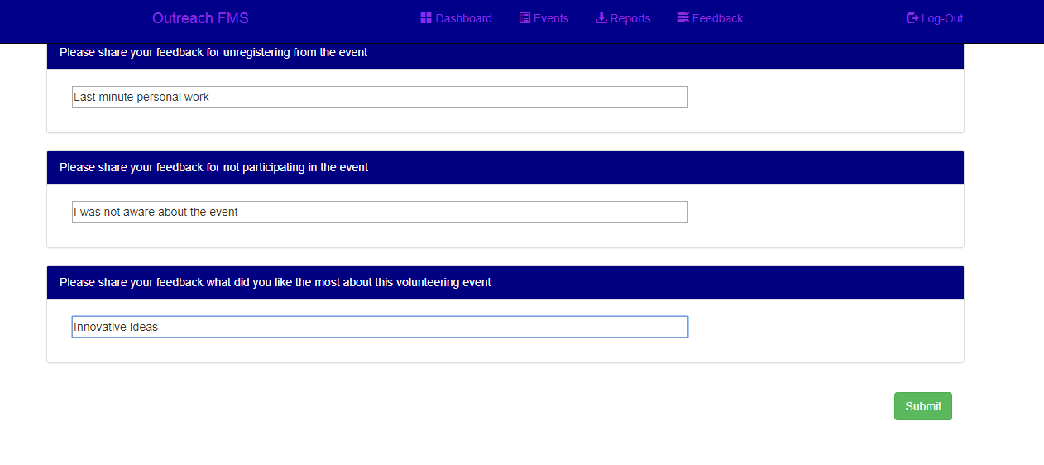

The feedback answers has been updated in the database.

