Building using Maven Task5 by Nivethitha

7.02.2025

Definition: Maven is like a project manager for Java applications. Just like a manager

organizes tasks, resources, and deadlines, Maven organizes dependencies, builds, tests, and deployments, ensuring everything runs smoothly and efficiently.

Step 1: Install Java and Maven on Ubuntu

Step 2: Fork the eKart Repository on GitHub

# Step 3: Configure Jenkins Create a New Job in Jenkins

1. Open **Jenkins** in your browser.
2. Click on **New Item** → Select **Freestyle Project** → Name it Maven_task5 → Click **OK**. **Configure the Job**

# Set up Build Tools:

* + - Under **Global Tool Configuration**, add **Java** and **Maven** if not configured.

# Set GitHub Repository:

* + - Go to **Source Code Management** → Select **Git**.
    - Paste the forked repository URL.
    - Set the branch to main.

# Add Build Command:

* + - Go to **Build** → Add Build Step → Select **Invoke top-level Maven targets**.
    - Enter: clean package -DskipTests
    - Then **Build Now**.

Step 4: Navigate to Jenkins Workspace cd /var/lib/jenkins/workspace

ls # List available projects cd Maven_task5

cd target

ls # Verify generated artifacts (e.g., .jar file)

Step 5: Check Docker Image and Kubernetes Deployment docker build -t test -f docker/Dockerfile

docker push nivethitha24/nivethitha

kubectl create deployment maven --image=test –port 80

kubectl expose deployment maven --type=NodePort --port=80 --target-port=8070 docker images | grep nivethitha24/mave # Verify Docker image is built

kubectl get pods # Check running pods

minikube service maven # Get the service URL Output and screenshots

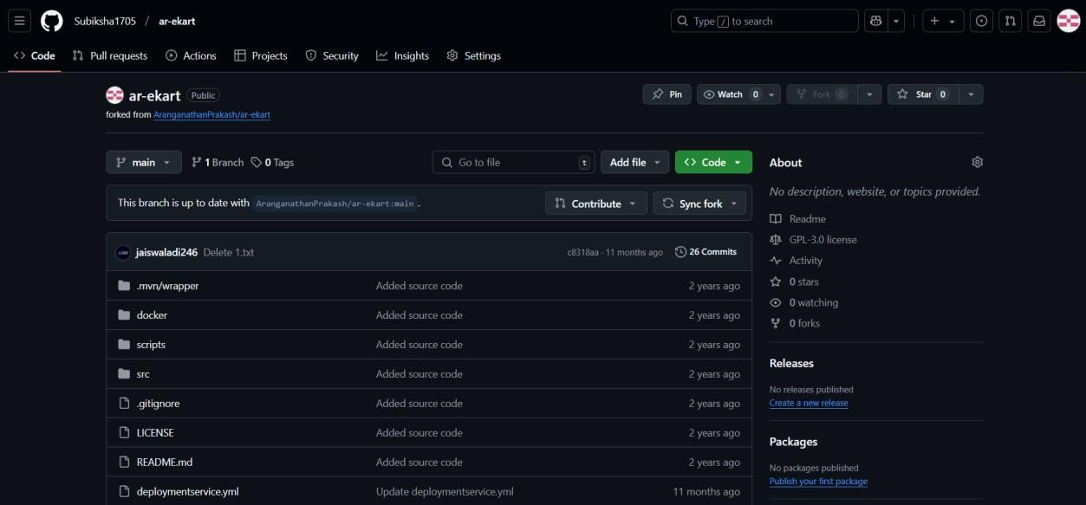

Jenkins Configration

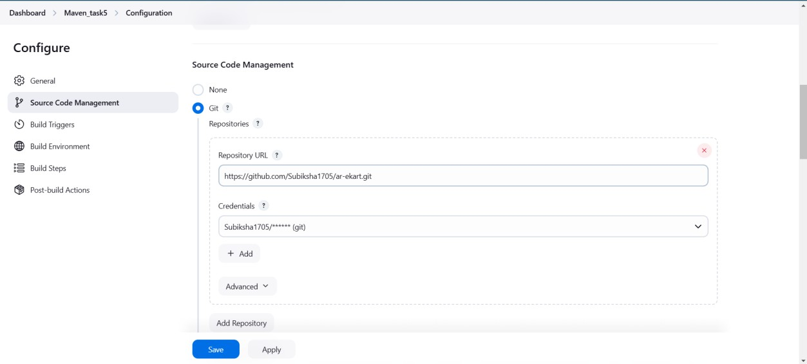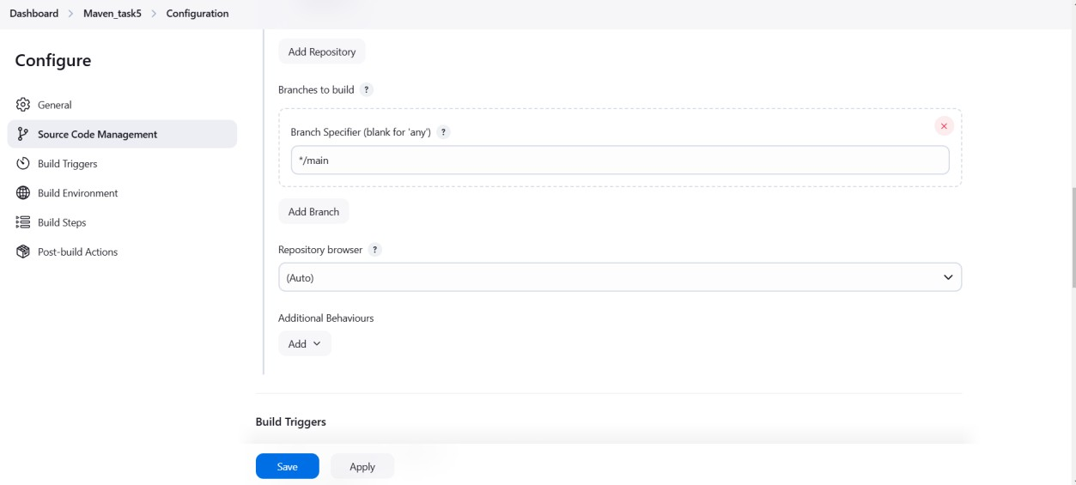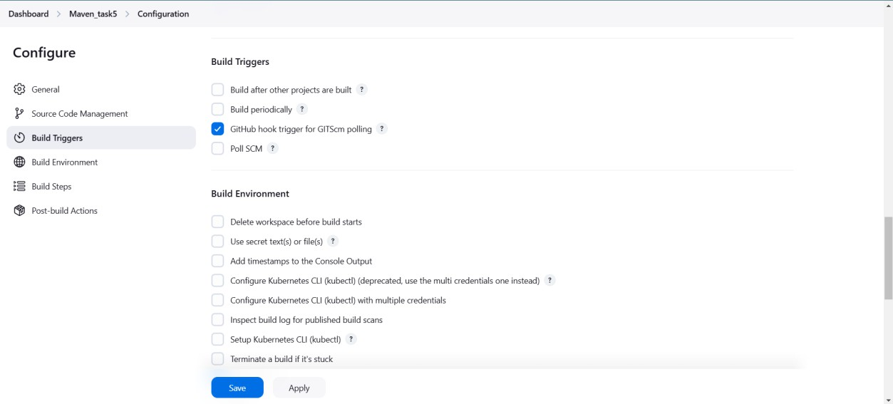

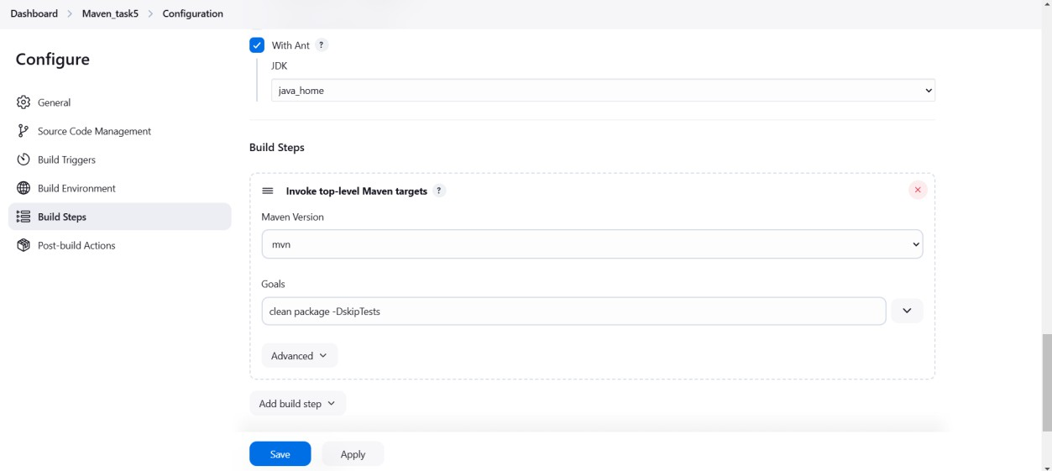

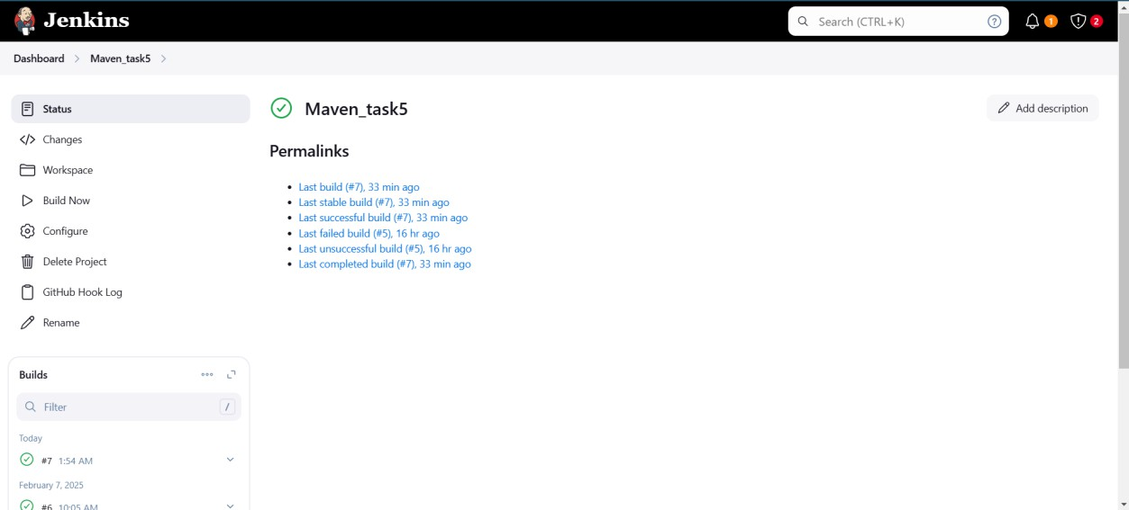

Output :

