**NIVETHITHA E.G**

**22ISR032**

**------------------------------------------------------------------------------------------------**

**INTRODUCTION:**

Nginx is a powerful web server and reverse proxy server that is widely used for serving static content, load balancing, and handling high traffic. Understanding the commands used in Nginx and their outputs is crucial for effective server management and troubleshooting.

**Command Explanation:**

The command **sudo visudo** is a critical command used in Unix-like operating systems for safely editing the **sudoers** file, which controls the permissions for users to execute commands with superuser privileges.

The command **touch index.html** is a commonly used command in Unix-like operating systems that serves two primary purposes: creating a new file and updating the timestamp of an existing file.

The command **nano index.html** is used to open the **index.html** file in the Nano text editor, which is a simple and user-friendly command-line text editor available in Unix-like operating systems.

The command **pwd** stands for "print working directory." It is a fundamental command used in Unix-like operating systems to display the current directory in which the user is working.

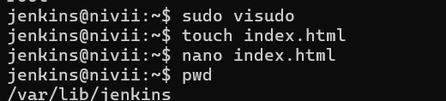

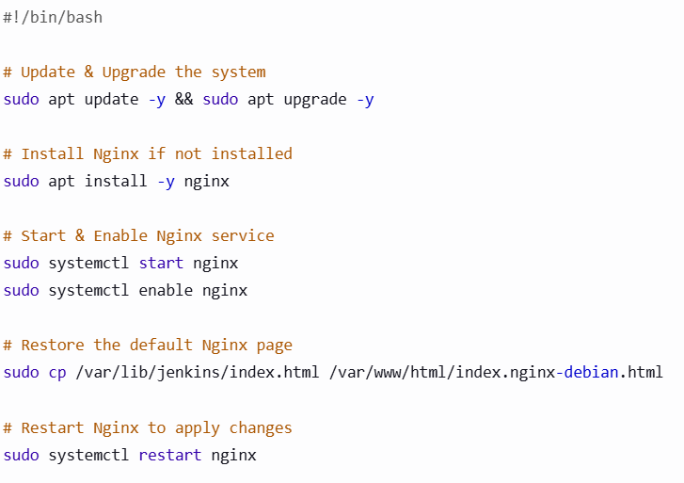

**1. #!/bin/bash**

This is a **shebang** (#!), which specifies that the script should be executed using the **Bash shell** (/bin/bash).

**2. Update & Upgrade the System**

bash

sudo apt update -y && sudo apt upgrade -y

* sudo apt update -y: Updates the package list to fetch the latest available versions.
* sudo apt upgrade -y: Upgrades all installed packages to their latest versions.
* -y: Automatically confirms the upgrade without prompting the user.

**3. Install Nginx if Not Installed**

sudo apt install -y nginx

* Installs **Nginx**, a powerful web server.
* -y ensures the installation proceeds without asking for confirmation.

**4. Start & Enable Nginx Service**

sudo systemctl start nginx

sudo systemctl enable nginx

* sudo systemctl start nginx: Starts the Nginx service.
* sudo systemctl enable nginx: Ensures Nginx starts automatically on system boot.

**5. Restore the Default Nginx Page**

sudo cp /usr/share/nginx/html/index.html /var/www/html/index.nginx-debian.html

* Copies the default **Nginx welcome page** (index.html) from /usr/share/nginx/html/ to /var/www/html/, renaming it as index.nginx-debian.html.
* This might be useful to restore the default welcome page if it was modified or deleted.

**6. Restart Nginx to Apply Changes**

sudo systemctl restart nginx

* Restarts the Nginx service to apply any changes.

**Default page output:**

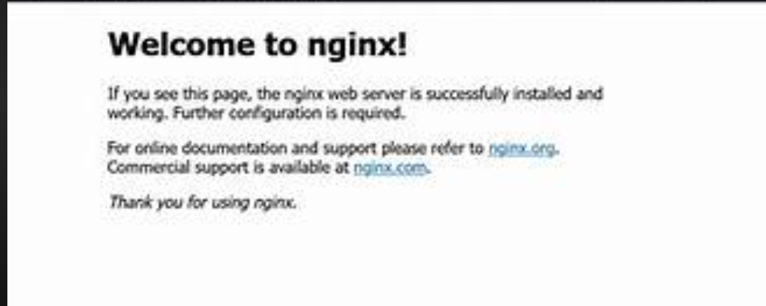

Index.html

<!DOCTYPE html>

<html lang="en">

<head>

<meta charset="UTF-8">

<meta name="viewport" content="width=device-width, initial-scale=1.0">

<title>NGINX</title>

<style>

body {

font-family: Arial, sans-serif;

text-align: center;

margin: 50px;

}

h1 {

color: #009639;

}

</style>

</head>

<body>

<h1>NGINX</h1>

<p>Welcome to the NGINX server. This is a simple HTML page.</p>

</body>

</html>

**Output**

