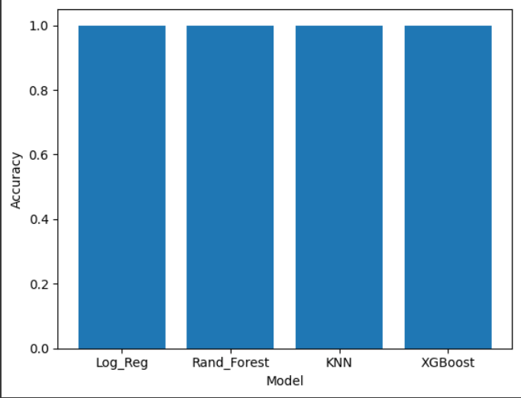

When we compare the accuracy of three models Random Forest ,KNN, XGBoost and Logistic Regression the accuracy is 100%.Our model predicts the value well.