**EX: 01 NAME: M. NIVASHINI**

**DATE: 02.07.2024 ROLL.NO.: 23MCA020**

**Exercise using Virtualization**

**Aim:**

To develop and work with the virtual machine (Windows, Linux) using VMWare.

**Steps to download VMWare:**

1. **Download**: Get the installer from VMware's website.
2. **Run Installer**: Double-click the downloaded .exe file.
3. **User Account Control**: Confirm permissions if prompted by UAC.
4. **Setup Wizard**: Follow the prompts, click "Next" to proceed.
5. **License Agreement**: Accept the terms and click "Next".
6. **Installation Type**: Choose "Typical" and click "Next".
7. **User Experience Settings**: Choose preferences or leave default.
8. **License Key**: Enter if available, otherwise skip and click "Next".
9. **Install**: Click "Install" to start installation.
10. **Completion**: Click "Finish" when installation completes.
11. **Restart (if required)**: Restart your computer if prompted.
12. **Launch**: Start VMware Workstation from desktop or Start menu.
13. **Activation**: Activate using license key if not done during installation.

**Steps to create Virtual Machine**

1. **Open VMware Workstation:** Launch VMware Workstation on your computer.
2. **Create a New Virtual Machine:** Click on "Create a New Virtual Machine" or go to `File -> New Virtual Machine`.
3. **New Virtual Machine Wizard:** Choose "Typical" or "Custom" configuration option. Click "Next".
4. **Select Installation Disk:** Choose "Installer disc image file (iso)". Click "Browse" and select the Windows ISO file. Click "Next".
5. **Guest Operating System:** VMware will detect the OS based on the ISO. Click "Next".
6. **Name the Virtual Machine:** Enter a name and select a location to store VM files. Click "Next".
7. **Specify Disk Capacity:** Set disk size and select "Store virtual disk as a single file". Click "Next".
8. **Ready to Create Virtual Machine:** Review settings. Click "Finish".
9. **Virtual Machine Settings:** Optionally adjust CPU, memory, etc. Click "OK".
10. **Start the Virtual Machine:** Select VM. Click "Power on this virtual machine".
11. **Install Windows:** Follow Windows installation prompts.
12. **Install VMware Tools:** After Windows installation, install VMware Tools for better integration.
13. **Complete Installation:** Follow any additional setup prompts.

**Steps to install g++ in Linux Virtual Machine:**

1. Open Terminal
2. To update use the command “sudo apt update”
3. To install g++ use the command “sudo apt-get install g++”
4. To check version of g++ in your workstation , use the command **“g++ - - version”**

**Source Code:**

#include <stdio.h>

int main()

{

int i, j, rows;

printf("Enter the number of rows: ");

scanf("%d", &rows);

for (i = 1; i <= rows; ++i)

{

for (j = 1; j <= i; ++j)

{

printf("* ");

}

printf("\n");

}

return 0;

}

**Output**

**Windows**

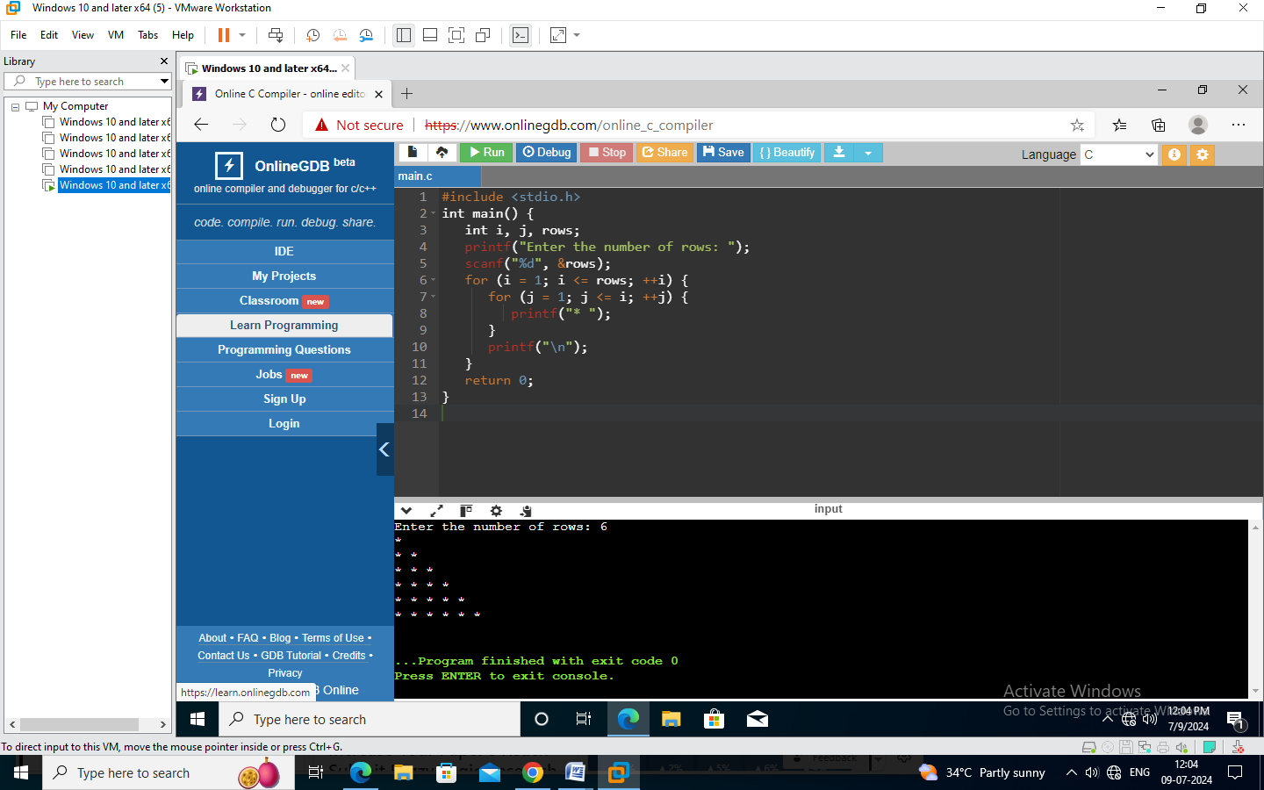

**Linux**

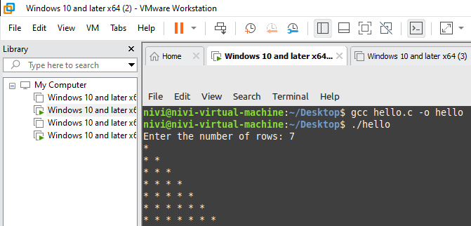

**Conclusion**

Thus the above virtual machines (Windows, Linux) has been developed and executed successfully.