**EX: 10 NAME: M. NIVASHINI**

**DATE: 24.09.2024 ROLL.NO.: 23MCA020**

**Exercise using S3 Bucket**

**Aim:**

To create a cloud storage using AWS Simple Storage Services (S3) Buckets by upload, download, create, copy, paste, empty and deleting the files and folders

**Theoretical Background**

**Steps to create a S3 storage bucket**

* **Step 1** : Sign in to AWS Management Console
* **Step 2** : Navigate to Buckets in Amazon s3 Dashboard.
* **Step 3** : Click create Bucket.
* **Step 4** : Give name for the Bucket and click create bucket.

**Steps to upload files to a bucket**

* **Step 1** : Click on the bucket name.
* **Step 2** : Click Upload.
* **Step 3** : Choose Add Files to upload files and choose Add Folders to upload folder .
* **Step 4** : In the File Upload dialog box choose the files to be uploaded .
* **Step 5** : Click Upload.

**Steps to download files from a bucket**

* **Step 1** : Open the bucket to display the files and folders in it.
* **Step 2** : Choose a file to be downloaded and click Download.

**Steps to work with files in a bucket**

* **Step 1** : Click on the bucket name.
* **Step 2** : Click Create Folder.
* **Step 3** : Give name for the folder and click Create Folder .
* **Step 4** : To move files in to new folder.
* **Step 5** : Choose the files to be moved.
* **Step 4** : Click on Actions and choose Copy.
* **Step 5** : In the Designation Browse to the new folder created and click choose designation and click Copy.

**Steps to empty a bucket**

* **Step 1** : Choose the Bucket to be Empty
* **Step 2** : Click Empty.

**Steps to delete a bucket**

* **Step 1** : Choose the Bucket to be deleted
* **Step 2** : Click Delete

**Output:**

**Uploading the files**

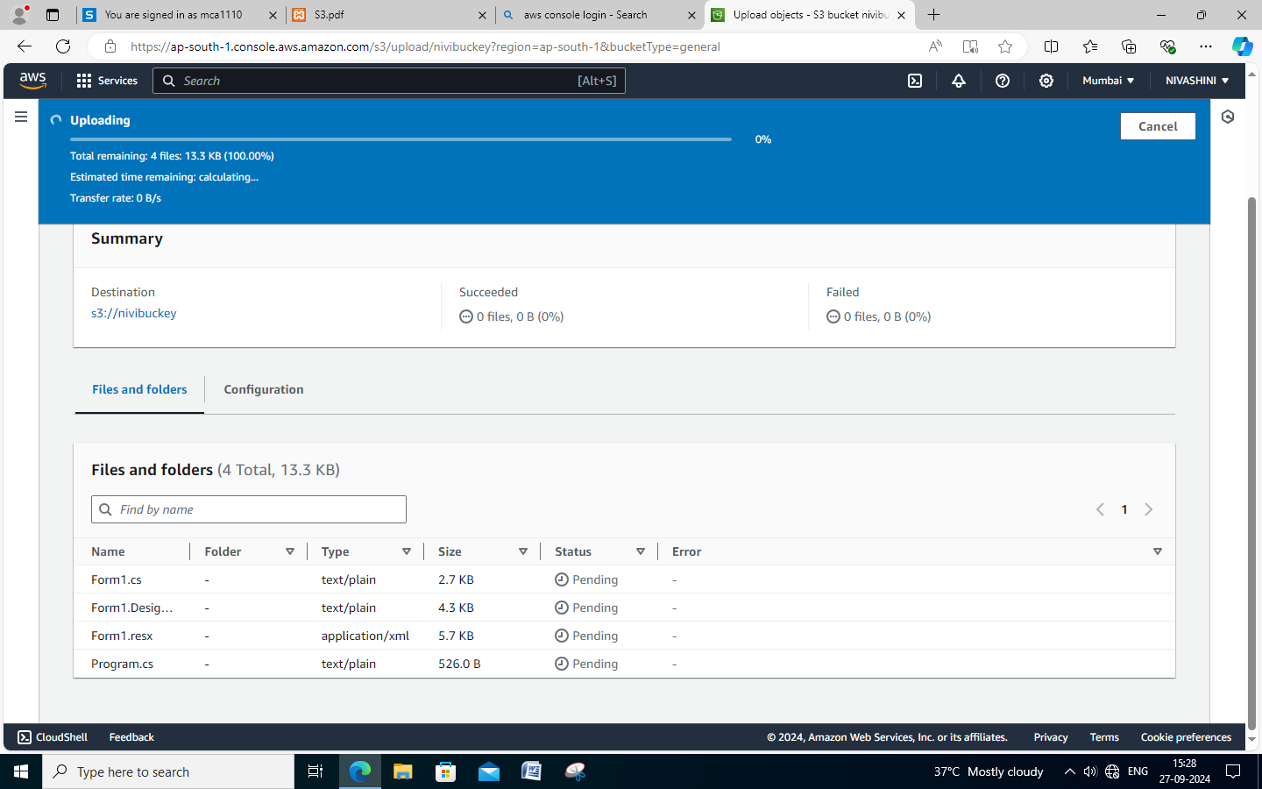

**Downloading the files**

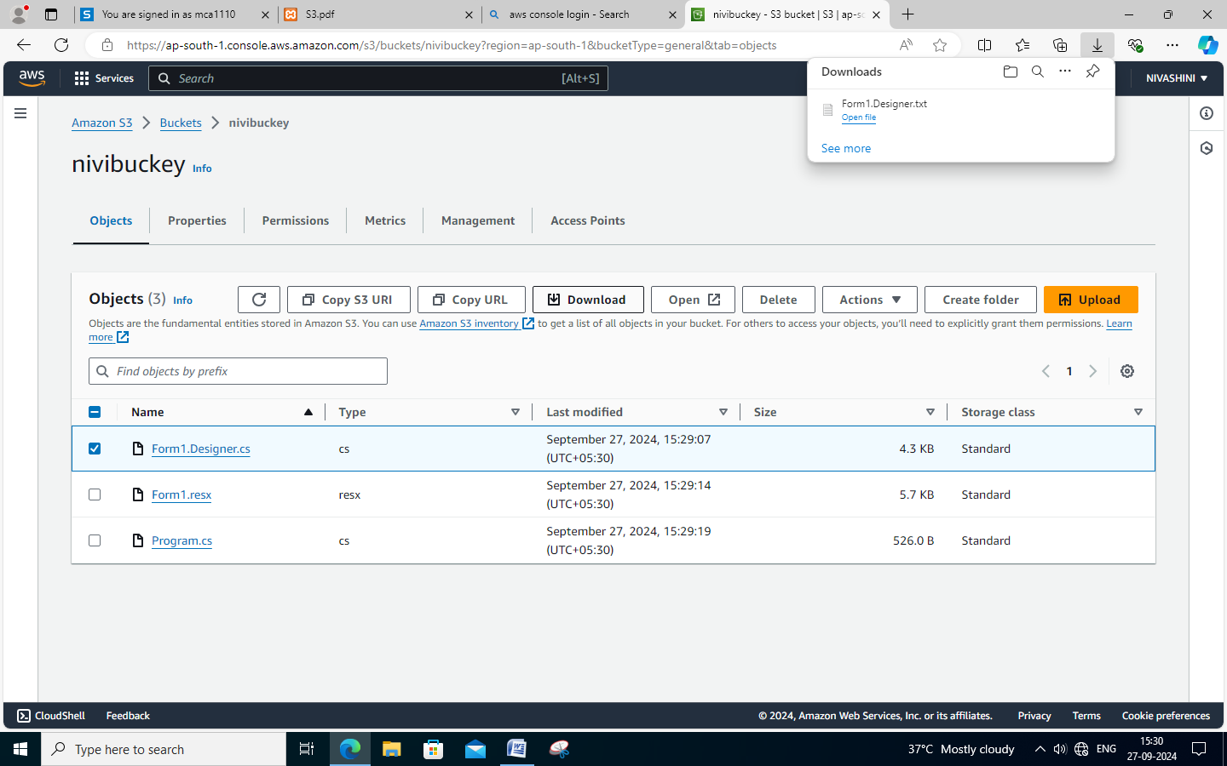

**Creating the folder**

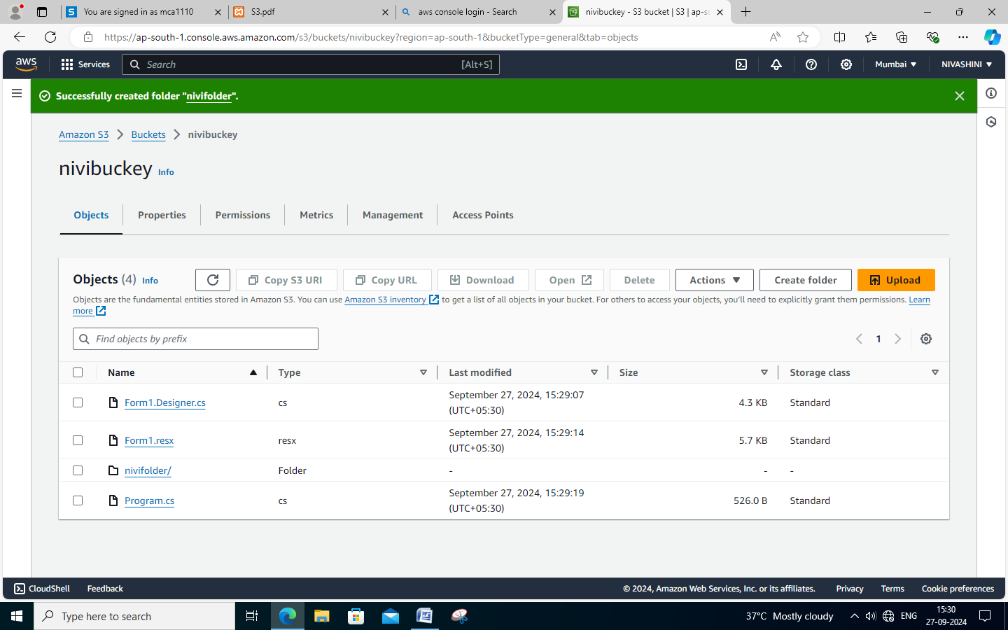

**Copying the files**

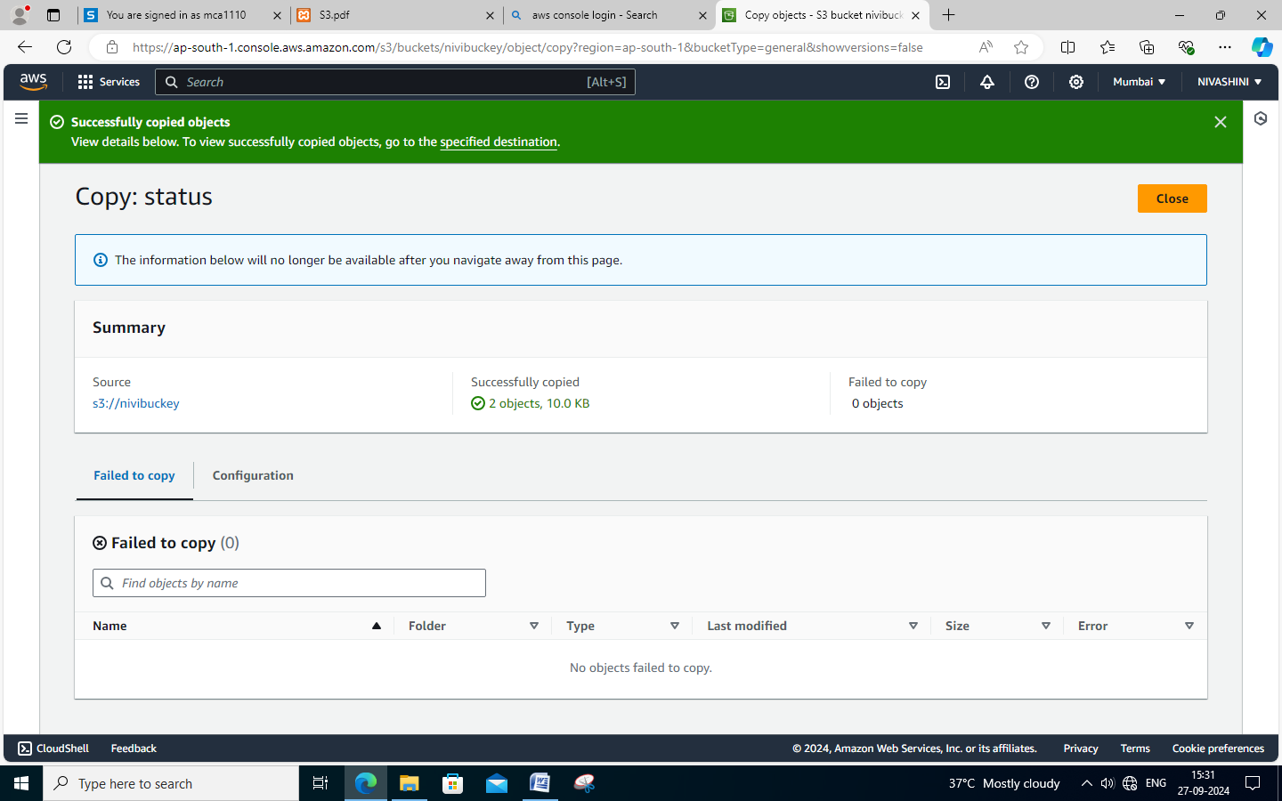

**Emptying the files**

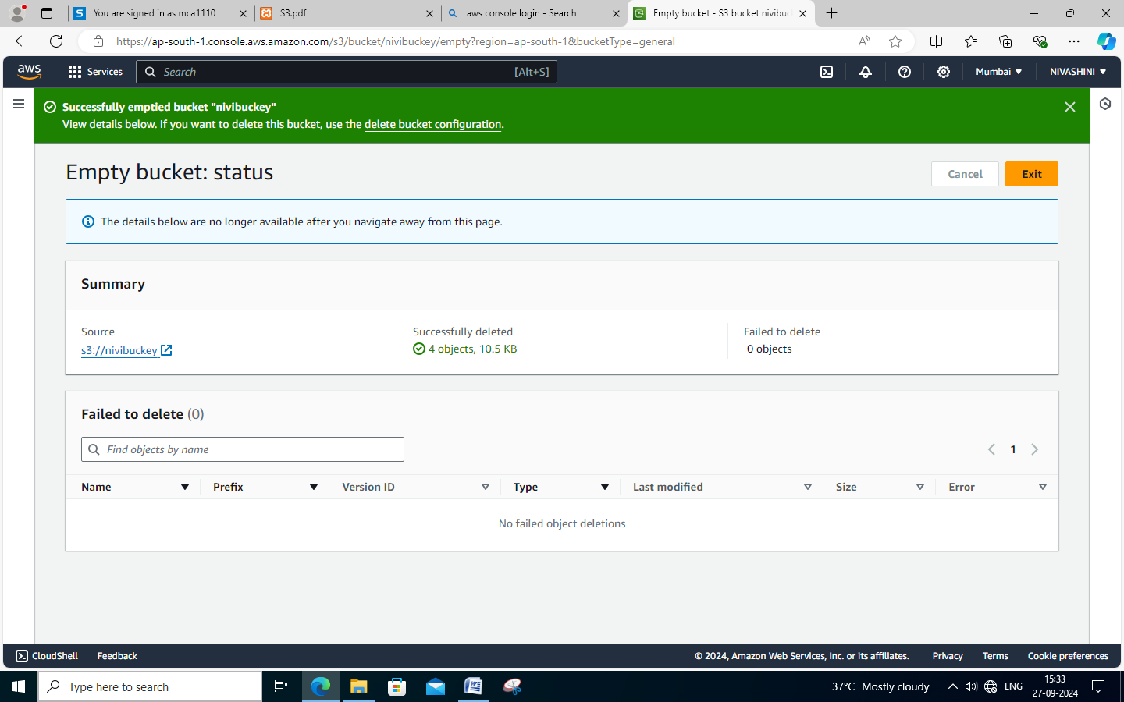

**Deleting the files**

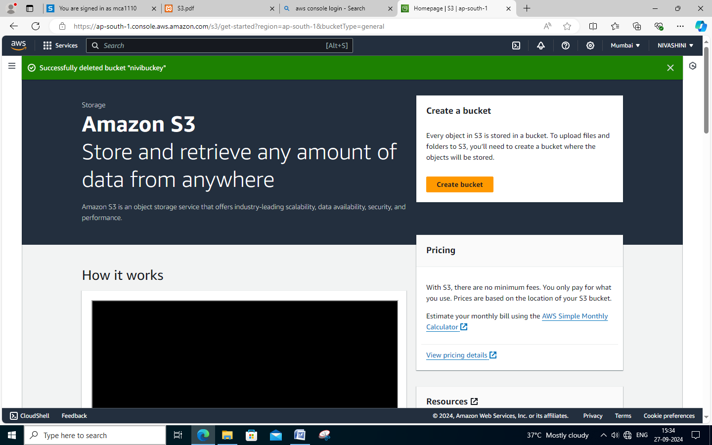

**Conclusion:**

Thus the creation of cloud storage using AWS Simple Storage Services (S3) Buckets by upload, download, create, copy, paste, empty and deleting the files and folders are done successfully.