**EX: 02 NAME: M. NIVASHINI**

**DATE: 09.07.2024 ROLL.NO.: 23MCA020**

**EC2 Instance Management**

**Aim:**

To develop and work with EC2 Instance Management using AWS.

**Theoretical Background**

**Windows EC2 Instance Management**

**1. Create a Windows EC2 Instance**

1. **Log in to AWS Management Console:**
   * Navigate to the AWS Management Console and sign in.
2. **Open the EC2 Dashboard:**
   * Go to **Services** and select **EC2**.
3. **Launch a New Instance:**
   * Click **Launch Instance**.
   * Choose an **Amazon Machine Image (AMI)**: Select a Windows Server AMI (e.g., Microsoft Windows Server 2022 Base).
   * Choose an **Instance Type**: Select an instance type (e.g., t2.micro).
   * Click **Next: Configure Instance Details**.
4. **Configure Instance Details:**
   * Configure as needed, then click **Next: Add Storage**.
5. **Add Storage:**
   * Review default settings and click **Next: Add Tags**.
6. **Add Tags:**
   * Add tags (e.g., Name: WindowsServerInstance), then click **Next: Configure Security Group**.
7. **Configure Security Group:**
   * Create or select a security group allowing RDP (port 3389).
   * Click **Review and Launch**.
8. **Review and Launch:**
   * Review your settings, click **Launch**, select or create a key pair, and click **Launch Instances**.

**2. Add a New Volume to the Windows Instance**

1. **Open the EC2 Dashboard:**
   * Go to **Volumes** under **Elastic Block Store**.
2. **Create a New Volume:**
   * Click **Create Volume**.
   * Specify the volume type, size, and availability zone (matching your instance).
   * Click **Create Volume**.
3. **Attach Volume to Windows Instance:**
   * Select the volume, click **Actions** > **Attach Volume**.
   * Choose the Windows instance and specify the device name (e.g., /dev/sdf).
   * Click **Attach**.

**3. Take a Snapshot of the Volume**

1. **Open the EC2 Dashboard:**
   * Go to **Volumes**.
2. **Create Snapshot:**
   * Select the volume, click **Actions** > **Create Snapshot**.
   * Enter a description and click **Create Snapshot**.

**4. Attach Snapshot to a New Instance**

1. **Create a Volume from Snapshot:**
   * Go to **Snapshots**, select the snapshot.
   * Click **Actions** > **Create Volume**.
   * Specify volume type, size, and availability zone, then click **Create Volume**.
2. **Attach Volume to New Instance:**
   * Select the new volume, click **Actions** > **Attach Volume**.
   * Choose the new Windows instance and specify the device name.
   * Click **Attach**.

**5. Modify Volume Size**

1. **Open the EC2 Dashboard:**
   * Go to **Volumes**.
2. **Modify Volume Size:**
   * Select the volume, click **Actions** > **Modify Volume**.
   * Enter the new size and click **Modify**.
3. **Extend the Volume in Windows:**
   * Log in to the Windows instance.
   * Open **Disk Management** and extend the volume to utilize the increased size.

**Output**

**Before Attaching Volume**

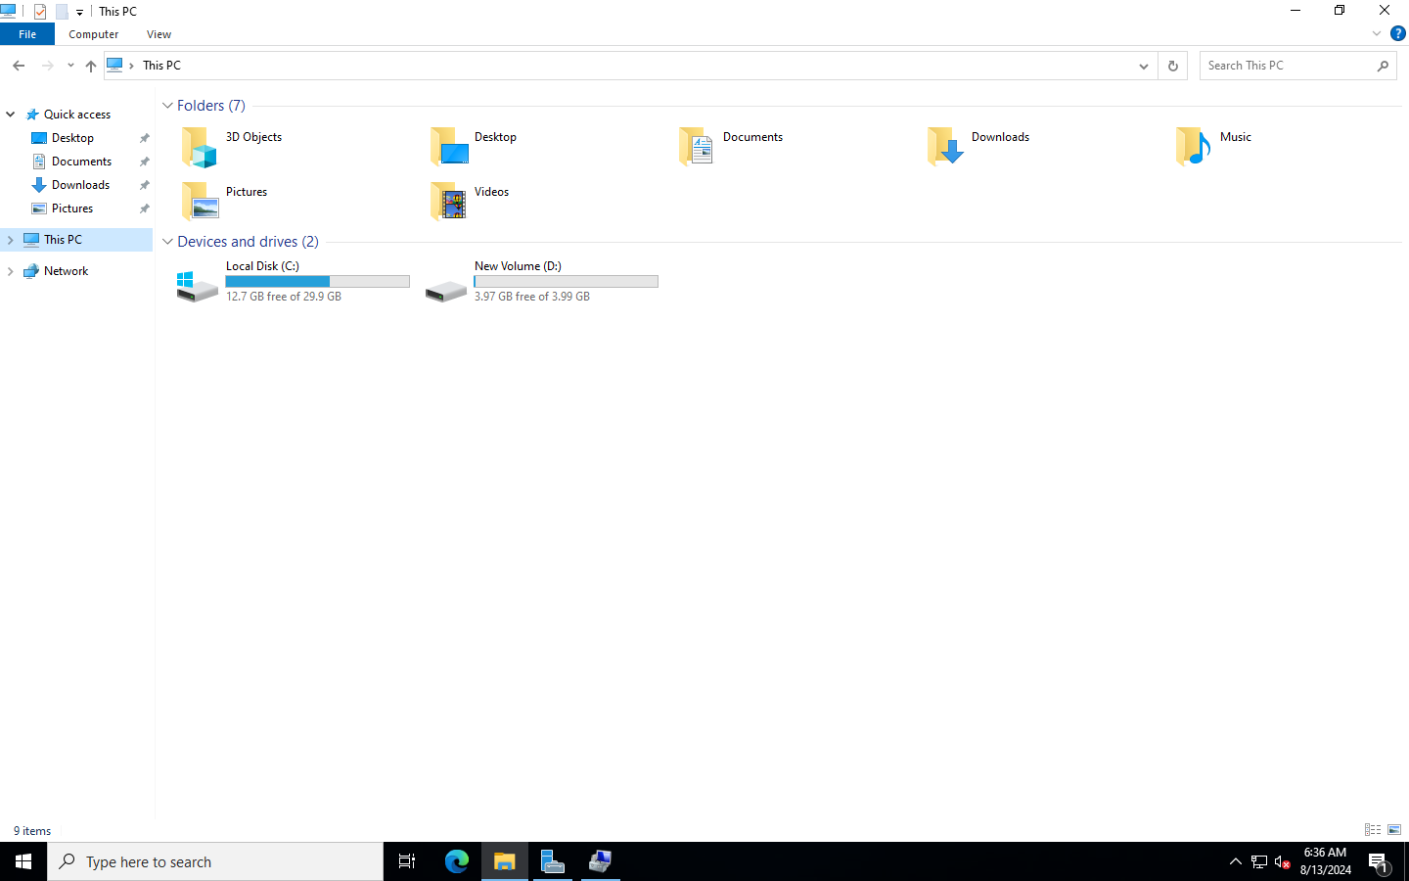

**After Attaching Volume**

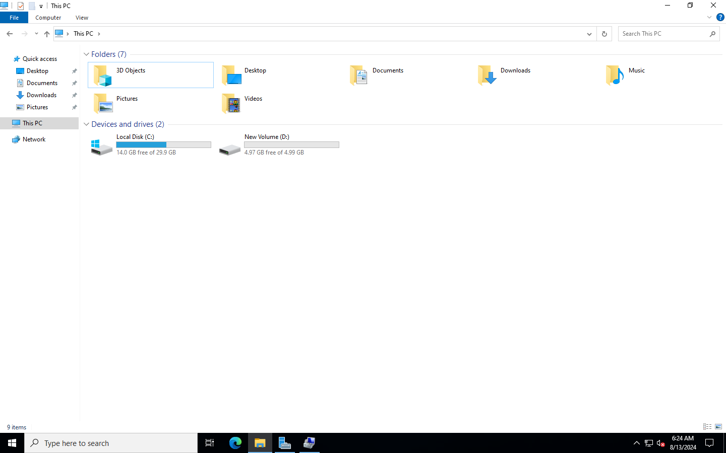

**Linux EC2 Instance Management**

**1. Create a Linux EC2 Instance**

1. **Log in to AWS Management Console:**
   * Navigate to the AWS Management Console and sign in.
2. **Open the EC2 Dashboard:**
   * Go to **Services** and select **EC2**.
3. **Launch a New Instance:**
   * Click **Launch Instance**.
   * Choose an **Amazon Machine Image (AMI)**: Select a Linux AMI (e.g., Amazon Linux 2023).
   * Choose an **Instance Type**: Select an instance type (e.g., t2.micro).
   * Click **Next: Configure Instance Details**.
4. **Configure Instance Details:**
   * Configure as needed, then click **Next: Add Storage**.
5. **Add Storage:**
   * Review default settings and click **Next: Add Tags**.
6. **Add Tags:**
   * Add tags (e.g., Name: LinuxServerInstance), then click **Next: Configure Security Group**.
7. **Configure Security Group:**
   * Create or select a security group allowing SSH (port 22).
   * Click **Review and Launch**.
8. **Review and Launch:**
   * Review your settings, click **Launch**, select or create a key pair, and click **Launch Instances**.

**2. Add a New Volume to the Linux Instance**

1. **Open the EC2 Dashboard:**
   * Go to **Volumes** under **Elastic Block Store**.
2. **Create a New Volume:**
   * Click **Create Volume**.
   * Specify the volume type, size, and availability zone (matching your instance).
   * Click **Create Volume**.
3. **Attach Volume to Linux Instance:**
   * Select the volume, click **Actions** > **Attach Volume**.
   * Choose the Linux instance and specify the device name (e.g., /dev/xvdf).
   * Click **Attach**.

**3. Take a Snapshot of the Volume**

1. **Open the EC2 Dashboard:**
   * Go to **Volumes**.
2. **Create Snapshot:**
   * Select the volume, click **Actions** > **Create Snapshot**.
   * Enter a description and click **Create Snapshot**.

**4. Attach Snapshot to a New Instance**

1. **Create a Volume from Snapshot:**
   * Go to **Snapshots**, select the snapshot.
   * Click **Actions** > **Create Volume**.
   * Specify volume type, size, and availability zone, then click **Create Volume**.
2. **Attach Volume to New Instance:**
   * Select the new volume, click **Actions** > **Attach Volume**.
   * Choose the new Linux instance and specify the device name.
   * Click **Attach**.

**5. Modify Volume Size**

1. **Open the EC2 Dashboard:**
   * Go to **Volumes**.
2. **Modify Volume Size:**
   * Select the volume, click **Actions** > **Modify Volume**.
   * Enter the new size and click **Modify**.
3. **Extend the Volume in Linux:**
   * Log in to the Linux instance via SSH.
   * Use commands like lsblk to find the device, and resize2fs (for ext filesystems) or xfs_growfs (for XFS) to extend the filesystem after resizing the volume.

**Output**

**Before Attaching Volumes**

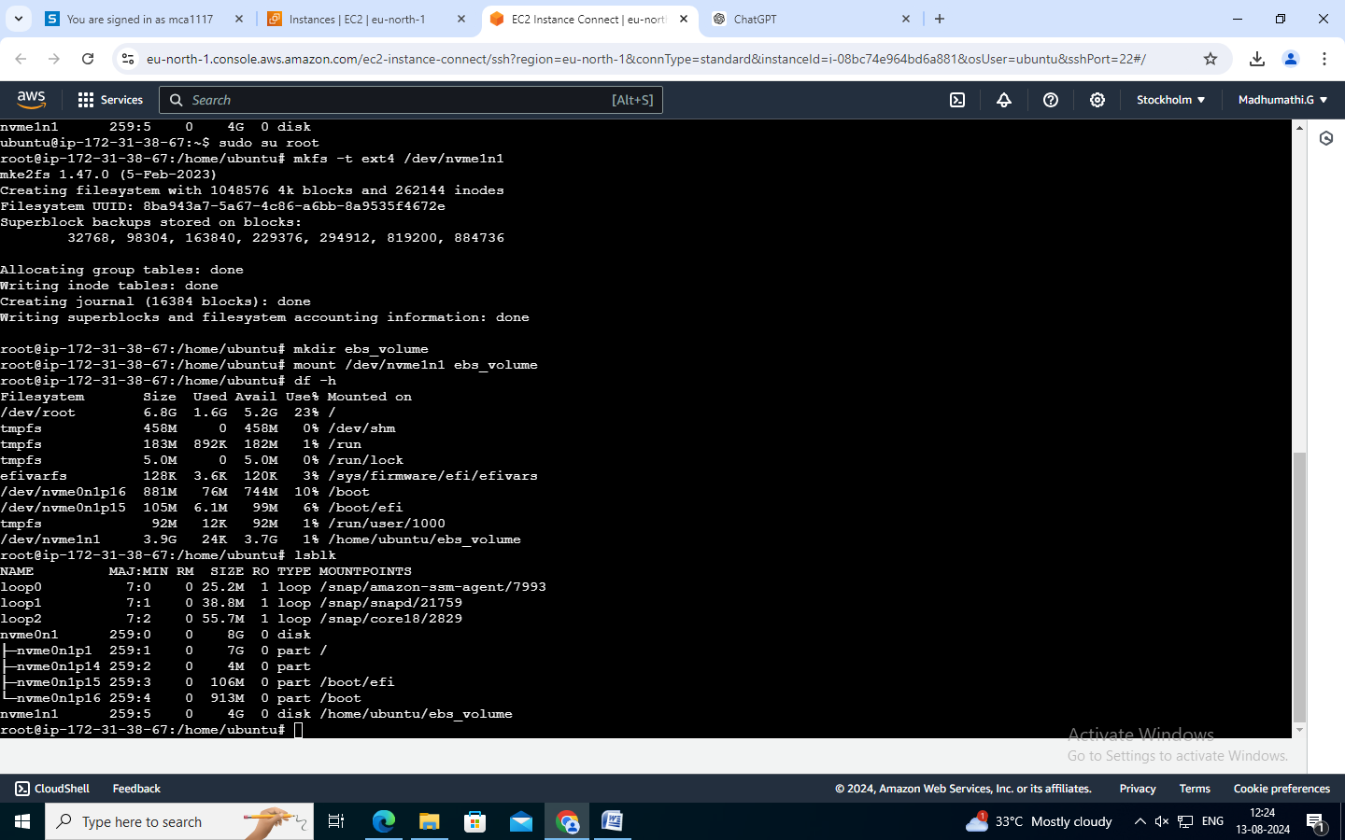

**After Attaching Volumes**

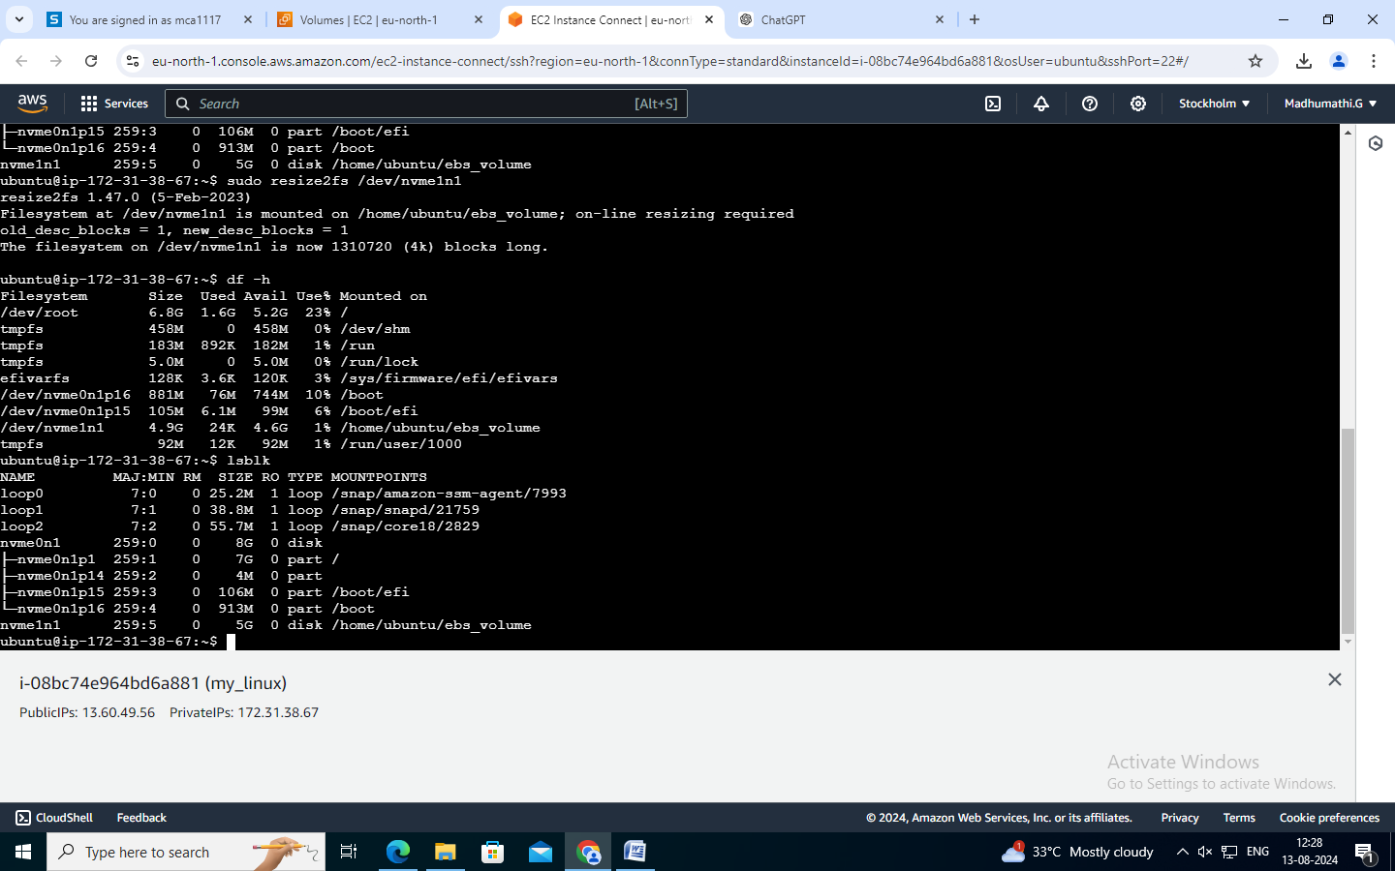

**Conclusion**

Thus the creation and managing Windows and Linux EC2 instances, added and attached new volumes, and took snapshots for backup or replication. Additionally, we resized volumes and verified changes, ensuring effective storage management across different operating systems has been developed and executed successfully.