**EX: 07 NAME: M. NIVASHINI**

**DATE: 13.08.2024 ROLL.NO.: 23MCA020**

**Advanced EC2 Operations**

**Aim:**

To create a snapshot of an EC2 instance's volume, attach it as a secondary volume to a new instance, and modify the volume size to observe the effects on data accessibility and system performance.

**Theoretical Background**

**1. Create a Snapshot of an EC2 Instance’s Volume**

1. **Identify the Volume to Snapshot:**
   * Open the AWS Management Console.
   * Navigate to the EC2 Dashboard.
   * Click on “Instances” and select the EC2 instance for which you want to create a snapshot.
   * Go to the “Description” tab and find the volume ID(s) under “Block devices.”
2. **Create the Snapshot:**
   * Navigate to the “Elastic Block Store” section in the EC2 Dashboard and select “Volumes.”
   * Find and select the volume ID identified earlier.
   * Click on “Actions” and select “Create Snapshot.”
   * Provide a name and description for the snapshot.
   * Click “Create Snapshot.”
3. **Verify Snapshot Creation:**
   * Go to “Snapshots” under “Elastic Block Store” in the EC2 Dashboard.
   * Ensure that the snapshot status is “completed” before proceeding.

**2. Attach the Snapshot to a New Instance as a Secondary Volume**

1. **Launch a New EC2 Instance:**
   * Go to the EC2 Dashboard and click on “Launch Instance.”
   * Choose an AMI, instance type, and configure instance details as required.
   * On the “Add Storage” step, do not add any additional volumes (we will attach the snapshot later).
   * Complete the instance launch process by configuring security groups and key pairs.
2. **Create a Volume from the Snapshot:**
   * Navigate to “Snapshots” in the EC2 Dashboard.
   * Select the snapshot you created.
   * Click on “Actions” and select “Create Volume.”
   * Choose the volume type, size (initially it can be the same as the snapshot size), and Availability Zone (must match the new instance’s AZ).
   * Click “Create Volume.”
3. **Attach the Volume to the New Instance:**
   * Go to the “Volumes” section in the EC2 Dashboard.
   * Select the newly created volume.
   * Click on “Actions” and select “Attach Volume.”
   * Choose the new EC2 instance from the drop-down list.
   * Specify a device name (e.g., /dev/sdf) and click “Attach.”
4. **Verify Volume Attachment:**
   * SSH into the new EC2 instance.
   * Use lsblk or sudo fdisk -l to list block devices and confirm that the new volume is attached.

**3. Modify the Volume Size After Attaching the Snapshot**

1. **Modify the Volume Size:**
   * Navigate to the “Volumes” section in the EC2 Dashboard.
   * Select the volume attached to the new instance.
   * Click on “Actions” and select “Modify Volume.”
   * Increase the volume size as needed. Note that you can only increase the size; reducing it is not supported.
   * Click “Modify” and then confirm the changes.
2. **Verify Volume Size Modification:**
   * Check the status of the modification under the “Volumes” section. It should show “modifying” until the operation completes.
3. **Resize the File System:**
   * SSH into the new EC2 instance.
   * Use lsblk to identify the device name (e.g., /dev/xvdf).
   * To resize the file system, run the appropriate command based on the file system type:
     + For **ext4** or **ext3**:

bash

Copy code

sudo resize2fs /dev/xvdf

* + - For **XFS**:

bash

Copy code

sudo xfs_growfs /dev/xvdf

* + Verify the increased available space:

bash

Copy code

df -h

**4. Observe the Impact on Data Availability and Performance**

1. **Check Data Availability:**
   * Verify that all data is available and accessible on the new instance by navigating through the mounted file system.
2. **Monitor Performance:**
   * Use monitoring tools like AWS CloudWatch or system utilities (e.g., iostat, vmstat) to observe the performance of the volume after resizing.

**Output**

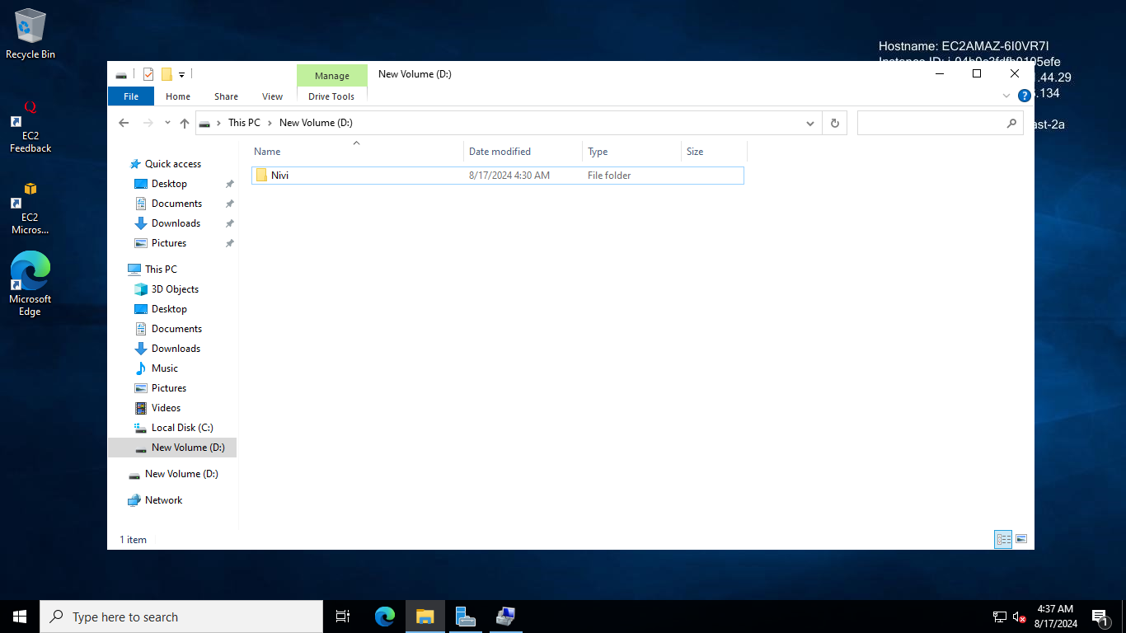

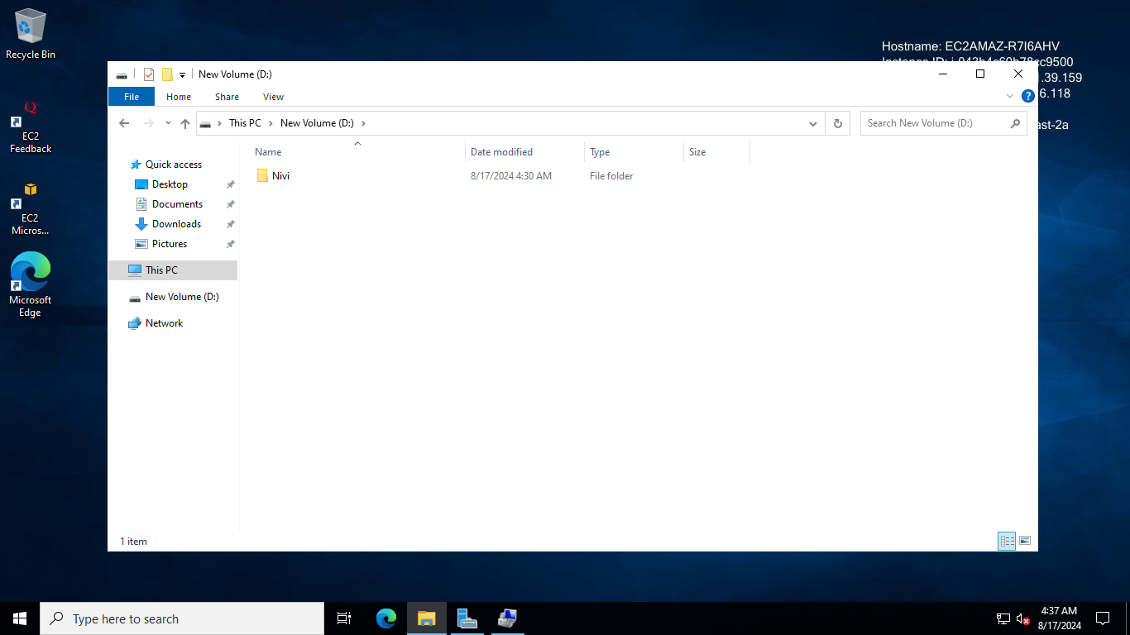

**Conclusion**

Thus successfully we creating and managing snapshots and volumes in EC2 demonstrates the flexibility of AWS EBS for backup and scaling. Observing the effects of resizing on data accessibility and performance highlights the robustness and adaptability of AWS storage solutions.