**EX: 09 NAME: M. NIVASHINI**

**DATE: 03.09.2024 ROLL.NO.: 23MCA020**

**Exercise to create IAM user**

**Aim:**

To create an IAM (Identity and Access Management) user using AWS Console.

**Theoretical Background**

* **Step 1** : Sign in to AWS Management Console
* **Step 2** : Navigate to the IAM Dashboard.
* **Step 3** : To create a new user, Click create User
* **Step 4** : Enter the name for the user and click next.
* **Step 5** : Choose Attach policy directly.
* **Step 6** : Type s3 in permission policies and select Amazons3fullAccess,Click next.
* **Step 7** : Click create User.

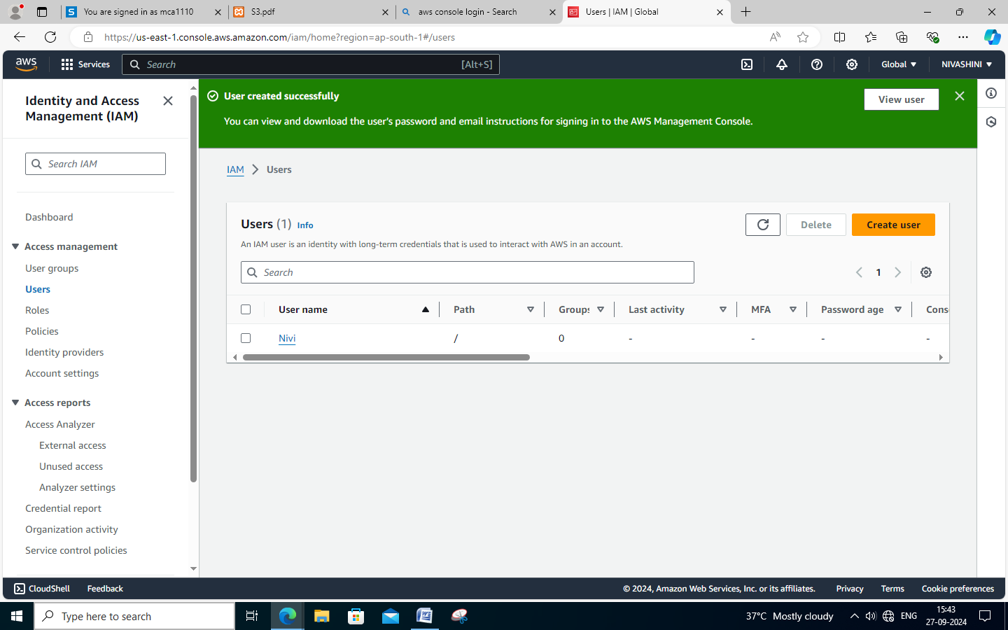

**Steps to provide username and password**

* **Step 1** : Click the user created
* **Step 2** : Navigate to security credential.
* **Step 3** : Copy the console sign in link and paste in a notepad.
* **Step 4** : Click Enable console access and choose Autogenerated Password and click Enable console access.
* **Step 5** : Copy the username and password in a notepad.
* **Step 6** : Open a new tab in a browser and paste the console sign in link
* **Step 7** : Paste the copied username and Password and click sign in.

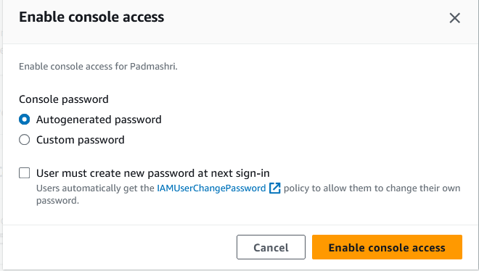

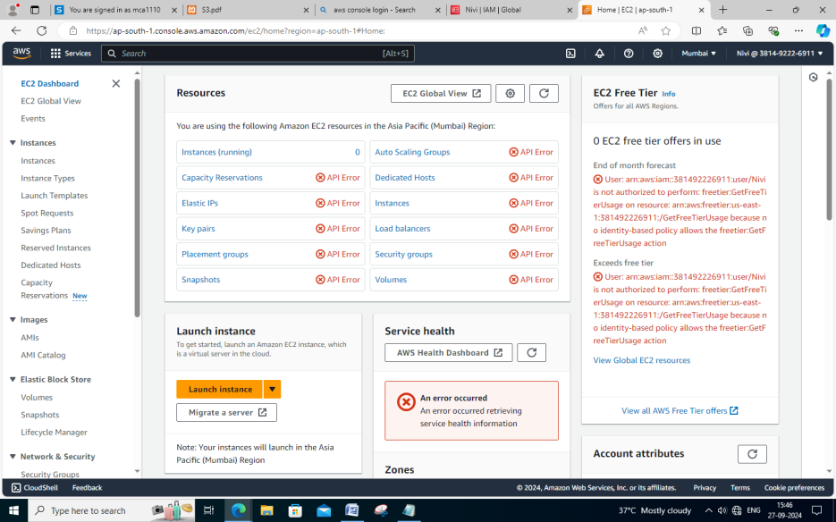

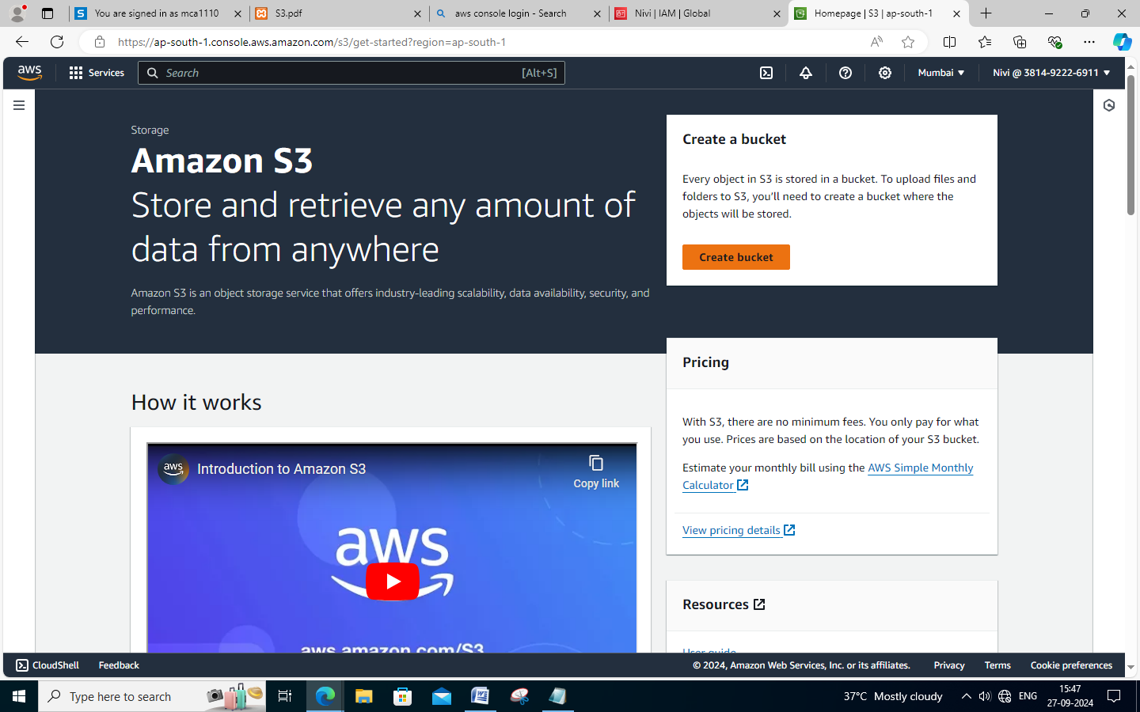

**Conclusion**

Thus, an IAM (Identity and Access Management) user is created using AWS Console successfully.