**EXCERCISE FOR CREATING VIRTUAL MACHINE**

**Ex.No : 01 Name : S.Yuvasri**

**Date: 02.07.2024 Roll.No: 23MCA039**

**AIM:**

To create a virtual machine for Linux, Windows using VMware WorkStation.

**THEORATICAL BACKGROUND:**

**Virtual Machine**

A virtual machine (VM) is a virtual environment which functions as a virtual computer system with its own CPU, memory, network interface, and storage, created on a physical hardware system. VMs are isolated from the rest of the system, and multiple VMs can exist on a single piece of hardware, like a server. Using virtual machines, there is easy maintenance, application provisioning, availability and convenient recovery.

**VMware**

VMware is a virtualization and cloud computing software provider. VMware is widely used as it tends to virtualize x86 architectures, which executes unmodified on-top of their hypervisors. Technology of VMware is based on the key concept of Full Virtualization.

**Operating System**

Windows Operating System, developed by Microsoft , known for its user-friendly interface and broad compatibility with hardware and software. Its robustness in gaming, productivity software, and multimedia capabilities has made it a staple in homes, businesses, and educational institutions globally.

Linux is a versatile and widely used open-source operating system. Built on the Unix-like kernel, Linux offers a stable and secure platform that powers everything from servers and mainframes to embedded devices and supercomputers. To execute C programs in Linux use these commands to install compiler

To update the linux os,

**sudo apt -get update**

To install compiler,

**sudo apt -get install g++**

**STEPS INVOLVED:**

**Step 1:** Create a new virtual machine in VMware workstation

**File -> New Virtual Machine (or) ctrl+N**

**Step 2:** After One popup window is displayed namely “New Virtual Machine Wizard”.In the window choose “Installer disc image file(iso)” and browse your iso file in the disk and click Next.

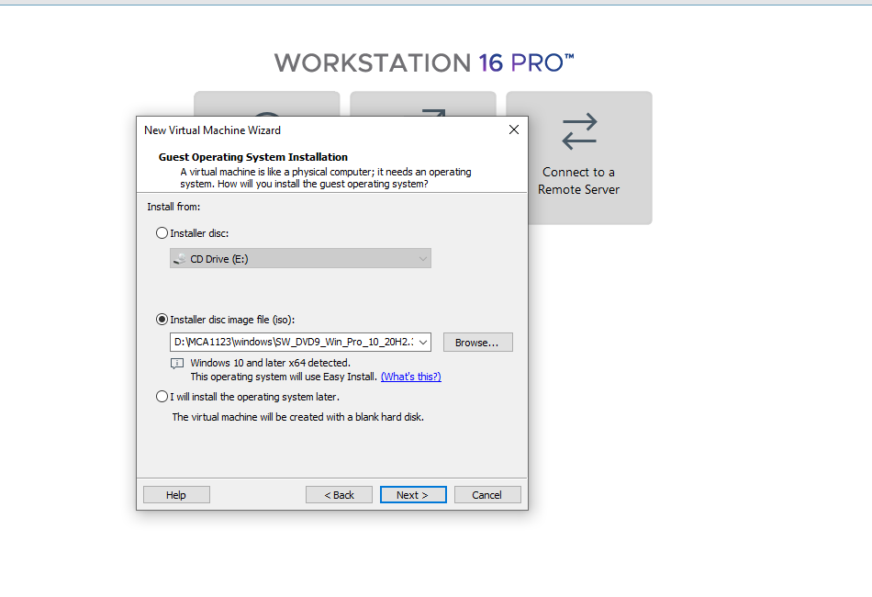

**Step 3 :** For creating windows virtual machine there is an textfield for product key there is no need to enter product key so click Next. Linux does not have a product key.

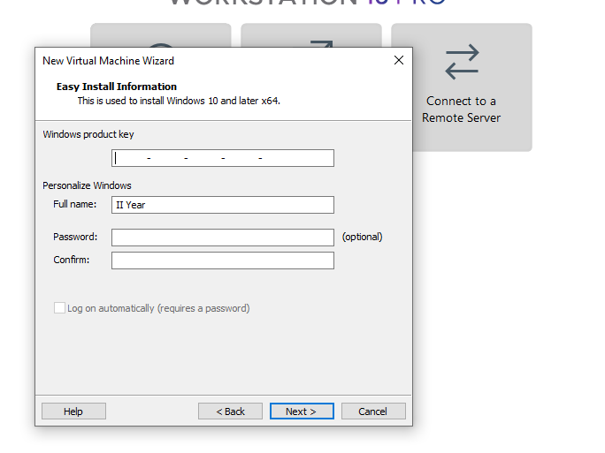

**Step 4:** Select a Guest operating system for which operating system will be installed on this virtual machine. Choose Microsoft windows for windows OS and Linux for Linux OS and version .

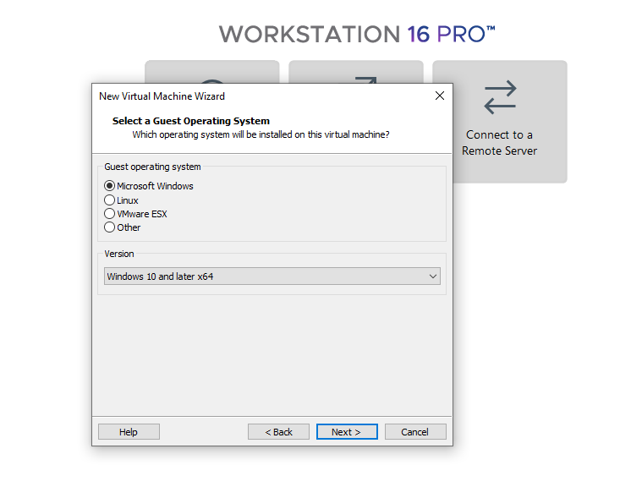  
**Step 5:** Name the virtual machine like “Windows” ,“Ubuntu” and select the location for the virtual machine.

**Step 6:** The virtual machine’s hard disk is stored one or more files on the host computer’s physical disk. So,Specify the disk capacity in the textfield.

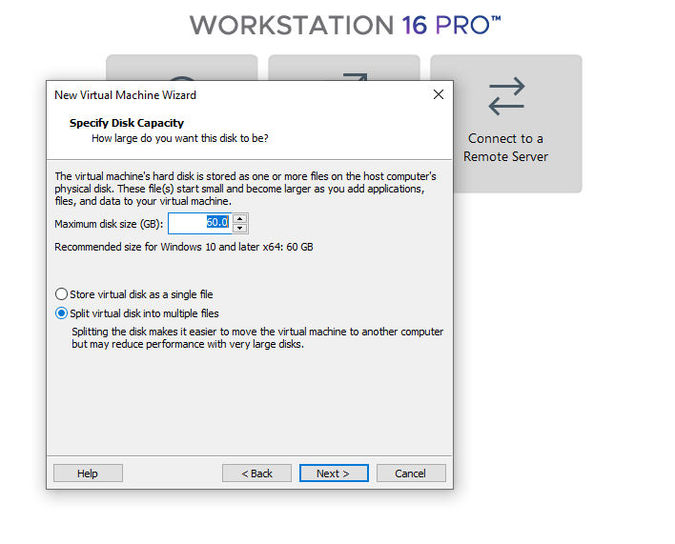

**Step 7:** After selecting the features it shows the list of settings according to the details. Review the details and click Finish.

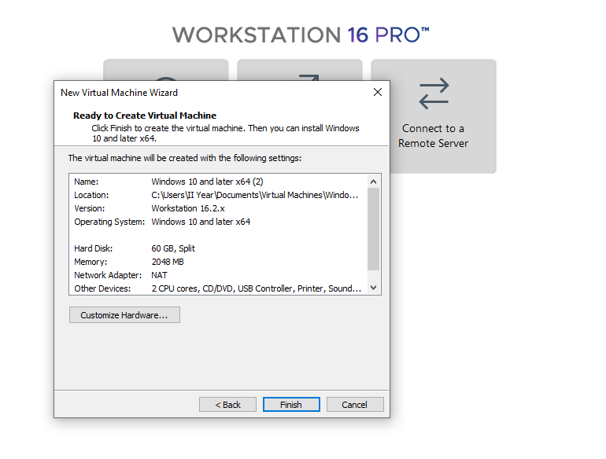

**Step 8:** Virtual machine is created. Click “Power on” to start the virtual machine.

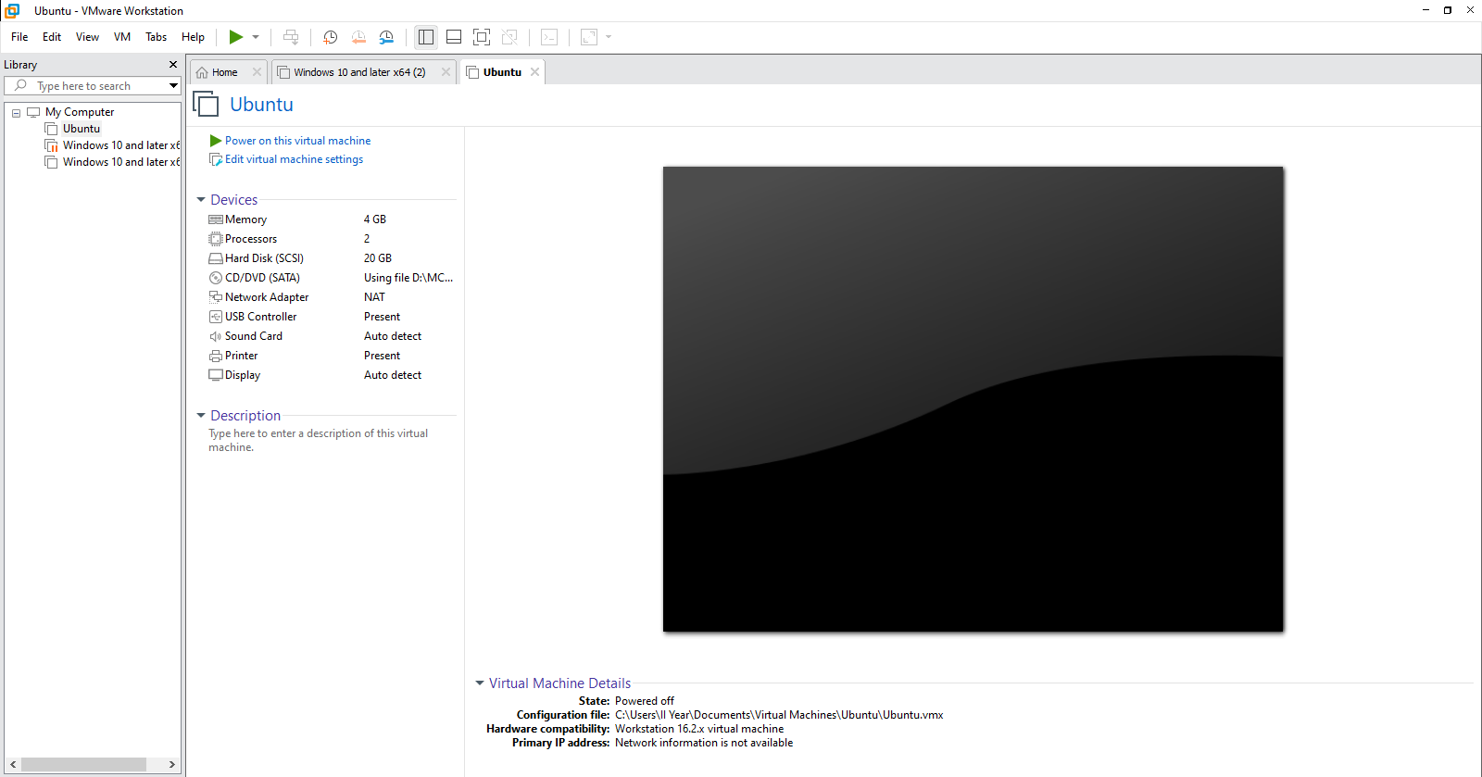

**OUTPUT:**

**Windows Virtual machine**

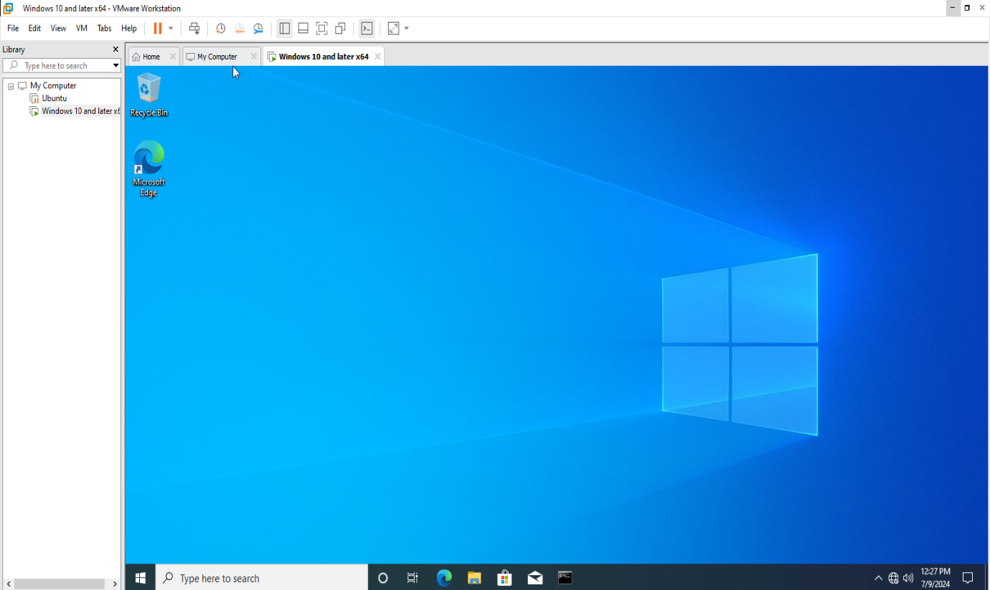

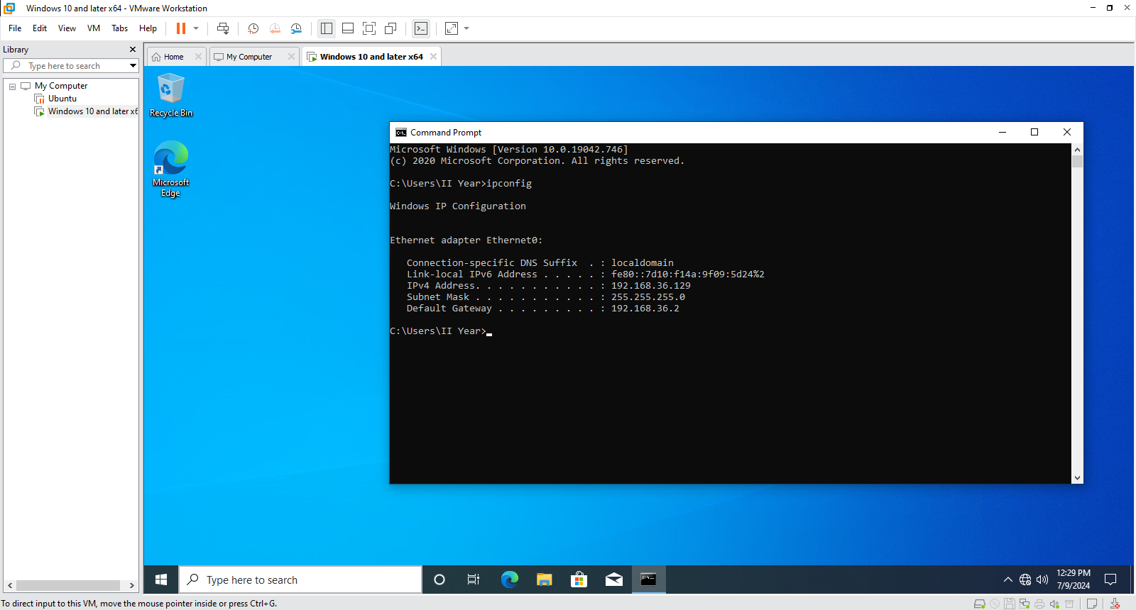

**Linux Virtual Machine**

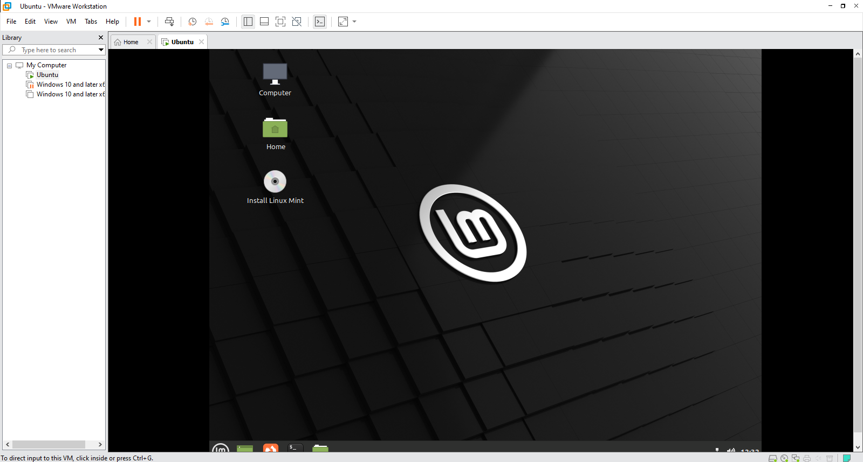

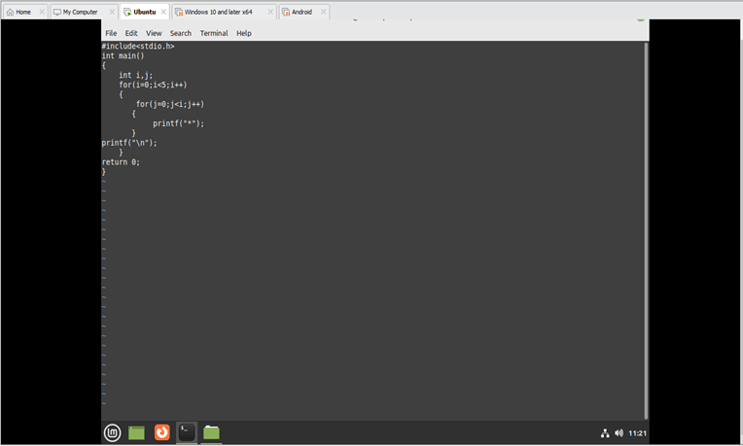

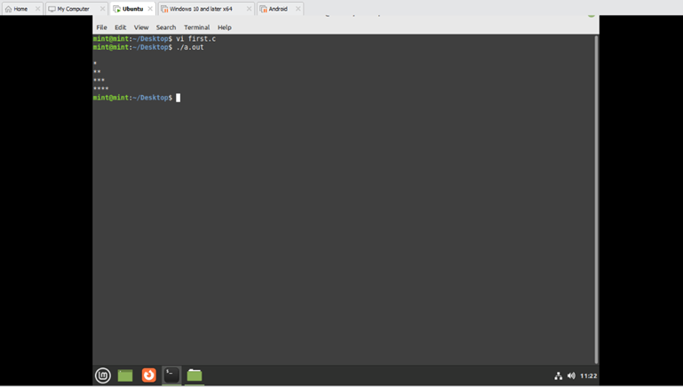

**CONCLUSION:**

Thus the above steps for creating virtual machine for windows, linux was setup successfully.