**CREATE A CLOUD STORAGE USING AWS S3 BUCKET**

**Ex.No : 10 Name : S.Yuvasri**

**Date : 24.09.2024 Roll.No: 23MCA039**

**AIM:**

To create an S3 bucket and upload files and create folders into the bucket in AWS.

**THEORETICAL BACKGROUND:**

**S3 bucket**

Amazon Web Services (AWS) S3 is object-based storage, where data (objects) are stored in S3 buckets. The AWS S3 Standard storage class provides safe, scalable, fast, and inexpensive storage and retrieval of any amount of data. The Standard class is designed for data that are accessed frequently. Other storage class options are available for different data storage requirements.

S3 has a basic monthly cost for storing data and this varies by AWS region. Transfer charges are applied for data moved out of an S3 bucket to the Internet, as well as data transferred between AWS regions, though these interregional transfer charges are much less. There are no charges for data uploaded to a bucket or transferred between S3 buckets (or any AWS services) in the same region.

**STEPS INVOLVED:**

**Step 1:** SIGN IN to AWS. The AWS Management Console will open

**Step 2:** Type S3 in the search box under Find Services, and click on “S3 Scalable Storage in the Cloud”

**Step 3:** Click on Create bucket in the S3 console

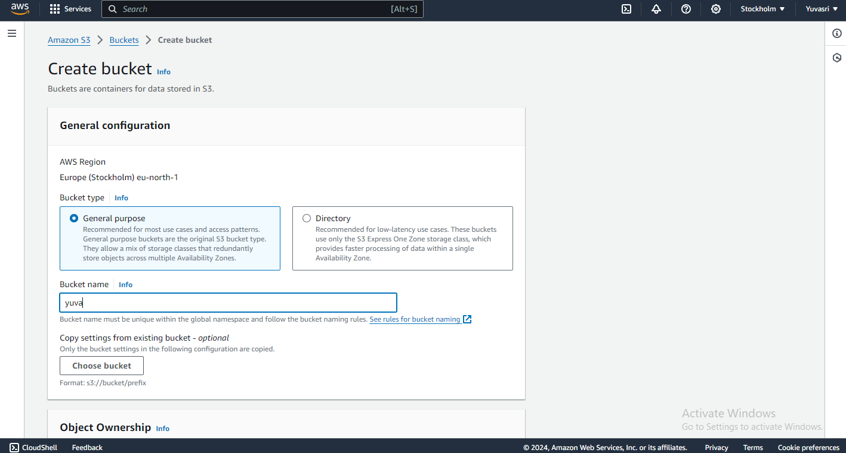

**Step 4:** Enter a Bucket name an click “Create Bucket”. New bucket is created.

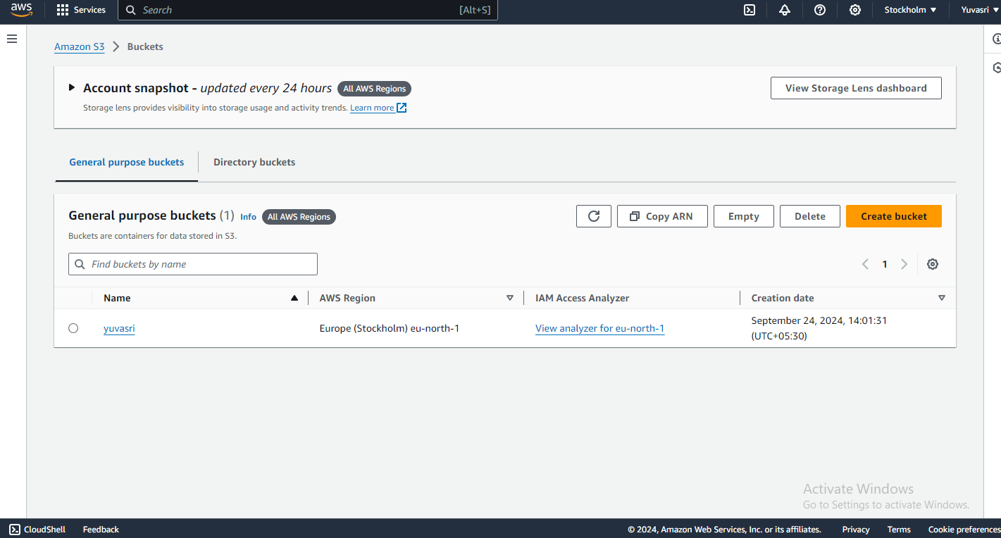

**Step 5:** Click on the bucket name in the S3 buckets console to open the bucket .The bucket is empty.

**Step 6:** Click on Upload. In this window, click “Add files” and browse the files.

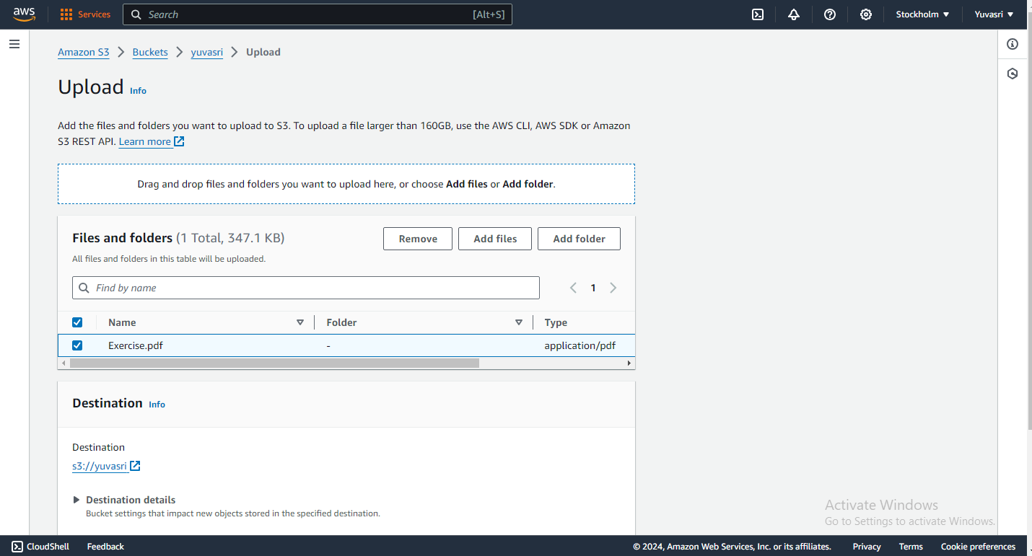

**Step 7:** And click “Upload files” and the files are uploaded in the bucket and the uploaded files are displayed.

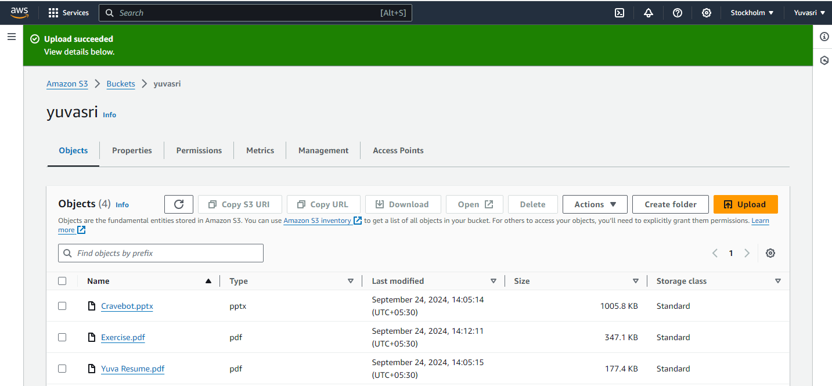

**Step 8:** Click on Create folder, give the folder a name, then click Save

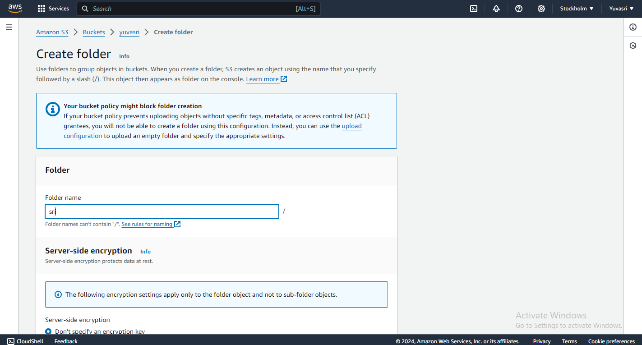

**Step 9:** Check the box in front of the file(s) you want to move to the new folder and go to “Create Actions” and click “Move” after selecting the files.

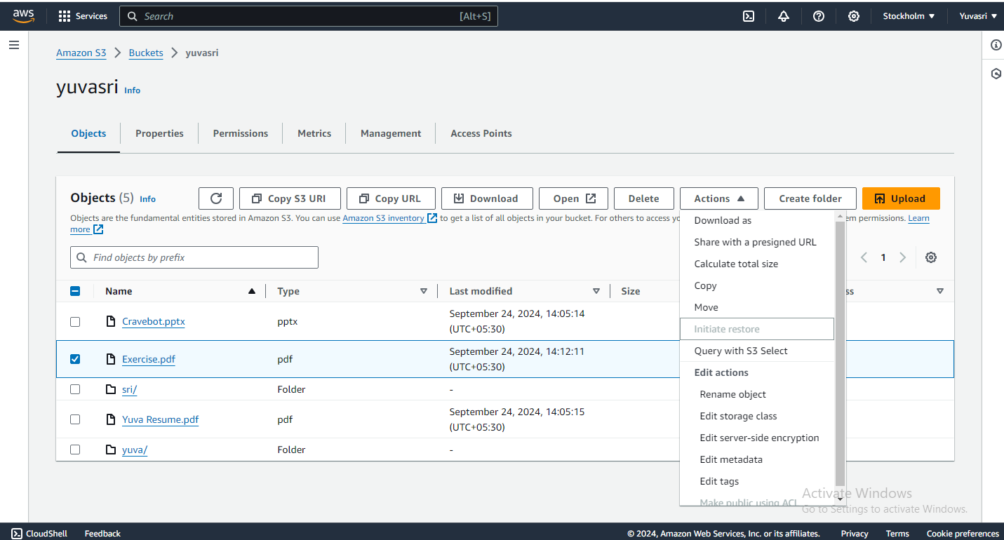

**Step 10:** And select destination with the help of “Browse S3” option and choose our folder destination.

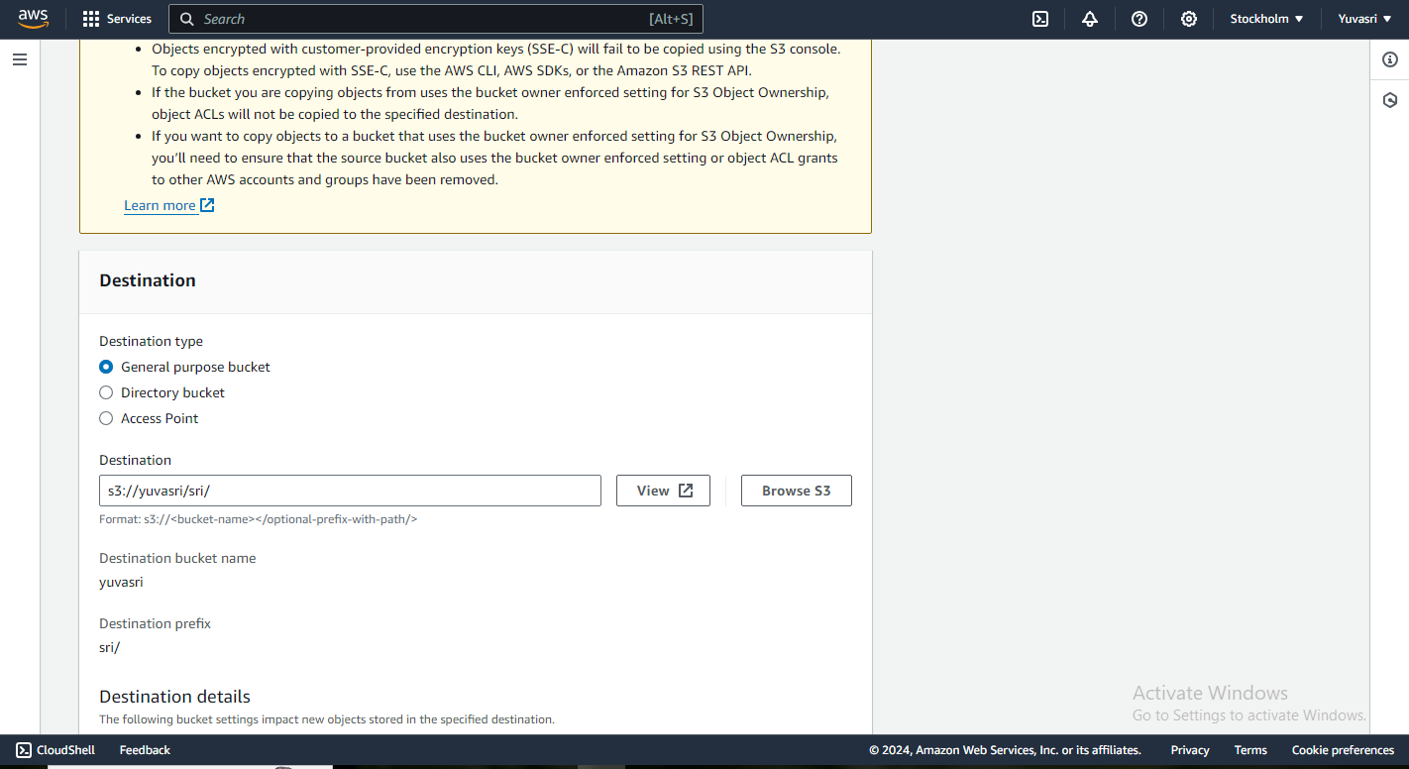

**Step 11:** After that click upload options and our file is moved into folder.

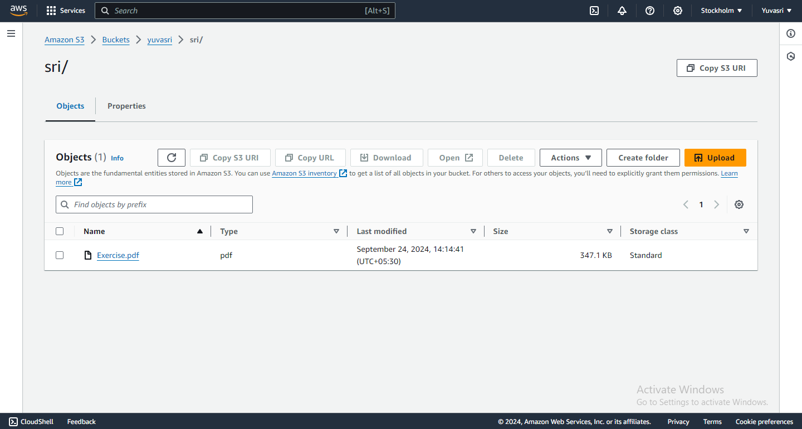

**CONCLUSION:**

Thus the above s3 bucket was created and upload files and folders into the bucket in AWS was executed successfully.