**CREATING AND MANAGING EC2 INSTANCES**

**Ex.No : 02 Name : S.Yuvasri**

**Date: Roll.No: 23MCA039**

**AIM:**

To create an EC2 instance with a Windows Server operating system and perform the following operations.

* Set up another EC2 instance with a Linux operating system.
* Add a new volume to each instance.
* Take snapshots of the volumes and attach them to new instances.
* Modify the volume size for each instance and observe the changes.

**THEORATICAL BACKGROUND:**

**EC2 Instance**

EC2 stands for Elastic Compute Cloud. EC2 is an on-demand computing service on the AWS cloud platform. Under computing, it includes all the services a computing device can offer to you along with the flexibility of a virtual environment. It also allows the user to configure their instances as per their requirements i.e. allocate the RAM, ROM, and storage according to the need of the current task. EC2 offers security, reliability, high performance, and cost-effective infrastructure so as to meet the demanding business needs.

**Snapshot**

A snapshot is an incremental backup, which means that we save only the blocks on the device that have changed since your most recent snapshot. Snapshots are designed to be incrementable so that a new snapshot only stores the changes that were made in the last snapshot and thus utilizes the space. Whenever a snapshot is taken, AWS takes a copy of the designated volume where the snapshot was taken; it could be either EC2 or Redshift. Only data inside the volume is copied so that it can be used for restoration.

**Volume**

An AWS volume is a durable, block-level storage device that you can attach to your instances. After you attach a volume to an instance, you can use it as you would use a physical hard drive. EBS volumes are flexible. For current-generation volumes attached to current-generation instance types, you can dynamically increase size, modify the provisioned IOPS capacity, and change volume type on live production volumes.

**STEPS INVOLVED:**

**1) Set up another EC2 instance with a Linux operating system.**

**Step 1:** In the AWS Console search “EC2 instance”. Go to Instances and click Launch Instances.In the launch instances give name for the instance like “MyWindows” ,”Linux”. After that choose application and os image such as windows or ubuntu server.

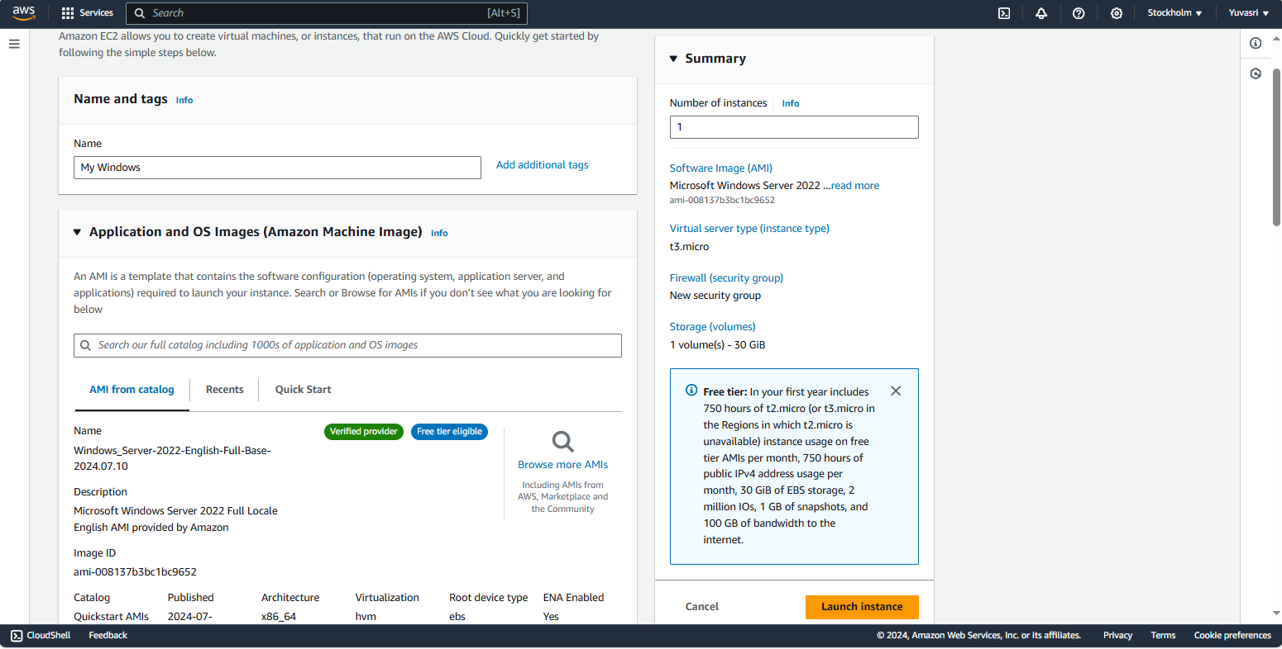

**Step 2:** Create a new keypair for our operating system. Keypair is used to securely connect to our instance.

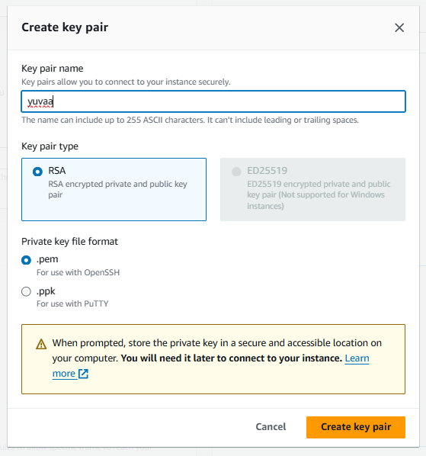

**Step 3:** In the network settings column click all the checkboxes for allowing SSH, HTTPS, HTTP for operating system

**Step 4:** After that click “Launch Instances”. EC2 instance is creating and it is in the running state.

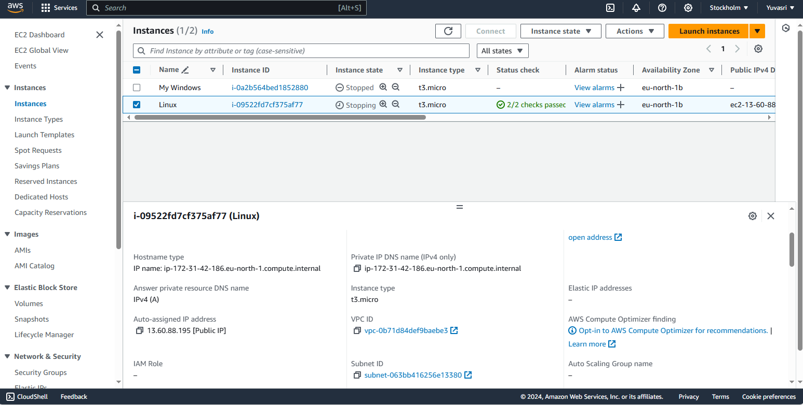

**Step 5:** For connecting our instances go to “Actions” Click “connect”. For connecting windows “Download remote desktop file”. In the file there are two text fields such as username and password. For password decrypt the .pem file.

For linux directly go to “Actions” and click “Connect”.

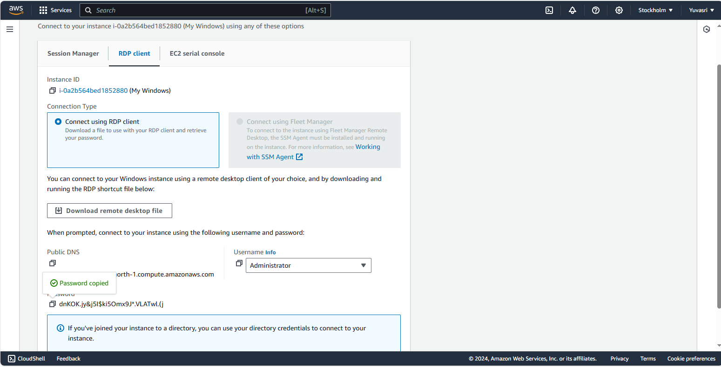

**Step 6:** Finally our EC2 instance is connected through remote connection.

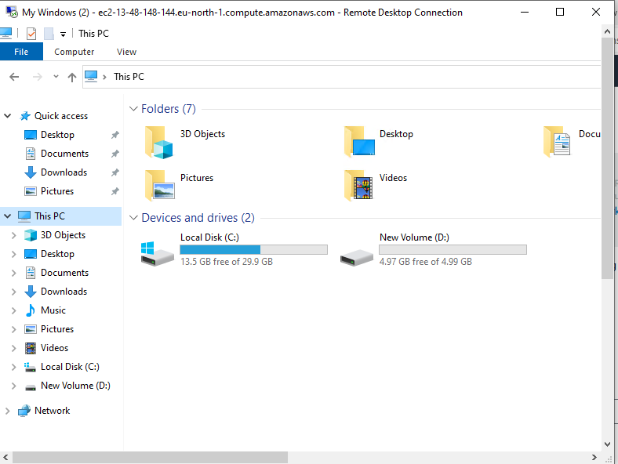



**2) Add a new volume to each instance.**

**Step 1:** Go to “Elastic Block Store” and click volumes.In the create volume choose the size of the volume. For linux 4GB amd for windows 5GB and click “Create volume”

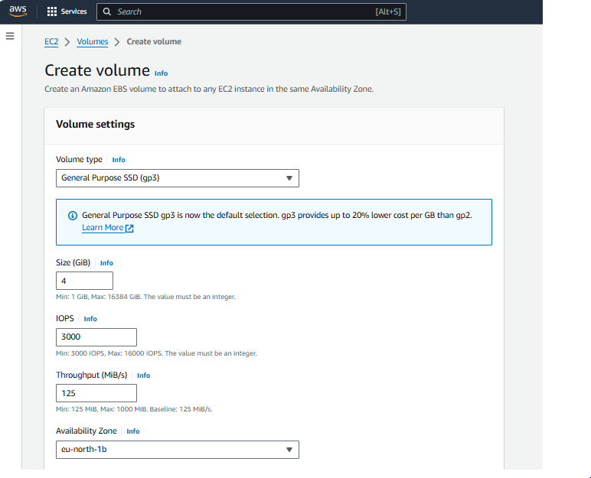

**Step 2:** After that go to “actions” and click “Attach volume”. In that choose the instance for attaching the volume in it. Choose device name for windows “/dev/sde” , for linux “/dev/nvme”

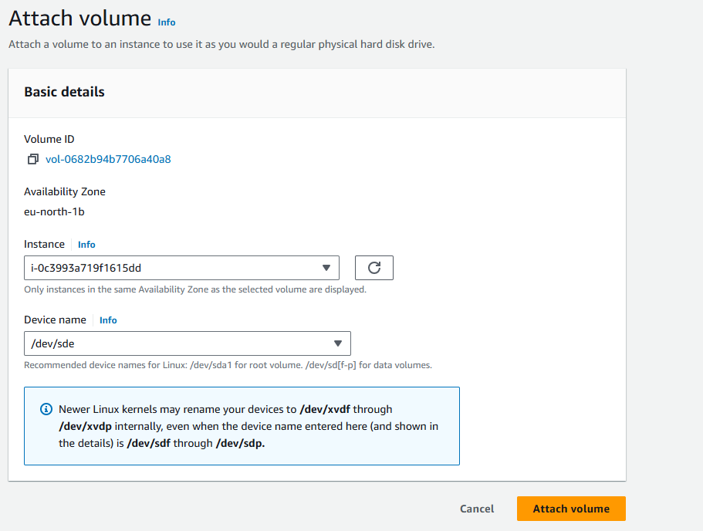

**Step 3:** After connecting to the remote connection, in windows go to “This PC” and right click and click the “Manage”. The server manager dashboard is opened. In that server manager dashboard click Tools.

**Step 4:** “Computer Management” is opened. In that go to disk management disk 1 is unallocated so right click and select “Online” and again right click “Initialize the disk”. And click “New Simple Volume” and new volume is created.

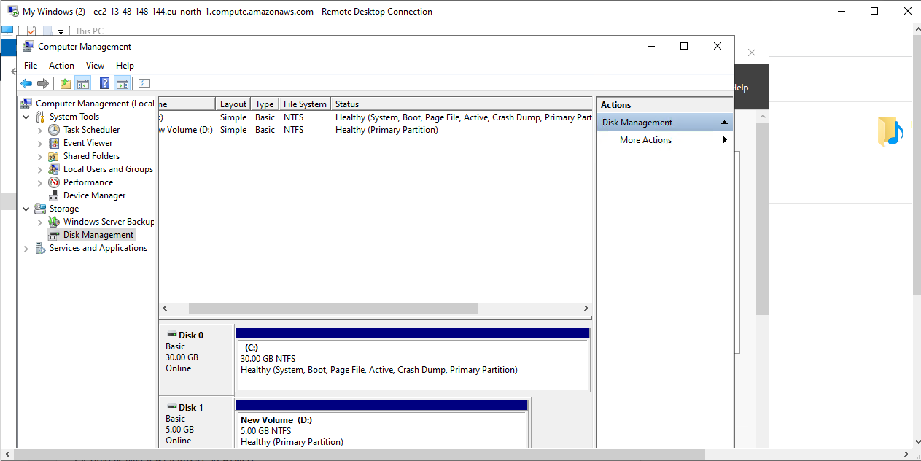

**Step 5:** New disk is created in the “This PC”



**Step 6:** For linux connect the instances and follow the commands

**sudo su //For changing the user to root**

**mkfs -t ext4 /dev/nvdme //For creating a filesystem**

**mkdir newvolume**

**mount /dev/nvdme newvolume**

**df -h //For check our volume is added in the filesystem**

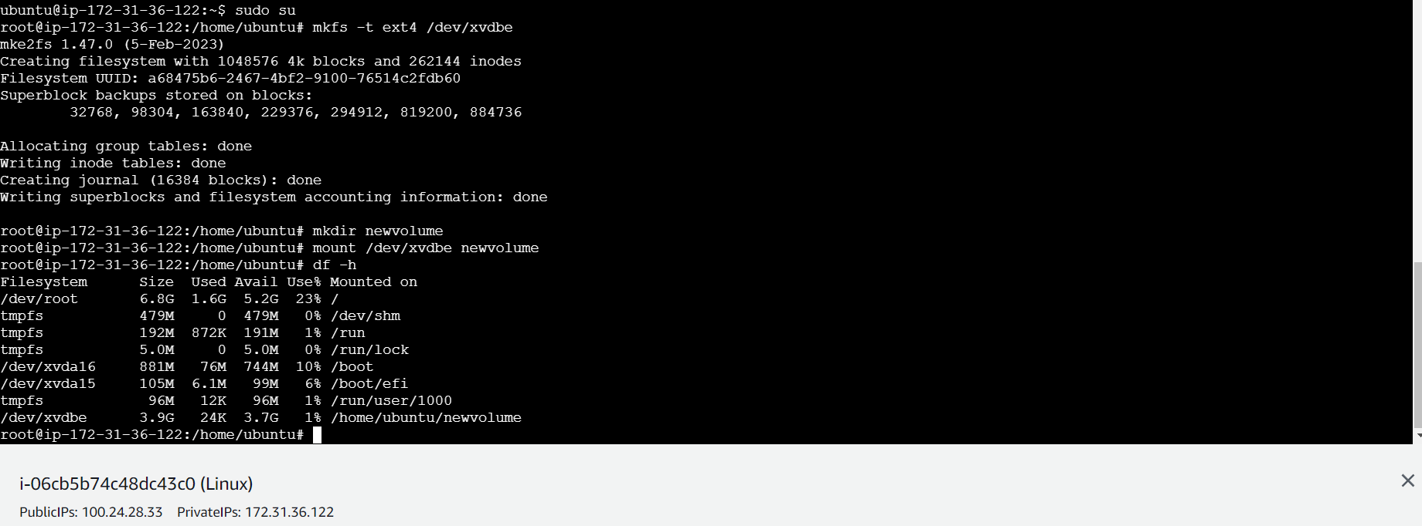

**3)** **Take snapshots of the volumes and attach them to new instances.**

**Step 1:** In the volume click the volume and go to actions🡪create a snapshot and give name for the snapshot. Snapshot is created.

**Step 2:** click the new snapshot and go to actions🡪create volume from snapshot and give the same volume size and click “create volume”

**Step 3:** Click Attach volume and attached the volume for new EC2 instances.

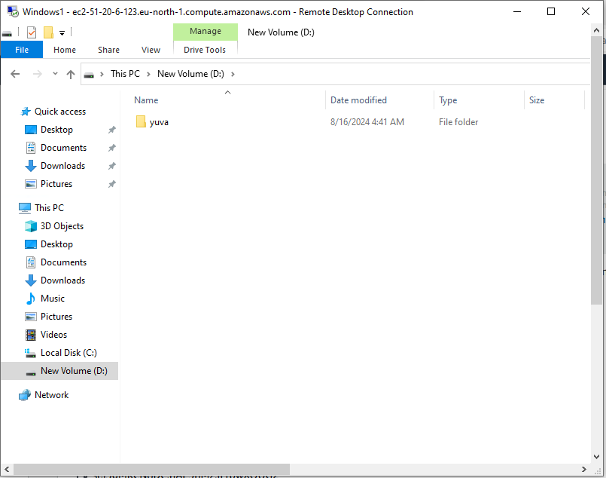

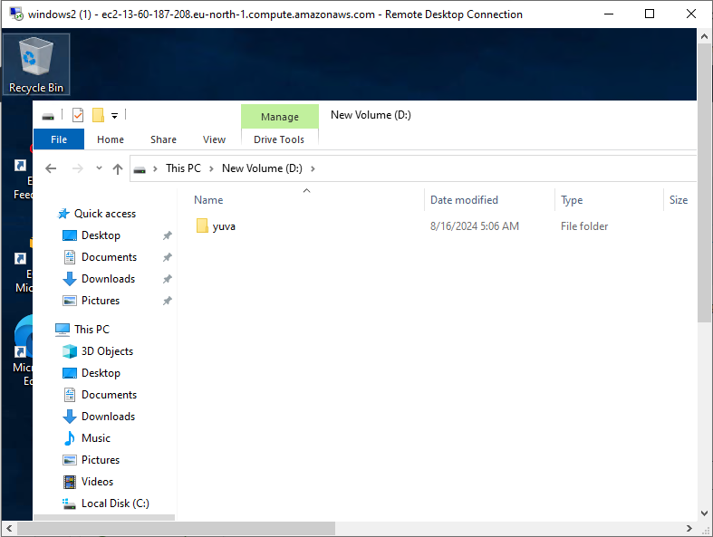

**Step 4:** For linux after add new volume following the commands and create new EC2 instance and follow the commands to check the folder in one volume is visible or not.

**mkdir newvolume**

**mount /dev/nvdme newvolume**

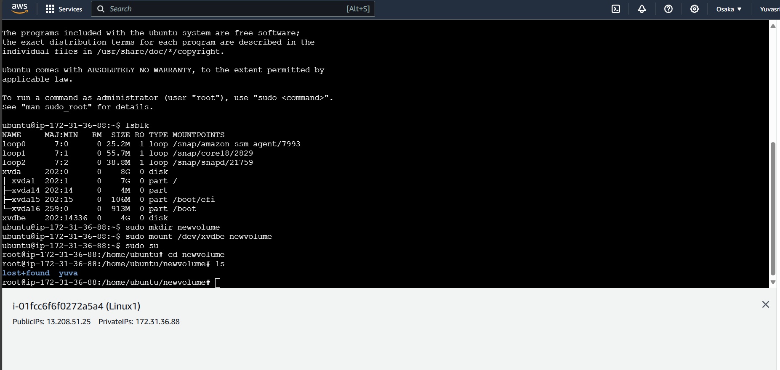

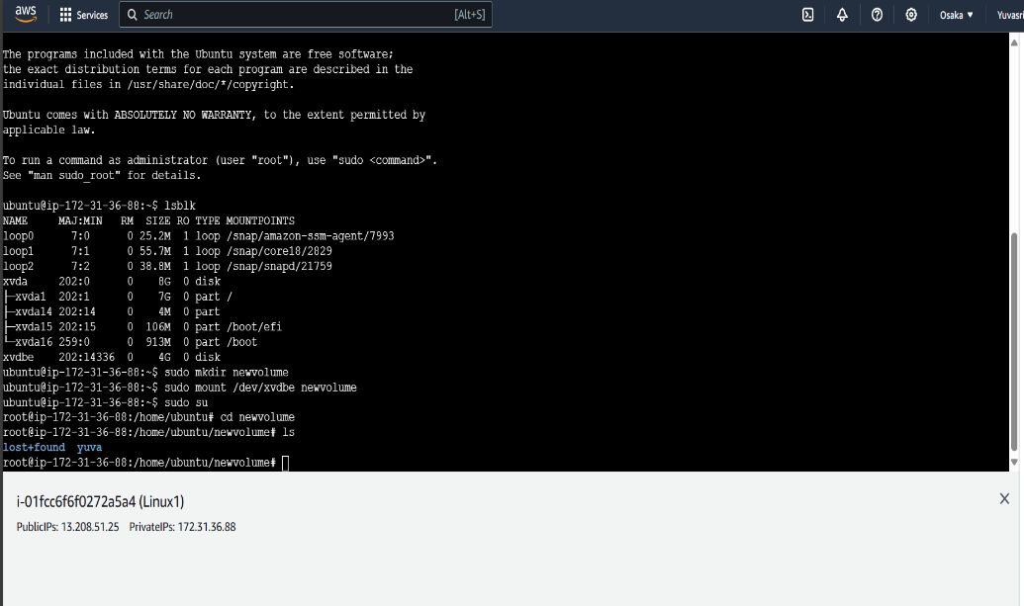

**4) Modify the volume size for each instance and observe the changes.**

**Step 1:** Create one volume and attach the volume in the ec2 instances for windows.

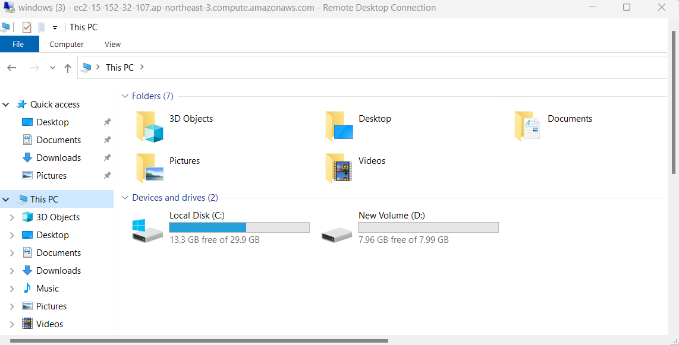

**Step 2:** After added to the instances go to volume and click “Modify Volume” . In the modify volume change the volume size and click “Modify”

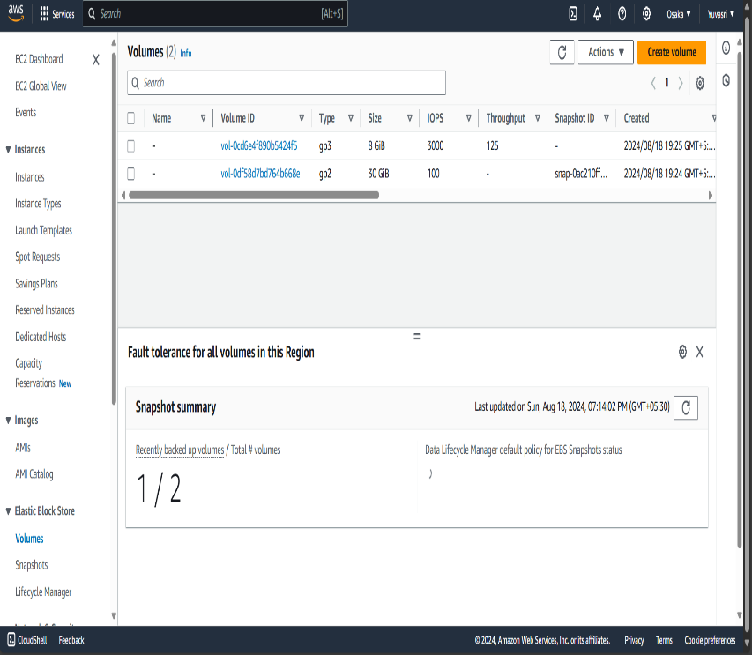

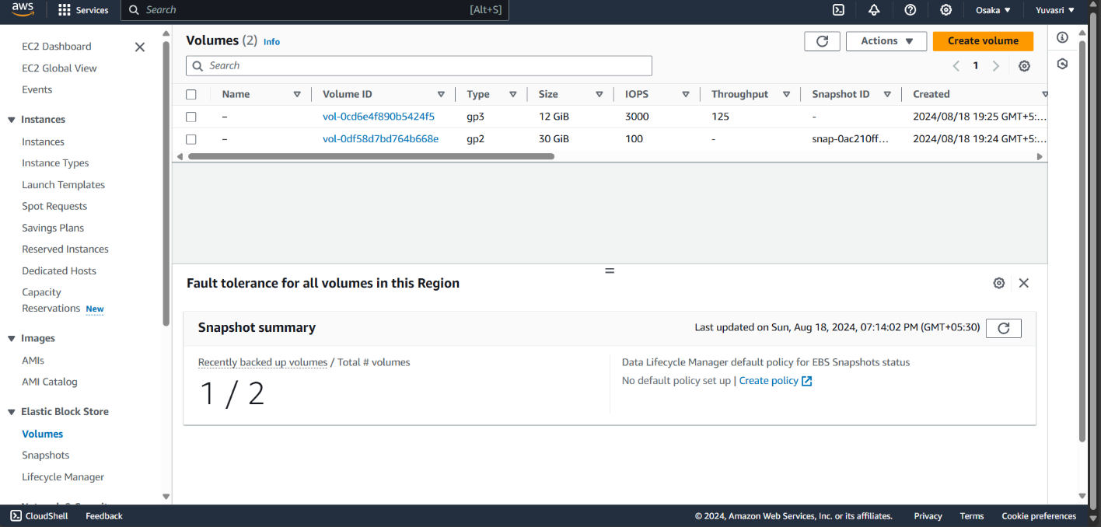

**Step 3:** After modify the volume size is changed and connect remote connection . In the windows go to disk management. In the disk management the remaining size is display in unallocated space.

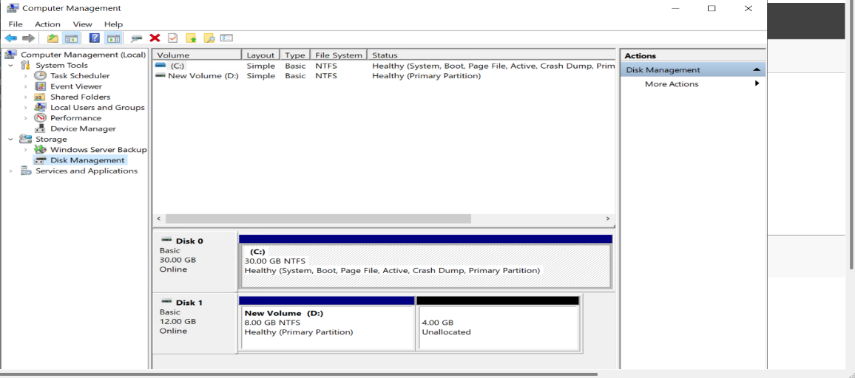

**Step 4:** Click the allocated space and select “Extend Volume” and click next. The volume is increased and shows in “This PC”

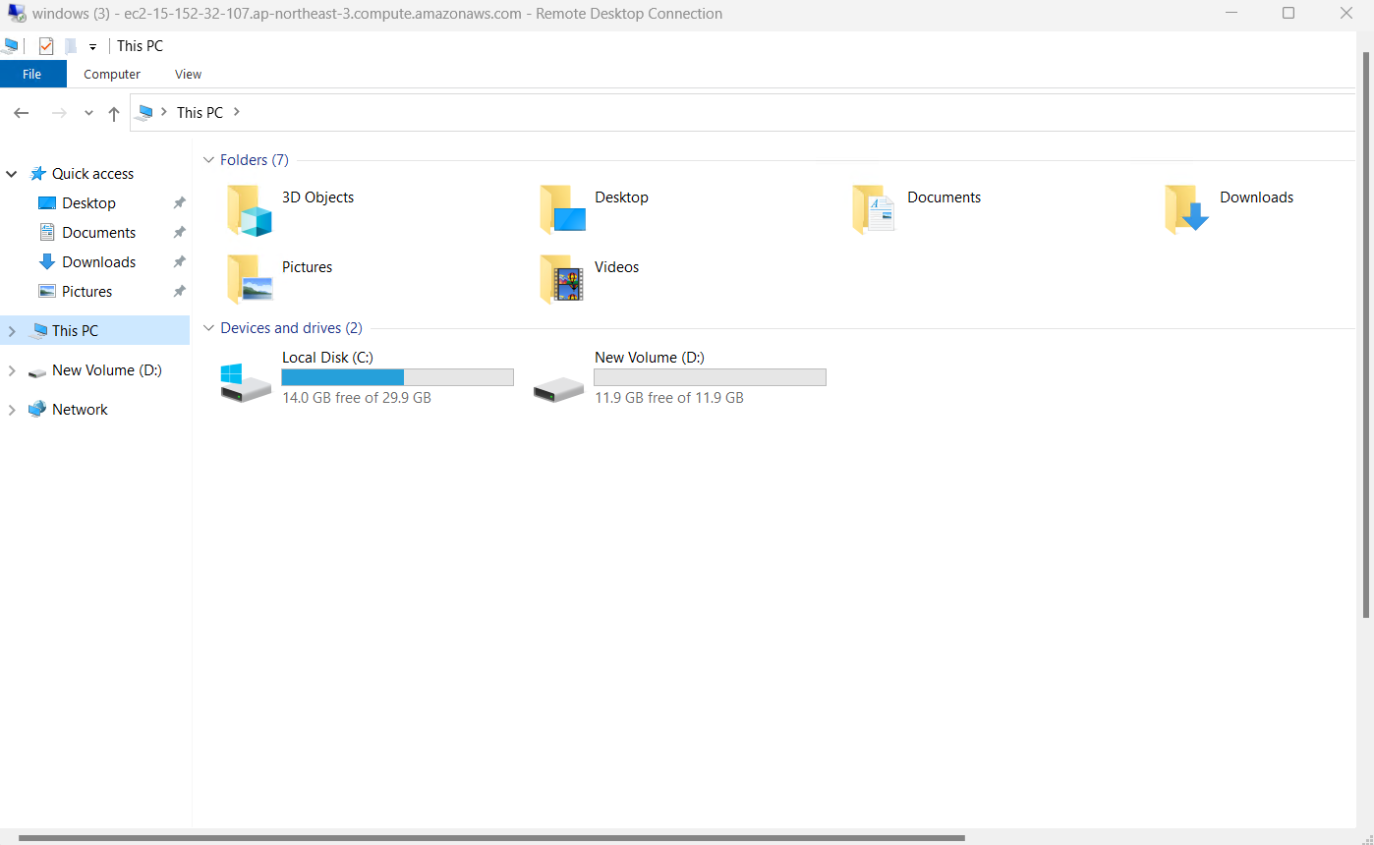

Step 5: For Linux create one volume and add the volume to the instance.



**Step 6:**After added to the instances go to volume and click “Modify Volume” . In the modify volume change the volume size and click “Modify”.

**Step 7:** For modify in the linux using the following commands

**sudo resize2fs /dev/xvdbe //For extend the volume**

**df -h //For checking volume is extended or not**

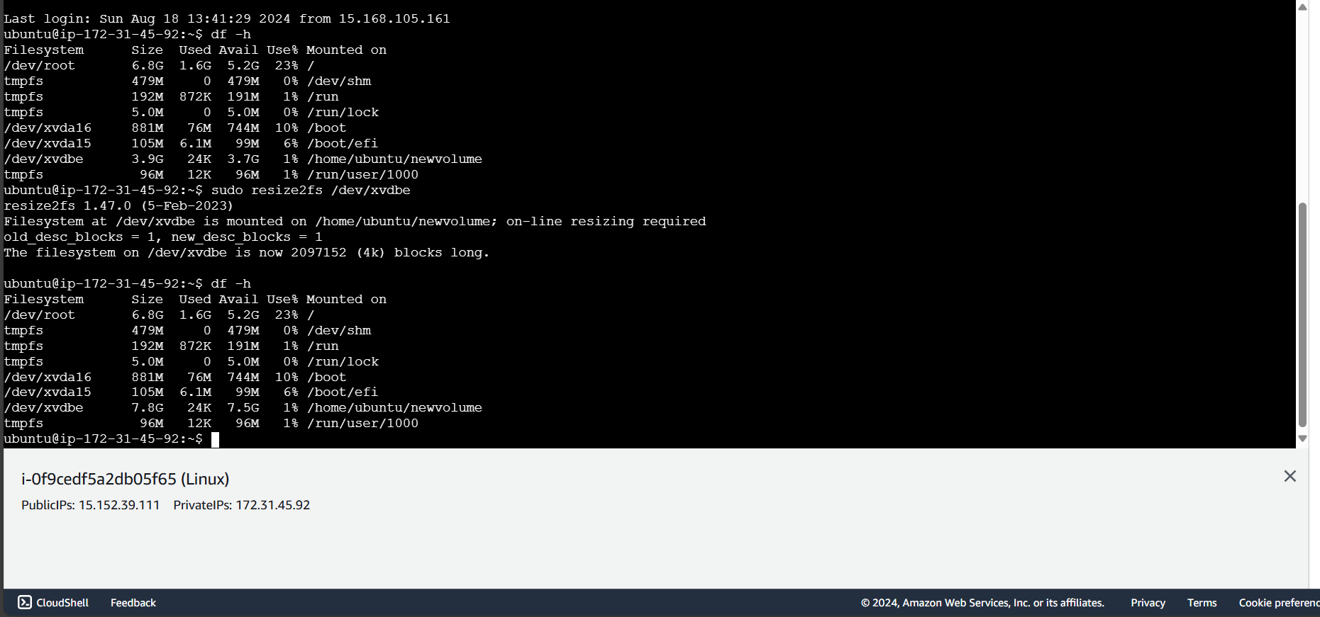

**CONCLUSION:**

Thus the above steps for creating and managing the EC2 instances such as creating, attach new volume, snapshot the volume and modify the volume in both windows and linux instance were executed successfully.