**DEPLOYING A WEBSITE ON EC2 INSTANCES**

**Ex.No : 03 Name : S.Yuvasri**

**Date: Roll.No: 23MCA039**

**AIM:**

To deploy a website on EC2 instances and follow the operations below,

* Set up a web hosting environment on both Windows and Linux EC2 instances.
* For the Linux instance, use WinSCP to upload a sample website and configure it.
* Test the website on both instances to ensure it's accessible via the web.

**THEORETICAL BACKGROUND:**

**EC2 Instance**

EC2 stands for Elastic Compute Cloud. EC2 is an on-demand computing service on the AWS cloud platform. Under computing, it includes all the services a computing device can offer to you along with the flexibility of a virtual environment. It also allows the user to configure their instances as per their requirements i.e. allocate the RAM, ROM, and storage according to the need of the current task. EC2 offers security, reliability, high performance, and cost-effective infrastructure so as to meet the demanding business needs.

**WinSCP**

WinSCP is a File Transfer Protocol client for Microsoft Windows. When using Linux machines, either as a Virtual Private Server or as a Virtual Machine on your local computer, one of the major problems that people encounter is to transfer their files from their host (main) machine to the Linux machine. This problem is generally resolved by a file transfer protocol client such as WinSCP and FileZilla. WinSCP uses the FTP (File Transfer Protocol) and SFTP (Secure File Transfer Protocol) protocols to transfer files from a Windows machine to any other machine (Linux in this case).

**STEPS INVOLVED:**

**1) Set up a web hosting environment on both Windows and Linux EC2 instances.**

**Step 1:** Create an instances for windows and Linux . Go to Instances and click Launch Instances.In the launch instances give name for the instance like “MyWindows” ,”Linux”. After that choose application and os image such as windows or ubuntu server.

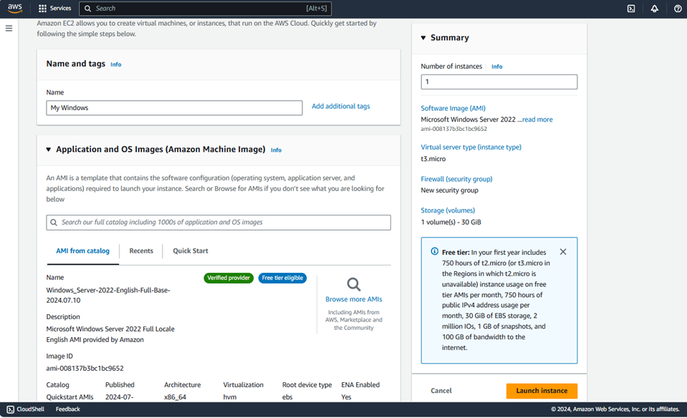

**Step 2:** Create a new keypair for our operating system. Keypair is used to securely connect to our instance.

**Step 3:** In the network settings column click all the checkboxes for allowing SSH, HTTPS, HTTP for operating system .After that click “Launch Instances”. EC2 instance is creating and it is in the running state.

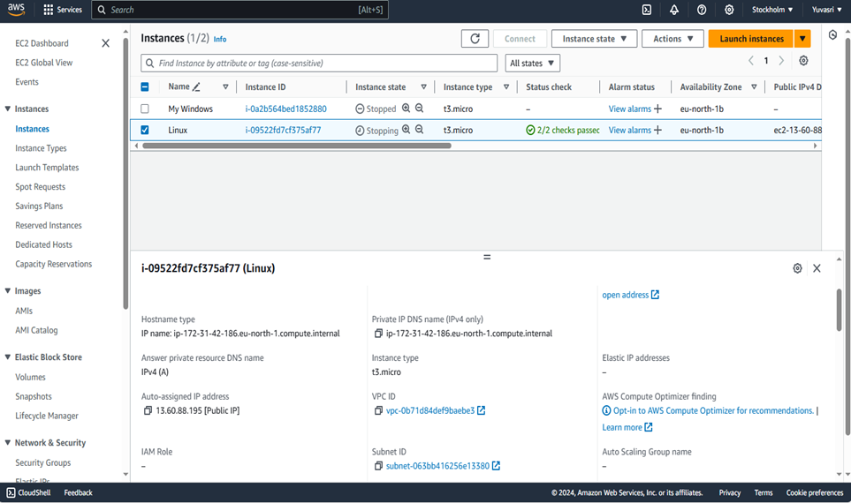

**Step 4:** For windows web hosting , connect our instances via remote connection . In the windows instances go to “This PC” and right click click “Manage”. It navigate to the “Server Manager” dashboard.

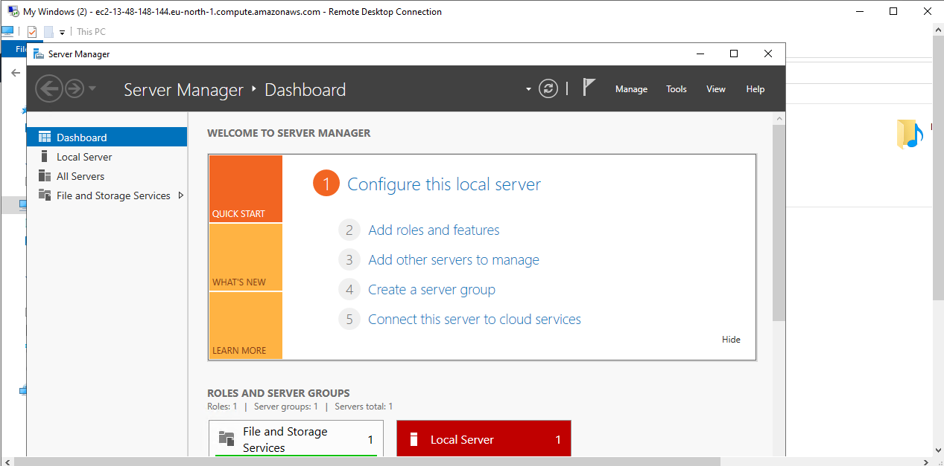

**Step 5:** On the dashboard, on the left panel, click on "Add Roles and Features." Click on "next" following Server Roles." Click on the "web server (IIS)" and click on "Add feature."

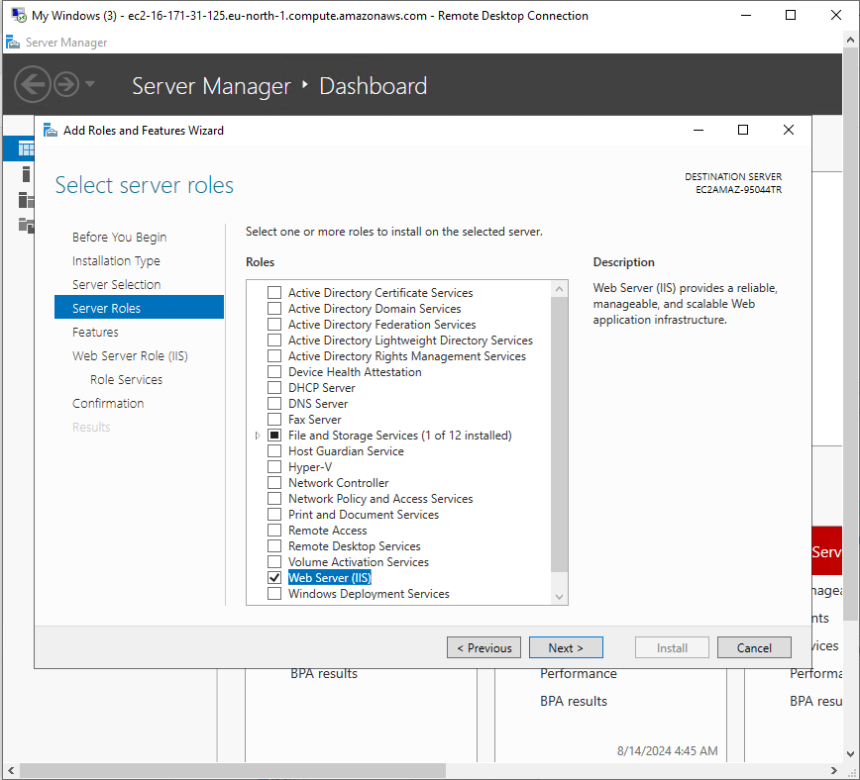

**Step 6:** Finally click “Install” .It installing the web server IIS in our pc.

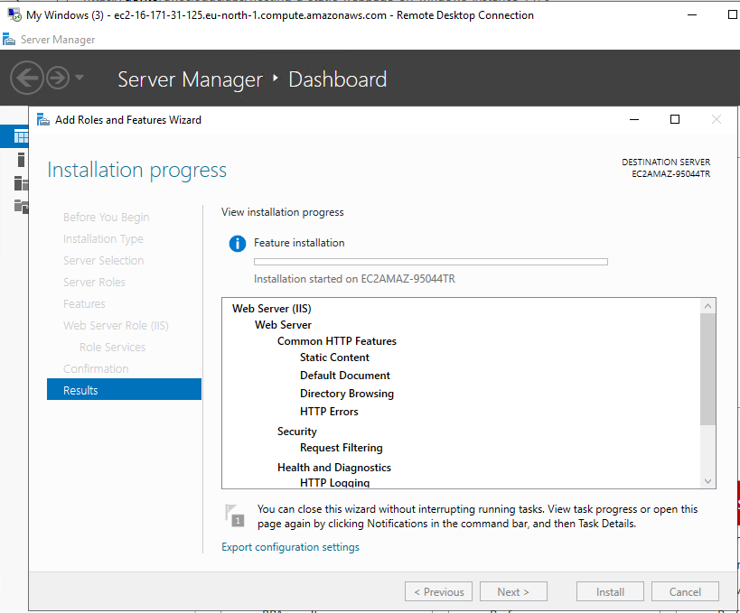

**Step 7:** Navigate to “Local Drive (C:) 🡪 inetpub 🡪 wwwroot”. Delete all the files.

Create a new text document . Save it as .html file.

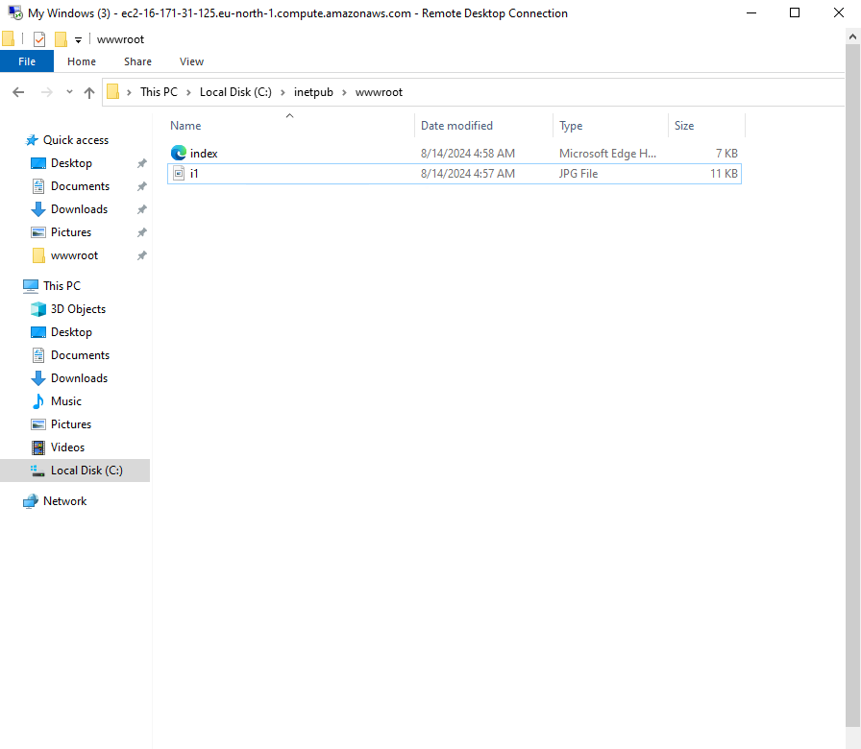

**2) For the Linux instance, use WinSCP to upload a sample website and configure it.**

**Step 1:** Download WinSCP for Linux from the browser. Install WinSCP in PC.

**Step 2:** In AWS, connect Linux instance. In the linux server, install apache server by using this commands,

**sudo su**

**apt-get update**

**apt-get install apache2**

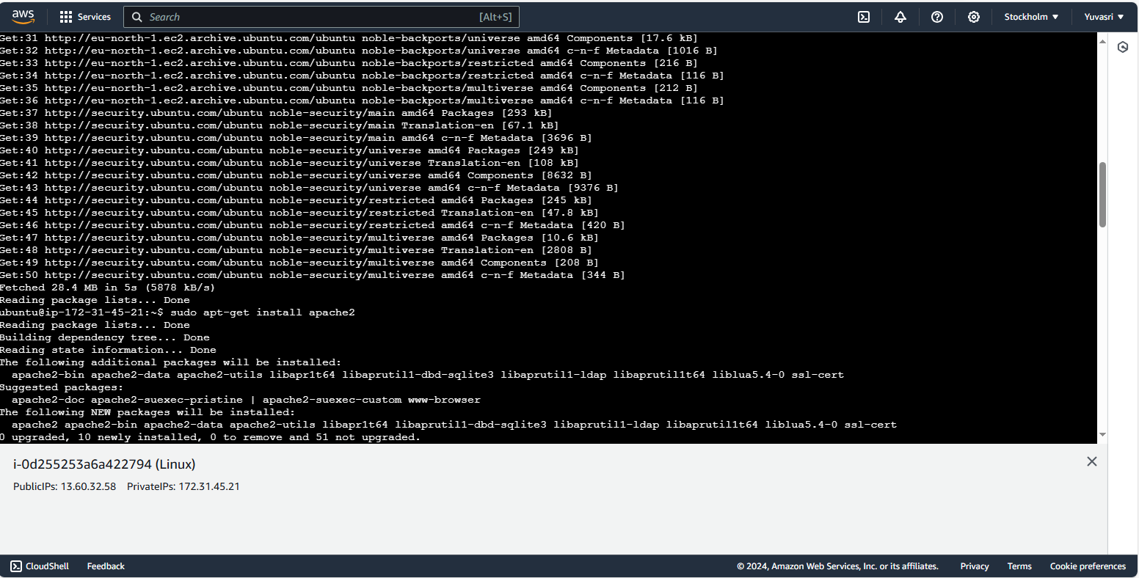

**Step 3:** For giving read write permission for the apache server index.html use chmod to rewrite the permission. Then only we can upload our website into the server.The following commands are used to give permissions,

**cd /var/www/html**

**chmod 777 /var/www/html/**

**ls -l /var/www/**

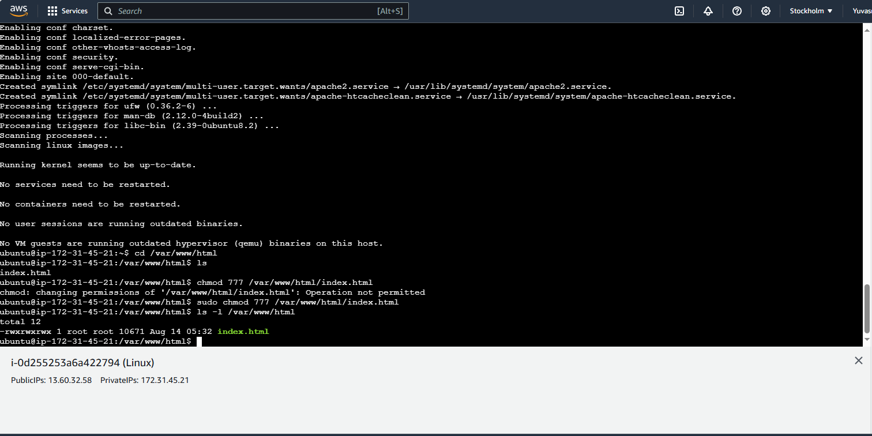

**Step 4:** In WinSCP , click New🡺Login .The login page is displayed . In the login page Hostname is IP address of the linux. Username is Ubuntu.

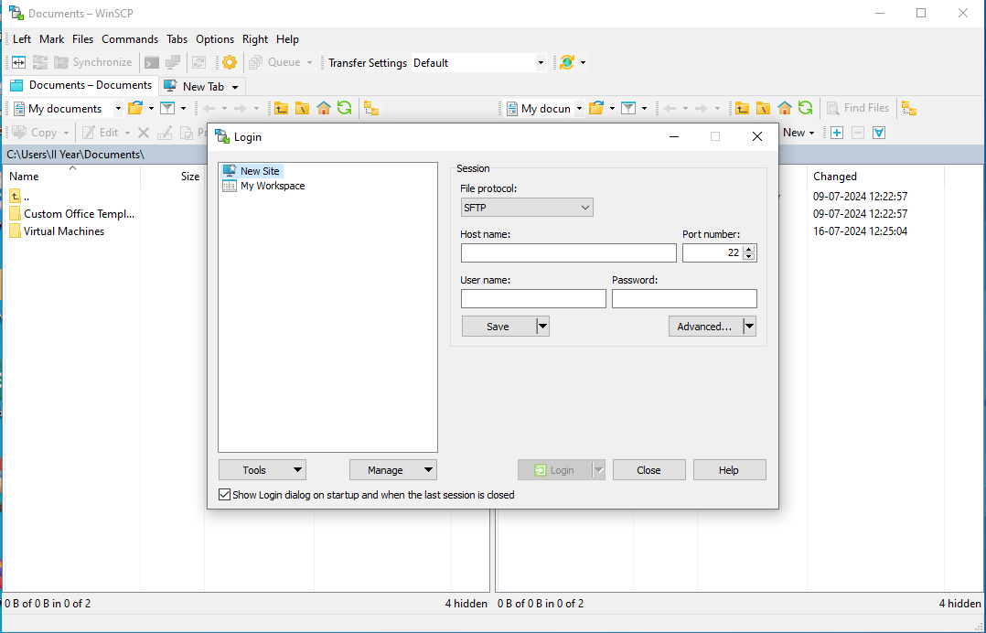

**Step 5:** For password go to Advanced Options🡪SSH🡪Authentication. In the authentication column choose our private key .ppk(putty primary key) file from our pc.

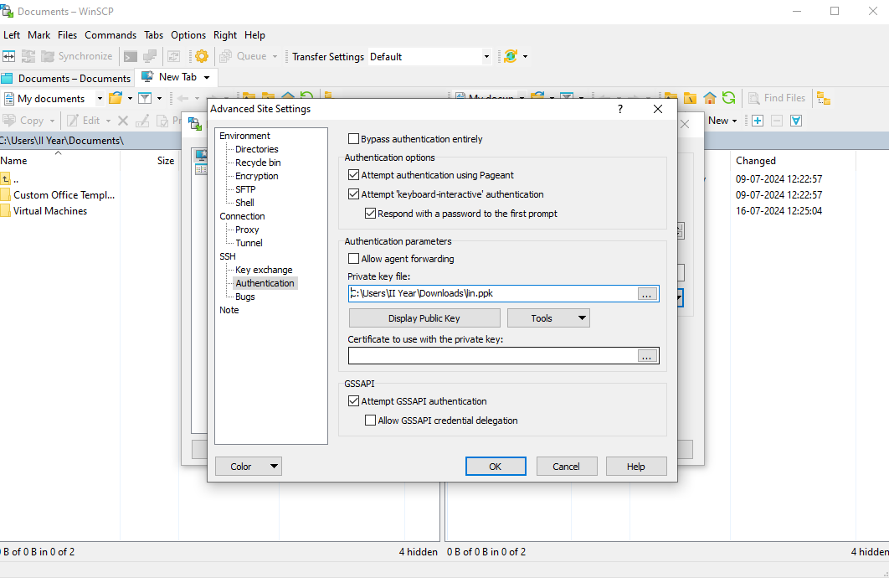

**Step 6:** After login in linux column go to /var/www/html/ . In this folder one default index.html is there .Now we upload our website to the linux . Search our file and click upload. It takes some time and rewrite the default file into our website html file.

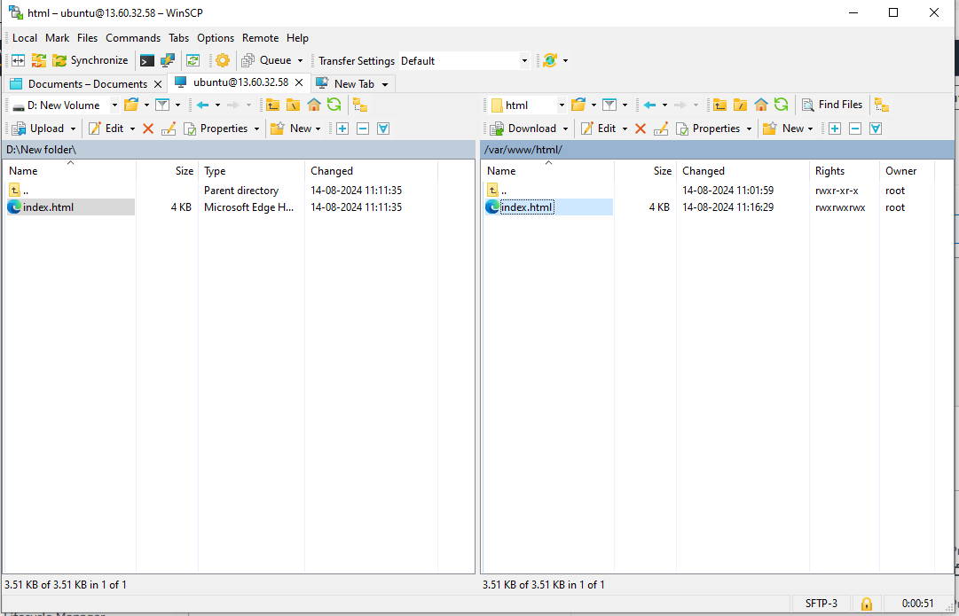

**3) Test the website on both instances to ensure it's accessible via the web.**

Copy the instances “Public IP Address” and paste it in any browser it shows our own website in the server.

**For Windows,**

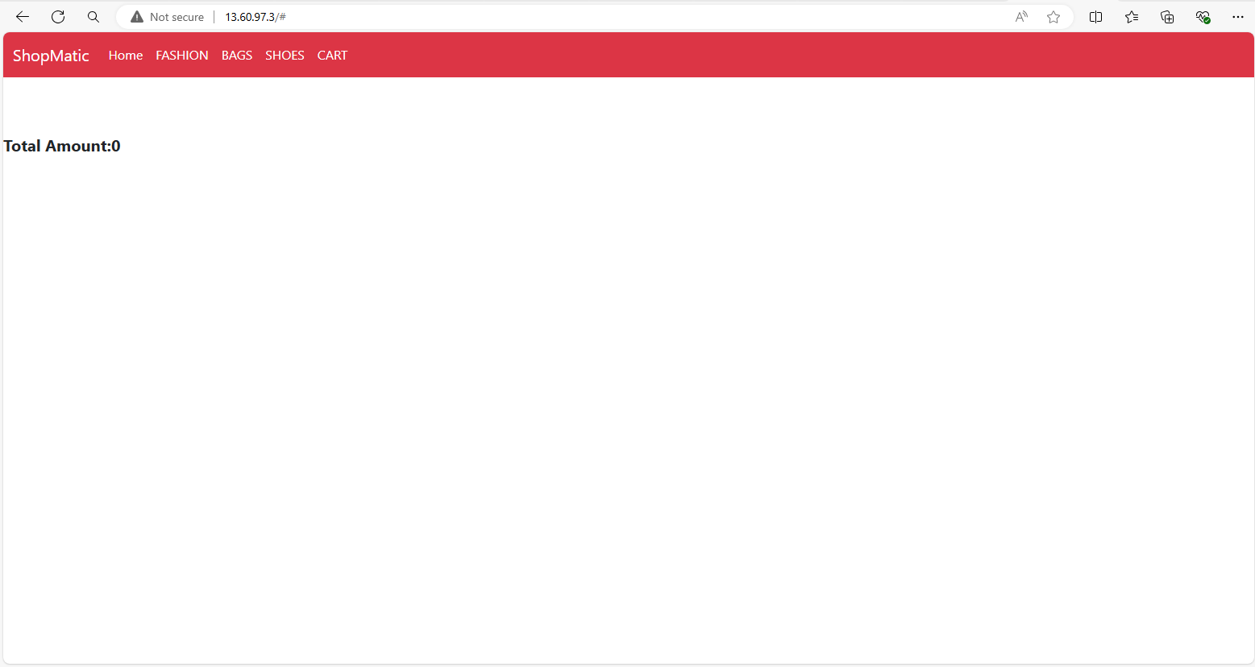

**For Linux,**

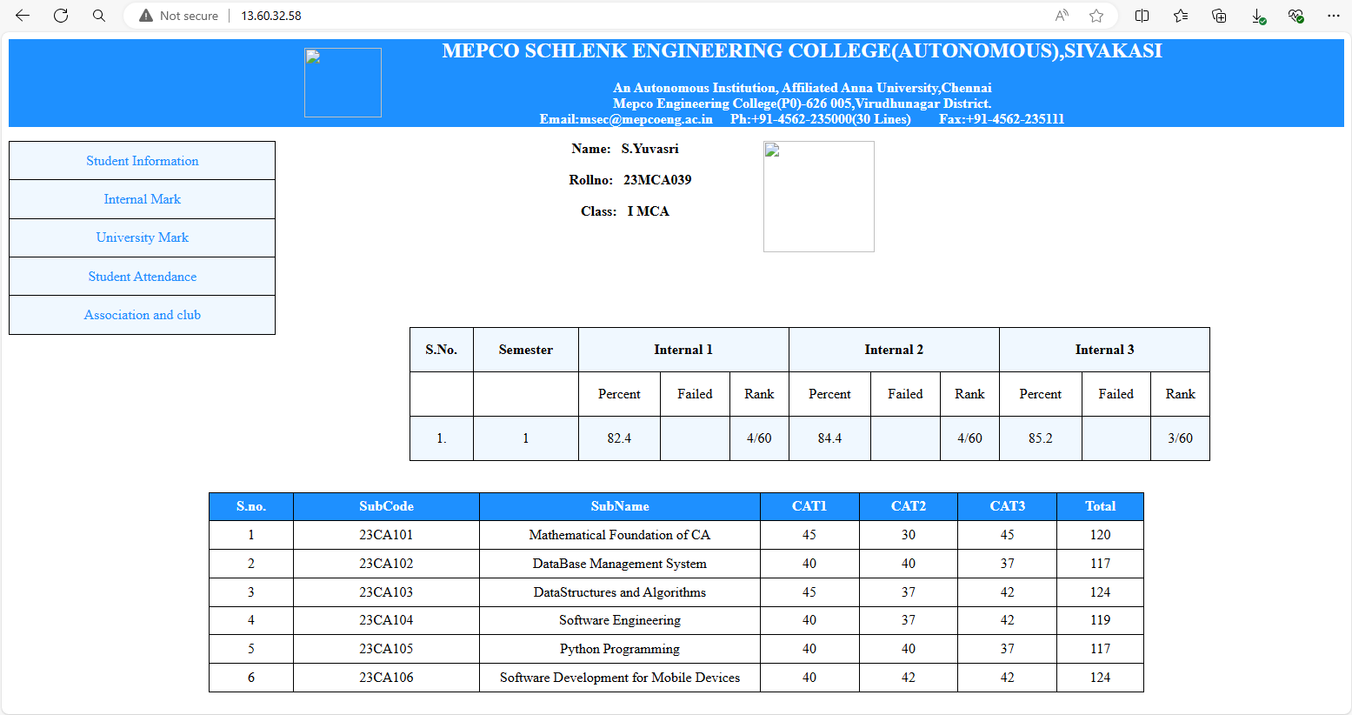

**CONCLUSION:**

Thus hosting a website on EC2 instances using AWS was deployed successfully in windows and linux.