**IMPLEMENTING LOAD BALANCING IN EC2**

**Ex.No : 05 Name : S.Yuvasri**

**Date: Roll.No: 23MCA039**

**AIM:**

To implement load balancing traffic in EC2 in AWS.

* Set up a load balancer that distributes traffic between multiple EC2 instances.
* Deploy an application on the instances and test the load balancer's traffic distribution.
* Experiment with different load balancing algorithms (e.g., round-robin, least connections).

**THEORETICAL BACKGROUND:**

**Load Balancing**

Anything that serves as a middleman between clients and servers or applications is called a load balancer. Requests are received from clients and sent to one or more registered targets, such as AWS Lambda functions, EC2 instances, or containers. To guarantee that it only directs traffic to available and in good-health targets, the Elastic load balancer also keeps an eye on the targets’ performance and health. The load balancer enhances the system’s efficiency, security, and dependability in this way.

**Application Load Balancer (ALB)**

ALB, or application load balancer: An ALB is designed to handle HTTP and HTTPS traffic at the application layer (Layer 7). Requests can be routed according to their content, including query parameters, host headers, and URL paths. Advanced capabilities including HTTP header manipulation, WebSockets, HTTP/2, gRPC, path-based, host-based, and content-based routing are also supported. APIs, microservices, and web applications may all be load-balanced with an ALB.

**Load Balancing Algorithms**

Static Load Balancing Algorithms

Static load balancing involves predetermined assignment of tasks or resources without considering real-time variations in the system. This approach relies on a fixed allocation of workloads to servers or resources, and it doesn’t adapt to changes during runtime.

Types of Static Load Balancing Algorithms

1. Round Robin
2. Weighted Round-Robin
3. Source IP hash

Dynamic Load Balancing Algorithms

Dynamic load balancing involves making real-time decisions about how to distribute incoming network traffic or computational workload across multiple servers or resources. This approach adapts to the changing conditions of the system, such as variations in server load, network traffic, or resource availability.

Types of Dynamic Load Balancing Algorithms

1. Least Connection Method
2. Least Response Time Method

**STEPS INVOLVED:**

**1) Set up a load balancer that distributes traffic between multiple EC2 instances.**

**Step 1:** Create two Ec2 instances in linux and in advanced details type the following commands.

**#!/bin/bash**

**sudo apt-get update**

**sudo apt-get install -y apache2**

**sudo su**

**echo “Welcome to Mysite $(hostname -f)”> /var/www/html/index.html**

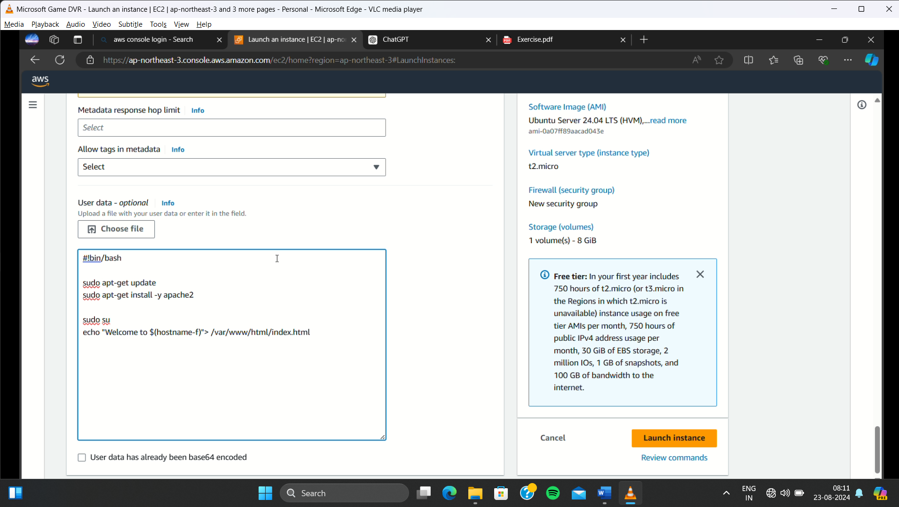

**Step 2:** Click “Launch Instances” and our instances are in the running state.

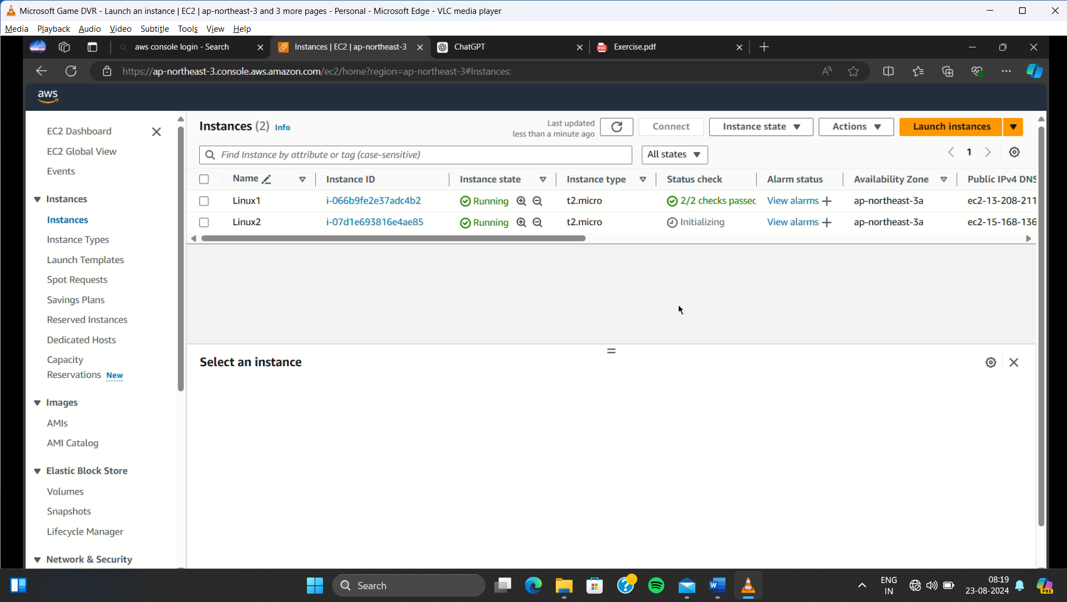

**Step 3:** Create one tatrget group . In the creation , choose instances and give name to the target group.

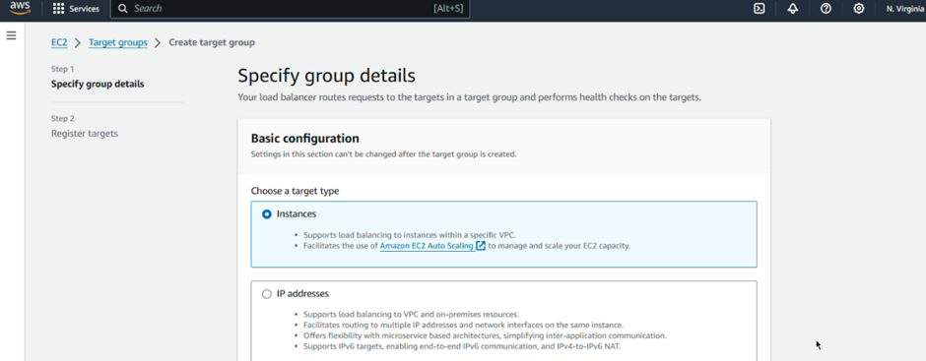

**Step 4:** After that click two instances and “include pending as below” is created and click “create target group”

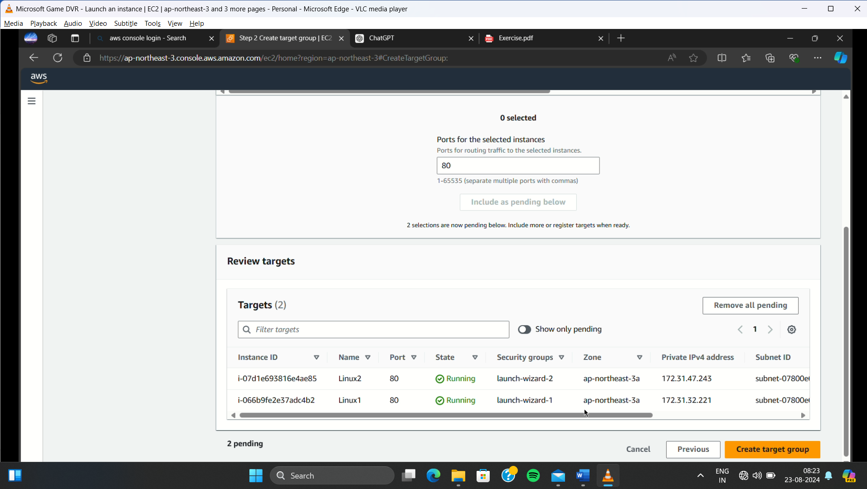

**Step 5:** Create load balancer go to load balancer and click create load balancer . Give name to the load balancer and click any three availability zones.

**Step 6:** Select two security groups of the EC2 instances.

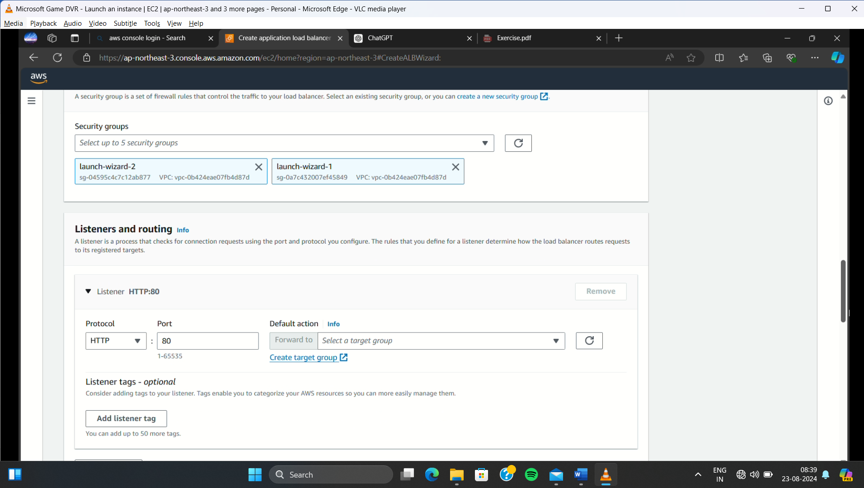

**Step 7:** In the listeners and routing column add our created target group name . And click “Create load balancer”.

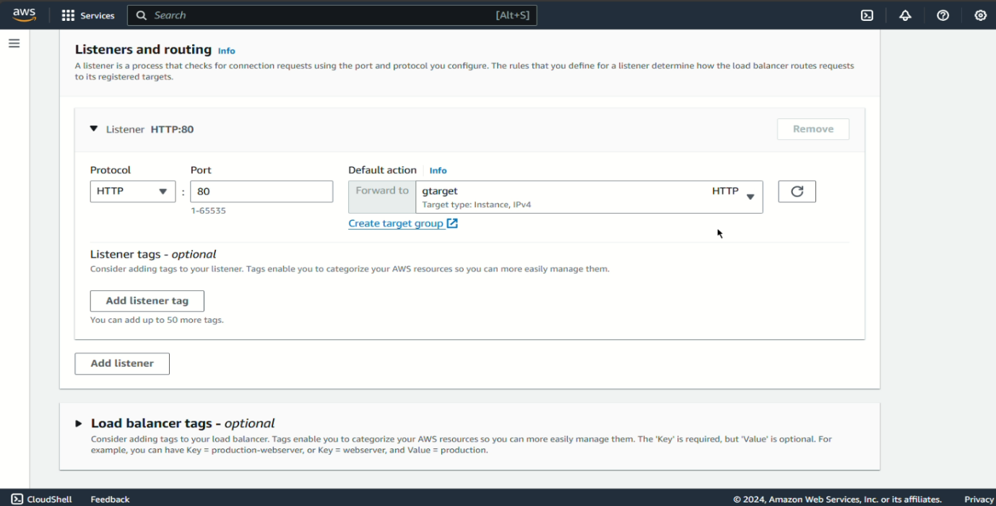

**2) Deploy an application on the instances and test the load balancer's traffic distribution.**

**Step 1:** Copy the “dns Address” of the load balancer and paste it in the browser.

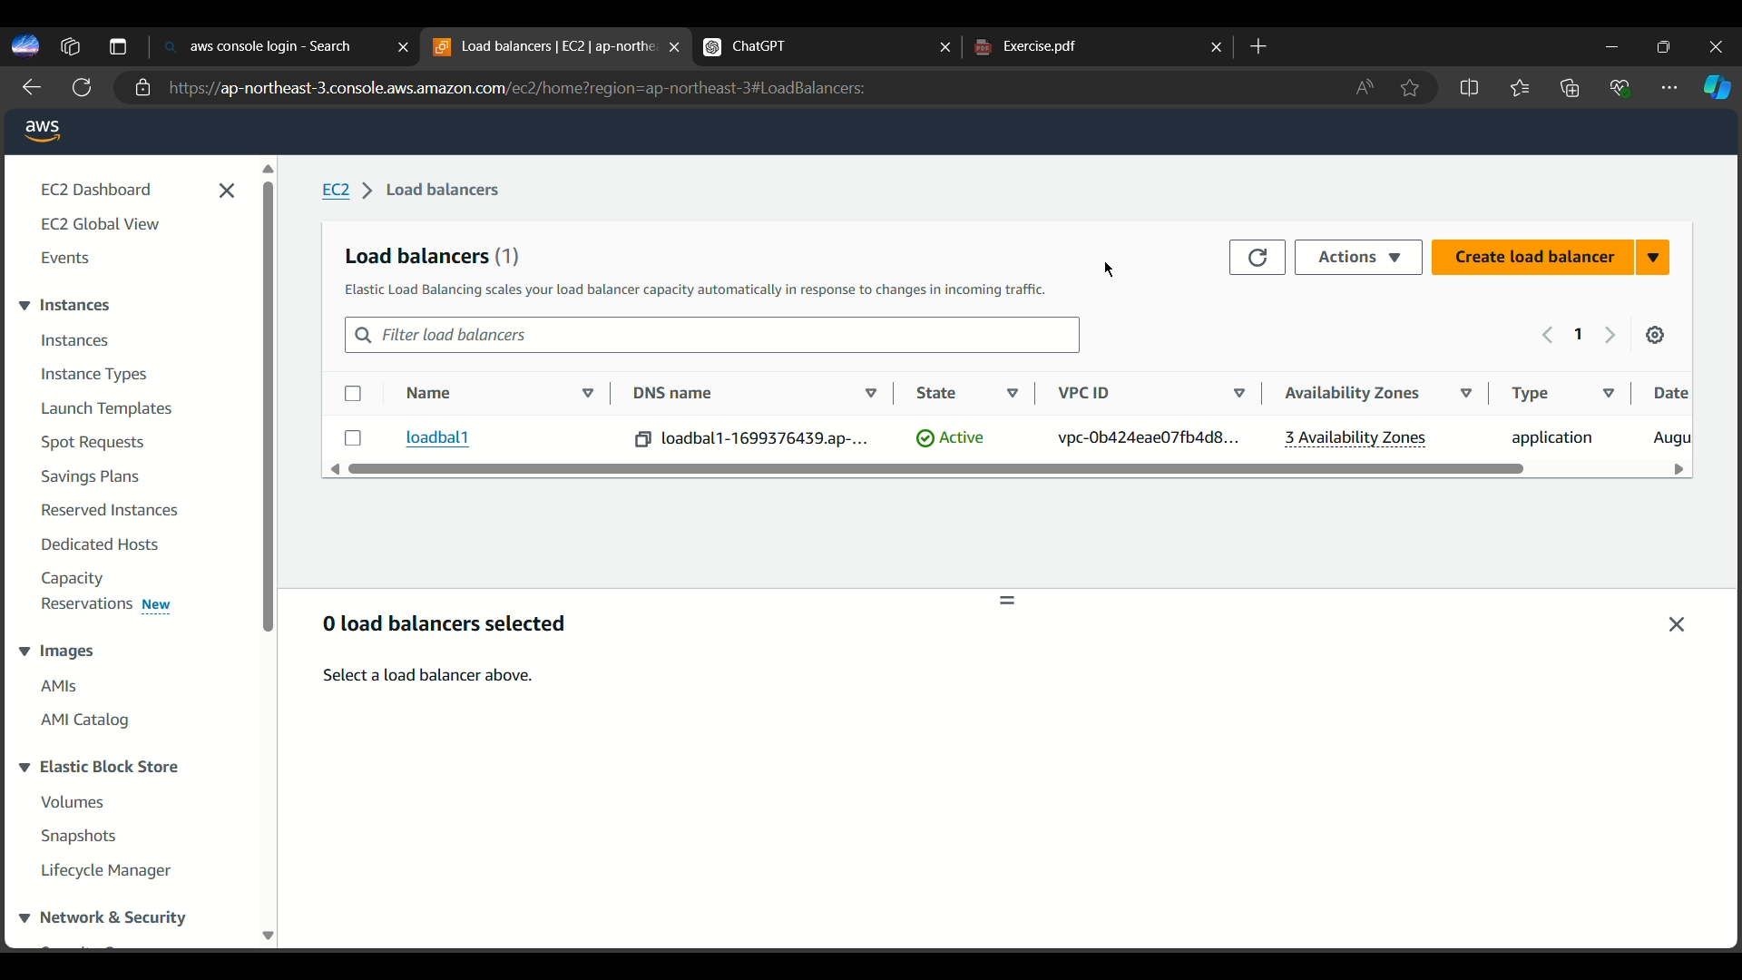

**Step 2:** In the browser it loads our site once we hit the refresh button it automatically changes to another ec2 instances.

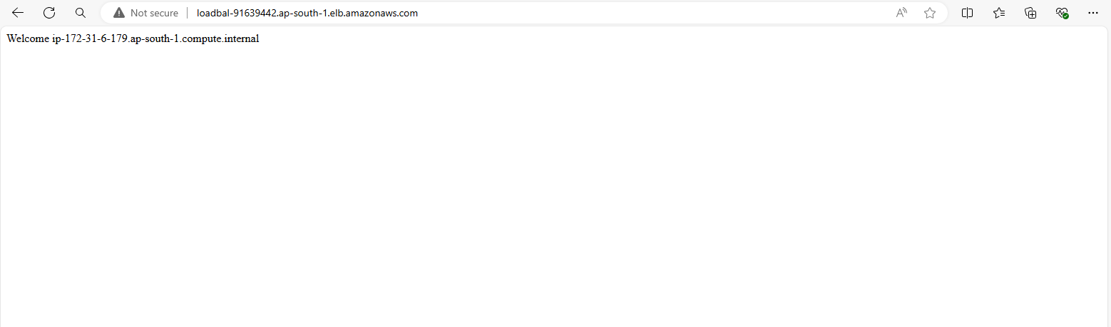



**3) Experiment with different load balancing algorithms (e.g., round-robin, least connections).**

**Step 1:** By default round robin algorithm is used in the load balancer . If we want to modify the behavior change the sticky sessions or weighted routing. For that click target group 🡪Attributes🡪Edit

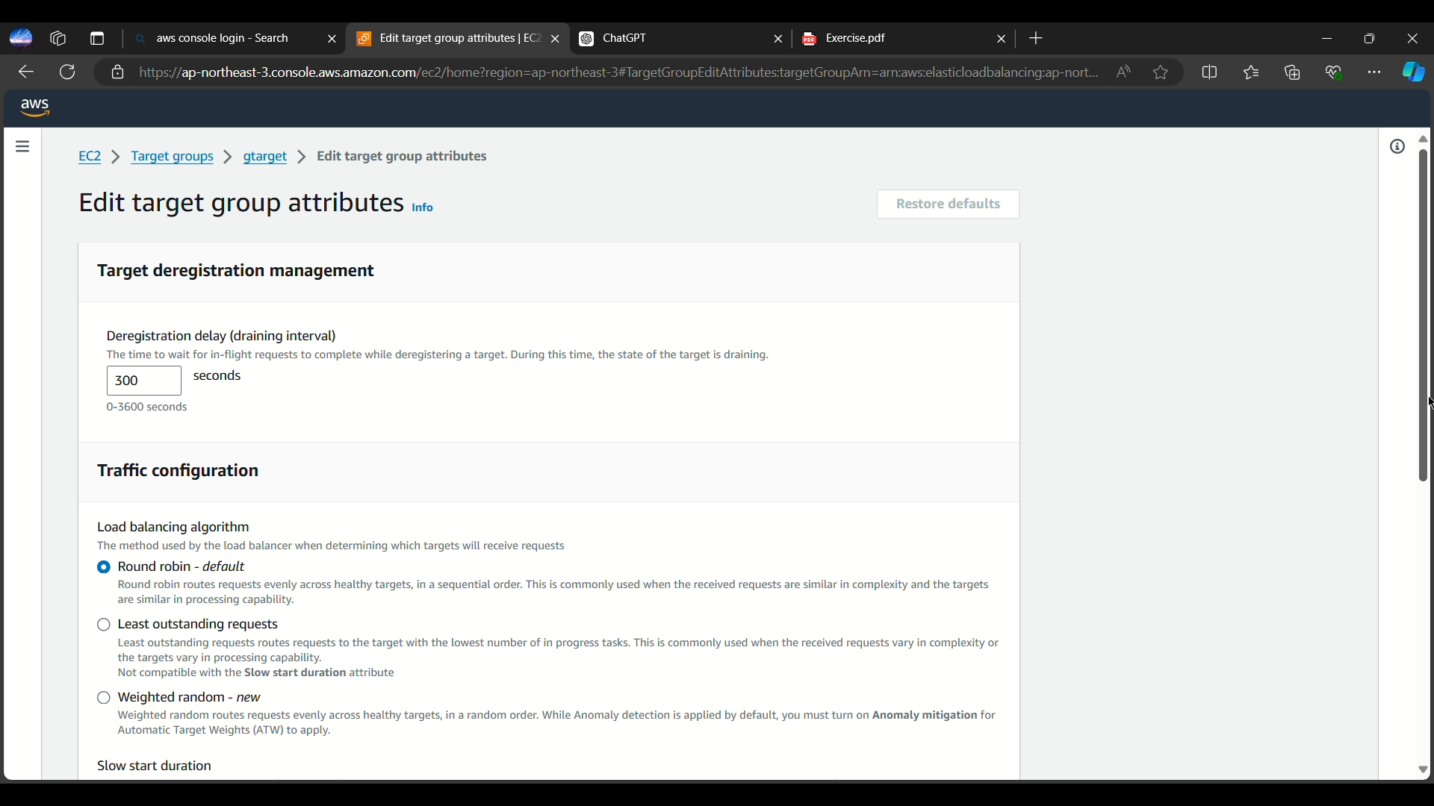

**Step 2:** In AWS Application load balancer doesn’t offer direct least connections or other algorithm don’t need to stimulate this by modifying the instance weight.

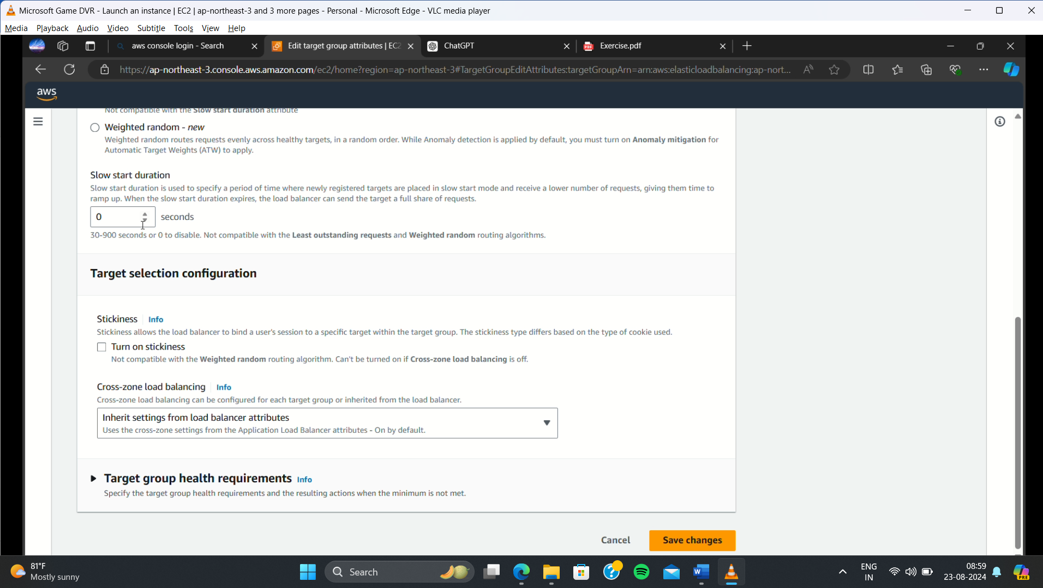

**CONCLUSION:**

Thus the above steps for implementing load balancer traffic in EC2 instances was executed successfully.