**SNAPSHOT AND VOLUME MANAGEMENT**

**Ex.No : 07 Name : S.Yuvasri**

**Date: Roll.No: 23MCA039**

**AIM:**

To perform some Advanced EC2 opterations in aws

* Create a snapshot of an EC2 instance’s volume.
* Attach the snapshot to a new instance as a secondary volume.
* Modify the volume size after attaching the snapshot and observe the impact on data availability and performance

**THEORETICAL BACKGROUND:**

**EC2 Instance**

EC2 stands for Elastic Compute Cloud. EC2 is an on-demand computing service on the AWS cloud platform. Under computing, it includes all the services a computing device can offer to you along with the flexibility of a virtual environment. It also allows the user to configure their instances as per their requirements i.e. allocate the RAM, ROM, and storage according to the need of the current task. EC2 offers security, reliability, high performance, and cost-effective infrastructure so as to meet the demanding business needs.

**Snapshot**

A snapshot is an incremental backup, which means that we save only the blocks on the device that have changed since your most recent snapshot. Snapshots are designed to be incrementable so that a new snapshot only stores the changes that were made in the last snapshot and thus utilizes the space. Whenever a snapshot is taken, AWS takes a copy of the designated volume where the snapshot was taken; it could be either EC2 or Redshift. Only data inside the volume is copied so that it can be used for restoration.

**Volume**

An AWS volume is a durable, block-level storage device that you can attach to your instances. After you attach a volume to an instance, you can use it as you would use a physical hard drive. EBS volumes are flexible. For current-generation volumes attached to current-generation instance types, you can dynamically increase size, modify the provisioned IOPS capacity, and change volume type on live production volumes.

**STEPS INVOLVED:**

**1) Create a snapshot of an EC2 instance’s volume.**

Step 1: In the AWS Console search “EC2 instance”. Go to Instances and click Launch Instances.In the launch instances give name for the instance like “MyWindows” ,”Linux”. After that choose application and os image such as windows or ubuntu server.

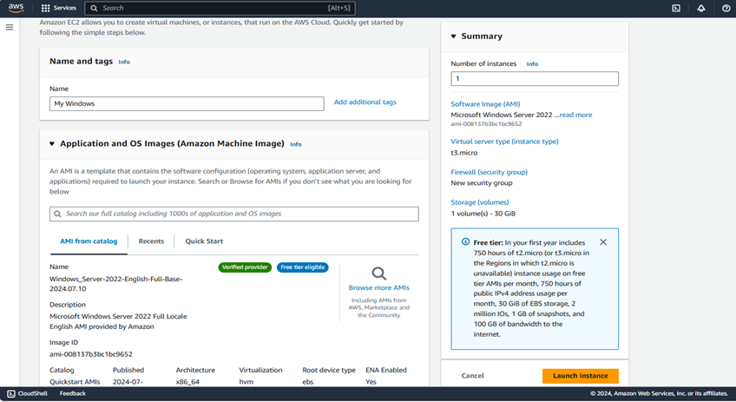

**Step 2:** Create a new keypair for our operating system. Keypair is used to securely connect to our instance.

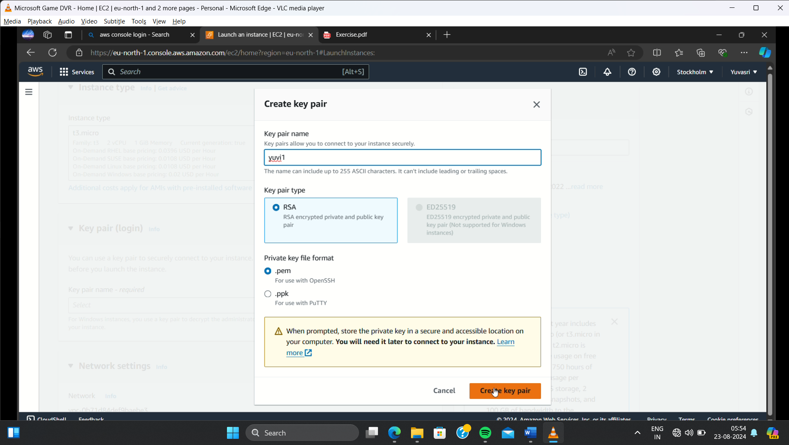

**Step 3:** In the network settings column click all the checkboxes for allowing SSH, HTTPS, HTTP for operating system

**Step 4:** After that click “Launch Instances”. EC2 instance is creating and it is in the running state.

**Step 5:** Go to “Elastic Block Store” and click volumes.In the create volume choose the size of the volume. For linux 4GB amd for windows 5GB and click “Create volume”

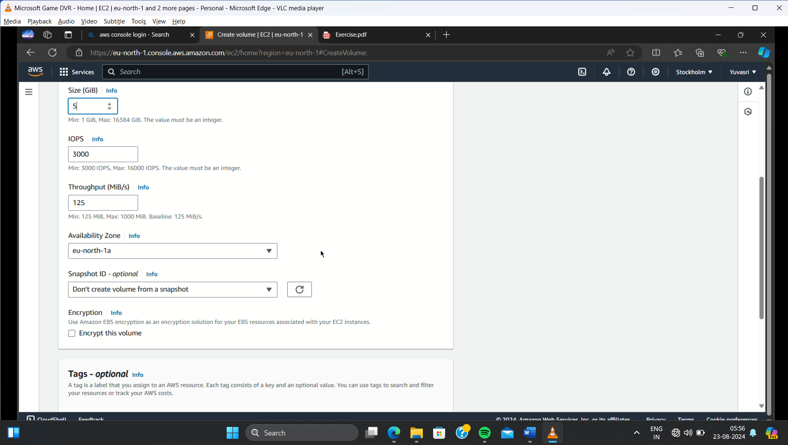

**Step 6:** After that go to “actions” and click “Attach volume”. In that choose the instance for attaching the volume in it. Choose device name for windows “xvdb” , for linux “/dev/xvdbe”

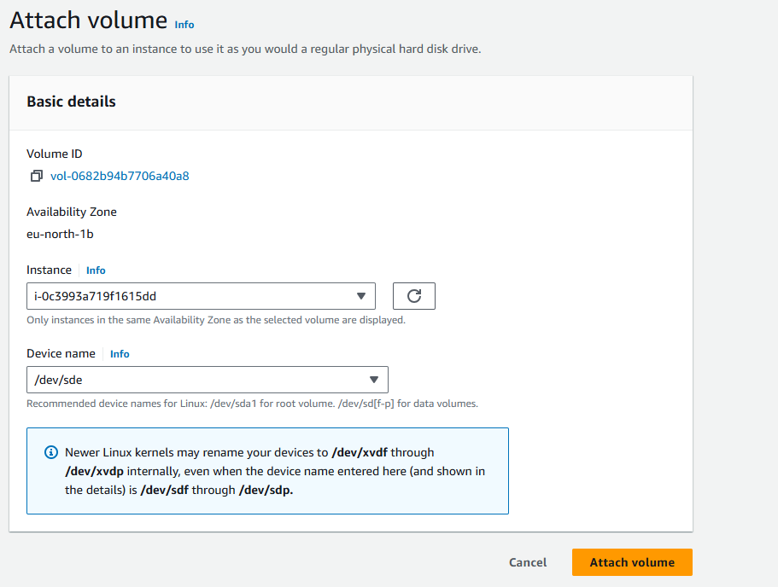

**Step 7:** After connecting to the remote connection, in windows go to “This PC” and right click and click the “Manage”. The server manager dashboard is opened. In that server manager dashboard click Tools.

**Step 8:** “Computer Management” is opened. In that go to disk management disk 1 is unallocated so right click and select “Online” and again right click “Initialize the disk”. And click “New Simple Volume” and new volume is created.

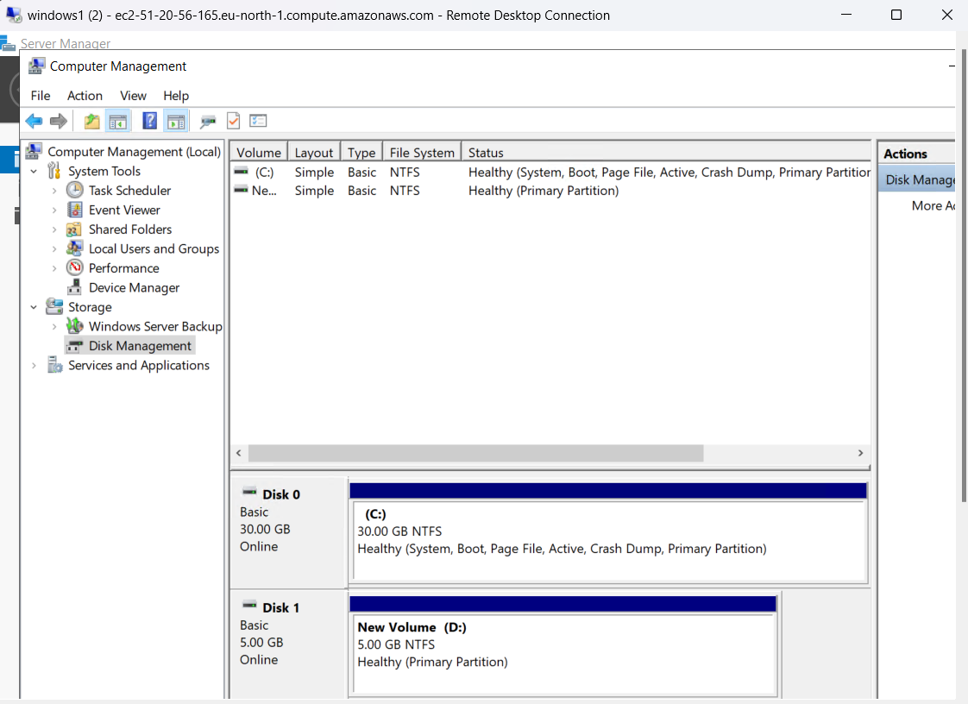

**Step 9:** New disk is created in the “This PC” and create some folders and files.

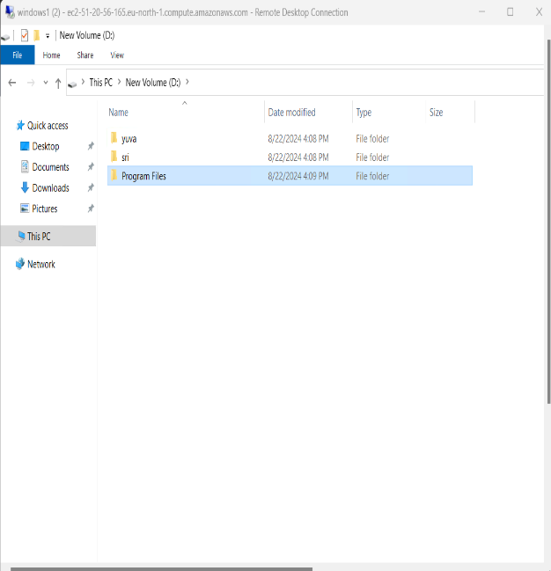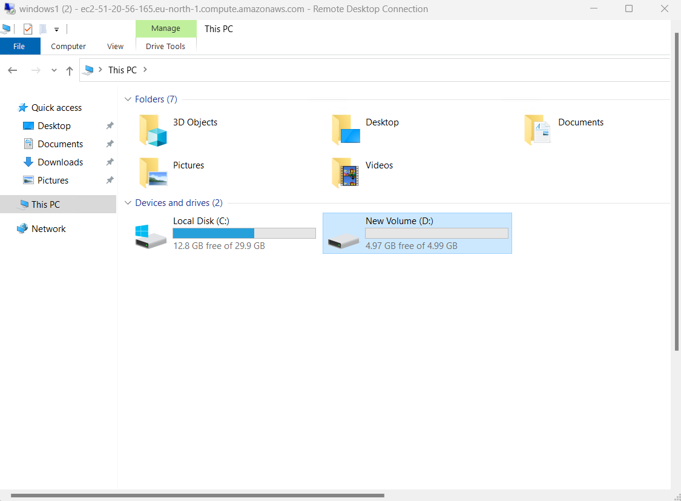

**Step 10:** For linux connect the instances and follow the commands

**sudo su //For changing the user to root**

**mkfs -t ext4 /dev/nvdme //For creating a filesystem**

**mkdir newvolume**

**mount /dev/nvdme newvolume**

**df -h //For check our volume is added in the filesystem**

**cd newvolume //Go to the newvolume**

**mkdir yuva //create folder**

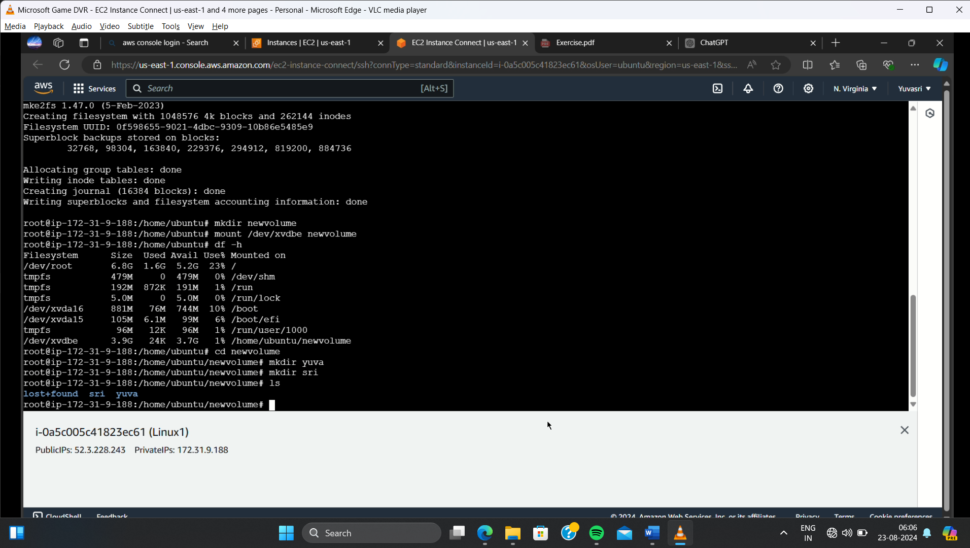

**Step 11:** In the volume click the volume and go to actions🡪create a snapshot and give name for the snapshot. Snapshot is created.

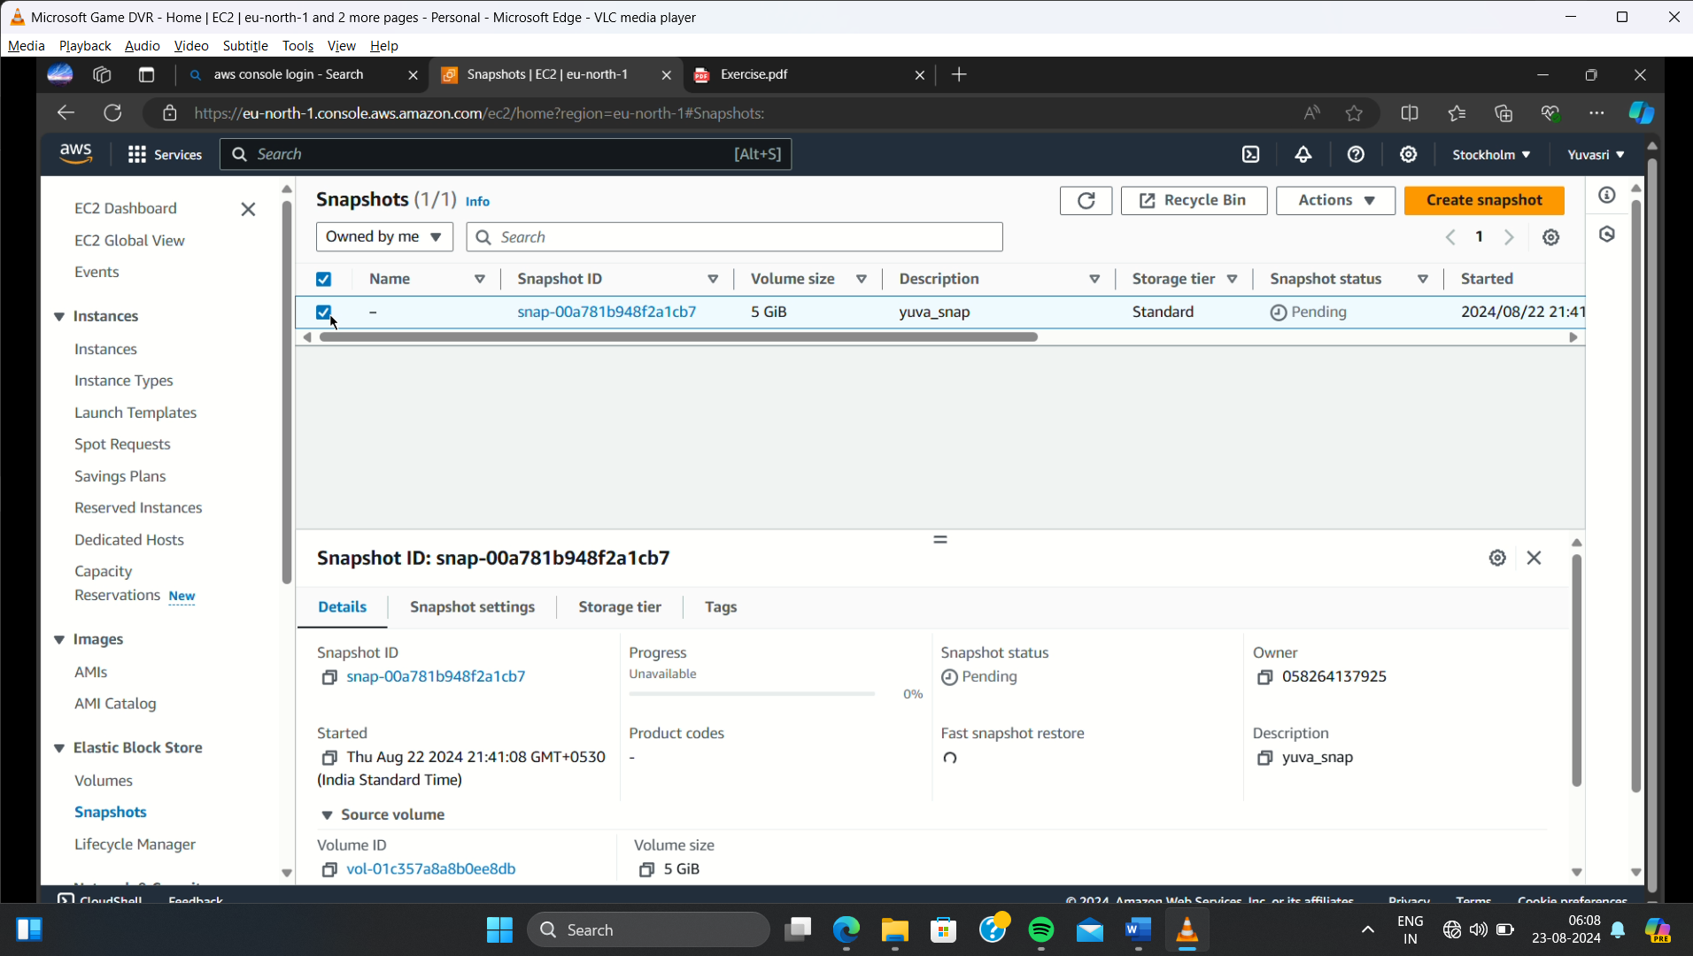

**2) Attach the snapshot to a new instance as a secondary volume.**

Step 1: Click the new snapshot and go to actions🡪create volume from snapshot and give the same volume size and click “create volume”

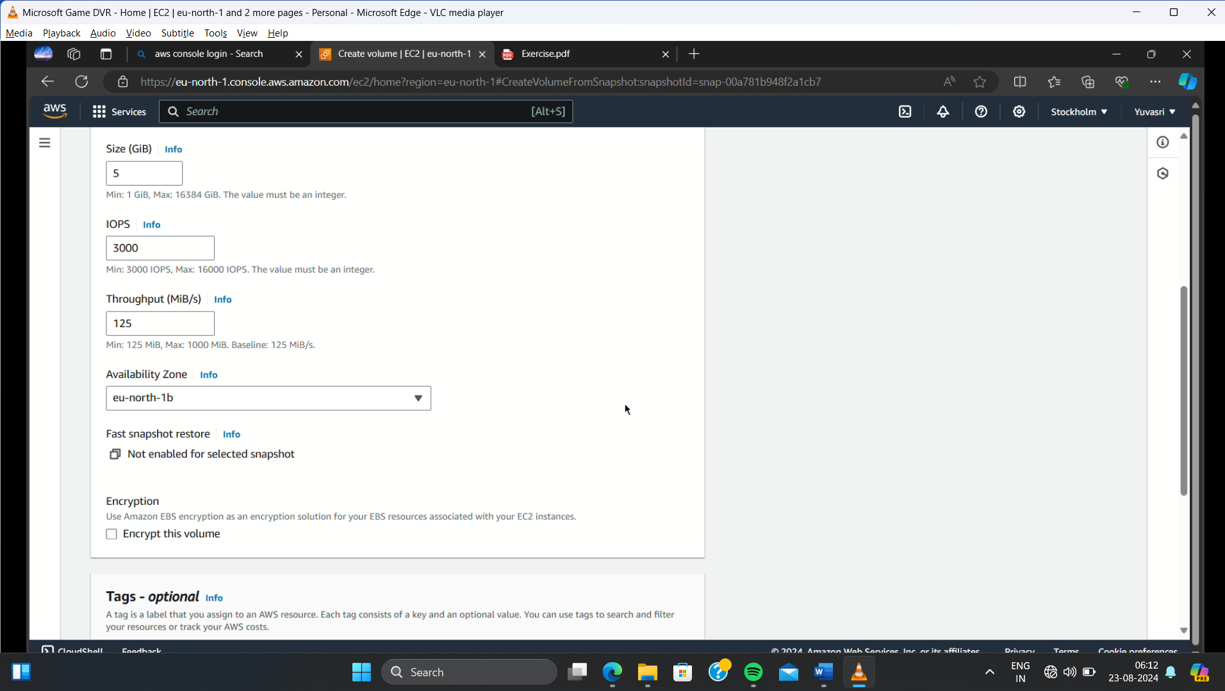

**Step 2:** Create one new EC2 instances for both linux and windows by following the above steps of the EC2 creation.

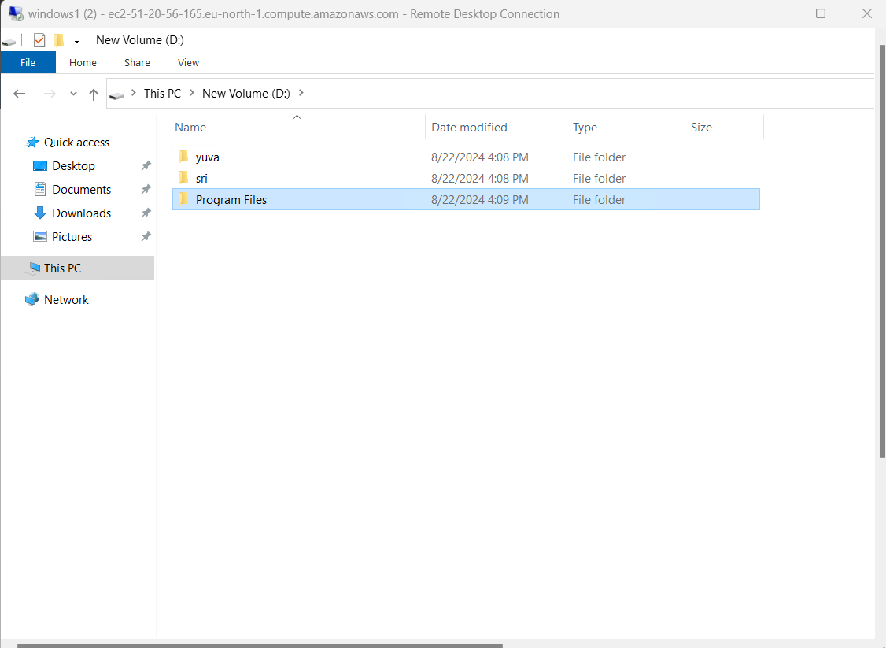**Step 3:** Click Attach volume and attached the volume for new EC2 instances.

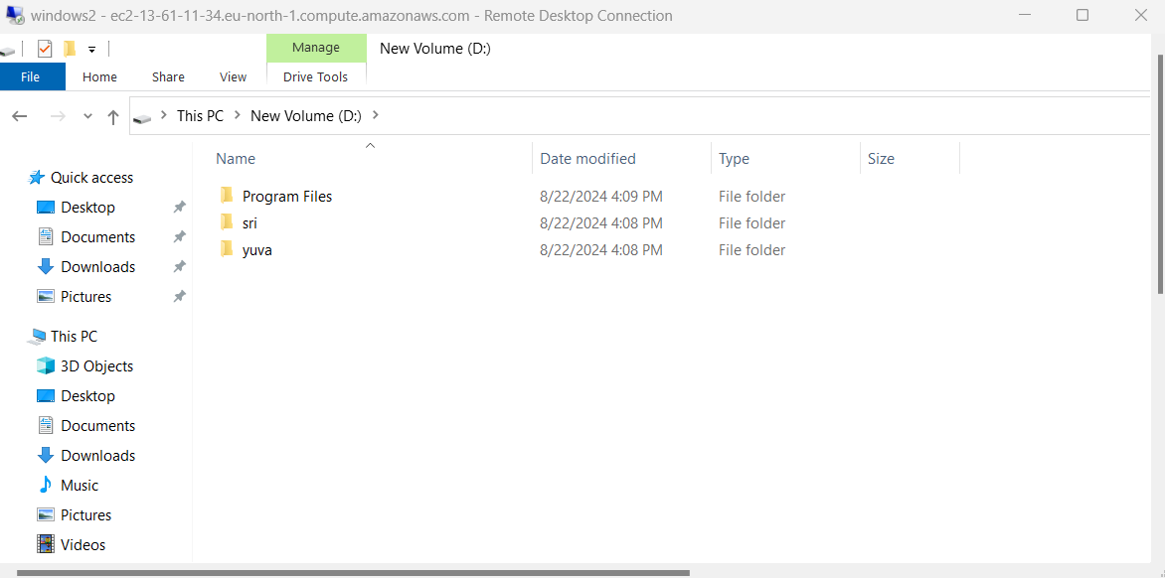

**Step 4:** For linux after add new volume following the commands and create new EC2 instance and follow the commands to check the folder in one volume is visible or not.

**mkdir newvolume**

**mount /dev/nvdme newvolume**

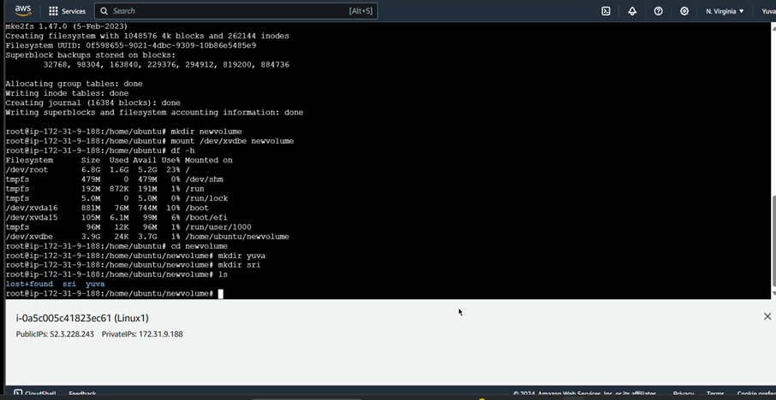

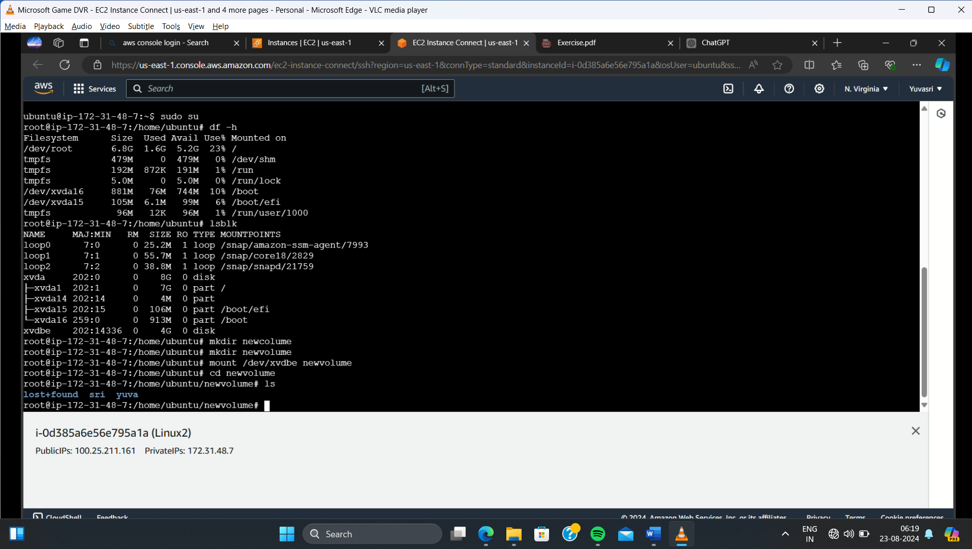

**3) Modify the volume size after attaching the snapshot and observe the impact on data availability and performance**

**Step 1:** Go to volume and click “Modify Volume”. In the modify volume change the volume size and click “Modify”

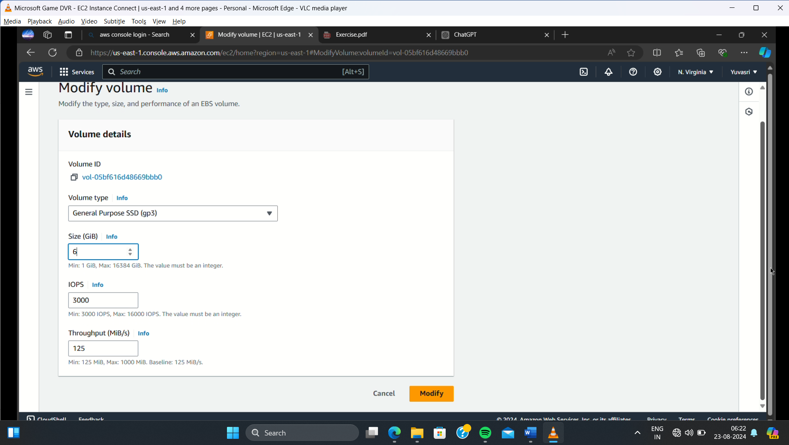

**Step 2:** After modify the volume size is changed and connect remote connection . In the windows go to disk management. In the disk management the remaining size is display in unallocated space. Click the allocated space and select “Extend Volume” and click next. The volume is increased and shows in “This PC”

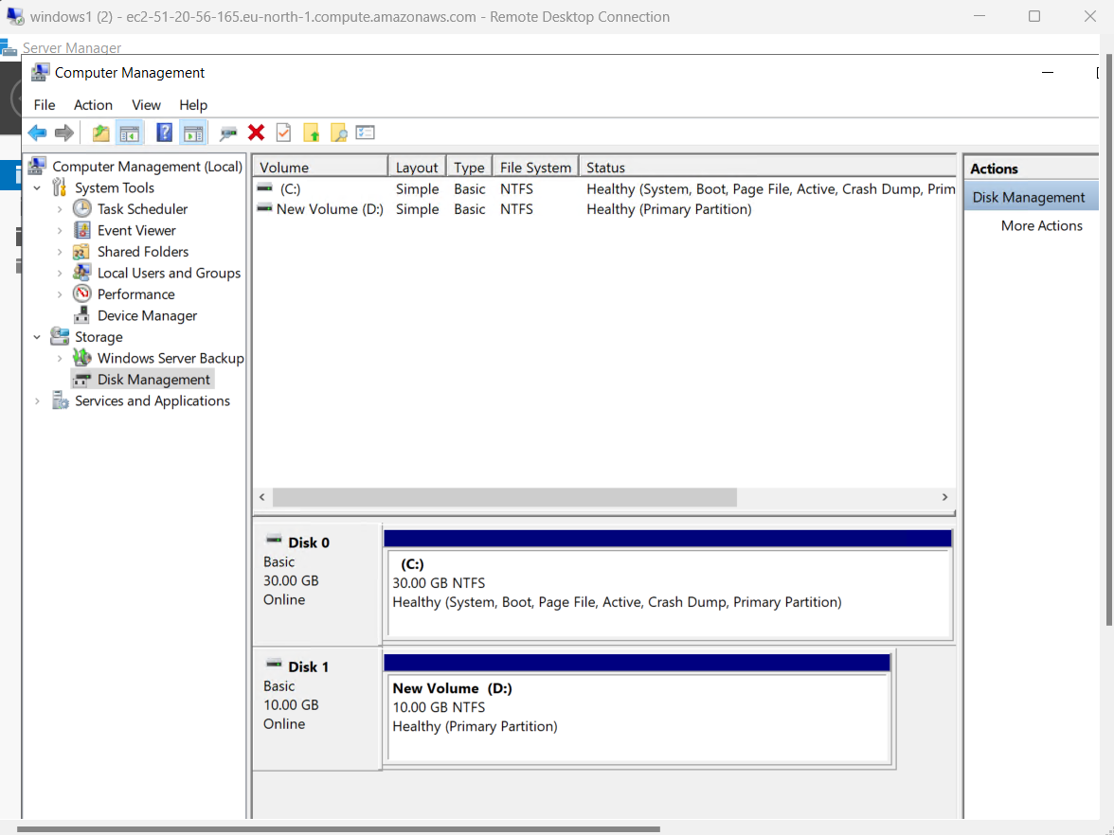

Step 3: For modify in the linux using the following commands

**sudo resize2fs /dev/xvdbe //For extend the volume**

**df -h //For checking volume is extended or not**

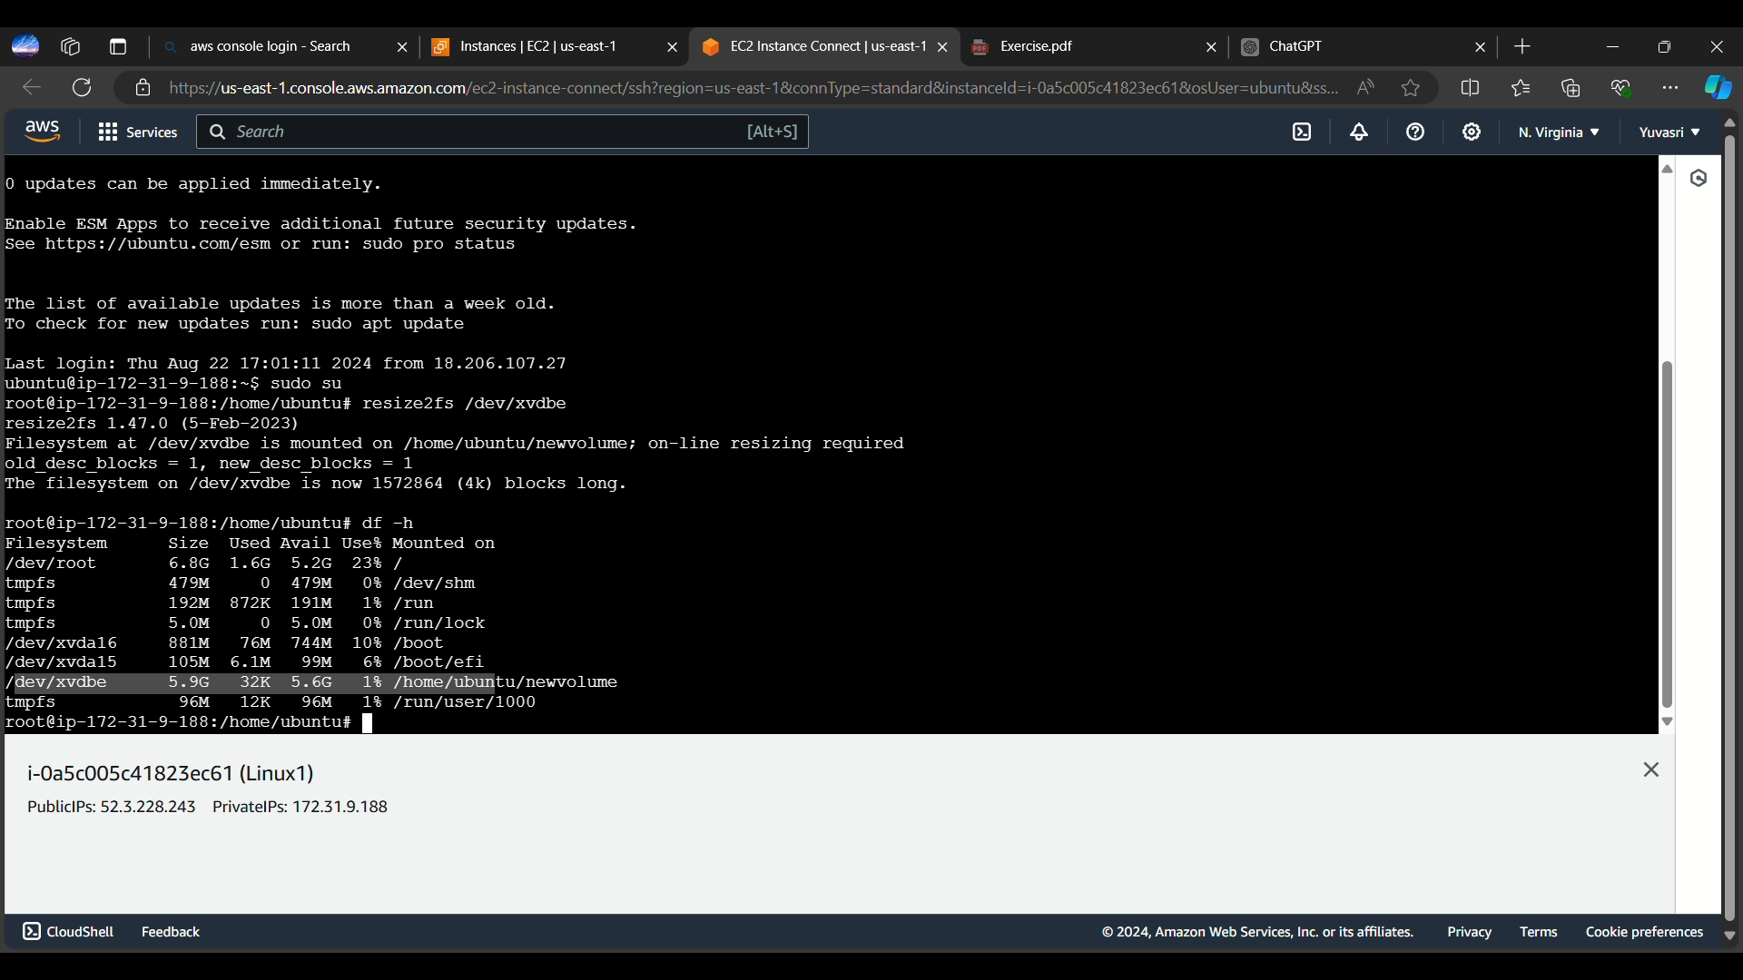

**Step 4:** After modifying the volume in one instances and the snapshot size is not modified because snapshot is immutable which means after creating the snapshot we cannot increase or decrease the volume of the snapshot. But our data in the EC2 instances are not deleted and it remains the same.





**CONCLUSION:**

Thus the above steps for performing advanced Ec2 instances operations such as snapshot and modify volume is executed successfully.