**EXERCISE USING IAM**

**Ex.No : 09 Name : S.Yuvasri**

**Date : 03.09.2024 Roll.No: 23MCA039**

**AIM:**

To create an IAM user via the root user and give policy and permissions for S3 bucket in AWS.

**THEORETICAL BACKGROUND:**

**IAM**

Identity and Access Management (IAM) manages Amazon Web Services (AWS) users and their access to AWS accounts and services. It controls the level of access a user can have over an AWS account & set users, grant permission, and allows a user to use different features of an AWS account.

Identity and access management is mainly used to manage users, groups, roles, and Access policies The account we created to sign in to Amazon web services is known as the root account and it holds all the administrative rights and has access to all parts of the account. The new user created an AWS account, by default they have no access to any services in the account & it is done with the help of IAM that the root account holder can implement access policies and grant permission to the user to access certain services.

**IAM Policies**

IAM policies define permissions for an action regardless of the method that you use to perform the operation. For example, if a policy allows the GetUser action, then a user with that policy can get user information from the AWS Management Console, the AWS CLI, or the AWS API. When you create an IAM user, you can choose to allow console or programmatic access. If console access is allowed, the IAM user can sign in to the console using their sign-in credentials. If programmatic access is allowed, the user can use access keys to work with the CLI or API.

**STEPS INVOLVED:**

**Step 1:** Go to IAM and click Users. And click create new User and type the username and click Next.

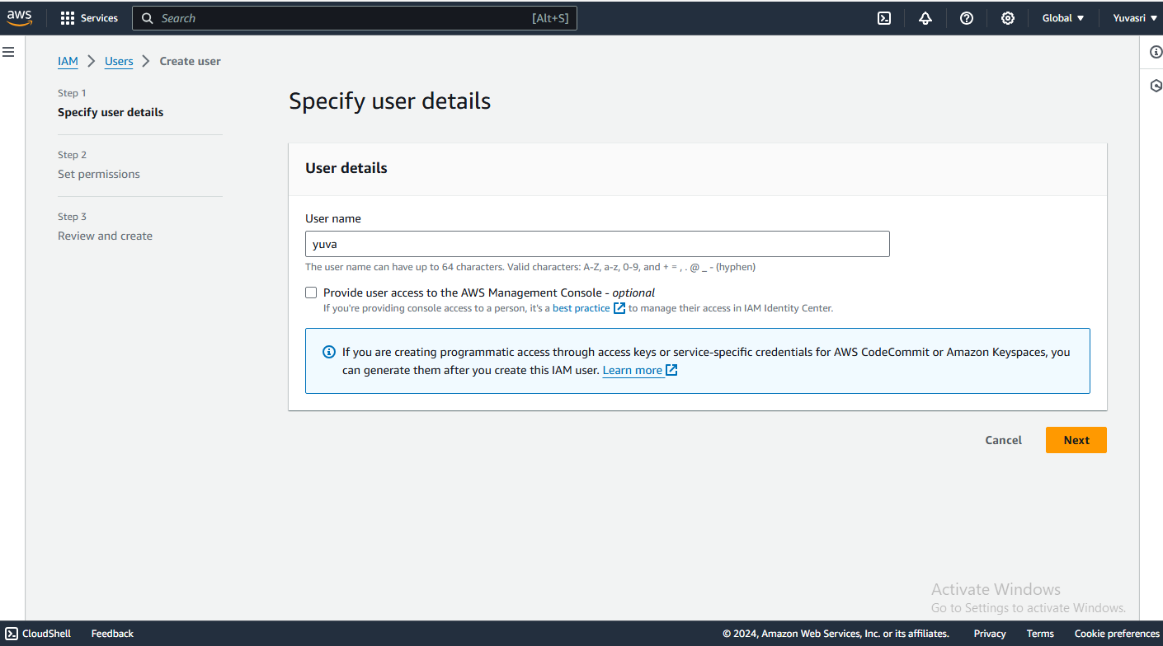

**Step2:** Select the permissions options as “Attach policies directly” and select the “AmazonS3FullAccess”

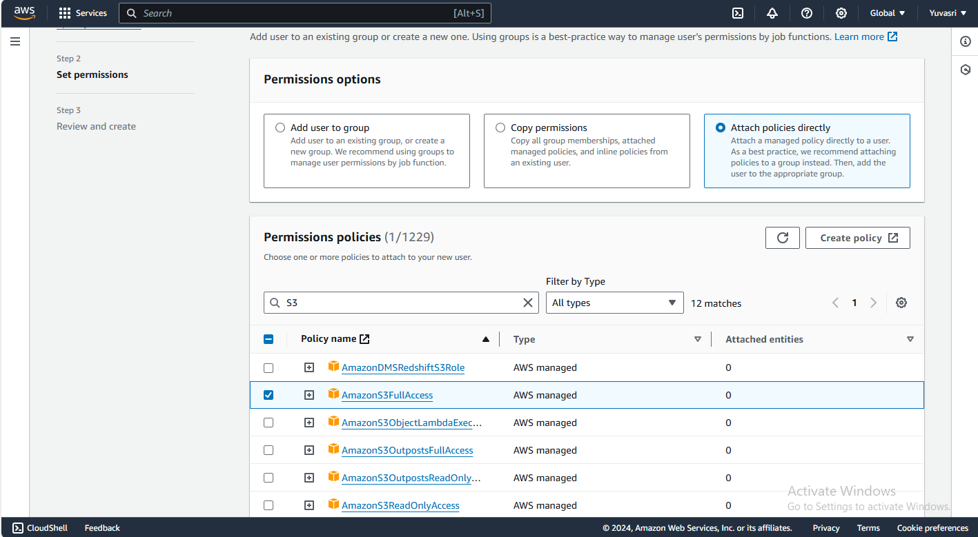

**Step 3 :** And click next and click “Create New User”.

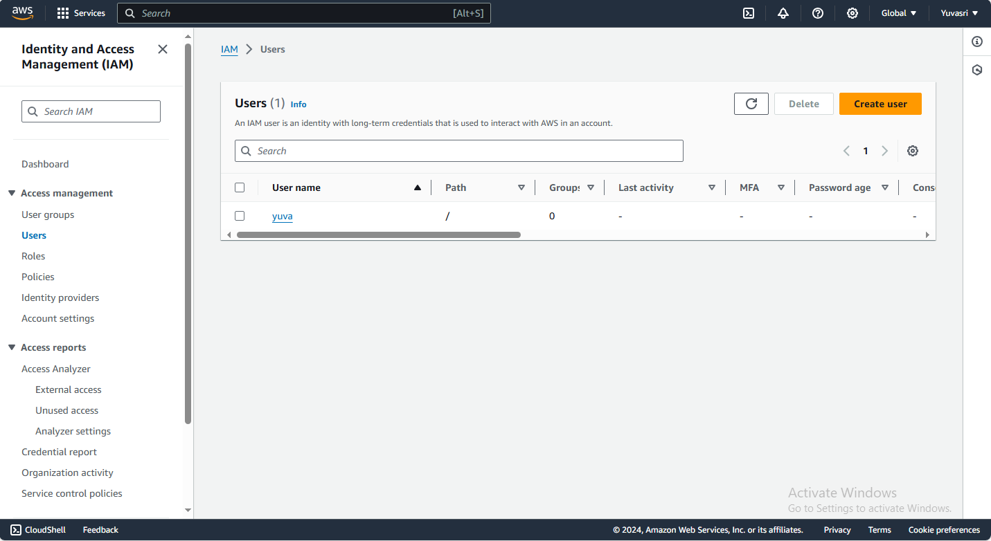

**Step 4:** Click the new user and go to security credentials and download the credentials.

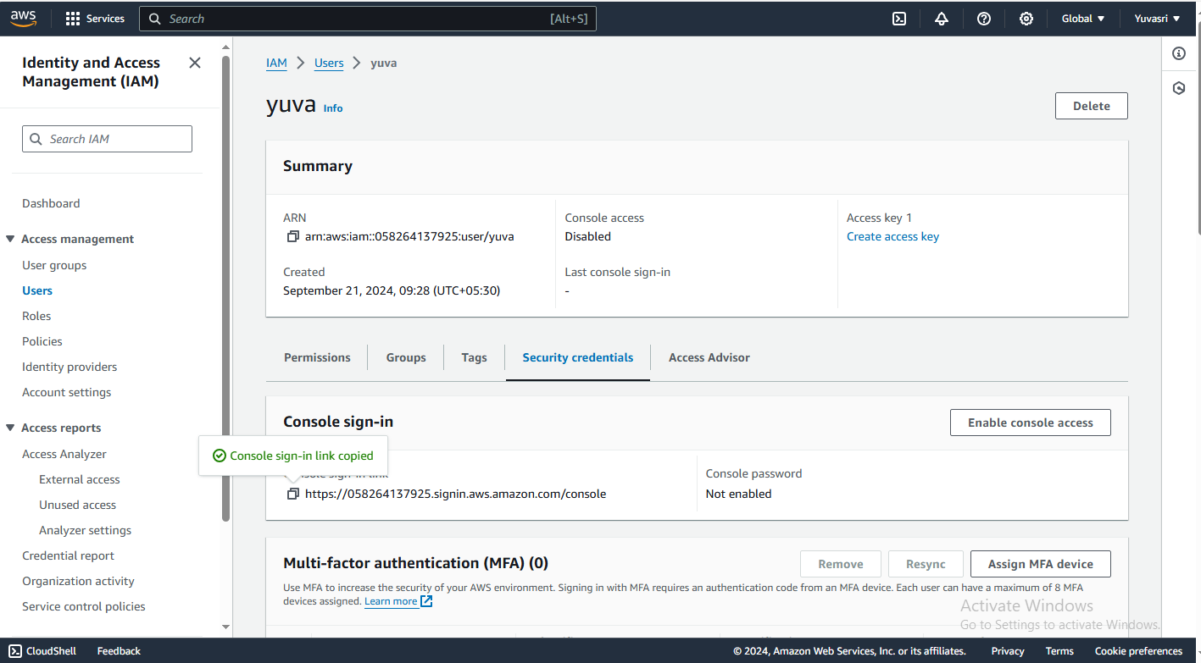

**Step 5:** And click “Enable console Access” and select “Auto Generated Password” and click “Enable console Access”.

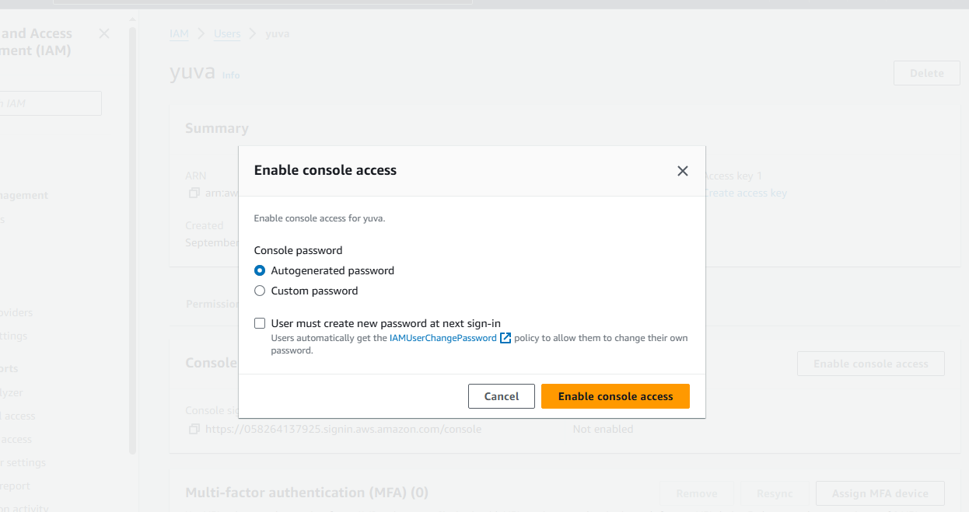

**Step 6:**Console Password is enabled.

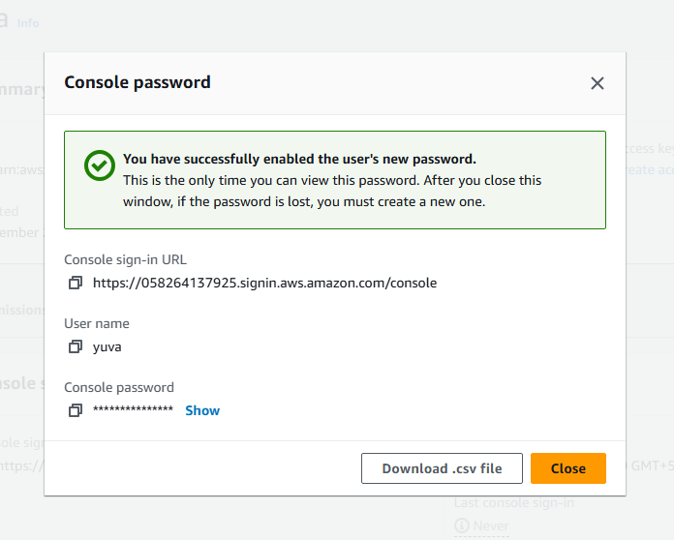

**Step 7:** Go to one private browsing window and paste the console sign in URL and give password and username.

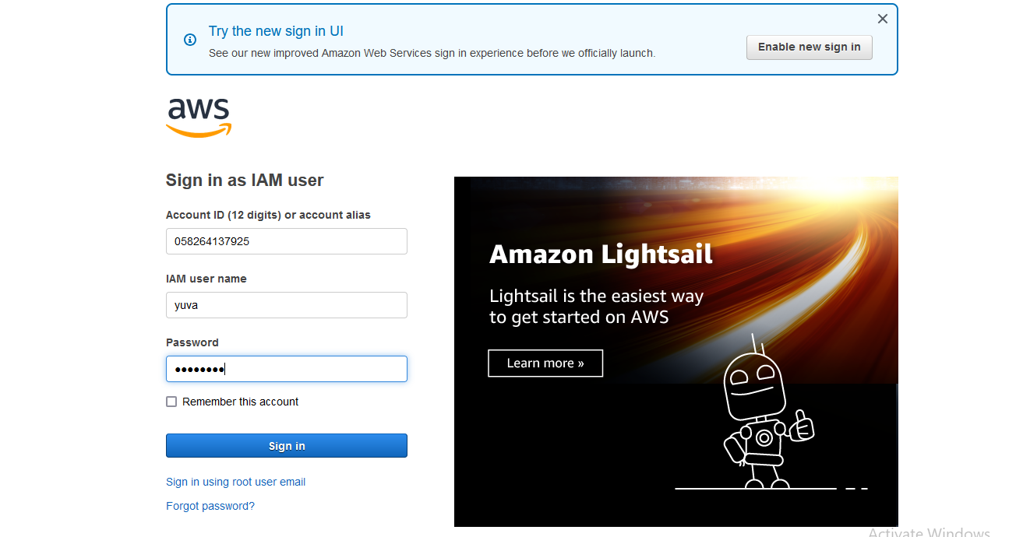

**Step 8:** Console home is opened in the window permissions are declined except our S3 bucket permission because we give the policy to the IAM user.

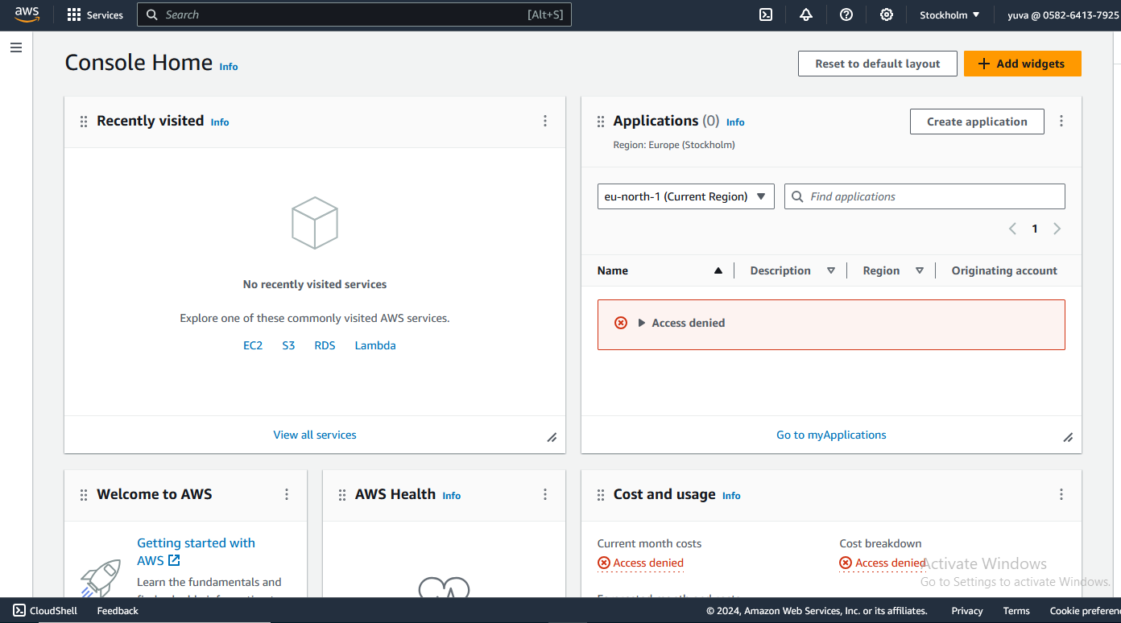

Step 9: One S3 bucket is shown because in the root user one bucket is created so it displays the bucket in IAM user.

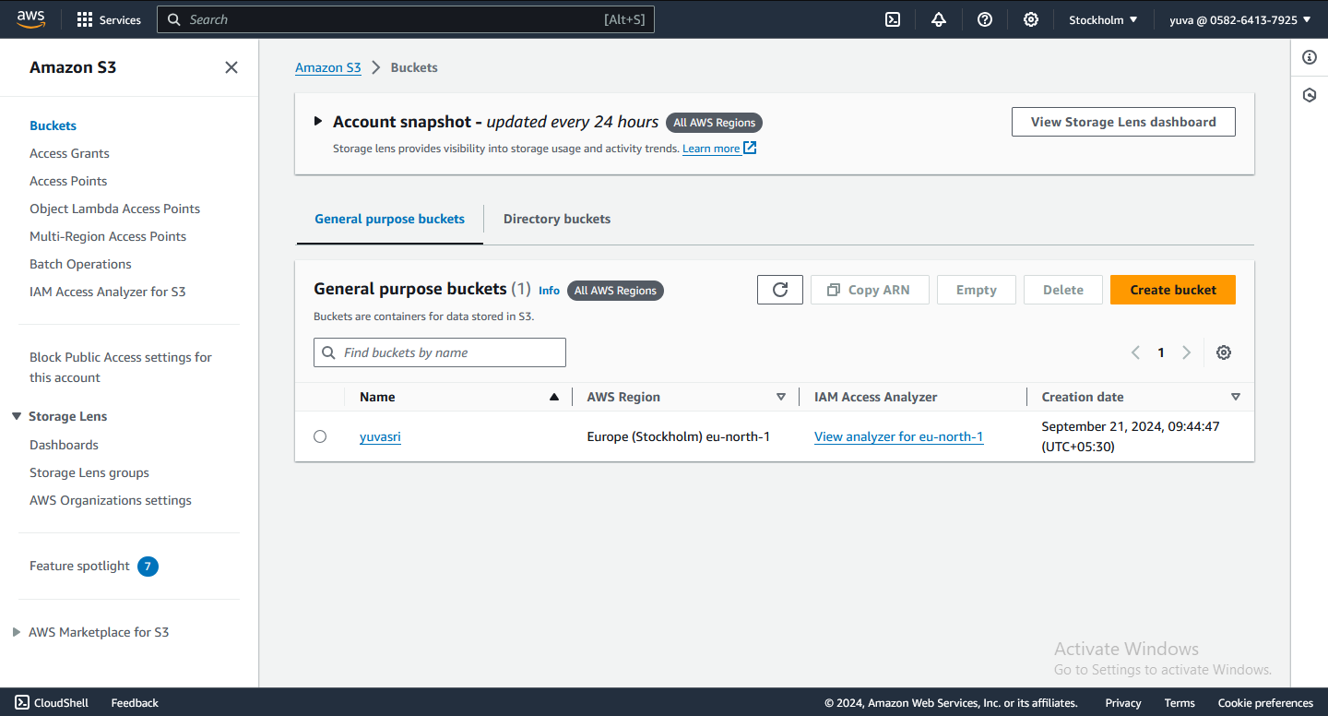

**CONCLUSION:**

Thus the above steps for creating an IAM user and give policies and permission in AWS was executed successfully.