Swift
Trilingual Multimodal Financial Support Ticket Management System
Final Report
Index number 123
9 October 2026

Abstract/ Executive summary
Swift addresses the difficulty of consistently triaging banking-support requests expressed in English, Sinhala, Tamil and their romanized forms, including tickets supported by screenshots. The project combines an aligned multilingual benchmark with a web application that preserves customer wording, extracts image text, predicts intent, sentiment and base priority, and supports staff review and response handling. The research corpus contains 13,077 unique source tickets represented in five language tracks, producing 65,385 aligned records. Model development uses identifier-based partitions, language-specific evaluation and explicit label-version provenance. Classical TF-IDF classifiers were compared with multilingual encoders, with LaBSE providing strong intent and sentiment results. On the separately reported official intent benchmark, LaBSE achieved 88.54% pooled macro-F1 against 83.18% for the linear SVM. A retained v8 sentiment evaluation reports Negative-class F1 of 0.7138, while a frozen-split priority run reports macro-F1 of 0.8900; these scores measure different targets and are not interchangeable evidence of human agreement. The application implements React interfaces, a FastAPI service, PostgreSQL persistence, authorized image attachments, conservative evidence fusion, prediction correction and audit history. Retrieval-grounded assistance uses approved banking sources and citation validation, alongside safety escalation and a separate agent-approved reply workflow. The September 2026 test evidence records 195 backend passes, two failures, three skips and 45 frontend passes. Multilingual safety escalation reached 840 of 841 paired tickets, but concurrent write and generation capacity, recovery behavior and comprehensive answer quality remain unverified. The outcome is a reproducible research platform and a functional support prototype suitable for controlled, human-supervised demonstrations. Production adoption requires stronger language parity, human label validation, operational testing and governance of generated guidance.

Table of Content
Abstract/ Executive summary 2
1. Introduction 4
1.1 Background of the application domain/ problem 4
1.2 Motivation for the selected system development 4
1.3 Importance and main purpose of the system 4
1.4 Overview/ summary of the system and used approach and outcome 4
2. Literature Review 5
3. System Models 6
3.1 System Requirement 6
3.2 System Design 7
3.3 Database Design 9
3.4 Machine Learning / Data Science System Design 10
4. System Implementation 12
4.1 Implementation Procedure 12
4.2 Materials 13
4.3 The Algorithm 14
4.4 Main Interfaces 15
5. System Testing and Analysis 17
5.1 Testing approach 17
5.2 Unit Testing, Results and analysis of testing 17
5.3 Aspects related to performance, security, failures 18
5.4 Evaluation of ML models 18
6. Conclusion and Future Work 19
Reference 20
Appendix 21
A.1 Architecture baseline and implementation trace 21
A.2 Interface figure provenance 21
A.3 Evidence provenance and comparison boundaries 22
A.4 Retained evidence locations 22

1. Introduction

1.1 Background of the application domain/ problem
Banking-support requests concern payments, transfers, cards, account access and disputed transactions. Similar requests can use different terminology, scripts or informal spelling, while a short message may omit information visible in an attached screenshot. BANKING77 demonstrates the granularity of this problem through 77 intent classes rather than a small set of broad topics [1]. In Sri Lankan support settings, English banking terms also appear within Sinhala and Tamil messages. A triage system must retain the meaning of these mixed expressions before recommending a queue or response.

1.2 Motivation for the selected system development
The development motivation is to reduce repeated manual interpretation while preserving staff control over consequential decisions. A single English-only classifier or keyword list can treat translations of the same issue differently. The project therefore evaluates five aligned language tracks and separates the customer's issue from the policy used to handle it. Screenshots extend the available evidence, but extracted text can be incomplete or misleading. The workflow must allow a ticket to proceed even when model inference or image processing is unavailable.

1.3 Importance and main purpose of the system
The main purpose is advisory triage: identify the issue, estimate its base priority and sentiment, expose uncertainty, and give staff sufficient context to act. Consistent multilingual routing matters because an unrecognized fraud complaint should not receive routine guidance simply because it was written in another script. Privacy and accountability are equally relevant. Customer text, model outputs and human corrections need separate records so that a later reviewer can determine how a ticket was handled. Swift does not execute payments or provide privileged access to bank accounts.

1.4 Overview/ summary of the system and used approach and outcome
Swift integrates a multilingual dataset and model evaluation harness with a role-based web application. The implemented text and image paths use extraction followed by classification; audio is outside the demonstrated implementation. Customer, agent and administrator interfaces support submission, review, assignment, escalation and status tracking. Retrieval-grounded policy assistance supplements the ticket workflow. The outcome is a functioning prototype with measurable classifier performance and retained test evidence. Its principal qualification is that benchmark performance establishes agreement with recorded labels, while safe deployment additionally depends on language parity, response validation, workload capacity and operational recovery.

2. Literature Review
Casanueva et al. introduce BANKING77 and resource-efficient intent detectors based on dual sentence encoders. Their work supports treating banking intent detection as a supervised representation problem and establishes a useful English benchmark. However, the source dataset does not supply the Sinhala, Tamil, romanized, sentiment, priority or screenshot annotations needed for this application. Swift extends that experimental setting through aligned language variants while retaining the original intent taxonomy.
Conneau et al. show that large-scale multilingual pretraining can support cross-language representation transfer in XLM-R. This provides a theoretical basis for pooling related tasks and language forms rather than fitting every language independently [2]. Feng et al. introduce LaBSE, which learns sentence representations across languages using multilingual training and alignment objectives [3]. Swift evaluates such encoders against TF-IDF baselines instead of assuming that a larger model is better. The local results favor multilingual encoders for intent, but romanized Tamil remains substantially weaker than the other tracks. A pretraining objective is consequently a model-selection rationale, not a guarantee of subgroup accuracy.
Lewis et al. combine retrieval with generation for knowledge-intensive language tasks. The key design implication is that a generated response can be conditioned on external evidence rather than relying only on model parameters [4]. Chen et al.'s BGE-M3 work supports multilingual and multiple retrieval representations, motivating its use for cross-language queries over approved banking content [5]. Swift uses dense embeddings together with PostgreSQL lexical search and ranking fusion. This implementation adds institutional source metadata, review-age filtering and escalation when evidence is insufficient; retrieval alone does not establish that an answer is correct.
Tesseract provides an open-source OCR route that can run without a remote vision service. Its official documentation identifies language packs and engine configuration as deployment inputs [6]. Swift's own benchmark compares extraction engines by script and degradation condition, because an overall average can conceal failures on blurred or low-resolution images. The resulting application keeps an engine adapter boundary rather than binding every screenshot to one provider.
The project's contribution is the integration of these methods with identifier-aligned trilingual and romanized evaluation, original-message preservation, conservative image evidence fusion and auditable human correction. Its novelty is this combined experimental and workflow design. It is not a claim of a new encoder architecture or demonstrated superiority over commercial banking-support systems, for which a controlled comparison has not been conducted.

3. System Models

3.1 System Requirement
The functional requirements cover secure registration and login, role-specific access, ticket submission in the supported language forms, optional image attachment, ticket history and response visibility. The system must preserve original text, produce advisory intent, priority and sentiment outputs, and record confidence and model identity. Agents must be able to accept or correct predictions, assign tickets, add internal notes, escalate sensitive cases and manage resolution. Administrators require user, queue, configuration and audit controls. Approved-source policy assistance and the staff reply workflow are distinct functions; assistance does not authorize financial action. These requirements originate in the project SRS and architecture, with the implemented scope refined by the application code [7].
The non-functional requirements concern confidentiality, traceability, responsiveness, resilience and multilingual consistency. Authentication must be enforced at the service boundary; customer ownership and staff roles must restrict ticket and attachment access. Input validation, sensitive-text masking and bounded provider timeouts limit exposure and stalled requests. Every correction and workflow transition must be attributable to an actor. Quality targets also require language-specific evaluation and usable responsive interfaces. Database restore, concurrent generation capacity and comprehensive answer quality remain acceptance work rather than achieved properties.
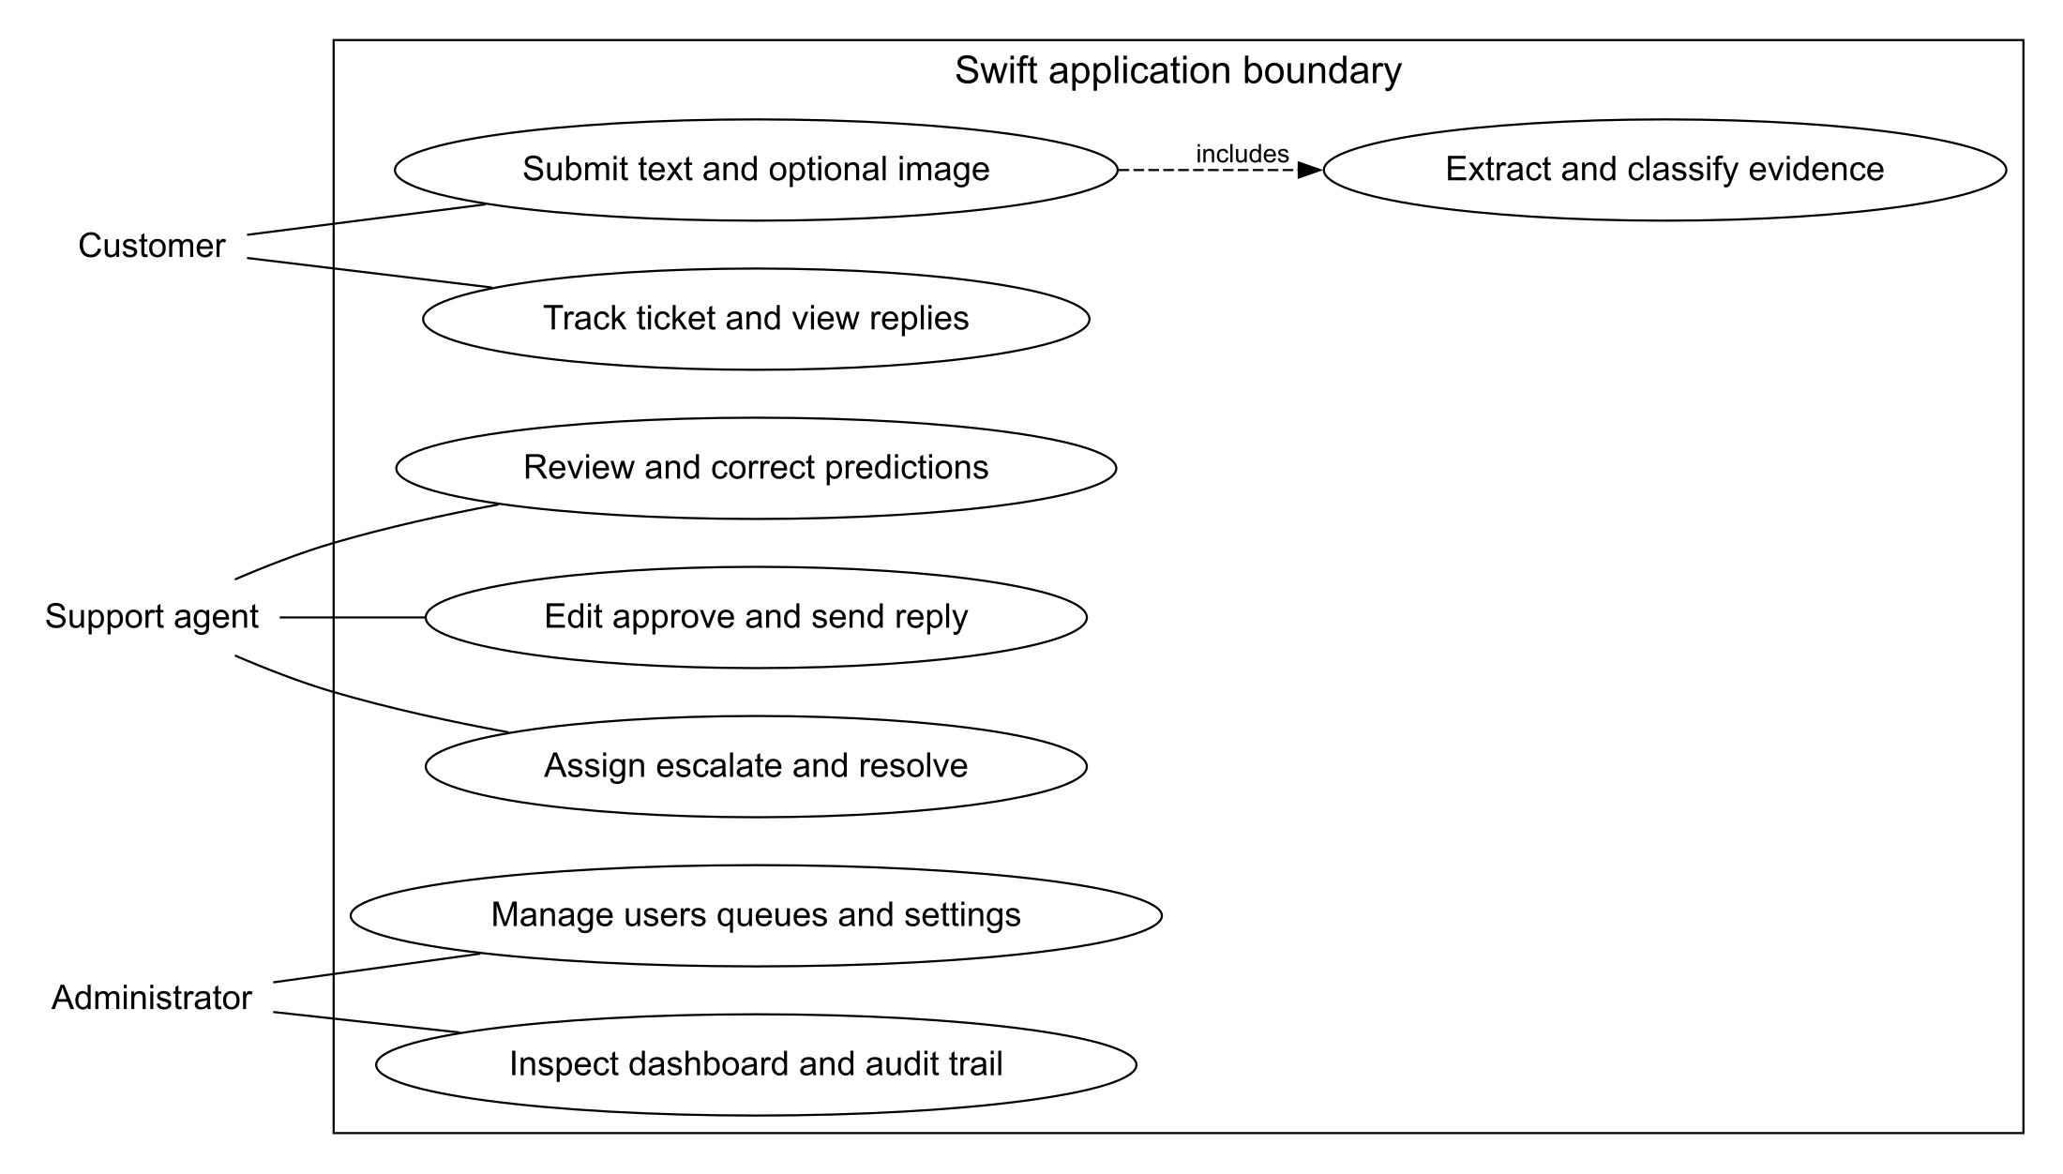
Fig. 1. Main use cases adapted from the project architecture to the implemented scope.
Fig. 1 identifies the three human actors and the principal functions inside the application boundary. Submission includes extraction and classification, while staff review remains separate from customer tracking. Administrator controls govern access and operation; the diagram intentionally excludes payment execution and external notification delivery.

3.2 System Design
The implemented architecture is a modular monolith for transactional support functions, with adapters around computational and provider-dependent work. React clients communicate with FastAPI through REST and JSON. The service owns authentication, ticket state, prediction review, authorized file access and audit persistence. PostgreSQL is the system of record; pgvector supports knowledge retrieval. Redis and Dramatiq define a worker boundary, while external model and generation providers can be replaced through configuration. This arrangement retains the separation proposed in the architecture document without requiring independently deployed microservices for every operation [8].
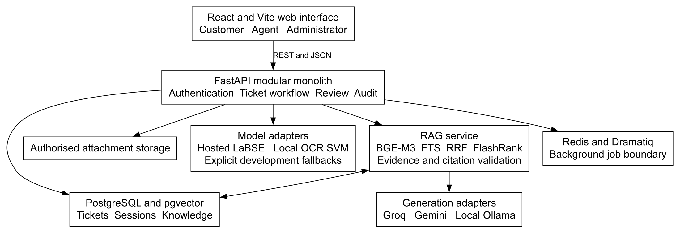
Fig. 2. Current application architecture adapted from the repository system architecture.
Fig. 2 distinguishes the transactional API from model inference and retrieval-grounded generation. Customer-text classification can call a hosted LaBSE endpoint, whereas OCR text uses a local calibrated SVM. Provider failures are represented explicitly rather than presented as successful transformer predictions. File storage is reached through authorized operations; possession of a path is not sufficient access.
The RAG component performs its own query normalization, guardrail checks, source filtering and grounding validation. Its generation adapters include Groq, Gemini fallback and configurable local Ollama evaluation. A model-generated answer therefore passes through more than one decision boundary. The customer assistance endpoint returns policy guidance or escalation, while ticket responses retain their own edit, approve and send lifecycle. Treating these as different paths prevents an agent-approval claim from being incorrectly applied to every customer assistance call.
The architecture also separates capabilities from operating guarantees. A background-job interface supports later workload isolation, but its presence does not establish replay reliability or horizontal capacity. Likewise, access controls and structured events provide accountability mechanisms, but backup retention and restore procedures require independent verification. The prototype remains a support application, with no bank-core integration or authority to change financial balances.

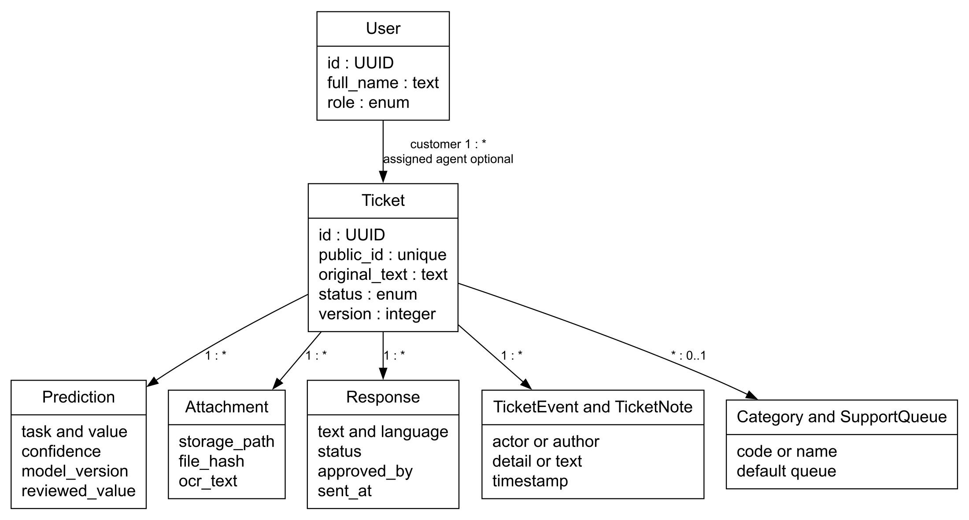
Fig. 3. Logical class view adapted to current SQLAlchemy entities.
Fig. 3 places Ticket at the center of the logical model. User supplies customer ownership and optional agent assignment, with roles represented by an enumeration. A ticket has many predictions, attachments, responses, events and notes. Prediction retains the original value and reviewed value, so accepting or correcting an output does not erase its provenance. Category and SupportQueue support routing; their optional ticket associations allow an unresolved or newly received item to exist before final assignment.
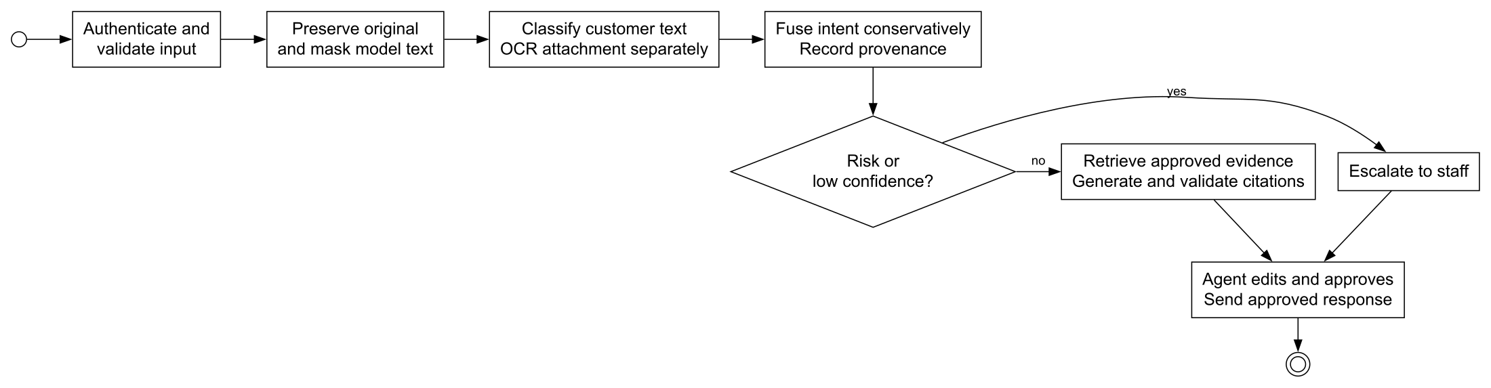
Fig. 4. Main ticket process adapted from the repository activity view.
Fig. 4 summarizes the operational sequence. Authentication and validation precede preservation and masking. Customer text and attachment text are classified separately before conservative fusion, avoiding an unconditional overwrite of the customer's description. Risk and uncertainty route a ticket to staff; eligible policy questions can request retrieved evidence and generation. The diagram's final approval stage applies to the staff reply workflow, not to every separate customer-assistance response.
The process records outcomes even when a provider fails. A low-confidence or unknown result can remain reviewable, and OCR failure does not justify replacing the stored original message. The ticket's version field and policy checks help coordinate state transitions, while events capture assignment, correction and response actions. This gives the agent workspace an inspectable history instead of a single unexplained final label.

3.3 Database Design
The database design follows the project's ER model but uses the implemented SQLAlchemy entities and migrations as the authority for current table names and constraints. Users and authentication sessions support role-based access and hashed refresh-token records. Tickets store customer and agent references, category and queue references, original text, masked model text, language, response language, state and version. Child tables preserve attachments, predictions, notes, events and responses. The broader DBML model remains a design reference; its additional dataset-version, model-registry and citation entities are not all implemented transactional tables.
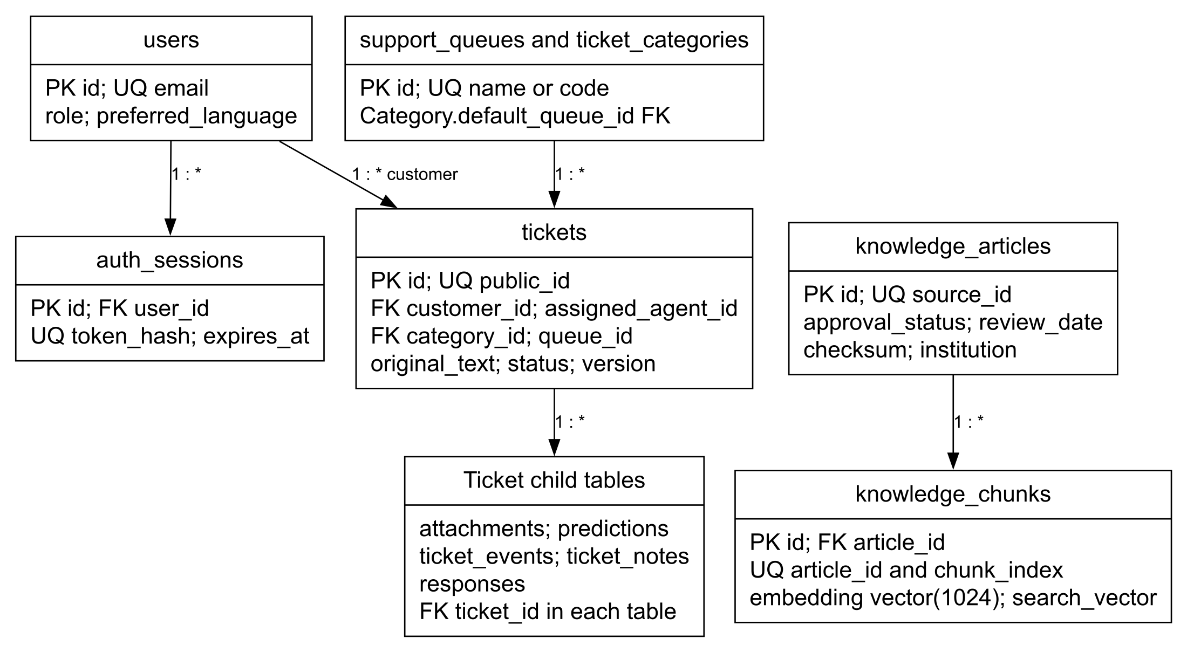
Fig. 5. Simplified implemented ER view adapted from the project database design.
Fig. 5 shows ownership and the one-to-many ticket associations. Unique email and public ticket identifiers prevent duplicate identities; foreign keys connect dependent records to their parent. Prediction uniqueness is defined over ticket, task and model version. Attachment rows store metadata and masked OCR text, with the actual file held outside the relational record. Responses preserve approval identity and timestamps independently of their textual content.
The knowledge subsystem adds knowledge_articles and knowledge_chunks. Article records include source identifiers, institution, approval state, review date and checksum. Each chunk belongs to one article and stores content, a 1,024-dimensional embedding and a generated text-search vector. HNSW and GIN indexes support vector and lexical retrieval respectively. Returned citations refer to source evidence, but persistent citation lineage must not be inferred from the broader conceptual ER design alone. Alembic migrations provide the reproducible schema-change history; PostgreSQL-specific behavior requires integration testing beyond an isolated unit-test database.

3.4 Machine Learning / Data Science System Design
The machine-learning design uses a single source-ticket identity across all language variants. Each labelled CSV has the columns id, text_en, text, category, sentiment and priority; category denotes the 77-way BANKING77 intent label. English, Sinhala, Singlish, Tamil and Tamilish files share aligned identifiers and labels. The source index remains unchanged, allowing translations, audits and predictions to be joined without relying on text equality. The current modelling manifest records 8,500 training, 1,498 development and 3,079 test tickets per track, with split identifier e7b5934392cd. These are the values in the retained experiment artifacts; the manifest is not regenerated [9].
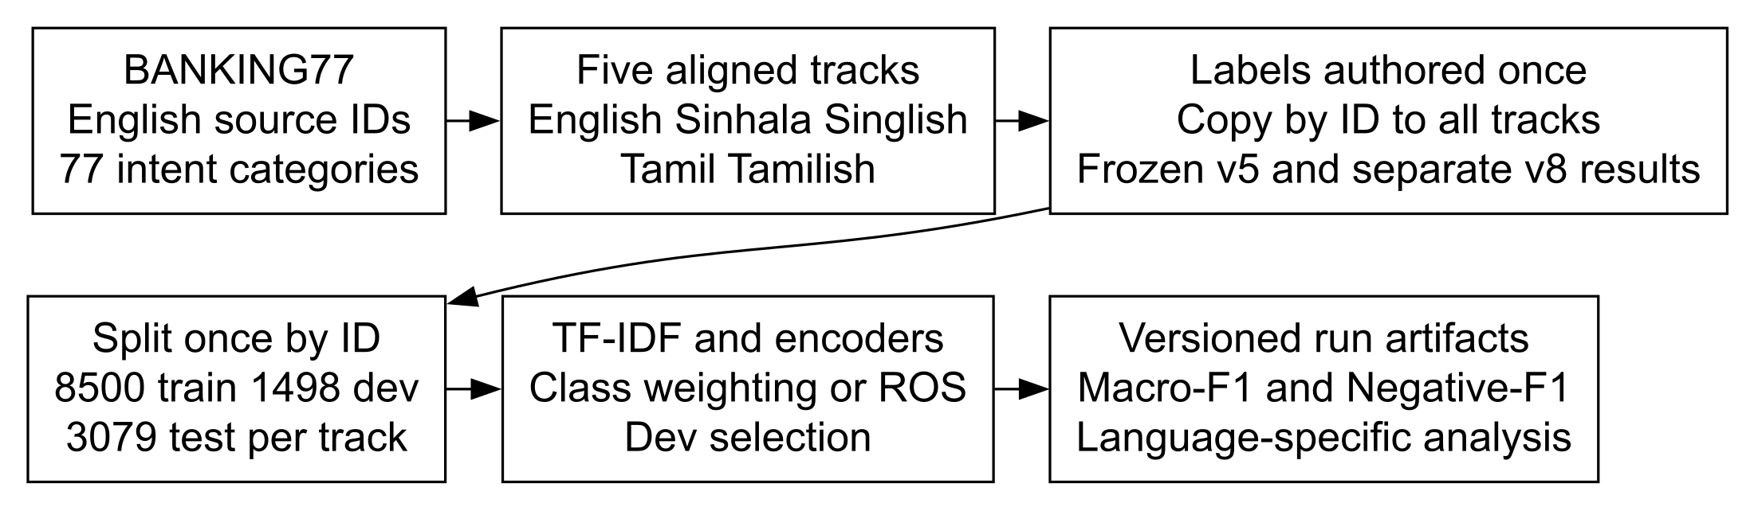
Fig. 6. Identifier-aligned data preparation and model evaluation pipeline.
Fig. 6 shows why splitting occurs before language fan-out is used for learning. Independent row splitting would permit a translated version of a development ticket to occur in training. Training pools contain 42,500 rows when all five tracks are used, but only 8,500 unique training tickets. Development selection and uncertainty analysis therefore need to recognize the repeated ticket identity.
Intent labels originate in BANKING77. Sentiment and priority were assigned once in English and propagated to the other tracks. The frozen v5 sentiment target is binary Neutral/Negative; the absence of Positive is an annotation choice. Separate v8 experiments use revised sentiment labels and must retain their version. October provenance notes establish that local source CSVs currently contain v5 counts, even though historical reports describe v8 evaluation. A v8 score cannot be presented as a score against today's local v5 labels.
The baseline design uses script-aware tokenization with word and character TF-IDF features and linear classifiers. Multilingual encoders, including LaBSE and XLM-R, are compared on development data. Class weighting and random oversampling address imbalance; synthetic interpolation is not used. Macro-F1 measures intent and priority performance, while Negative-class F1 is the sentiment headline because an always-Neutral model can achieve high accuracy without recognizing any negative ticket. Results retain task, model, label version, split and training regime so that incompatible cells cannot silently become a ranking [10].

The serving design preserves this experimental separation. Customer text is the primary input to the hosted multilingual classifier. Attachment OCR text is classified locally, and its intent can decide only when the customer-text prediction is weak and the attachment offers stronger evidence. The current confidence floor is 0.60. Agreement between weak inputs retains the shared label with stronger confidence; disagreement does not automatically replace a confident customer-text prediction. Risk rules can raise serving priority to Critical, a workflow state outside the three-class training target. Runtime enums also tolerate Positive, although the frozen training corpus contains no Positive examples.
The OCR component exposes Tesseract and Google Cloud Vision through a common extraction interface. It retains original image evidence and stores masked extracted text separately from the customer's message. Synthetic image benchmarks guide engine selection, but they do not establish accuracy on real banking photographs. In particular, unexpected improvements after blur can result from noisy text suppressing distractors, rather than better extraction. End-to-end classification must therefore be measured separately from character error rate.
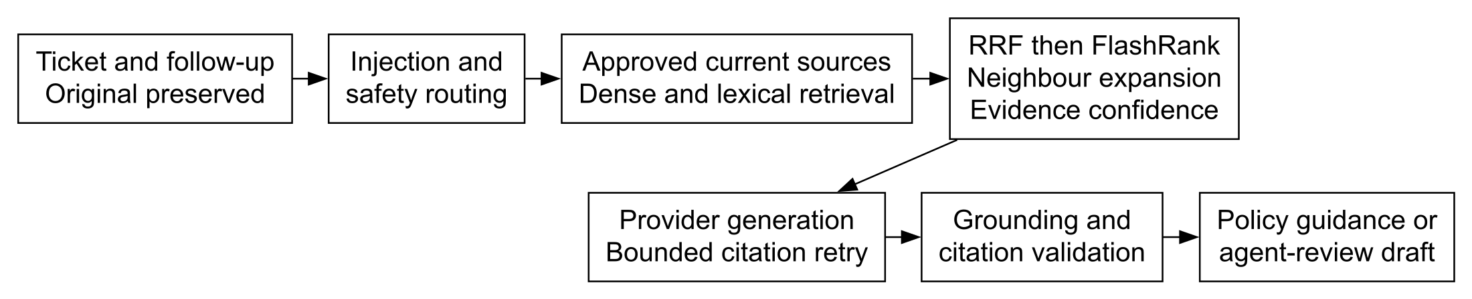
Fig. 7. Evidence-conditioned policy assistance with safety and grounding checks.
Fig. 7 describes the RAG design. Queries use BGE-M3 dense retrieval and PostgreSQL full-text search over approved, current sources. Reciprocal-rank fusion combines candidate rankings, FlashRank reranks them, and neighboring chunks provide context. Evidence confidence is based primarily on dense relevance, with smaller ranking and reranker contributions. The source institution remains attached to the evidence so that unrelated bank policies are not combined into unsupported advice.
Generation is bounded by the retrieved evidence and followed by citation and grounding checks. Missing evidence, unsafe requests, provider errors or invalid answers produce escalation. A limited citation-repair attempt can correct formatting, but it does not supply missing factual support. The design thus links language modelling to explicit evidence and operational policy. It leaves human assessment of answer quality, calibration under expanded knowledge coverage and the consistency of multilingual safety routing as separate validation obligations.

4. System Implementation

4.1 Implementation Procedure
Implementation combines a reproducible research pipeline with an incrementally developed web application. The data track prepared translations and romanizations, applied aligned sentiment and priority labels, and emitted non-destructive audit files. The modelling track used the shared swiftbench harness, persisted run identities and evaluated pooled and per-language models. This procedure made dataset defects and subgroup gaps visible before the application incorporated classifier adapters.
The application uses FastAPI with typed request and response models, dependency-based authentication and API documentation derived from the service contract. These framework facilities support consistent validation and an inspectable REST interface [11]. The frontend uses React components for stateful customer, agent and administrator workflows, built with Vite and TypeScript. React's component model allows shared controls and prediction cards to be reused across the role-specific pages [12]. Routing protects role-specific navigation, while service-side authorization remains the enforcement boundary.
SQLAlchemy manages persistence, and Alembic manages schema evolution. The core service creates and updates tickets, stores model outputs, applies workflow policy and records audit events. The attachment path validates files, authorizes download and runs blocking OCR away from the asynchronous request event loop. Sensitive spans are masked for model processing while the original message remains available as the authoritative customer record. The local OCR classifier loads a TF-IDF SVM and calibration parameters once rather than rebuilding them for each request.
External inference is called through bounded adapters. A cold or unavailable hosted model returns an explicit unknown or failure-labelled intent rather than holding submission indefinitely. Priority and sentiment development rules provide an identifiable fallback, and critical-risk rules can override the learned priority. These decisions are exposed through model-version strings and confidence, preventing fallback outputs from being confused with measured LaBSE behavior.
The RAG implementation is isolated under the backend retrieval package. Ingestion validates the source manifest and immutable raw checksum before producing chunks from cleaned Markdown. Deployment configuration selects local or hosted embeddings and generation providers. Redis and Dramatiq retain a background-processing boundary, while container configurations separate frontend, API, worker and persistence services. Unit, API, browser, security and data audits were applied across implementation stages; the release decision depends on retained evidence for each path rather than on successful compilation alone.
The deployment implementation includes an EC2 Docker Compose demonstration with a Caddy HTTPS gateway, static frontend and private database, Redis and Ollama services. The public override enables secure cookies and Redis rate limiting; its runbook describes certificate renewal and frontend rebuilds. This demonstrates a deployable prototype topology, while production availability and financial-service suitability still require operational evidence.

4.2 Materials
The primary material is the project's BANKING77-derived corpus, stored as ten UTF-8 labelled CSVs with 9,998 training and 3,079 test rows per language track. These files represent 13,077 source tickets rather than 65,385 independent customer interactions. Sinhala text was hand-corrected into colloquial, code-mixed language; Singlish was rule-generated from that text while preserving banking loanwords. Tamil and Tamilish were machine-translated without an equivalent hand-correction pass. A 500-ticket human-annotated English gold set supports evaluation of label quality independently of the labels used for training.
The knowledge material comprises five approved English-language documents covering savings accounts, card disputes, card-to-card transfers, personal loans and fraud warnings. The source manifest retains institution, URL, review date, version, approval status, raw capture, cleaned Markdown path and checksum. Commercial Bank, People's Bank and CBSL sources retain distinct authority and institution metadata; their contents are policy material, not live customer-account data [13].
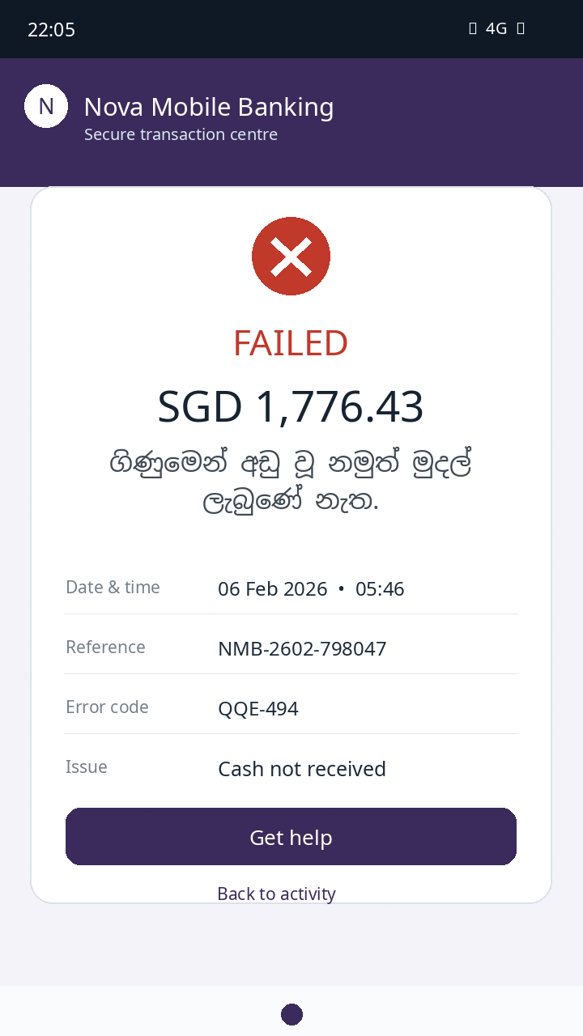
Fig. 8. Example project-generated banking screenshot used as OCR material.
Fig. 8 illustrates the synthetic image material. The OCR suite uses 500 rendered examples under four conditions, producing 2,000 images. Clean, rotated, blurred and low-resolution variants share the same intended text. The image is a generated test artifact rather than an actual banking record. This controlled material permits paired engine comparisons, but additional real photographs and user-typed romanized tickets are needed to assess field performance [14].

4.3 The Algorithm
The central triage algorithm preserves input provenance while combining customer text and optional image evidence. It does not concatenate every input and assume that the largest text block is authoritative. Instead, it validates access, stores the original message, masks model input, obtains customer-text predictions and classifies OCR separately. The local attachment classifier estimates confidence from calibrated SVM margins. Image evidence can affect intent only when the original-text prediction is below the confidence floor and the attachment is more persuasive.
PROCEDURE TRIAGE(ticket, optional_image)
authorize caller; validate message and attachment
preserve original message; mask model input
text_result := classify_customer_text(masked_message)
final_intent := text_result.intent
IF image exists THEN
extracted := extract_and_mask_image_text(image)
ocr_result := calibrated_local_intent(extracted)
IF text_result.intent.confidence < 0.60 THEN
IF ocr_result.label = text_result.intent.label THEN
retain label; retain stronger confidence and provenance
ELSE IF ocr_result.confidence > text_result.intent.confidence THEN
final_intent := ocr_result
apply critical-risk override; record predictions and events
IF unsafe OR confidence insufficient THEN request staff review
ELSE IF policy assistance requested THEN
evidence := retrieve approved current banking sources
IF evidence missing THEN escalate
ELSE generate bounded answer; validate grounding and citations
IF provider fails OR validation fails THEN escalate
staff reply: edit -> approve -> send; record each transition
END PROCEDURE
Fig. 9. Pseudocode for conservative multimodal ticket triage and response routing.
Fig. 9 expresses the important decision sequence without reproducing source code. The customer-text prediction remains primary above 0.60 confidence. If weak inputs agree, the common intent is retained; if they disagree, the stronger OCR prediction can decide. Critical-risk rules remain a serving-policy override rather than a new dataset label. Model identities and decision events are retained so that an agent can distinguish a text-only prediction, an OCR decision and a combined result.
The classification stage tolerates provider failure through explicit fallback values. An attachment processing failure is recorded and leaves the customer text available for review. Risk or insufficient confidence triggers a staff-review path. For eligible assistance, retrieval and generation form another bounded stage: approved evidence is required, citations are validated, and an unavailable provider or unsupported answer leads to escalation. Separate staff replies must pass the edit and approval lifecycle before sending.
The procedure's cost is dominated by provider calls and OCR, not by the small number of local comparisons in fusion. Its complexity therefore cannot be represented adequately by a single algorithmic time-order expression. Request timeouts, model warm-up, image resolution and knowledge-index size determine observed latency. The confidence threshold and calibrated SVM scores also need validation after a model, language distribution or OCR engine changes; the pseudocode defines the policy but does not prove its optimality.

4.4 Main Interfaces
The customer interface combines submission with visible support history. A ticket includes a subject, detailed description and preferred response language. The interface accepts natural wording across the supported language forms, preserves line breaks and Unicode, and offers an optional image-evidence control. A privacy acknowledgement discourages passwords, PINs and complete payment-card details. Validation messages appear at the corresponding input rather than as an unexplained submission failure.
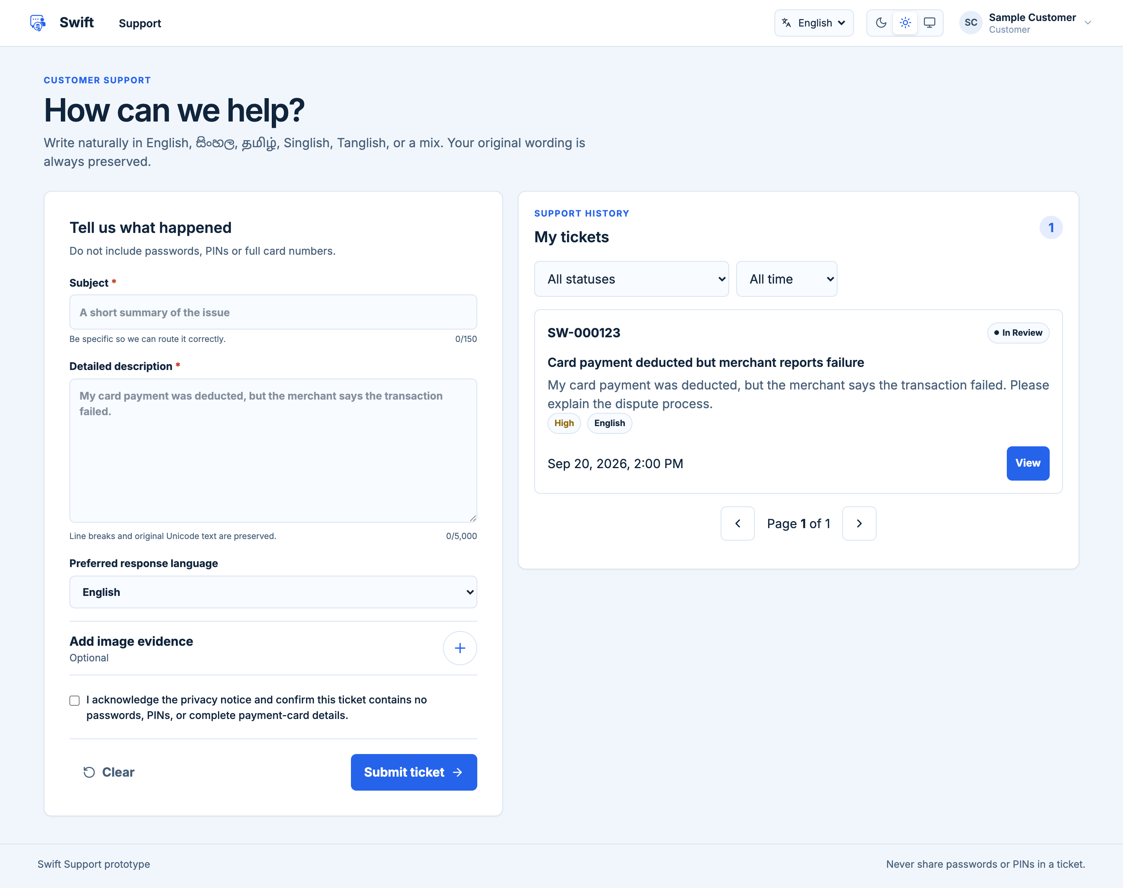
Fig. 10. Implemented customer submission and history interface with illustrative data.
Fig. 10 shows the actual React submission page rendered with an illustrative ticket fixture. The sample identity, ticket content and status are demonstration data, not records from a bank or evidence of live model performance. The customer can inspect ticket history and continue to a detail page without navigating a staff queue. A response-language choice is independent of automatic language-form detection, which matters for code-mixed or romanized submissions.
The processing display distinguishes validation, original-message preservation, language detection, prediction and optional image extraction. It provides progress feedback while the service completes the operation. Ticket details expose status and customer-visible events, while internal staff notes remain outside the customer's view. Responsive layouts support a browser on mobile screens; the implemented system is not a separate native mobile application.

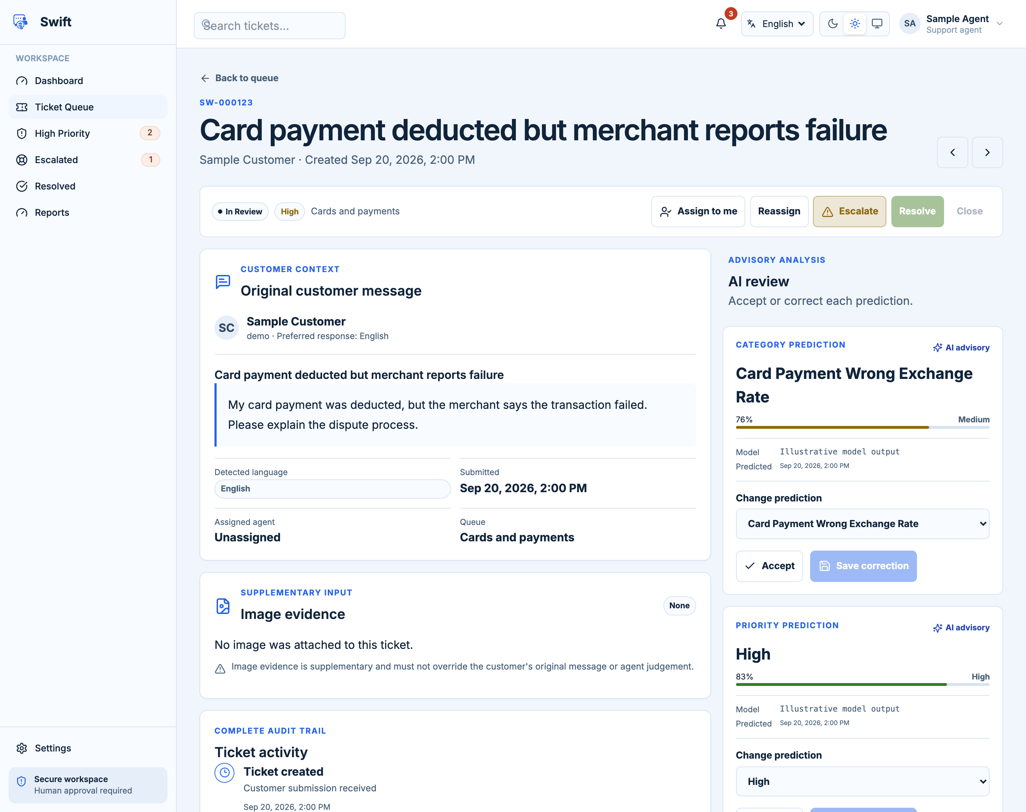
Fig. 11. Implemented agent ticket workspace with illustrative prediction values.
Fig. 11 shows the staff workspace rendered from the implemented React components. It places the customer's message beside advisory predictions, confidence and model identity. The deliberately illustrative prediction values show the correction mechanism; they are not measured outputs from a deployed endpoint. Staff can accept a prediction or record a replacement with a reason. Assignment, escalation and resolution controls are tied to workflow permissions and current ticket state.
Further down the workspace, image evidence, internal notes, timeline events and the response editor support a complete review. Generated text is editable, and the response lifecycle separates draft, approval and sending. Feedback therefore affects the recorded review decision rather than silently rewriting the original model output or customer message. Visible loading and error states help distinguish a failed request from an empty ticket.
The agent dashboard summarizes new, assigned, high-priority, critical and escalated tickets and links to relevant queues. Its category, language and volume summaries support queue awareness; they do not demonstrate a measured improvement in response time. Administrator interfaces separately manage users, queues and settings and expose audit activity. This separation reduces accidental crossover between customer assistance, staff case handling and system governance, while API authorization supplies the corresponding server-side protection.

5. System Testing and Analysis

5.1 Testing approach
Testing combines white-box unit and integration checks with black-box API and browser workflows, static analysis, passive security scanning, accessibility audits, load testing and non-mutating dataset validation. The retained September 2026 test report covers the implemented text and image prototype. Its measurements are evidence from that execution cycle, not a new certification of the current working tree. Source review in this report establishes present implementation behavior where possible, while unexecuted release checks remain explicit [15].
The backend suite exercises authentication, ownership, role separation, workflow policy, input validation, attachments, masking, inference adapters, grounding checks, rate limits and database behavior. Frontend tests check components and interactions, while browser tests cover login and responsive display. API business-flow assertions and published-contract checks examine integration beyond the unit boundaries. Dataset audits verify schema, source-text and cross-language label alignment without changing the files.

5.2 Unit Testing, Results and analysis of testing
The retained pytest log reports 195 passed, two failed and three skipped tests. The report states 199 collected cases, with an additional collection-stage skip recorded separately; a summed outcome count must not be presented as an independent collection count. Both failures involve decoding files under a non-UTF-8 platform default. One affected the raw-SQL inspection test, so a successful SQL-injection claim cannot be inferred for that check on the failing platform. The skipped paths include optional contract fuzzing and two evaluations requiring an ingested database and generation provider.
Backend coverage is reported as 71.72% statement and 43.41% branch. The frontend suite passed 45 cases across 18 files, but coverage was 21.82% line and 19.14% branch. Passing component tests consequently do not establish complete authenticated customer, agent and administrator workflow coverage. Retained Ruff and strict mypy checks passed, as did the frontend lint, type-check and production build gates.
The API business flow retained ten requests with 23 assertions and no failures. Cypress recorded three passing browser tests, and Selenium evidence included desktop and mobile display. Dataset evidence reports all ten labelled files passing schema and alignment checks. These results support a controlled demonstration, while incomplete provider evaluations and low frontend coverage limit the release claim. Explicit UTF-8 reads, expanded authenticated workflow tests and rerun integration evidence are required before treating the unresolved areas as closed.

5.3 Aspects related to performance, security, failures
The retained read-only load log contains 2,000 samples with zero errors, a 17.0 ms mean and 39 ms p95. It covers five authenticated read endpoints, not ticket creation, image extraction or generation. Single-user measurements of approximately 2.1 seconds for ticket creation and 26.6 seconds for assistance indicate that expensive paths require their own concurrent scenarios. Lighthouse reports performance 95 and accessibility 100; axe reports zero automated violations. Neither result replaces keyboard, screen-reader or zoom testing.
The September guardrail diagnostic detected all 18 prompt-injection cases and included ticket-context scanning. Paired safety evaluation escalated 840 of 841 English-flagged tickets in every language; ticket 1410 remained a Tamil/Tamilish gap. The API scan retained no medium or high findings, while the frontend retained three medium-risk findings. Backup restore, cache outage, worker replay and provider failover remain untested. An earlier RAG study found confidence-gate rejection despite strong ranked retrieval; current code changes the confidence formula and lexical query construction, but the historical measurements cannot establish the revised pipeline's answer quality [16].

5.4 Evaluation of ML models
The official intent comparison uses 9,998 training and 3,079 test tickets per track. LaBSE reports 88.54% pooled macro-F1, XLM-R 88.29% and the linear SVM 83.18%. Tamilish scores 70.57% for LaBSE versus 94.13% English, identifying a material subgroup gap. These official-split results are distinct from the frozen-manifest experiments; apparent decimal differences in recomputed prediction summaries must not be interpreted as independent improvements.
On the frozen manifest, completed seed-43 priority tests use train+dev fitting, six epochs and class weighting. Pooled macro-F1 is 0.8888 for XLM-R, 0.8847 for mmBERT and 0.8820 for LaBSE. An older three-epoch LaBSE run reports 0.8900 over 15,395 language rows; these training regimes remain separate [10]. Priority's human-gold agreement is 0.7722 macro-F1, so high model agreement with the generated rule does not prove human-level urgency assessment. Separate v8 sentiment records report LaBSE Negative-F1 0.7138. Local CSVs currently retain v5 labels, and the v5 and v8 results have different negative-class support. No cross-version sentiment ranking is valid without rescoring against the same target.
OCR-to-intent evaluation scores 1,868 of 2,000 synthetic cases; 132 OTP cases are excluded because no BANKING77 category expresses their meaning. Overall SVM accuracy is 77.25% with Tesseract and 78.27% with Google Vision; LaBSE records 76.77% and 77.94% respectively. These use an explicit acceptable-intent mapping and are not directly comparable to 77-way ticket macro-F1. Combined with synthetic imagery, translation provenance, six disclosed train/test text overlaps and repeated language variants, these limits make controlled evaluation essential before operational claims.

6. Conclusion and Future Work
Swift provides an implemented response to the multilingual interpretation and evidence-handling problem described in the introduction. The project preserves customer wording, represents English, Sinhala, Tamil and romanized variants under aligned ticket identities, and connects classification to a reviewable support workflow. Screenshot extraction extends the evidence available to staff without making an image-derived prediction authoritative by default. Role-based interfaces, persistent ticket history and recorded corrections provide a practical basis for accountable case handling.
The model experiments establish that multilingual encoders improve intent performance over the measured classical baseline on the official benchmark. They also establish that language coverage is uneven: Tamilish remains substantially weaker than the other tracks. Sentiment performance depends on the label version and minority-class evaluation, while priority performance measures agreement with a generated annotation policy. These findings directly qualify the original purpose of consistent triage. A high pooled score is insufficient when the same issue can receive a different decision in another language.
The application outcome is a working, human-supervised prototype rather than a completed production banking service. Retained tests support authentication, ownership, workflow and review functions, but unresolved encoding failures, medium-risk web-hardening findings and incomplete operational testing remain relevant. Retrieval and citation checks provide mechanisms for grounded guidance, yet comprehensive answer quality has not been demonstrated for the revised system. No measured reduction in bank response time, customer loss or agent workload can be claimed from the available experiments.
Future work should first strengthen the evidence that governs deployment. The residual Tamil/Tamilish safety case requires a named regression test, and guardrail evaluation should extend beyond the small authored injection corpus. The revised retrieval pipeline needs a retained development and held-out answer-quality evaluation with independent reviewers, source correctness and language-specific outcomes. Concurrent scenarios should include ticket creation, attachment OCR and generation, followed by database restore, cache and worker failure, replay and provider-failover exercises.
Further research should collect human-typed romanized requests and real banking screenshots with suitable consent and privacy controls. Native-speaker review of Tamil and Tamilish would clarify whether subgroup errors arise from translation, spelling variation or model representation. Label-quality assessment should precede further sentiment-model scaling, and serving priority should incorporate waiting time and queue state without altering the frozen training target. Reconciled split, checkpoint and label provenance would support repeatable comparisons and safer model replacement.
The system's significance is the combination of reproducible multilingual evaluation with a support process that exposes uncertainty and retains human responsibility. Its next stage should be governed by demonstrable language parity, source-grounded answer quality and operational reliability, preserving the original objective of more consistent banking-support triage.

Reference
[1] I. Casanueva et al., “Efficient Intent Detection with Dual Sentence Encoders,” Proc. NLP4ConvAI, pp. 38–45, 2020, doi: 10.18653/v1/2020.nlp4convai-1.5.
[2] A. Conneau et al., “Unsupervised Cross-lingual Representation Learning at Scale,” Proc. ACL, pp. 8440–8451, 2020, doi: 10.18653/v1/2020.acl-main.747.
[3] F. Feng et al., “Language-agnostic BERT Sentence Embedding,” Proc. ACL, pp. 878–891, 2022, doi: 10.18653/v1/2022.acl-long.62.
[4] P. Lewis et al., “Retrieval-Augmented Generation for Knowledge-Intensive NLP Tasks,” Advances in Neural Information Processing Systems, vol. 33, pp. 9459–9474, 2020.
[5] J. Chen et al., “M3-Embedding: Multi-Linguality, Multi-Functionality, Multi-Granularity Text Embeddings Through Self-Knowledge Distillation,” arXiv:2402.03216, 2024.
[6] Tesseract project, “Tesseract User Manual.” [Online]. Available: https://tesseract-ocr.github.io/tessdoc/ (Accessed on 9 October 2026).
[7] Swift project team, “Software Requirements Specification” and “Software Architecture Document,” docs/srs/srs.pdf and docs/architecture/architecture.pdf, 2026.
[8] Swift project team, “Application implementation,” backend/app/, backend/alembic/versions/, frontend/src/, backend/RAG.md and deploy/ec2-dev/, repository snapshot, 9 October 2026.
[9] Swift project team, “Aligned multilingual corpus and frozen modelling split,” datasets/*/*_labeled.csv, ml/splits/split_manifest.json and ml/README.md, 2026.
[10] Swift project team, “Detailed classifier results and provenance,” RESULTS.md, ml/reports/RESULTS.md, ml/reports/runs/ and ml/predictions/, October 2026.
[11] FastAPI, “FastAPI Documentation.” [Online]. Available: https://fastapi.tiangolo.com/ (Accessed on 9 October 2026).
[12] React, “React Documentation.” [Online]. Available: https://react.dev/ (Accessed on 9 October 2026).
[13] Swift project team, “Approved banking knowledge sources,” docs/rag_sources/rag_source_manifest.csv and documents/cleaned/, captured and reviewed 29 July 2026.
[14] Swift project team, “OCR benchmark and OCR-to-intent evaluation,” ml/OCR/README.md, ml/reports/ocr_google_vision_benchmark.md and ml/reports/intent_accuracy_by_ocr_engine.md, September 2026.
[15] Swift project team, “Master Test Plan and Test Report,” v3, Testing/Swift_Master_Test_Plan_and_Report_v3.md and Testing/test_evidence/, 20 September 2026.
[16] Swift project team, “RAG system error analysis,” docs/rag_error_analysis/findings.md and probe_manifest.json, measured commit f6ad3c1, 2026.

Appendix

A.1 Architecture baseline and implementation trace
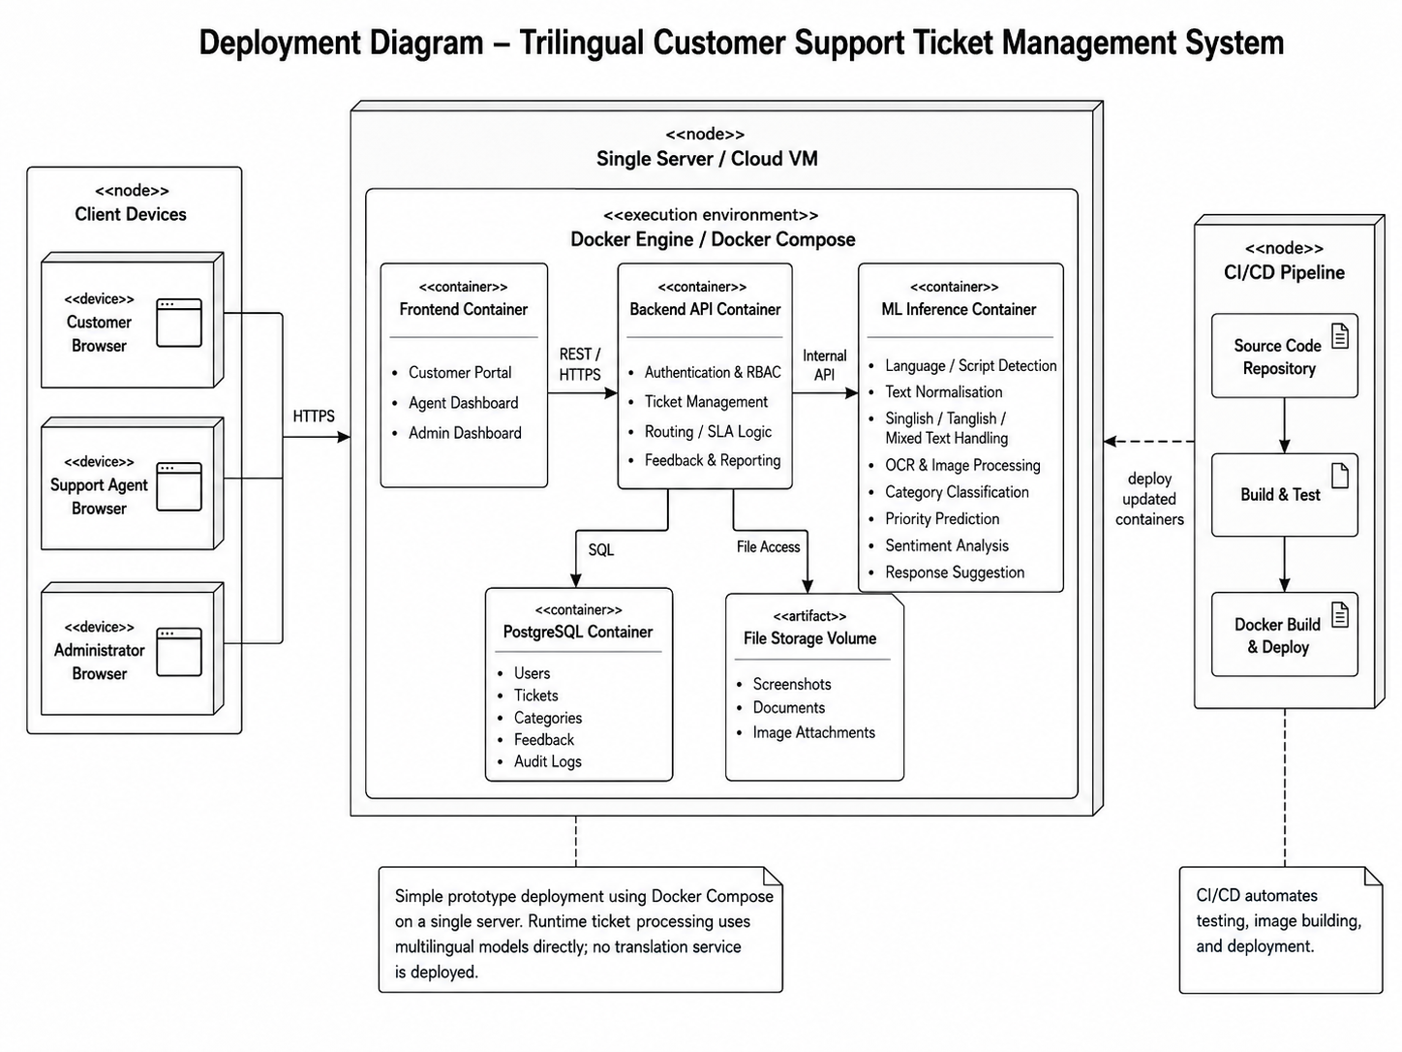
Fig. 12. Repository deployment design baseline reused for architectural traceability.
Fig. 12 reproduces the repository's deployment design to retain the intended separation of presentation, application, computation and storage. It is a design baseline rather than an attestation that all drawn nodes are independently operated. The main report adapts these views to the current implementation. Model, vision and generation boundaries remain relevant, but queue replay, backup restoration, object-store deployment and production scaling require operational verification.
The original class and ER images also include concepts such as separate role tables, priority entities, SLA records and a larger model registry. The implemented service uses a role enum and direct ticket priority fields; the core ORM stores reviewed prediction values on prediction records. The simplified main-report views therefore show implemented relationships rather than all planned entities. Voice processing, bank-core access and real external notifications are outside the demonstrated application scope.

A.2 Interface figure provenance
The interface figures were rendered from frontend/src/ using intercepted demonstration responses. No real user account was created and no application data was modified. The displayed identities, queue state, confidence values and predictions are illustrative fixtures. They document visible controls and layout, not endpoint accuracy, workload totals or an executed business transaction.

A.3 Evidence provenance and comparison boundaries
The reference experiment manifest is ml/splits/split_manifest.json, whose stored identifier is e7b5934392cd. Its ticket counts are 8,500 training, 1,498 development and 3,079 test, repeated across five language tracks. Older local working notes use a different identifier and status description. Published comparisons must retain the manifest stamped in their actual run artifacts; no split has been generated or changed in preparing this report.
Official-split intent comparisons and frozen-split development experiments have different training regimes. The 88.54% intent headline is taken from the official comparison table, while 0.883424 is a retained prediction-summary result reported in the verification overlay. They are not separate evidence of a newly improved checkpoint. The older priority run records train+dev fitting, three epochs and a final best epoch. The root RESULTS.md separately records completed six-epoch seed-43 priority tests for LaBSE, XLM-R and mmBERT on the same frozen manifest. Other encoder runs with test-driven epoch selection require their own provenance checks and must not be promoted through the same claim.
Sentiment has two annotation histories. The v5 prompt is frozen and the local CSVs currently reflect its minority counts. Historical v8 experiments retain a revised target with different negative support. Human-gold prompt scores describe label quality, not a mathematical upper bound on every model or an estimate of live customer satisfaction. The report does not overwrite or propagate any dataset label.
The retained system test log reports a Windows/Python 3.13 execution environment and two encoding-related failures. The test report's front matter identifies build e6ef318, whereas the offline guardrail JSON stamps 4cefa60. This mixed provenance prevents treating the evidence collection as a single-commit release certification. Backend, frontend, API, accessibility and load summaries are attributed to the September cycle and their retained files. They have not been re-executed as part of report authoring.

A.4 Retained evidence locations
Backend outcomes are recorded in Testing/test_evidence/pytest-v3.txt. Frontend outcomes are in vitest-v3.json. The guardrail and paired safety results are in offline_guardrails-v3.json, and language detection is in offline_language-v3-after-detector-fix.json. API business-flow evidence is in newman-final.json. Read-only load samples are in jmeter-business-final.jtl. Accessibility and browser performance are recorded in axe-final.json and lighthouse-final.json. Dataset structure is recorded in ds-validation-final.json and data-cleaning-final.txt. The complete test report retains the detailed defect register and test traceability.
These records should be rerun and retained for a consistent release revision before deployment approval. The immediate acceptance scope remains a controlled demonstration with staff review, disclosed language limitations and disabled financial actions.

