Classification and Order Prediction of Financial Support Tickets Across Sinhala, Tamil, and Romanized Scripts
Abstract— Bank support desks must choose which ticket to handle next, as urgent cases such as fraud have a limited response window. Treating ticket prioritization as a classification task, we train multilingual models on an offline labelled dataset to predict each ticket’s intent, sentiment, and priority. Fine-tuned LaBSE achieves the best pooled intent (0.8835 macro-F1); sentiment (0.7138 Negative-F1) and priority (0.8901 macro-F1) it ties with other encoders, small decoders, and the SVM within their confidence intervals. Intent accounts for 76.9% of the uncertainty in priority, treating classification heads as independent evidence counts shared signal twice; an equal-weight log pool merges direct priority predictions with an intent-conditioned chain, reducing log loss by 27.4% and resolving collinearity. We then specify a dynamic urgency scoring function that couples this combined posterior with elapsed waiting time, so that queue position reflects both predicted severity and accrued delay and no ticket can be starved indefinitely by construction. To train and evaluate the system, we expanded BANKING77 into a corpus of 65,385 tickets across five language variants, pairing LLM-generated priority and sentiment labels, with sentiment-label quality assessed against a manually annotated gold subset.
Index Terms—multi-label classification, Sinhala, Tamil, romanized text, transliteration, queue scheduling, multilingual NLP
I. Introduction
A customer support desk must decide which next ticket should be attended to. High severity issues such as payment fraud require immediate intervention under strict response windows, whereas routine balance inquiries tolerate delays of several hours. When customer requests arrive faster than staff can process them, a backlog forms. In this operating environment, the dispatch order in which tickets are assigned to agents directly determines whether service level agreements (SLAs) are upheld or violated.
Published work on bank complaint handling has focused on predicting static categories and evaluating held-out classification performance [1]. A predicted label alone, however, does not specify a dispatch order. One possible policy serves tickets First Come First Served (FCFS); another groups them by predicted priority and uses arrival order within each group. Deshmukh and Shiravale [2], for example, prioritize complaints by sentiment intensity, break equal-intensity ties by arrival order, and introduce a waiting-time threshold for lower-intensity complaints.
Converting classifier outputs into an operational queue raises three challenges: prolonged waits under static priority, loss of predictive uncertainty, and variation across languages and scripts. First, static priority allows newly arriving urgent inquiries to overtake older routine requests. This can leave low-priority customers with inadequate service levels; delay-dependent and accumulating-priority disciplines address this by incorporating elapsed waiting time [3], [4]. Second, discrete argmax binning places a confident High-priority prediction (0.99 posterior probability) and an uncertain 0.51 versus 0.49 near tie into the same tier. In a two-type queue with imperfect class information and linear waiting costs, Argon and Ziya [5] show that ranking customers by their posterior signal outperforms any finite-class priority policy.
Third, multilingual banking messages span English, Sinhala, and Tamil, alongside informal Romanized scripts (Singlish and Tanglish). Sinhala-English code-mixed language identification and Sinhala script-sensitivity studies document challenges associated with these script variants [6], [7]. BANKING77 provides English queries labeled for 77 banking intents [8]; it does not provide parallel Sinhala, Tamil, or Romanized versions with joint sentiment and priority annotations. We therefore extend this corpus to support multilingual classification and dispatch research.
Under this operational setting, we examine two research questions:
RQ1 How accurately do fine-tuned multilingual pre-trained models (sentence encoders, masked encoders and small decoders) classify the intent, sentiment and priority of banking tickets in Sinhala, Tamil and their romanized forms, compared to a TF–IDF baseline?
RQ2 How can continuous classifier posteriors for ticket severity, sentiment, and intent criticality be combined into a single urgency score?
Our contributions are twofold. First, a multilingual model benchmark study spanning classical TF–IDF models, sentence encoders, masked encoders, and instruction-tuned decoders over five language variants. Second, a urgency scoring method that combines the output distributions of the separate intent and priority classifiers to a single priority distribution via logarithmic opinion pooling.
II. Related Work
Support ticket classification and prioritization. Prior work frames ticket handling as single-target text classification, including bank complaint categorization [1]. Closest to this work, Deshmukh and Shiravale [2] derive priority from sentiment intensity and promote a complaint once it has waited past a fixed threshold, which Section VI generalizes to a continuous accrual. Static labels do not specify an order of service: desks default to First Come First Served (FCFS) or to discrete priority classes, and discrete binning discards the uncertainty continuous dispatch needs.
Multilingual representations and transliterated scripts. Expanding BANKING77 [8] into low-resource settings requires representations robust to script variation: cross-lingual masked encoders [9], [10], Indic-vocabulary encoders [11], sentence encoders [12], and instruction-tuned decoders [13]. The Sinhala literature, surveyed in [14], reports two patterns our benchmark tests jointly. Architecture matters little on minority targets: adapter variants of XLM-R move code-mixed sentiment macro-F₁ by only one to two points [15]. Task-specific fine-tuning, by contrast, dominates prompting — on banking reviews [16], on native Sinhala [17], and on Sinhala news comments [18].
Romanized South Asian text. Informal romanization introduces script sensitivity and non-standard orthography [7], [19] that subword tokenizers handle poorly, and word-level language identification in Latin-script Sinhala-English is context-dependent, with a CRF over character $n$-grams beating every neural model at small data scale [6]. One alternative is to reverse-transliterate into native script before inference [20], [21]. We model the romanized tracks directly, which makes our Tanglish figures a floor rather than a ceiling.
Annotation by prompting. Prompted annotation addresses label scarcity, but its errors propagate into every downstream comparison [22]. We therefore treat our labels as silver and measure their ceiling against human gold.
Dispatch under uncertainty. The $cμ$ rule [23] minimizes holding cost under linear delay penalties, while delay-dependent disciplines [3] and the accumulating priority queue [4] let priority accrue with waiting time to prevent starvation. Argon and Ziya [5] prove that under noisy classification, ordering by a continuous posterior index rather than a discrete argmax class minimizes expected long-run holding cost.
III. Multilingual Corpus and Annotation
A. Multilingual Corpus Construction
Building the system required diverse banking queries with expanded annotations. Because no public corpus provides these annotations, we construct a five-track corpus across three languages by expanding the BANKING77 dataset [8], which provides 13,077 English customer queries across 77 intents.
Each query was translated into four parallel tracks using Gemini 3.6 Flash [24]: native script Sinhala, native script Tamil, and informal Latin script romanizations of each (Singlish and Tanglish). Customer identifiers and class labels are aligned across all versions, producing a 5 track parallel corpus of 65,385 rows.
B. Data Cleaning and Preparation
We dropped 55 duplicate source query pairs across all five tracks and reworded translation collisions, where two English queries were rendered identically in a target language. The corpus is partitioned into a single frozen document-level split across all five tracks: 8,500 training tickets (42,500 rows), 1,498 validation tickets (7,490 rows), and 3,079 test tickets (15,395 rows), ensuring zero query or translation leakage across splits.
C. LLM Labeling and Annotation Validation
BANKING77 provides 77 intents but not the distress and severity labels queue prioritization needs. We generated binary sentiment (Neutral, Negative) and three priority tiers (Low, Medium, High) with structured LLM prompts over the English source text, copying labels across tracks. Priority was elicited separately from intent because urgency varies within an intent: inside transfer not received by recipient, a general inquiry about transaction times is Low priority whereas a time-critical request is High. Positive sentiment was omitted because retail banking inquiries rarely express praise.
To bound label quality without leakage, 500 tickets were annotated by human reviewers before the prompts were authored. Raw prompt output reached 0.7812 Negative-F₁ (Cohen’s $κ=0.766$); the shipped labels, after a final rule check, reach 0.7931 Negative-F₁ (95% confidence interval 0.667 to 0.896, agreement 0.976, $κ=0.780$) against the gold annotations.
D. Intent and Task Class Distributions
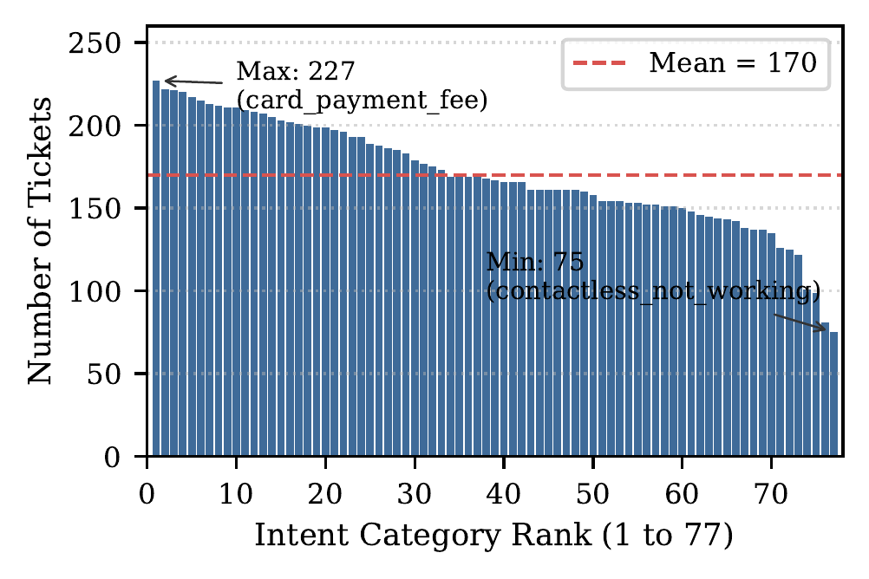
Fig. 1. Intent distribution across all 77 categories in the BANKING77 dataset ranked by frequency ($μ=170$, range $75$ to $227$).
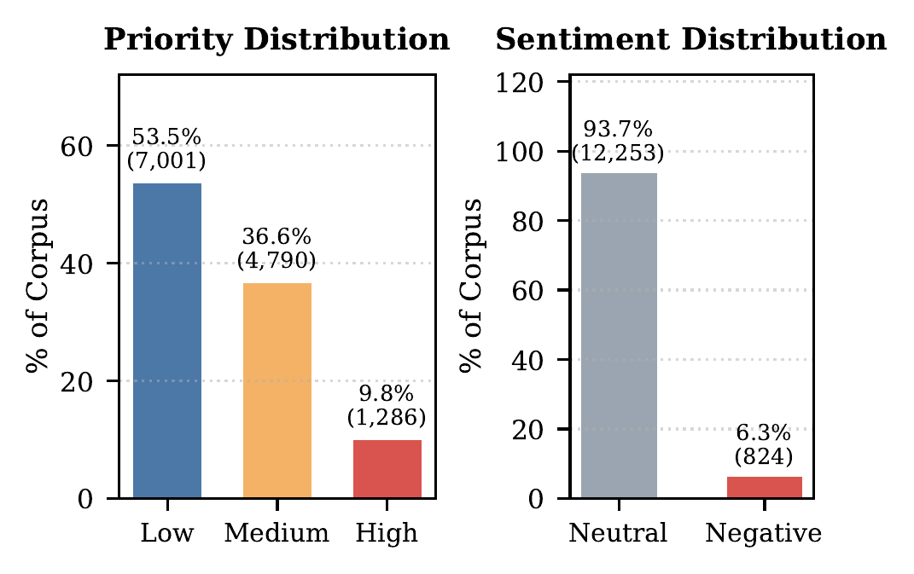
Fig. 2. Operational class imbalance across Priority tiers (left) and Sentiment targets (right) over the 13,077 ticket corpus.
As shown in Fig. 1, BANKING77 intents display balanced coverage across all 77 categories ($μ=169.8$ tickets, range $75$ to $227$, normalized entropy 0.982). In contrast, the resulting operational targets exhibit severe class imbalance (Fig. 2): Priority follows an inverse severity distribution with 53.5% Low, 36.6% Medium, and only 9.8% High urgent tickets. Sentiment is 93.7% Neutral and 6.3% Negative, capturing customer dissatisfaction and distress for queue escalation.
IV. Multilingual Ticket Classification
A. Tokenizer Inductive Filtering
Table I. Tokenizer subword fertility (tokens per word) and vocabulary size.
Model | Vocab | English | Sinhala | Singlish | Tamil | Tanglish
LaBSE | 501k | 1.18 | 1.37 | 1.62 | 1.86 | 2.00
Gemma 3 | 262k | 1.18 | 2.24 | 1.86 | 2.20 | 2.21
SinLlama | 139k | 1.16 | 1.28 | 2.00 | 11.46 | 2.34
Llama 3.2 | 128k | 1.16 | 7.39 | 2.00 | 11.46 | 2.34
Qwen 3 | 152k | 1.16 | 5.97 | 2.02 | 9.22 | 2.35
Prior to fine-tuning, we screen candidate tokenizers for subword fragmentation across 2,000 sampled tickets per language track (Table I). Parameter scale does not compensate for severe subword fragmentation: Western BPE tokenizers (Llama 3.2 and Qwen 3) shred native Indic text into 6 to 11 subwords per word, inflating sequence lengths and degrading attention efficiency. While specialized vocabulary extension in SinLlama [17] achieves high compression on native Sinhala (1.28 tokens per word), its lack of Dravidian vocabulary causes Tamil fertility to collapse to 11.46, preventing trilingual deployment. The magnitude of these penalties is consistent with survey figures of 8.83 to 12.86 subword tokens per word for Sinhala against roughly one for English [14]. In contrast, Gemma 3 provides balanced fertility across all five tracks (1.18 to 2.24) with zero control character loss.
B. Operational Evaluation Metrics
Standard classification accuracy is deeply misleading under severe class imbalance. In our banking corpus, customer sentiment exhibits severe class skew with 93.7% Neutral and only 6.3% Negative tickets (6.33% on the test split, 195 of 3,079 tickets). A naive majority class baseline predicting always Neutral achieves 93.7% accuracy while scoring exactly 0.0000 Negative-F₁, failing to detect every dissatisfied customer. In our empirical class-balancing experiments, the unweighted empirical risk baseline posted the highest raw accuracy (0.9281) but the lowest Negative-F₁ (0.3171), demonstrating that accuracy actively penalizes models that attempt to learn minority escalation signals. Consequently, we discard accuracy and adopt Negative-F₁ as the headline evaluation metric for sentiment.
For operational priority, tickets follow an inverse severity distribution (53.5% Low, 36.6% Medium, and 9.8% High). We report macro-averaged $F_{1}$ across all three tiers so that performance on the critical High priority escalation tier is weighted equally with the dominant Low priority class (majority class baseline scores 0.2361 macro-F₁). For intent, we evaluate 77 category macro-averaged $F_{1}$ across all transaction intents to ensure uniform assessment across both frequent and rare query types.
C. Classical Baseline Benchmark
Table II. Classical TF–IDF baselines. Bal.: class-balancing arm selected on dev (– none, CW class weight, ROS oversampling). Best per column in bold.
Model | Bal. | English | Sinhala | Singlish | Tamil | Tanglish | Pooled
Intent (macro-F₁, 77 classes)
Linear SVM | – | 0.9180 | 0.8666 | 0.8793 | 0.8528 | 0.6127 | 0.8308
Logistic Regression | – | 0.9096 | 0.8595 | 0.8751 | 0.8302 | 0.5854 | 0.8189
SGD (mod. Huber) | – | 0.9079 | 0.8489 | 0.8646 | 0.8305 | 0.5669 | 0.8115
Complement NB | – | 0.7772 | 0.6732 | 0.7194 | 0.7234 | 0.4925 | 0.6792
Sentiment (Negative-F₁)
Linear SVM | CW | 0.7198 | 0.6412 | 0.6633 | 0.7249 | 0.5722 | 0.6653
Logistic Regression | ROS | 0.6995 | 0.6256 | 0.6545 | 0.6776 | 0.5074 | 0.6383
SGD (mod. Huber) | ROS | 0.6842 | 0.5954 | 0.6218 | 0.6608 | 0.4577 | 0.6092
Complement NB | ROS | 0.5139 | 0.5083 | 0.5302 | 0.5239 | 0.3738 | 0.4968
Priority (macro-F₁)
Linear SVM | CW | 0.9050 | 0.8848 | 0.8918 | 0.8854 | 0.7984 | 0.8734
Logistic Regression | ROS | 0.8987 | 0.8810 | 0.8889 | 0.8849 | 0.7985 | 0.8706
SGD (mod. Huber) | ROS | 0.8953 | 0.8802 | 0.8831 | 0.8853 | 0.7805 | 0.8659
Complement NB | CW | 0.8643 | 0.8479 | 0.8540 | 0.8653 | 0.7782 | 0.8422
We evaluate four classical classifiers over a shared TF–IDF feature union of word 1–2 grams and character 3–5 grams, the latter carrying most of the signal on the romanized tracks, where no spelling standard exists. Linear SVM establishes the strongest classical baseline, taking the best score in 17 of the 18 task-by-track cells; Logistic Regression edges it only on Tanglish priority (0.7985 vs. 0.7984), and trails it by 1.2 points on pooled intent. The margin between the two linear margin based models and the SGD linear model is small, but Complement Naive Bayes falls well behind on both imbalanced targets, losing 15.2 points of pooled intent macro-F₁ and 16.9 points of pooled Negative-F₁ to the SVM, confirming that its closed-form class priors cannot substitute for discriminative training on the minority escalation classes. Tanglish is the weakest track for every model and every task, a pattern the encoder benchmark below only partly closes.
D. Multilingual Encoder Benchmark
Table III. Multilingual encoder benchmark, per track and pooled. Best per column within each task in bold. Priority rows marked s43 use six epochs and seed 43.
Model | English | Sinhala | Singlish | Tamil | Tanglish | Pooled
Intent (macro-F₁, 77 classes)
Linear SVM | 0.9180 | 0.8666 | 0.8793 | 0.8528 | 0.6127 | 0.8308
LaBSE | 0.9412 | 0.9319 | 0.9034 | 0.9329 | 0.6928 | 0.8835
XLM-R base | 0.9402 | 0.9244 | 0.8987 | 0.9151 | 0.7067 | 0.8801
mmBERT | 0.9374 | 0.9123 | 0.9013 | 0.9147 | 0.6566 | 0.8680
MuRIL base | 0.9226 | 0.7224 | 0.8888 | 0.9080 | 0.7824 | 0.8467
Sentiment (Negative-F₁)
Linear SVM | 0.7198 | 0.6412 | 0.6633 | 0.7249 | 0.5722 | 0.6653
LaBSE | 0.8032 | 0.7234 | 0.6757 | 0.7606 | 0.5948 | 0.7138
XLM-R base | 0.7838 | 0.7215 | 0.6361 | 0.7473 | 0.5981 | 0.7007
mmBERT | 0.7723 | 0.6766 | 0.6905 | 0.7386 | 0.6159 | 0.7000
MuRIL base | 0.7967 | 0.5577 | 0.6463 | 0.7465 | 0.6235 | 0.6790
Priority (macro-F₁)
Linear SVM | 0.9050 | 0.8848 | 0.8918 | 0.8854 | 0.7984 | 0.8734
LaBSE | 0.9229 | 0.9179 | 0.8817 | 0.9130 | 0.8142 | 0.8901
MuRIL base | 0.9095 | 0.8072 | 0.8861 | 0.9120 | 0.8412 | 0.8717
XLM-R base (s43) | 0.9188 | 0.9099 | 0.8841 | 0.9042 | 0.8267 | 0.8888
mmBERT (s43) | 0.9198 | 0.9036 | 0.8846 | 0.9050 | 0.8084 | 0.8847
As shown in Table III, fine-tuned LaBSE takes the best pooled score on all three tasks among the encoders, with margins of +8.01 percentage points (pp) of macro-F1 on both Tamil and Tanglish intent over the SVM. XLM-R base is the closest competitor, within 0.34 points pooled and 0.10 points on English intent. MuRIL trails on pooled intent (0.8467), but the pooled column conceals two facts: its deficit is concentrated in a single cell, Sinhala intent at 0.7224, where Sinhala script falls outside its vocabulary, and it takes the best Tanglish score on all three tasks, leading LaBSE by 8.96 points on Tanglish intent.
E. Generative Decoder and SLM Benchmark
We selected Gemma 3 after the tokenizer screen (Table I): its fertility is balanced across all five tracks (1.18–2.24), whereas Llama 3.2 and Qwen 3 heavily fragment native Indic text and SinLlama fragments Tamil. Tokenizer screening controls sequence length; the benchmark below separately evaluates classification performance.
Table IV. Gemma 3 decoder benchmark. Lower panel: pooled 1B configurations; 270M sentiment and priority were evaluated on dev only. Best per column in bold.
Model | English | Sinhala | Singlish | Tamil | Tanglish | Pooled
Intent, per track (macro-F₁)
Gemma 3 1B | 0.9358 | 0.9221 | 0.8962 | 0.9110 | 0.6281 | 0.8635
Gemma 3 270M | 0.9288 | 0.8874 | 0.8706 | 0.8907 | 0.6041 | 0.8414

Gemma 3 1B configuration (pooled) | Intent | Sentiment | Priority
Per-task heads | 0.8635 | 0.7126 | 0.8898
One shared head | 0.8673 | 0.7048 | 0.8904
Three shared heads | 0.8616 | 0.7042 | 0.8895
We adapt Gemma 3 across 1B and 270M parameter scales using parameter-efficient LoRA (Table IV), examining three core questions:
LoRA Projection Coverage. Expanding LoRA coverage from attention projections alone ($q,v$) to all seven linear projections ($q,k,v,o,gate,up,down$) produced the largest gain in the decoder study (+2.70 points on 1B, +4.56 points on 270M validation), indicating that the apparent cross-script deficit under partial LoRA was a parameter coverage artifact.
Parameter Scaling and Minority Collapse. The 270M model gives up 2.21 points of pooled intent macro-F₁ to the 1B model (0.8414 against 0.8635), but collapses far harder on the minority target: on development data it reaches 0.5611 Negative-F₁ against the 1B model’s 0.7098, a 14.87 point gap. Compressed capacity degrades disproportionately under severe label skew.
Joint Multi-Task Architecture. A single Gemma 3 1B backbone equipped with a shared classification head guided by task prefix prompts achieves 0.8673 on intent, 0.7048 on sentiment, and 0.8904 on priority on the frozen test set, matching single-task encoders on priority with 0% cross-task misrouting.
F. Representation Probing Diagnostics
To isolate representation transfer we probed frozen backbones with a linear classifier. Pretrained LaBSE scored 0.8015 on priority and 0.7822 on intent, substantially below the classical TF–IDF baseline (0.8734 and 0.8308), which demonstrates that frozen representations cannot be served without supervised fine-tuning.
V. Information Theoretic Posterior Combination
A. Quantifying Inter Label Dependence
Predicting intent, sentiment, and priority via independent output heads overlooks their joint statistical structure. Evaluating mutual information on training data ($n=9,998$ tickets, in nats) reveals strong asymmetric coupling: prior entropy $H(prio)=0.9333$; $I(int;prio)=0.7178$ (resolving 76.9% of priority entropy); $I(sent;prio)=0.0172$ (1.8%); and $I(sent;prio∣int)=0.0149$ (86.6% survives conditioning). Thus, intent provides a dominant, overlapping signal for priority, while sentiment acts as a sparse, non-redundant orthogonal adjustment. Fitting linear mixtures of the form $w_{P}P(prio)+w_{I}P(int)$ induces collinearity, as weights sum redundant estimates of the same underlying event.
B. Candidate Combination Rules and Evaluation
We benchmark five probabilistic combination mechanisms on the frozen test split: (i) Marginal: direct priority head $P_{head}(prio∣x)$; (ii) Stacked Generalization: a multinomial logistic meta learner [25]; (iii) Intent Chain: a classifier chain [26] marginalizing over intent, $P_{chain}(k∣x)=\sum_{i=1}^{77}{P}(int=i∣x) P(prio=k∣int=i)$, where contingency $P(prio∣int)$ is estimated on training gold labels; (iv) Full Chain: conditioning priority jointly on intent and sentiment; and (v) Log Pool: the normalized geometric mean of the direct priority head and the intent chain:
$$P_{pool}(k∣x)∝(P_{head}(prio=k∣x) P_{chain}(k∣x))^{1/2} (1)$$
Logarithmic opinion pooling aggregates dependent experts sharing background information without linear double counting.
Table V. Priority combination rules on the frozen test split.
Combination Rule | Log Loss | macro-F₁
Marginal (priority head alone) | 0.3697 | 0.8901
Stacked generalization [25] | 0.3333 | 0.8914
Intent chain [26] | 0.3160 | 0.8742
Full chain (intent + sentiment) | 0.3111 | 0.8749
Log pool (head $×$ intent chain) | 0.2683 | 0.8983
Selection is governed by multiclass log loss (cross entropy) to ensure calibrated continuous posteriors for downstream queue scheduling (Table V). Equal weight log pooling attains the lowest log loss (0.2683) and highest macro-F₁ (0.8983), reducing log loss by 27.4% over the standalone priority head (0.3697) and effectively resolving label collinearity.
C. The Calibration Trap in Operational Ordering
On development data, fine-tuned LaBSE exhibits an Expected Calibration Error (ECE) of 0.0658. Post hoc temperature scaling [27] reduces ECE to 0.0192. However, examining temperature scaled posteriors for operational ranking reveals a critical trade off: temperature scaling pulls logits toward uniform entropy, compressing the dynamic range that differentiates urgent incidents from routine inquiries. While post hoc calibration optimizes population level probability reliability, it diminishes score separation across distinct priority tiers. Because dispatch ordering relies on ranking separation rather than population level marginal calibration, we emit uncalibrated pooled posteriors.
VI. Dynamic Urgency Scoring and Dispatch
A. Formulation of the Ticket Urgency Score
The dynamic queue ordering mechanism translates continuous posteriors and elapsed waiting time into an operational priority scalar. For waiting ticket $t$ evaluated at dispatch time $τ$, the Ticket Urgency Score $U(t,τ)$ couples intrinsic severity $S(t)$ with multiplicative aging:
$$U(t,τ)=S(t) \left(1+α a(t,τ)\right), a(t,τ)=\frac{τ−arrival(t)}{D_{k}} (2)$$
$$S(t)=w_{P} \hat{E}[sev∣t]+w_{S} \hat{P}(Neg∣t)+w_{I} κ(\hat{ı}(t)) (3)$$
subject to simplex weights $w_{P},w_{S},w_{I}≥0$, j​wj=1, aging coefficient $α≥0$, and class response deadline $D_{k}$.
Equation (2) integrates three principles: (i) Continuous Expected Severity: Rather than discrete argmax assignment, expected severity E[sev∣t]=k​pk(t) sevk over $sev=(0,0.5,1.0)$ smoothly separates confident Low tickets ($S≈0$) from borderline 0.51/0.49 ties ($S≈0.25$), preventing premature dispatch of uncertain items. (ii) Empirical Intent Criticality Prior: The prior $κ(i)=\hat{P}(High∣int=i)$ measures historical escalation risk on training data. Critical intents (e.g., lost or compromised card, where $κ≈1.0$) guarantee high urgency even when customer wording appears calm. (iii) Multiplicative Relative Aging: Normalizing wait time by class SLA $D_{k}∈\{30,120,480\}$ minutes ensures aging scales with intrinsic severity. Long waiting Low tickets accelerate as $a(t,τ)→1$, eventually overtaking fresh Medium inquiries to structurally eliminate starvation. A discrete form of this idea appears in [2], where a citizen complaint waiting past a fixed threshold is promoted one tier; Eq. (2) replaces that single step with a continuous accrual normalized by the class deadline.
B. Parameter Fitting and Signal Ablation
Grid search on the development set over the 3 simplex (0.05 resolution) and exponential $α$ yields optimal weights $w=(0.80,0.10,0.10)$ and $α=16$. The optimization landscape is stable: 71 of 231 simplex points lie within 5% of optimal holding cost across $w_{P}∈[0.10,0.90]$, reflecting the strong informational overlap between intent and priority identified in Section V. Component ablation on development gold sets confirms that grounding priority in the empirical intent prior $κ(i)$ shields critical accounts from false-negative omissions, while the sentiment adjustment $w_{S}$ selectively elevates frustrated customers within their priority tier without destabilizing overall queue ordering.
VII. Limitations
Every reported score measures agreement with LLM generated silver labels whose accuracy against human judgment is bounded by our 500 ticket gold validation ceiling (0.7931 Negative-F₁, $κ=0.780$), while priority tiers carry unadjudicated silver noise in the rare High class (9.8%). Labeling prompts were authored and evaluated solely on English source text and copied identically across tracks, overlooking language specific nuances in how urgency and grievance are expressed natively. The corpus expands from English BANKING77 via automated translation pipelines; translated queries inherit Western banking concepts (such as virtual card provisioning) that diverge from South Asian retail payment ecosystems, and cannot fully replicate the organic code-mixing, colloquial idioms, and non-standard phonetic spelling native to Sinhala, Tamil, Singlish, and Tanglish customer chat. All models were tuned on development data and opened the frozen test partition once as benchmark comparisons rather than field generalization guarantees. The prior evidence we build on is also thicker for Sinhala than for Tamil: we found no Tamil-English word-level code-mixed study of comparable rigour to [6], so the Tamil and Tanglish tracks are less well grounded in prior work than their Sinhala counterparts, and the 312$×$ romanization penalty reported in [7] is intrinsic perplexity on decoder-only models rather than encoder classification accuracy, so it motivates rather than predicts the gaps we measure. Finally, post hoc temperature scaling optimizes ECE by compressing logit variance, demonstrating that conventional probability calibration trades off directly against score separation in operational dispatch.
VIII. Conclusion
This paper contributed a five-track multilingual support ticket corpus carrying intent, sentiment, and priority labels, a cross-script benchmark of four model families on all three targets, and a measurement of the statistical dependence between the targets.
Fine-tuned LaBSE gives the best pooled intent macro-F₁ (0.8835 against 0.8308 for the strongest classical baseline), a margin significant under both paired bootstrap and McNemar tests. On sentiment and priority the four encoders, the three Gemma 3 1B configurations and the classical SVM fall inside one another’s intervals — pooled Negative-F₁ spans 0.679 to 0.714 and pooled priority 0.872 to 0.890, with the best priority score belonging to a decoder. So we claim no architectural advantage on those targets. The dominant source of variation is script rather than architecture: romanized Tanglish costs every model 14 to 32 points of intent macro-F₁ relative to English, and MuRIL, which ranks last on pooled intent, has both the smallest romanization gap and the best absolute Tanglish score on all three tasks. Measuring inter-label mutual information showed that intent explains 76.9% of priority entropy, and an equal-weight logarithmic pool of the direct priority head and an intent-conditioned chain cuts log loss by 27.4% where a linear mixture of the same estimates is collinear by construction.
Acknowledgment
In accordance with the conference policy on AI-generated text, Parts of this manuscript were drafted with a large language model (Claude Opus 5) from author- supplied results, outlines, and notes. Google Gemini (3.6 Flash) was used to produce the non-English corpus renderings and the sentiment and priority labels described in Section III; this use forms part of the reported methodology rather than the manuscript writing. No AI system generated the experimental results, numerical values, or tables. The authors reviewed the AI-assisted material and take responsibility for the accuracy and integrity of the manuscript.
References
[1] S. Arya, “Bank customer complaint classification using machine learning and deep learning models,” International Journal for Research Trends and Innovation (IJRTI), vol. 11, no. 2, Feb. 2026.
[2] K. V. Deshmukh and S. S. Shiravale, “Priority based sentiment analysis for quick response to citizen complaints,” in Proc. IEEE Int. Conf. for Convergence in Technology (I2CT), 2019.
[3] L. Kleinrock, “A delay dependent queue discipline,” Naval Research Logistics Quarterly, vol. 11, no. 3-4, pp. 329–341, 1964.
[4] D. A. Stanford, P. Taylor, and I. Ziedins, “Waiting time distributions in the accumulating priority queue,” Queueing Systems, vol. 77, no. 3, pp. 297–330, 2014.
[5] N. T. Argon and S. Ziya, “Priority assignment under imperfect information on customer type identities,” Manufacturing & Service Operations Management, vol. 11, no. 4, pp. 674–693, 2009.
[6] J. R. I. Smith, “Sinhala-English language detection in code-mixed data,” Master’s thesis, University of Moratuwa, Dept. of Computer Science and Engineering, Apr. 2020.
[7] M. Rajapakse and R. Weerasinghe, “Script sensitivity: Benchmarking language models on Unicode, Romanized and mixed-script Sinhala,” arXiv:2601.14958, 2026.
[8] I. Casanueva, T. Temčinas, D. Gerz, M. Henderson, and I. Vulić, “Efficient intent detection with dual sentence encoders,” in Proc. 2nd Workshop on Natural Language Processing for Conversational AI. Association for Computational Linguistics, 2020, pp. 38–45.
[9] A. Conneau, K. Khandelwal, N. Goyal, V. Chaudhary, G. Wenzek, F. Guzmán, E. Grave, M. Ott, L. Zettlemoyer, and V. Stoyanov, “Unsupervised cross-lingual representation learning at scale,” in Proc. 58th Annual Meeting of the Association for Computational Linguistics. Association for Computational Linguistics, 2020, pp. 8440–8451.
[10] M. Marone, O. Weller, W. Fleshman, E. Yang, D. Lawrie, and B. Van Durme, “mmBERT: A modern multilingual encoder with annealed language learning,” arXiv:2509.06888, 2025.
[11] S. Khanuja, D. Bansal, S. Mehtani, S. Khosla, A. Dey, B. Gopalan, D. K. Margam, P. Aggarwal, R. T. Nagipogu, S. Dave, S. Gupta, S. C. B. Gali, V. Subramanian, and P. Talukdar, “MuRIL: Multilingual representations for Indian languages,” arXiv:2103.10730, 2021.
[12] F. Feng, Y. Yang, D. Cer, N. Arivazhagan, and W. Wang, “Language-agnostic BERT sentence embedding,” in Proc. 60th Annual Meeting of the Association for Computational Linguistics (Volume 1: Long Papers). Association for Computational Linguistics, 2022, pp. 878–891.
[13] Gemma Team, “Gemma 3 technical report,” arXiv:2503.19786, 2025.
[14] N. de Silva, “Survey on publicly available Sinhala natural language processing tools and research,” arXiv:1906.02358, 2019.
[15] H. Rathnayake, J. Sumanapala, R. Rukshani, and S. Ranathunga, “Adapter based fine-tuning of pre-trained multilingual language models for code-mixed and code-switched text classification,” Research Square, 2022, doi: 10.21203/rs.3.rs-1564359/v2.
[16] W. P. U. Senevirathna, F. A. Rizvi, A. M. N. H. Adhikari, D. Kasthurirathna, T. Navojith, and L. Abeywardhana, “Enhancing multilingual sentiment analysis with explainability for Sinhala, English, and code-mixed content,” arXiv:2504.13545, 2025.
[17] H. W. K. Aravinda, R. Sirajudeen, S. Karunathilake, N. de Silva, R. Kaur, A. S. Bhankhar, and S. Ranathunga, “SinLlama: A large language model for Sinhala,” arXiv:2508.09115, 2025.
[18] I. Bandaranayake and H. Usoof, “Sentiment analysis of Sinhala news comments using transformers,” in Proc. First Workshop on NLP for Indo-Aryan and Dravidian Languages (IndoNLP). Association for Computational Linguistics, 2025, pp. 74–82.
[19] T. G. D. K. Sumanathilaka, “Romanized Sinhala to Sinhala reverse transliteration using a hybrid approach,” Master’s thesis, University of Colombo School of Computing, 2022.
[20] S. Perera, L. P. Jayakodi, T. G. D. K. Sumanathilaka, and I. Anuradha, “IndoNLP 2025 shared task: Romanized Sinhala to Sinhala reverse transliteration using BERT,” in Proc. First Workshop on NLP for Indo-Aryan and Dravidian Languages (IndoNLP). Association for Computational Linguistics, 2025, pp. 135–140.
[21] D. Sumanathilaka, S. Perera, S. Dharmasiri, M. Athukorala, A. D. Herath, R. Dias, P. Gamage, R. Weerasinghe, and Y. H. P. P. Priyadarshana, “Swa-bhasha resource hub: Romanized Sinhala to Sinhala transliteration systems and data resources,” arXiv:2507.09245, 2026.
[22] C. G. Northcutt, A. Athalye, and J. Mueller, “Pervasive label errors in test sets destabilize machine learning benchmarks,” in Proceedings of the Neural Information Processing Systems Track on Datasets and Benchmarks, 2021.
[23] D. R. Cox and W. L. Smith, Queues. London: Methuen / Chapman and Hall, 1961.
[24] Gemini Team, “Gemini: A family of highly capable multimodal models,” arXiv:2312.11805, 2023.
[25] D. H. Wolpert, “Stacked generalization,” Neural Networks, vol. 5, no. 2, pp. 241–259, 1992.
[26] K. Dembczyński, W. Cheng, and E. Hüllermeier, “Bayes optimal multilabel classification via probabilistic classifier chains,” in Proceedings of the 27th International Conference on Machine Learning (ICML), 2010, pp. 279–286.
[27] C. Guo, G. Pleiss, Y. Sun, and K. Q. Weinberger, “On calibration of modern neural networks,” in Proc. 34th Int. Conf. Machine Learning (ICML), 2017, pp. 1321–1330.

