**Use Case Scenario**

1. **Use case**: User find all active games that he can join.
   1. **Brief description**: Allow the user to find all active games which the user can join.
2. **Actors**: Primary – registered user, secondary – Texas Hold’em system.
3. **Precondition**: The user is logged in.
4. **Postcondition**: The system display all active games that the user can join.
5. **Flow of Events**:
   1. **Basic Flow**:
      1. The user enters to active games menu.
      2. The system display all active games that the user can join.
   2. **Alternate Flows**:
      1. Select a search criterion  
         The user select criterion from criteria list.  
         In such case the system display all active games that the user can join according to the selected criterion.
      2. Enter an invalid input   
         The user enters an invalid input for selected criterion.  
         the system notifies the user that he enters an invalid input,   
         and select for a valid input.
      3. EXIT  
          If the user decided to exit the application, the user disconnect from the system.

**Acceptance Test Scenarios**

1. **Use case**: User find all active games that he can join.
2. **Good**:
   1. User find all active games that he can join.
   2. User select a search criterion and find all active games according to the selected criterion.
   3. User exit the application: AF EXIT is activated.
3. **Bad**:
   1. User enter an invalid input: AF Enter an invalid input is activated.
4. **Sad**:

4.1 There is no active games to show for the user.

**Use Case Diagram**

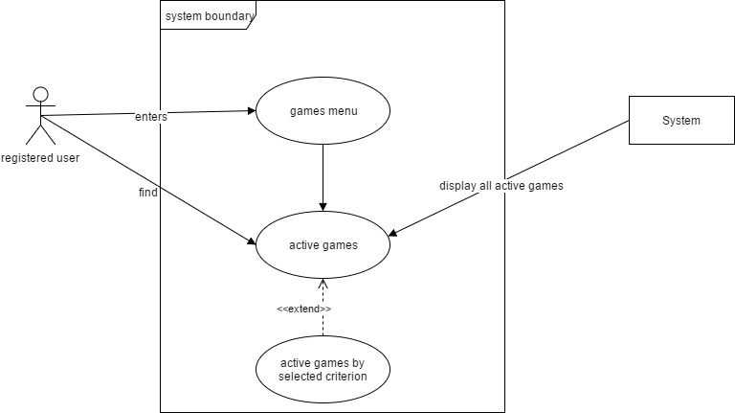

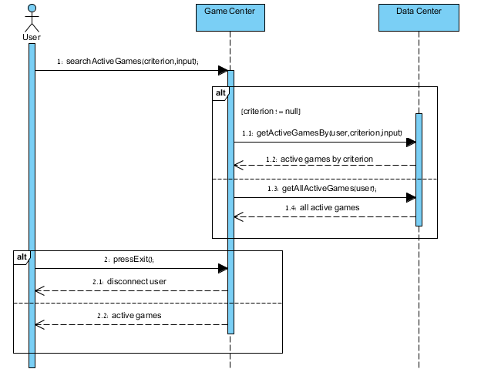**Sequence Diagram**

**Activity Diagram**

