**Use Case Scenario**

1. **Use case**: Leave a game.
   1. **Brief description**: Allow the user to leave the game and redirect him to game center.
2. **Actors**: Primary – registered user, secondary – GameService, Game
3. **Precondition**:
   1. The user is logged in
   2. The user is spectating game or playing.
4. **Post-condition**:
   1. The user left the game.
5. **Flow of Events**:
   1. **Basic Flow**:
      1. The user selects to leave.
      2. The system redirects the user to the game center.
   2. **Alternate Flows**:

None

**Acceptance Test Scenarios**

**Use case**: Leave a game.

1. **Good**:
   1. The user left the game: The user selects leave and selects "Leave" option, then the system redirect the user to the games Center.
2. **Bad**:
   1. Force quit: The game doesn’t respond and the user must force quit
3. 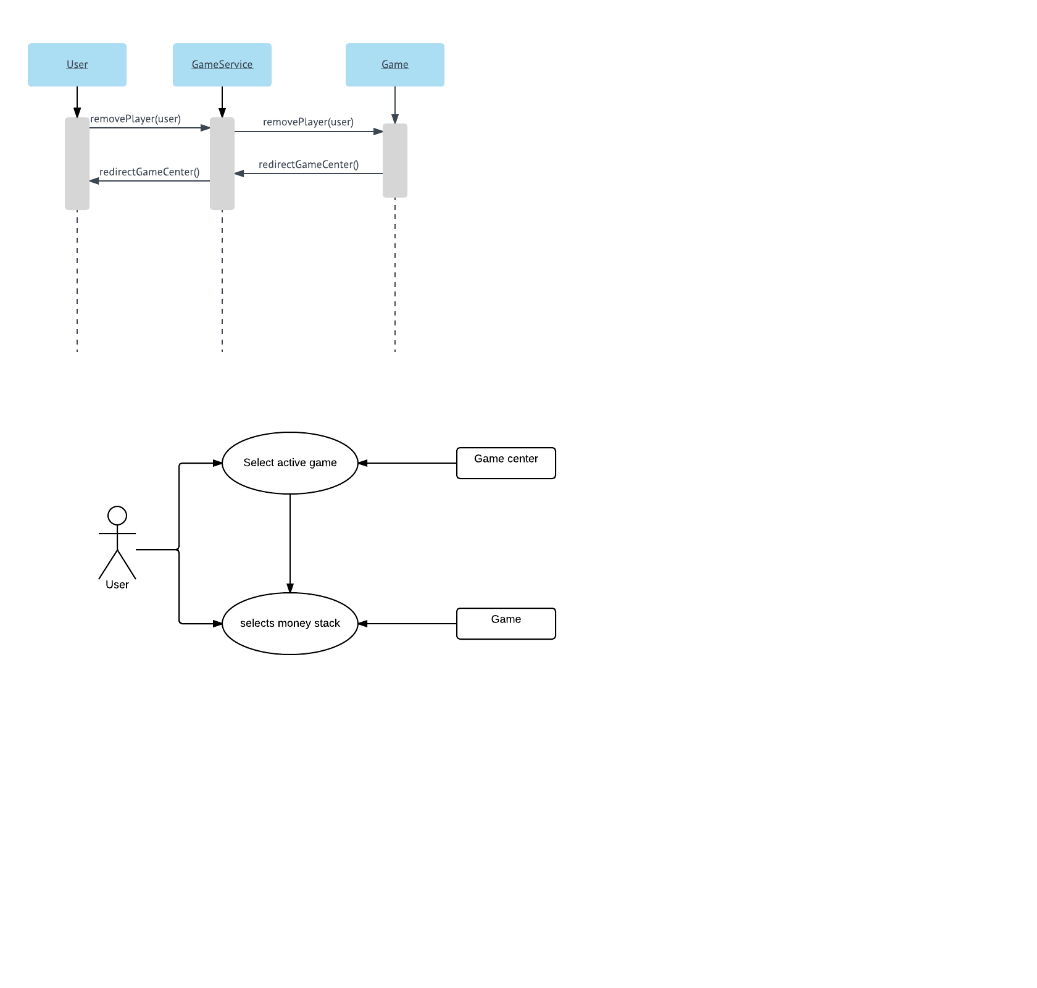**Sad**: