**Use Case Scenario**

1. **Use case**: User login to the system.
   1. **Brief description**: Allow the user to login to the game system. The user enters his username and password, and after successful authentication, he is logged in.
2. **Actors**: Primary – registered user, secondary – Texas Hold’em system, data center.
3. **Precondition**:
   1. The user is logged out.
   2. The user is a registered user.
4. **Postcondition**:
   1. The user is logged in.
5. **Flow of Events**:
   1. **Basic Flow**:
      1. User logs in with username and password.
      2. The system validates the entered credentials
      3. The system logs in the user into the Texas Hold’em system.
   2. **Alternate Flows**:
      1. Invalid Username / Password  
         If in the basic flow the user enters invalid username and/or password, the system will return a user login failure result. The actor can then choose to cancel the login and exit the system, in which case the flow is finished with no changes to the current session, or to retry the login and return to the beginning of the basic flow.

**Acceptance Test Scenarios**

1. **Use case**: User login to the system
2. **Good**:
   1. Successful login to the system: The registered user enters legit username and password and is logged into the Texas Hold’em system.
3. **Bad**:
   1. Max amount of characters: The user enters more than the maximum allowed characters to the username and/or password field, AF Invalid Username / Password is activated.
4. **Sad**:
   1. Invalid username / password: The user entered an incorrect combination username or password, AF Invalid Username / Password is activated.

**Use Case Diagram**

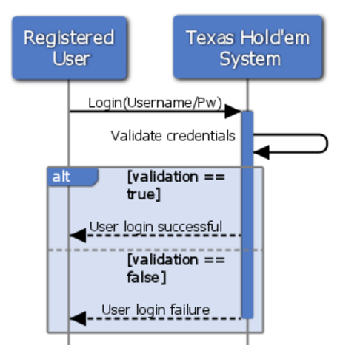

**Use Case Scenario**

1. **Use case**: User logout of the system.
   1. **Brief description**: Allow the user to logout of the system. The user clicks the “Logout” button and the session is terminated.
2. **Actors**: Primary – registered user, secondary – Texas Hold’em system
3. **Precondition**: The user is logged in
4. **Postcondition**: The user is logged out.
5. **Flow of Events**:
   1. **Basic Flow**:
      1. User logouts
      2. The system terminates the current session
      3. The system returns logout result
   2. **Alternate Flows**: None

**Acceptance Test Scenarios**

1. **Use case**: User logout of the system.
2. **Good**:
   1. Successful logout of the system: The registered user clicks “Logout,” and the system terminates the user’s session and redirects him to the login menu.
3. **Bad**:
   1. Force quit: The game doesn’t respond and the user has to force quit without logging out properly.
4. **Sad**:
   1. Quitting without logging out: The user exists the program without logging out.

**Use Case Diagram**

