**Use Case Scenario**

1. **Use case**: Maintain leagues.
2. **Brief description**: managing which users are in which league at any given moment
3. **Actors**: Primary – The League Center, secondary – user.
4. **Precondition**: Game just ended.
5. **Postcondition**: User has been placed in the appropriate league.
6. **Flow of Events**:
   1. **Basic Flow**:
      1. The system checks the current state of the user's points.
      2. The system finds the appropriate league for the user.
      3. The system place the user in this league.
   2. **Alternate Flows**:
      1. New user:  
         New user has been registered to the system. The system place him in the lowest league.
      2. Lack of activity:

When a user login to the system and hasn't logged in to the system over a week, the system place him in one league lower than his previous league.

**Acceptance Test Scenarios**

1. **Use case**: Maintain leagues.
2. **Good**:
   1. New user placed in the lowest league: The user registered successfully to the system, and placed in the first league.
   2. Change in user points: The user has gained some points after a game, the system successfully placed him in the appropriate league.

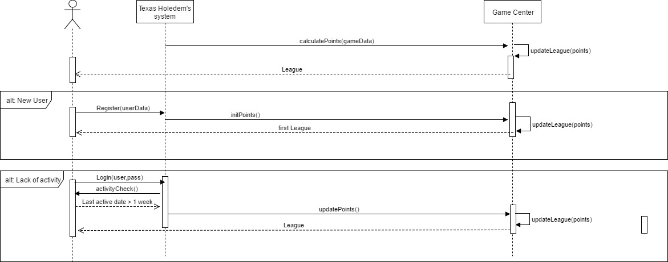**Sequence Diagram**