**Use Case Scenario**

1. **Use case**: Set criteria for moving to a new league.
2. **Brief description**: Set the Minimum ranking of league.
3. **Actors**: Primary – The Game Center, secondary – Highest ranking user.
4. **Precondition**: The user has the highest ranking
5. **Postcondition**: League criteria changed.
6. **Flow of Events**:
   1. **Basic Flow**:
      1. The user calls modifyLeague(league,newRank).
      2. The System checks if there are any leagues with the same rank as newRank.
      3. The System change the minimum Rank of the chosen league.
      4. The System return feedback to the user.
   2. **Alternate Flows**:
      1. League with the same rank already existed:  
         The system doesn't change the league, and return negative feedback to the user.

**Acceptance Test Scenarios**

1. **Use case**: Modify Criteria.
2. **Good**:  
   1.1 New Rank: The user enters a rank that not in use in another league. The league rank is update successfully.
3. **Bad:**
   1. The user enters a not existed league.
4. **Sad:**

3.1 The user enters an already in use rank.

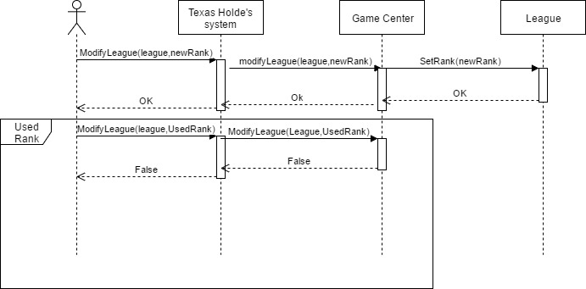**Sequence Diagram**