**Use Case Scenario**

1. **Use case**: Move Players between leagues.
2. **Brief description**: Move player from his current league to the chosen league.
3. **Actors**: Primary – The Game Center, secondary – Highest ranking user.
4. **Precondition**: The user has the highest ranking
5. **Postcondition**: League criteria changed.
6. **Flow of Events**:
   1. **Basic Flow**:
      1. The user calls ChangeLeague(User,newLeague).
      2. The System remove the user from his current league.
      3. The System adds the user to the chosen League.
      4. The System return feedback to the user.
   2. **Alternate Flows**:
      1. .

**Acceptance Test Scenarios**

1. **Use case**: Move Players between leagues.
2. **Good**:  
   1.1 New Rank: The user enters a rank that not in use in another league. The league rank is update successfully.
3. **Bad:**
   1. The user enters a not existed league.
4. **Sad:**

3.1 The user enters an already in use rank.

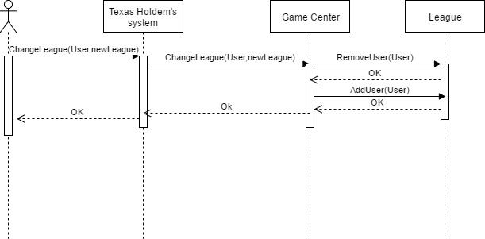**Sequence Diagram**