**Use Case Scenario**

1. **Use case**: User watch a replay games that are no longer active.
   1. **Brief description**: Allow the user to watch a replay games that are no longer active.  
      The user select a game that are no longer active from no active games list, after the selection the user watch the game.
2. **Actors**: Primary – registered user, secondary – Texas Hold’em system.
3. **Precondition**: The user is logged in.
4. **Postcondition**: The user watch a replay game.
5. **Flow of Events**:
   1. **Basic Flow**:
      1. The user selects a game that no longer active.
      2. The system returns a replay of the selected game.
   2. **Alternate Flows**:
      1. CANCEL  
          The user can cancel the flow any time.   
          In such case the system stops the replay and return the user to initial menu.
      2. EXIT  
          If the user decided to exit the application, the user disconnect from the system.

**Acceptance Test Scenarios**

1. **Use case**: User watch a replay games that are no longer active.
2. **Good**:
   1. User success to watch a replay game: select a game that are no longer active.
   2. User cancel the flow: AF CANCEL is activated.
   3. User exit the application: AF EXIT is activated.
3. **Bad**:
4. **Sad**:  
   4.1.

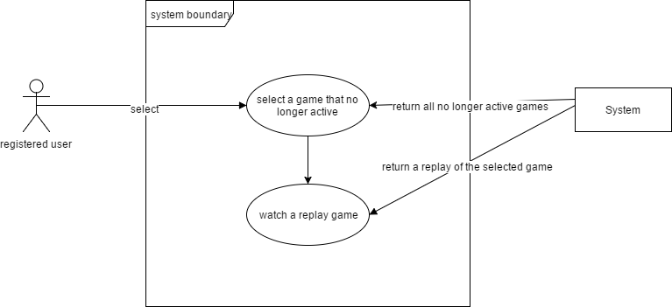**Use Case Diagram**

**System sequence diagram**

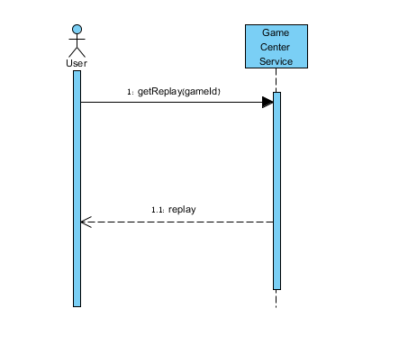

**Detailed sequence diagram**

