**Use Case Scenario**

1. **Use case**: User Save favorite turns from replays.

* 1. **Brief description**: Allow the user to save favorites turns from a replays games.  
     The user select favorite turns to be saved, after the selection the system save those turns to be viewed on later occasions.

1. **Actors**: Primary – registered user, secondary – Texas Hold’em system.
2. **Precondition**: The user watch a replay game.
3. **Postcondition**: The favorite turns are save in system.
4. **Flow of Events**:
   1. **Basic Flow**:
      1. The user select favorite turns from current running replay game.
      2. The system save selected favorite turns for later occasions.
   2. **Alternate Flows**:
      1. Already save  
         The user select favorite turns that already saved.  
         In such case the system notify the user that those turns is already saved  
         and don't save twice the same turns.
      2. CANCEL  
          The user can cancel the flow any time.   
          In such case the system stop the saving and continue the replay.
      3. EXIT  
          If the user decided to exit the application, the user disconnect from the system.

**Acceptance Test Scenarios**

1. **Use case**: User save favorite turns from replays**.**
2. **Good**:
   1. User success to save selected turns.
   2. User select favorite turns that already saved: AF Already save is activated.
   3. User cancel the flow: AF CANCEL is activated.
   4. User exit the application: AF EXIT is activated.
3. **Bad**:
4. **Sad**:

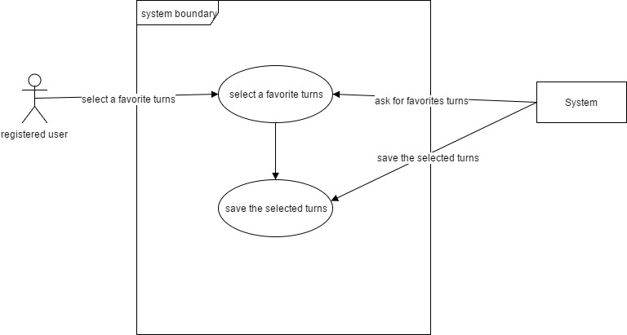**Use Case Diagram**

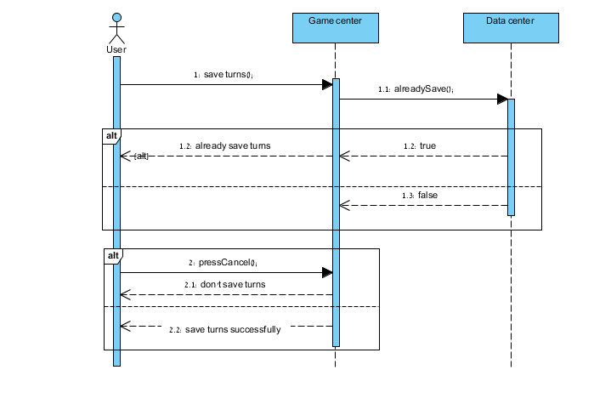**Sequence** **Diagram**

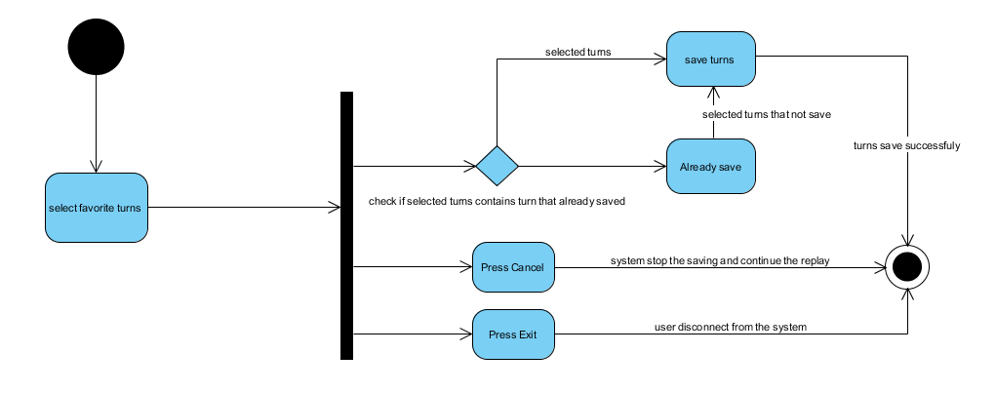**Activity Diagram**