**Use Case Scenario**

1. **Use case**: Spectate active game.
   1. **Brief description**: Allow the user to spectate an active game without playing in the game.
2. **Actors**: Primary – registered user, secondary – Texas Hold’em system, Game center, Game
3. **Precondition**:
   1. The user is logged in
   2. The user is a registered user.
4. **Post-condition**:
   1. The user is spectate active game.
5. **Flow of Events**:
   1. **Basic Flow**:
      1. The user selects **spectate Games** Option.
      2. The user selects game from active games.
      3. The system redirect the user to the game.
   2. **Alternate Flows**: None.

**Acceptance Test Scenarios**

1. **Use case**: User Spectate active game.
2. **Good**:
   1. The user spectate an active game: The user selects active game and selects "spectate" option, the system redirect the user to the game page as a spectator.
3. **Bad**:
   1. Force quit: The game doesn’t respond and the user has to force quit
4. 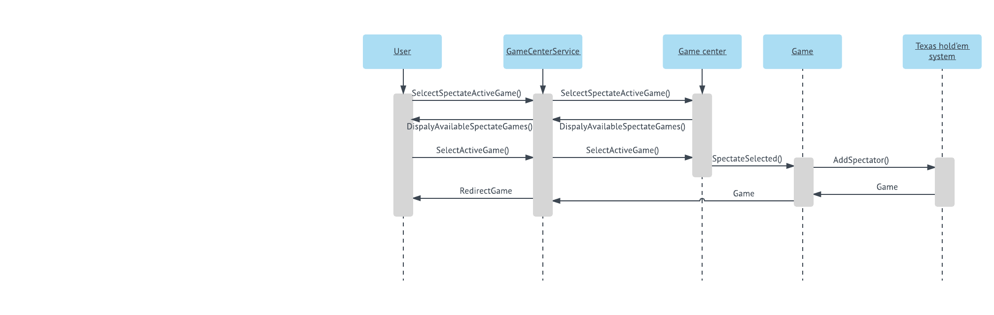**Sad**: None