**Use Case Scenario**

1. **Use case**: Information storing.
   1. **Brief description**: Store all the information from a game, such as: actions performed by all players in the game, the cards dealt at each round, round beginning and end, etc.
2. **Actors**: Primary – Information Center, secondary – Game Center.
3. **Precondition**:
4. **Postcondition**:
5. **Flow of Events**:
   1. **Basic Flow**:
      1. When game is ended, the game center send the game log to the Info Center.
      2. The Info Center parse the game log, and compute the statistical information.
      3. The Info Center saves the game log, and updates the user statistics.
   2. **Alternate Flows**:

**Acceptance Test Scenarios**

1. **Use case**: Information storing
2. **Good**:
   1. Blah.
3. **Bad**:
   1. Blah.
4. **Sad**:
   1. Blah
   2. Blah

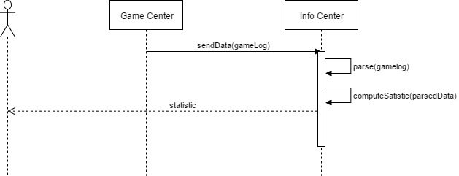**Use Case Diagram**