1. Show a result of Josephus Problem for 7 soldiers.

Display in the console log below

* 1. *1 Kills 2*
  2. *3 Kills 4*
  3. *5 Kills 6*
  4. *7 Kills 1*
  5. *3 Kills 5*
  6. *7 Kills 3*
  7. *7 Remains alive*

2)(EXAM) Solve sudoku

Start

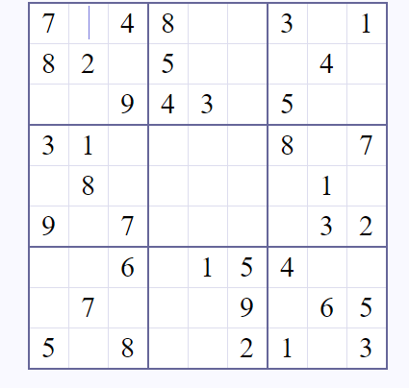

Solution

