**1.0. Adaptation from template**

The w3css ‘start page’ template (look at reference section) was adapted to design the homepage of the Book Program Discussion (BPD)website.

Specifically, the ‘Quote of the day’ section and the footer section from the template were the sections retained in the high-fidelity prototype.

* 1. **Overview of homepage**

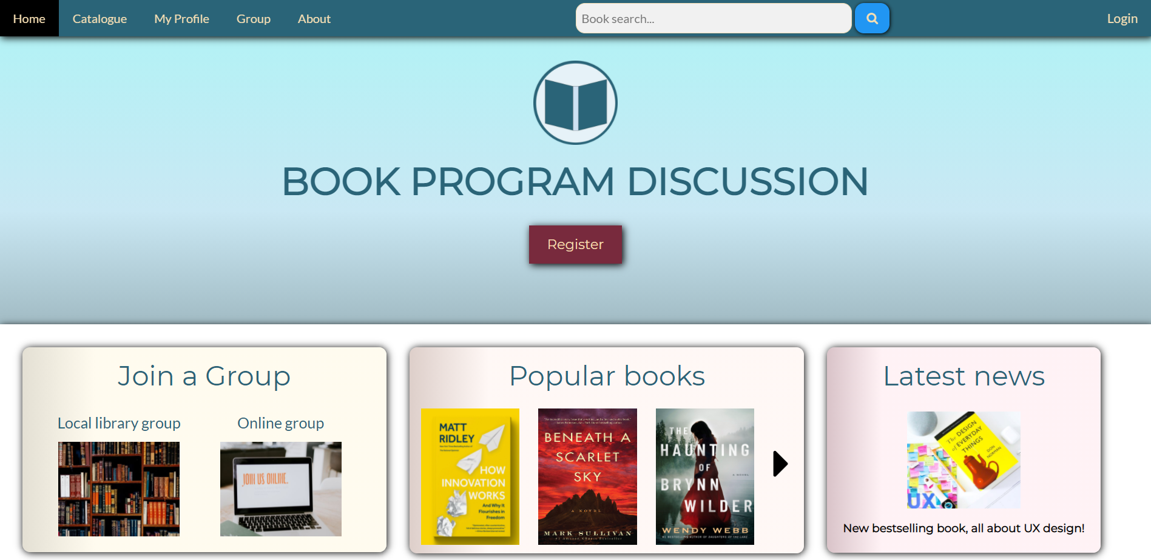

Figure 1: Homepage

The homepage consists of the navigation bar at the top of the page, a header banner which contains the name of the website and the ‘Register’ button for the website, a three box grid which contains useful content items for the website, a novelty quote banner and lastly a footer which contains links to social media for the book program discussion (BPD) organisation.

* 1. **Overview of registration form**

In accordance with the brief, the registration form is a modal window which opens when the ‘Register’ button of the homepage is clicked. The registration form has the BPD logo and the title of the form at the top of the window. It also contains a close button on the top right of the window. The registration form consists of three main sections: the user details section, the contacts section and the addresses section. For each of these sections, the title of the section is not given in the form since it adds content to the page that does not add any overall value to the registration form.

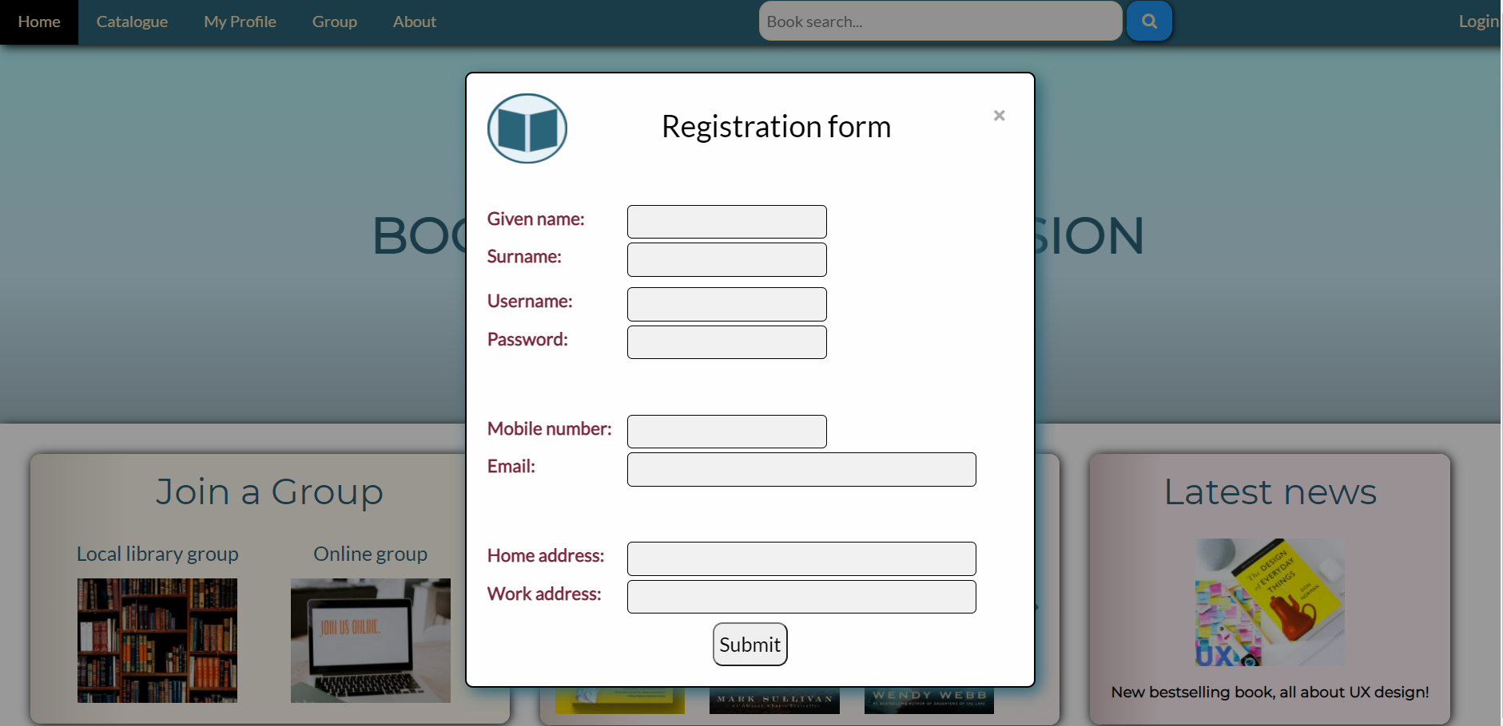

Figure 2: Registration form

* 1. **Placeholder logo**

The place holder logo was designed primarily with the specified assigned colour (AC), 2A6478. The logo consists of a simple book cover surrounded by a circle which provides closure to the logo. The background of the logo is the lightest tint colour variation of the AC.

Figure 3: Logo

This logo was chosen as the placeholder logo because it summarises the main feature of the website, books, but is also minimalistic such that it does not overshadow the rest of the high-fidelity prototype. Additionally, since it employs the assigned colour, it fits well aesthetically with the colour scheme of the high-fidelity prototype.

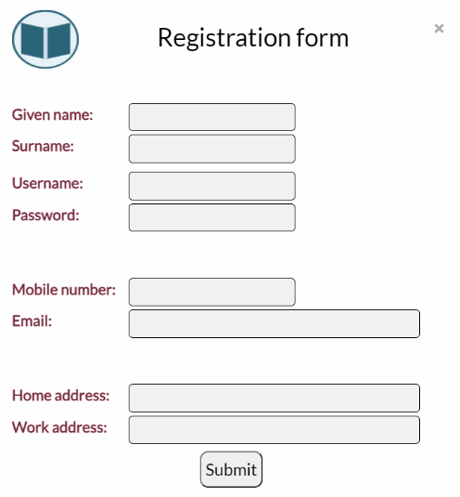**2.0. Application of Gestalts principles**

Figure 4

Gestalts principles were used throughout the design of this high-fidelity prototype in order to alleviate a user’s experience with the homepage and the registration form of the BPD website.

In accordance with Gestalts proximity principle, the input fields of the registration form that are from the same section were placed in close proximity to each other, as seen in *Figure* *4* on the right. This will allow the user to break down the form into its three main components so the user is able to easily digest what information the registration process is asking them to provide.

To respect Gestalts common fate principle, the labels and the text boxes for all input fields of the registration form start from the same x-axis line. This can be seen in *Figure 4* above. Additionally there are only two different length of input fields in the registration to signify that there are only two fundamental input answer lengths being asked of the user. By applying the common fate principle the complexity of the registration form is decreased as the user is able to divide the window into simpler components.



Figure 5

The navigation bar adheres to Gestalts similarity principle as all the buttons have a consistent style. This means that buttons, such as the ‘Login’ button, that are quite distant to its family of buttons can still be related back due to the similarity of their design.



Figure 6

The header banner of homepage is a strong advocate of Gestalts symmetry principle as all its elements are situated centrally with equal weighting applied on both sides of it. Symmetry creates holistic harmony and makes sure that the user’s attention falls on the overall page first and does not get preoccupied by the busier sections of the page.

**2.1. Design principle: Balance**

Balance is most prominently achieved in the homepage by designing major sections of the page to be symmetrical. This includes the header banner, the ‘quote of the day’ section and the footer of the page. as seen in *Figure 1* above.

For asymmetrical sections of the page, balance was achieved by distributing the optical weight the internal elements of the section as evenly as possible. This can be seen with the placement of the components of the navigation bar, which despite its asymmetry is able to achieve good balance.



Figure 7

The placing of the search bar, as seen in *Figure 7* above, helps add much needed optical weight to the right-side of the navigation bar and creates more balance overall in the navigation bar.

**2.2. Design principle: Emphasis**

To add emphasis to certain sections and elements of the homepage, drop shadows were used along with other techniques such as positioning and careful consideration of relative size and colour of different elements.



Figure 8

For example the ‘Register’ button, as seen in *Figure 8* above, is placed on the centre of the header banner and is the only element of the banner that has a drop shadow. Additionally, the colour scheme of the button is split-complementary to the blue of the rest of the elements (also the assigned colour) and hence immediately contrasts the rest of the section.

The register button was emphasised because it helps achieve the primary task of the high-fidelity prototype of making a user open and complete a registration form.



Figure 9

Another user of emphasis in the page would be the search button icon which stands out from its darker blue background and helps the user locate the book search bar of the page. This is so that a user that is specifically looking for a particular book in the BPD database they can do so as efficiently as possible.

**2.3. Design principle: Unity**

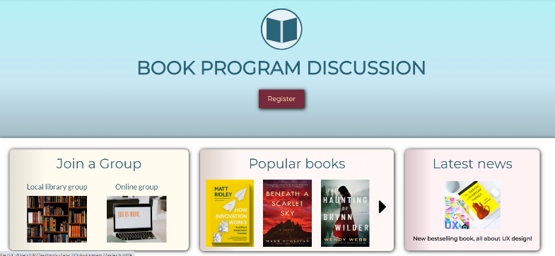There are two key concepts that help provide unity in the homepage: the use of gradients in the content parts of the page and the use of drop shadows in most of the elements of the page.

Figure 10

The use of a gradient background for the header banner of the page and the content grid boxes below it, establish a design trend in the majority of the homepage, thus improving the unity of the page. This can be seen in *Figure 10* on the right.

Drop shadows were also present throughout the homepage as well as the registration form and helped establish the depth of different page elements. These drop shadows were another point of unity as they built on the user’s overall understanding of the homepage without adding any extra information to the page.

**2.4. Colour scheme**

The assigned colour for the assigned colour (AC) for the homepage was “2A6478”, *Figure 11* on the right.

Figure 11: Assigned colour

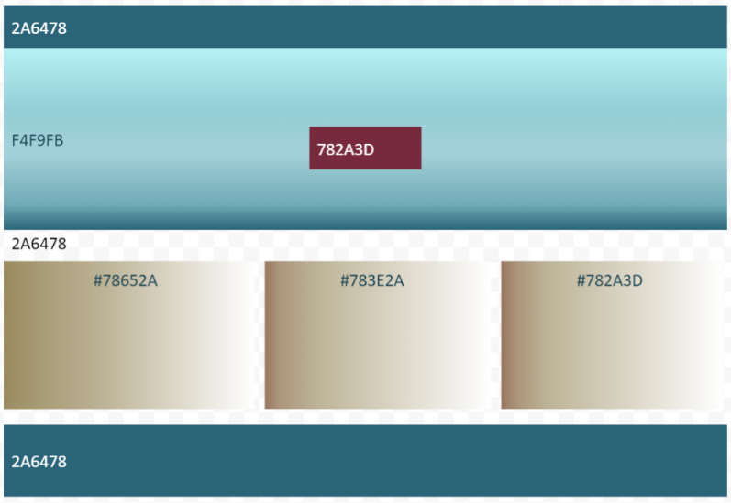The background colour selection for the majority of the content of the page was done with respect to the AC, this can be seen in *Figure 12* on the right.

Figure 12

The navigation bar and the ‘Quote of the day’ was of the AC. The header banner was a gradient from the AC to the lightest tint colour variation of the AC.

The register button on the middle of the header banner was the darker split complementary colour to the AC. This made the button stand out while also making the overall page more vibrant.

Lastly the three colours used for the content grid boxes were gradients of the lighter split-complementary colour to the AC, the complementary colour to the AC and the darker split-complimentary colour to the AC, respectively. Split-complementary/complementary colours help add brightness to the page without causing too much tension when they are used in supplement with the major colour (oberlo.com). Hence, this concept was applied on the AC for the homepage.

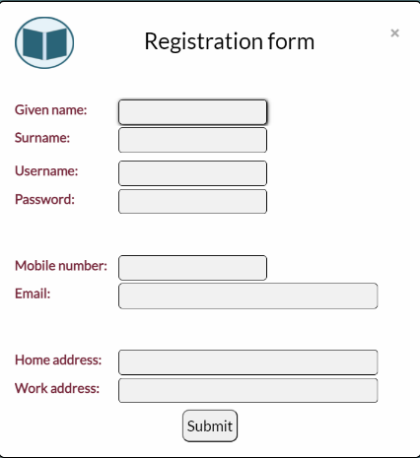For the registration form, the logo introduced the assigned colour to the modal window. The only other colour, barring black, grey and white, was the darker split-complementary colour of the assigned colour, 782A3D. The use of this colour for the labels of the input fields contrasted them well with the background of the form.

Figure 13

No other vibrant colours were used for the registration form to reduce the visual load of the window so that the user can concentrate on filling out the form correctly.

**2.5. Accessibility considerations**

**2.5.1. Colour accessibility**

|  |  |
| --- | --- |
| **Element** | **Colour contrast** |
|  | 15.98:1 |
|  | 5:1 |
|  | 7.27:1 |
|  | 6.19:1 |
|  | 6.39:1 |
|  | 6.22:1 |
|  | 6.07:1 |
|  | 19.4:1 |
|  | 9.55:1 |

Figure 14: Colour accessibility table

All textual elements passed the colour contrast test and had a colour contrast ratio of above 4.5.

**2.5.2. Keyboard accessibility**

All elements of the homepage as well as the webpage are accessible using just the keyboard. Additionally, all visual elements of the page, such as buttons and images, have a title that describes their functionality and relevance to the user. This ensures that those users that utilise screen readers can navigate the functionality of the homepage and the registration form with ease.

**3.0. References**

**Template:** <https://www.w3schools.com/w3css/tryw3css_templates_start_page.htm>

**Images:**

Book 1 – <https://unsplash.com/photos/H-LIL57PHCc>

Book 2 - https://i.gr-assets.com/images/S/compressed.photo.goodreads.com/books/1523909873l/38321944.jpg

Book 3 - https://i.gr-assets.com/images/S/compressed.photo.goodreads.com/books/1591946396l/

50720434.jpg –

Local library group – https://unsplash.com/photos/NIJuEQw0RKg

Online group – https://unsplash.com/photos/EeS69TTPQ18

Latest news – https://unsplash.com/photos/89WgWuyK2Jo

**Colour scheme design:** https://www.oberlo.com/blog/color-combinations-cheat-sheet