**NITTE MEENAKSHI INSTITUE OF TECHNOLOGY**

(AN AUTONOMOUS INSTITUTION, AFFILIATED TO VISVESVARAYA TECHNOLOGY UNIVERSITY, BELGAUM,

APPROVED BY AICTE &amp; GOVT OF KARNATAKA)



**PHASE-1 PROJECT REPORT [21-CSP40]**

On

**OBJECT DETECTION USING SENSORS IN IOT**

*Submitted in partial fulfilment of the requirements for the award of Degree of*

Bachelor of Engineering

*in*

*Computer Science and Engineering*

Submitted by:

Chandana G P 1NT20CS405

Niveditha G 1NT20CS412

Rakshita Joshi 1NT20CS413

Under the Guidance of

Mr. Vinay T R

Assistant Professor,

Dept. of CS&E, NMIT



**Department of Computer Science and Engineering**

(Accredited by NBA Tier-1)

**2021-2022**

**NITTE MEENAKSHI INSTITUTE OF TECHNOLOGY**

(AN AUTONONOMUS INSTITUTION, AFFLILIATED TO VISVESVARAYA TECNOLOGICAL UNIVERSIT, BELGAUM, APPROVED BY AICTE &amp; GOVT.OF KARNATAKA)

Department of Computer Science and Engineering

**(Accredited by NBA Tier-1)**



**CERTIFICATE**

This is to certify that the Project title is an authentic work carried out by name Chandana G P(1NT20CS405), Niveditha G(1NT20CS412), Rakshita Joshi(1NT20CS413) bonafide students of Nitte Meenakshi institute of Technology, Bangalore in partial fulfilment for the award of the degree of Bachelor of Engineering in COMPUTER SCIENCE AND ENGINEERING of Visvesvaraya Technological University, Belagavi during the academic year 2021-22. It is certified that all correction and suggestions indicated during the internal assessment has been incorporated in the report. This project has been approved as it satisfies the academic requirement in respect of project work presented for the said degree.

**Internal Guide Signature of the HOD Signature of Principal**

Mr. Vinay T R Dr. Sarojadevi H Dr. H.C. Nagaraj

Assistant Professor, Professor, Head, Principal,

Dept. CSE, NMIT, Dept. CSE, NMIT, NMIT,

Bangalore Bangalore Bangalore

Signature of Examiner (Internal) Signature of Examiner (SEE)

1. 1.

2. 2.

**DECLARATION**

We hereby declare that

1. The project work is our original work
2. This Project work has not been submitted for the award of any degree or examination at any other university/College/Institute
3. This Project Work does not contain other persons’ data, pictures, graphs or other information, unless specifically acknowledged as being sourced from other persons.
4. This project Work does not contain other persons’ writing , unless specifically acknowledged as being sourced from other researchers. Where other written sourced have been quoted, then:
5. Their words have been re-written but the general information attributed to them as been referenced;
6. Where their exact words have been used, their writing has been placed inside quotation marks, and referenced.
7. This Project Work does not contain text, graphics or tables copied and pasted from the Internet, unless specifically acknowledged, and the source being detailed in the thesis and in the Reference sections.

|  |  |  |
| --- | --- | --- |
| **NAME** | **USN** | **SIGNATURE** |
| Chandana G P | 1NT20CS405 |  |
| Niveditha G | 1NT20CS412 |  |
| Rakshita Joshi | 1NT20CS413 |  |

DATE:

**ACKNOWLEDGEMENT**

The Satisfaction and euphoria that accompany the successful completion of any task would be incomplete without the mention of the people who made it possible, whose constant guidance and encouragement crowned our effort with success. I express my sincere gratitude to our Principal Dr. H. C. Nagaraj, Nitte Meenakshi Institute of Technology for providing facilities . We wish to thank our HoD, Dr. Sarojadevi H. for the excellent environment created to further educational growth in our college. We also thank her for the invaluable guidance provided which has helped in the creation of a better project .

I hereby like to thank our Guide Mr. Vinay T R, Assistant Professor, Department of Computer Science & Engineering on his periodic inspection, time to time evaluation of the project and help to bring the project to the present form.

Thanks to our department Project coordinators. We also thank all our friends, teaching and non- teaching staff at NMIT, Bangalore, for all the direct and indirect help provided in the completion of the project.

|  |  |  |
| --- | --- | --- |
| NAME | USN | SGNATURE |
| Chandana G P | 1NT20CS405 |  |
| Niveditha G | 1NT20CS412 |  |
| Rakshita Joshi | 1NT20CS413 |  |

DATE:

**ABSTRACT**

IoT (Internet of Things) is a communication network that connects physical or things to each other or with a group all together. The use is widely popular nowadays and its usage has expanded into interesting subjects. Especially, it is getting more popular to research in cross subjects such as mixing smart systems with computer science and engineering applications together. Object detection is one of these subjects. Real-time object detection is one of the foremost interesting subjects because of its compute costs.Gaps in methodology, unknown concepts and insufficiency in mathematical modelling makes it harder for designing these computing algorithms. Algorithms in these applications can be developed with in machine learning and/or numerical methods that are available in scientific literature. These operations are possible only if communication of objects within theirselves in physical space and awareness of the objects nearby. Artificial Neural Networks may help in these studies. In this study, yolo algorithm which is seen as a key element for real-time object detection in IoT is researched. It is realized and shown in results that optimization of computing and analyzation of system aside this research which takes Yolo algorithm as a foundation point. As a result, it is seen that our model approach has an interesting potential and novely. Object detection is a computer technology innovation identified with computer vision and image processing that manages to identify occurences of semantic objects of a specific class, (for example, people, structures or vehicles) in digital images and videos. Well-informed spaces of object detection incorporate face identification and pedestrian face recognition. Object detection has applications in numerous spaces of computer vision, including image recovery and video surveillance. In its least complex structure, tracking can be characterized as a technique for finishing an article progressive picture casings to decide its overall development as for different items. As such, a tracker relegates predictable marks to be followed objects in various casings of video.

DECLARATION

ACKNOWLEDGEMENT

ABSTRACT

TABLE OF CONTENTS

CHAPTER 1: INTRODUCTION

1.1 Background

1.2 Brief history of Technology/concept

1.3 Applications

1.4 Research motivation and Problem statement

1.4.1 Research Motivation

1.4.2 Statement of the Problem

CHAPTER 2: LITERATURE SURVEY

2.1 Introduction

2.2 Related work

2.3 Study of Tools/Technology

2.4 Summary

CHAPTER 3: SYSTEM REQUIREMENTS SPECIFICATIONS

3.1 System Requirements

3.1.1 Hardware Requirements

3.1.2 Software Requirements

CHAPTER 4: DESIGN

4.1 Architectural Design

4.2 Dataflow Diagram

CHAPTER 5: IMPLEMENTATION

CHAPTER 6: CONCLUSION

CHAPTER 7: REFERENCES

**CHAPTER 1 : INTRODUCTION**

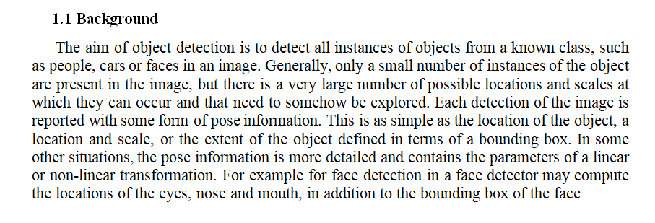

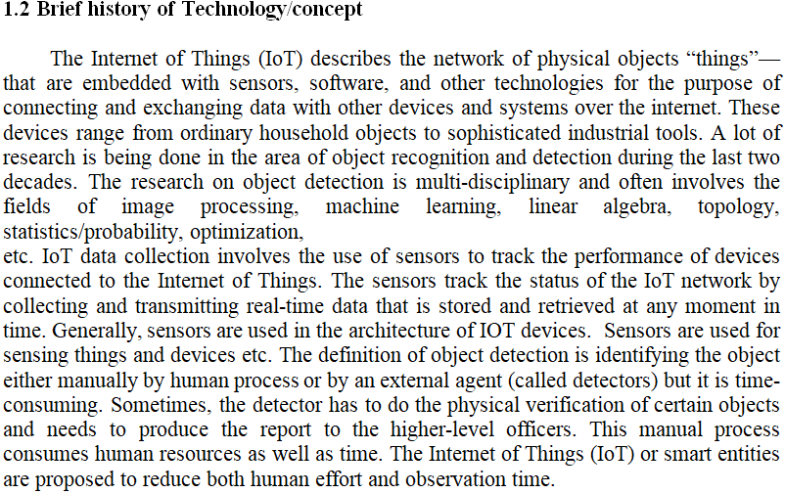

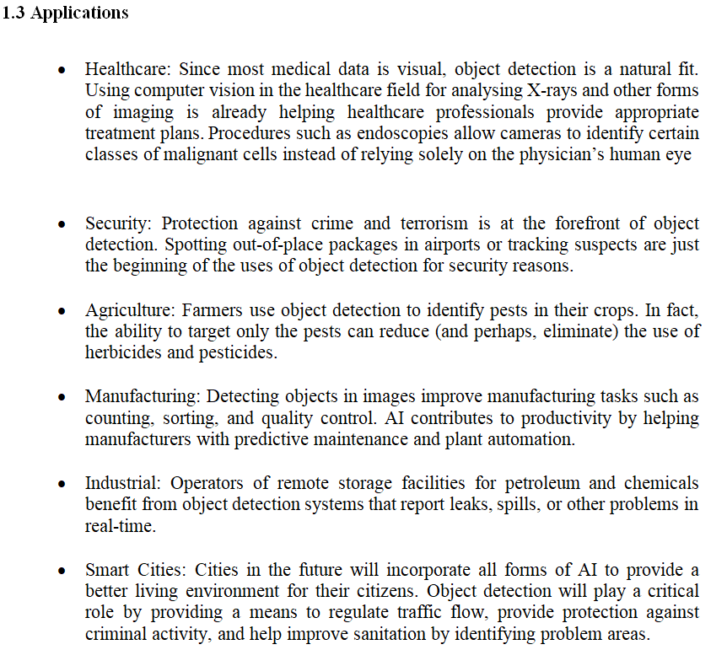

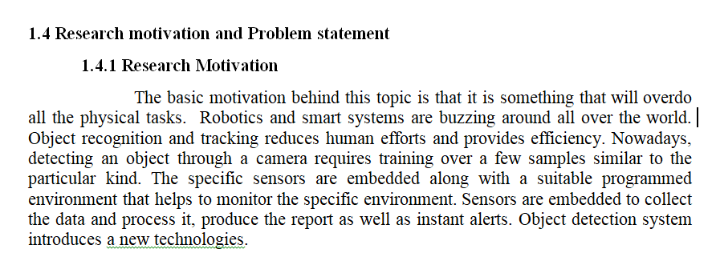

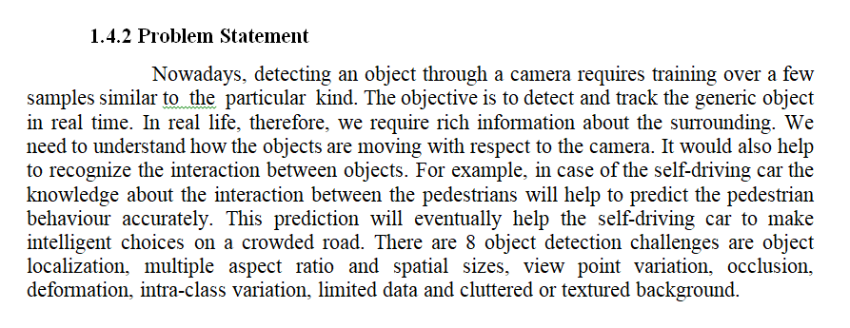

**CHAPTER 2: LITERATURE SURVEY**

**2.1 Introduction**

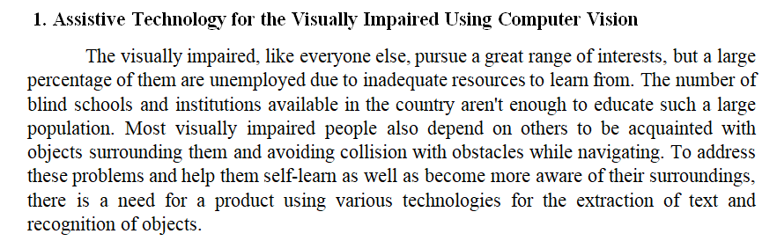

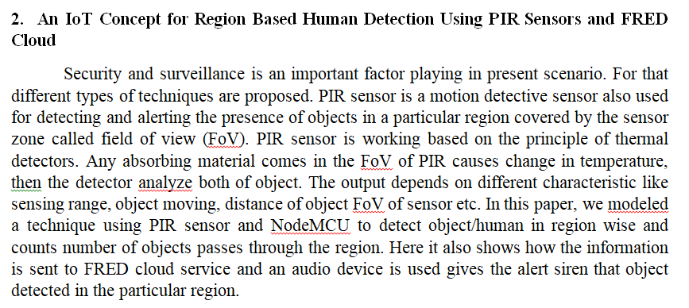

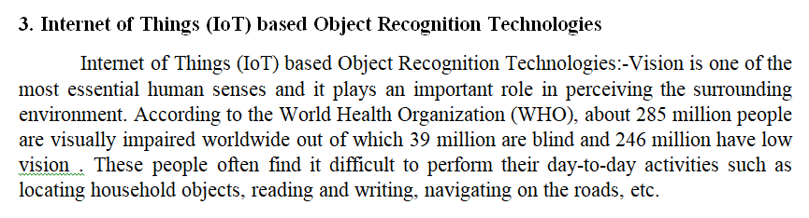

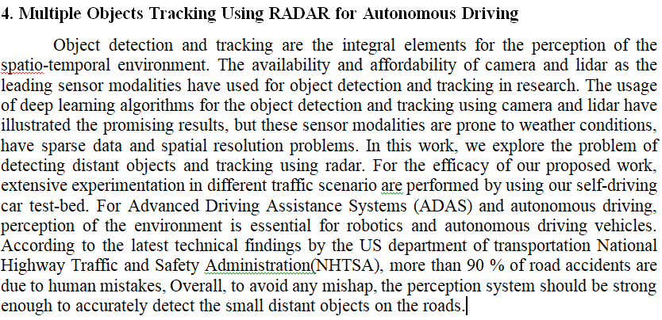

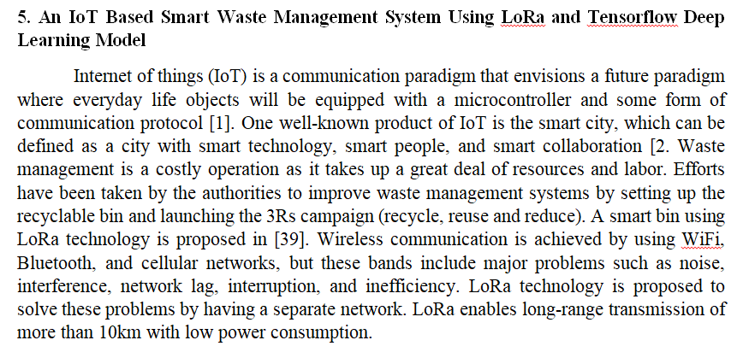

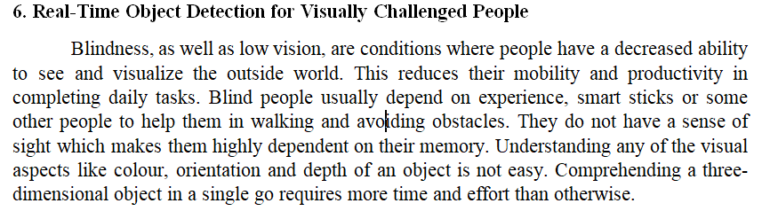

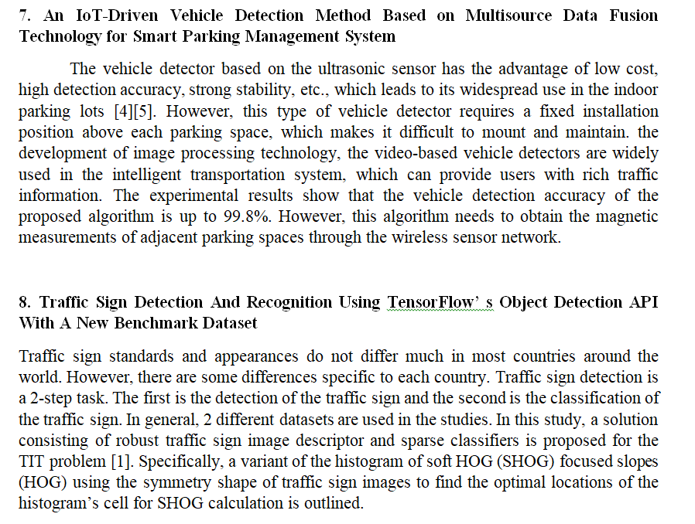

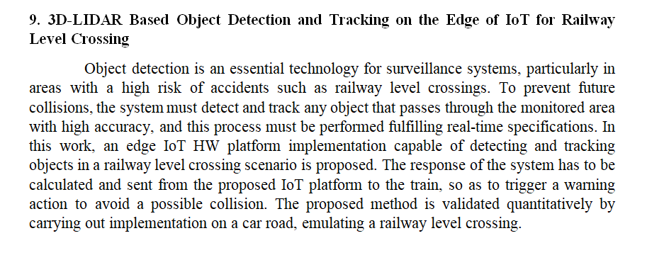

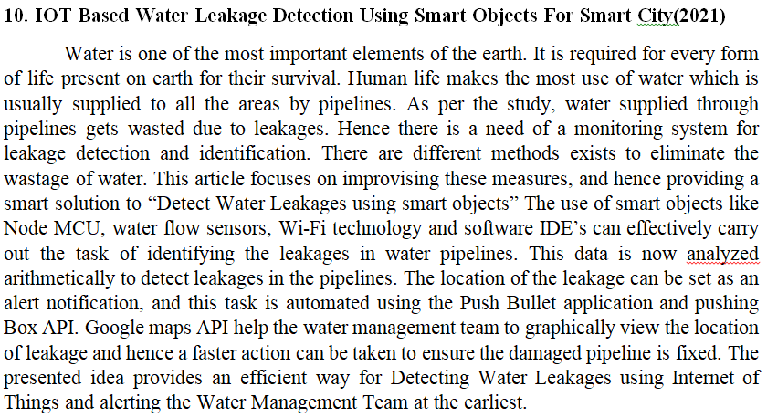

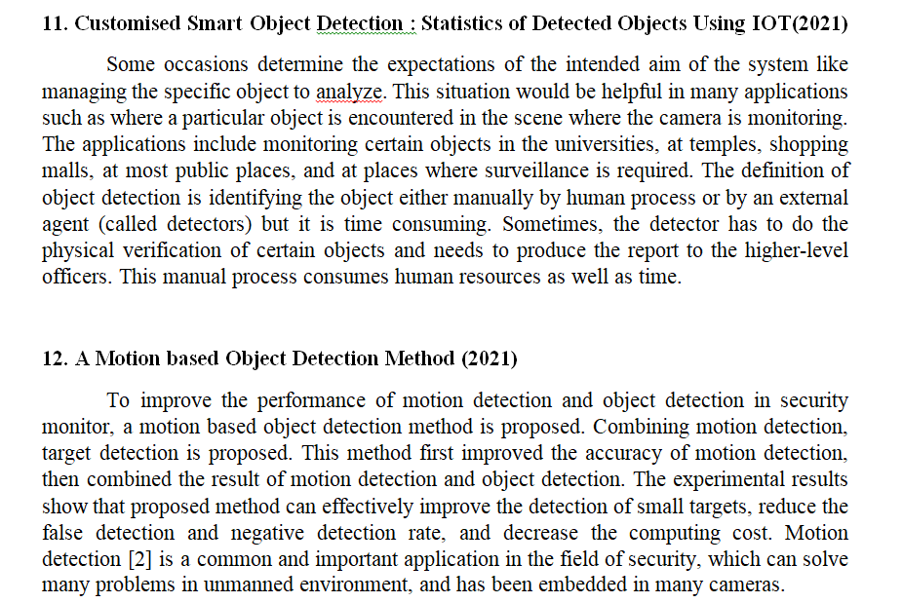

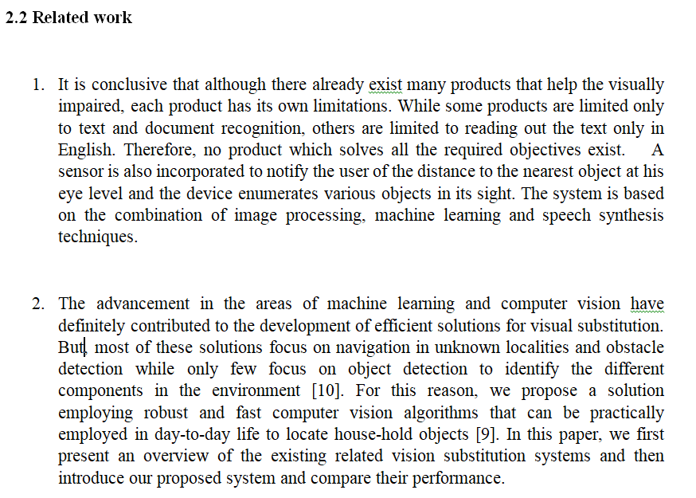

1. A wireless transceiver is one of the necessary electronic components for the WVDs. The wireless transceiver can not only achieve long-distance data interaction but also measure radio channel parameters. UWB is a wireless communication technology with the advantages of low cost and strong anti-interference ability, which can achieve wireless data interaction for the WVDs. Moreover, the UWB technology also has the function of measuring the Time-of-Flight (TOF) parameter of radio waves which can be used to calculate the length of the propagation path of radio waves.According to the electromagnetic theory, the presence of a vehicle in the wireless environment will affect the radio wave propagation paths, resulting in the change in TOF and energy of radio waves.
2. The application has a very simple and easily navigable As soon as the application is launched, the camera will start capturing the real time video. As soon as the user presses a button, the server-side backend algorithm will start processing it and notify the user accordingly as output audio.The software does not require an internet connection for its running and hence, it does not have any such dependency.The model achieved a maximum accuracy of 85.5% in mobile phones and 89 % in web applications. Though in most of the cases our model works accurately in detecting the different objects it may not work well in cases where the object is too close to the camera or is not a part of the trained dataset. The objects should not be too close to the camera frame and should be placed at a distance more than the focal length of the lens.
3. An IoT-based embedded system is proposed in. GSM communication technology is used as the platform to perform data transmission to the server. Web-based Android applications are developed to interface with a web server to provide information from sensors monitoring bin status, amount of waste in the bin, and time of waste collection. A second IoT-based smart bin is proposed in. It comes with three compartments, each with its own functionality: The first compartment consists of an infrared IR sensor and metal detector. The second compartment consists of an IR sensor and moisture sensor to detect dry and wet waste. The last compartment is subdivided into three bins for the collection of segregated waste respectively.

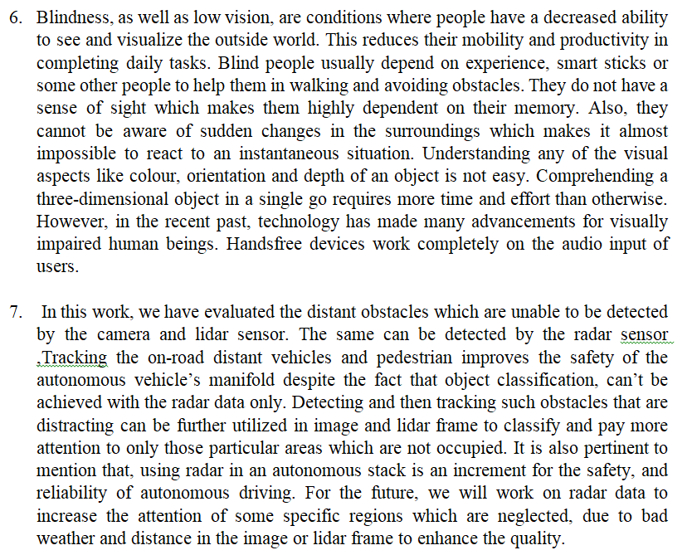

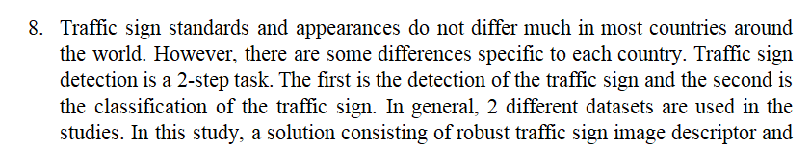

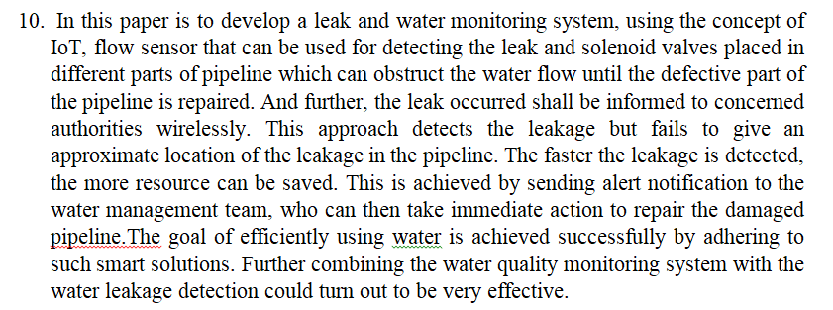

1. There are few approaches existed but they are not doing the proposed system objectives. The details such as first in which manually finding the objects by self or external monitoring and second are monitoring the output of the camera at the control room which is like the camera’s video is monitoring continuously and identify any odd behaviour or odd object will inform to the nearest vigilance entity to take up and follow up the work.
2. This advantage of motion detection is that there are more false positives and it is uncertain what target is in the detected area.The deficiency of object detection includes (1) hard to detect small object, (2) missed and false detection often occurs, (3) high computing cost.his method can effectively improve the detection of small objects, reduce the false alarm rate and decrease computing cost.

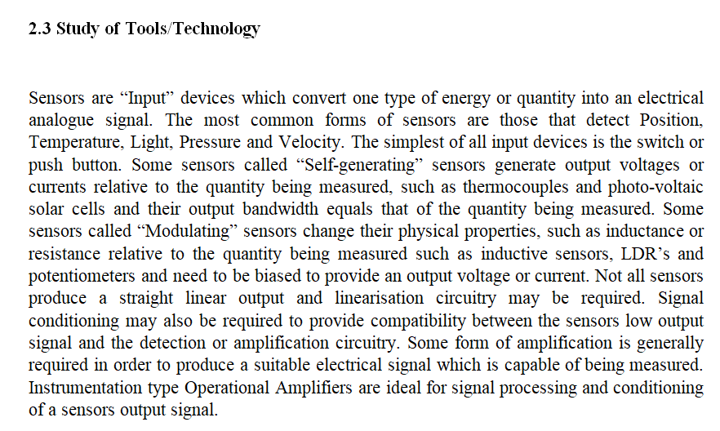

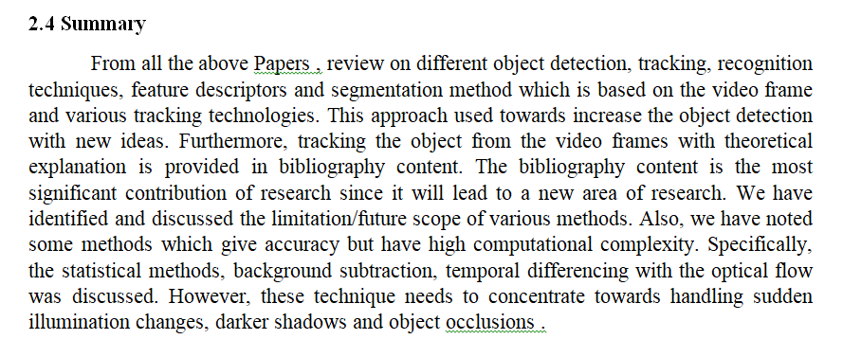

**CHAPTER 3: SYSTEM REQUIREMENTS SPECIFICATIONS**

3.1 System Requirements

3.1.1 Hardware Requirements

* Power Supply
* NodeMCU
* IR Sensor
* Ultrasonic Sensor
* Buzzer
* Vibration Module

3.1.2 Software Requirements

* Arduino IDE
* C/ C++

**CHAPTER 4: DESIGN**

**4.1 Architectural Design**

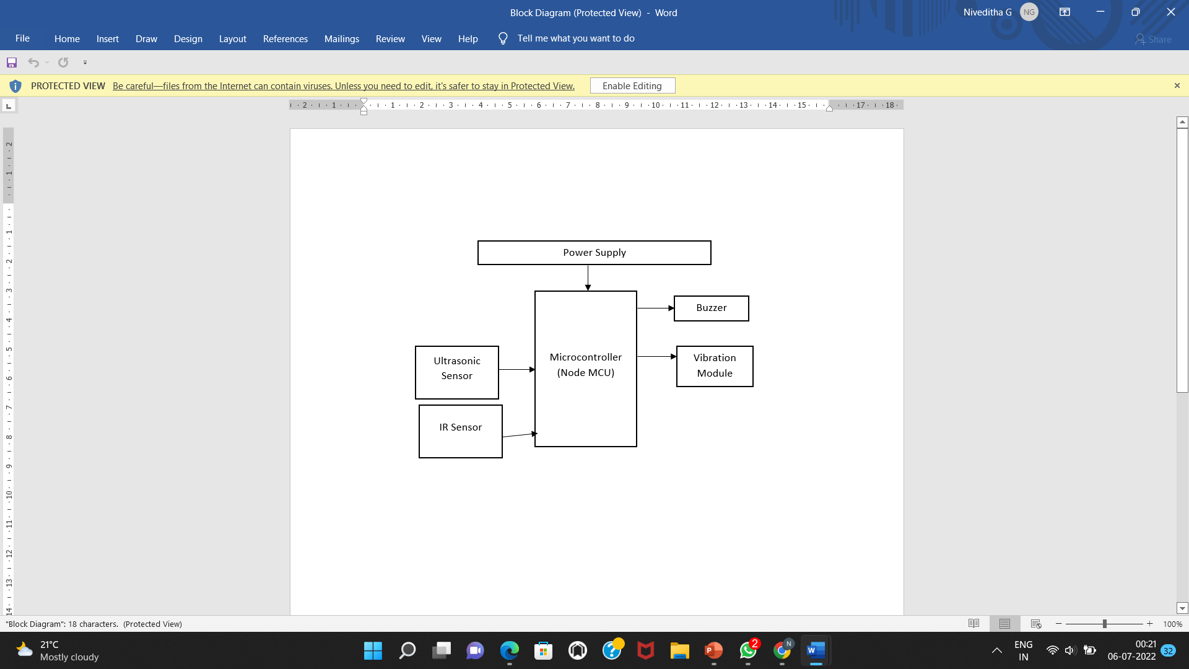

**4.2 Data Flow Diagram**

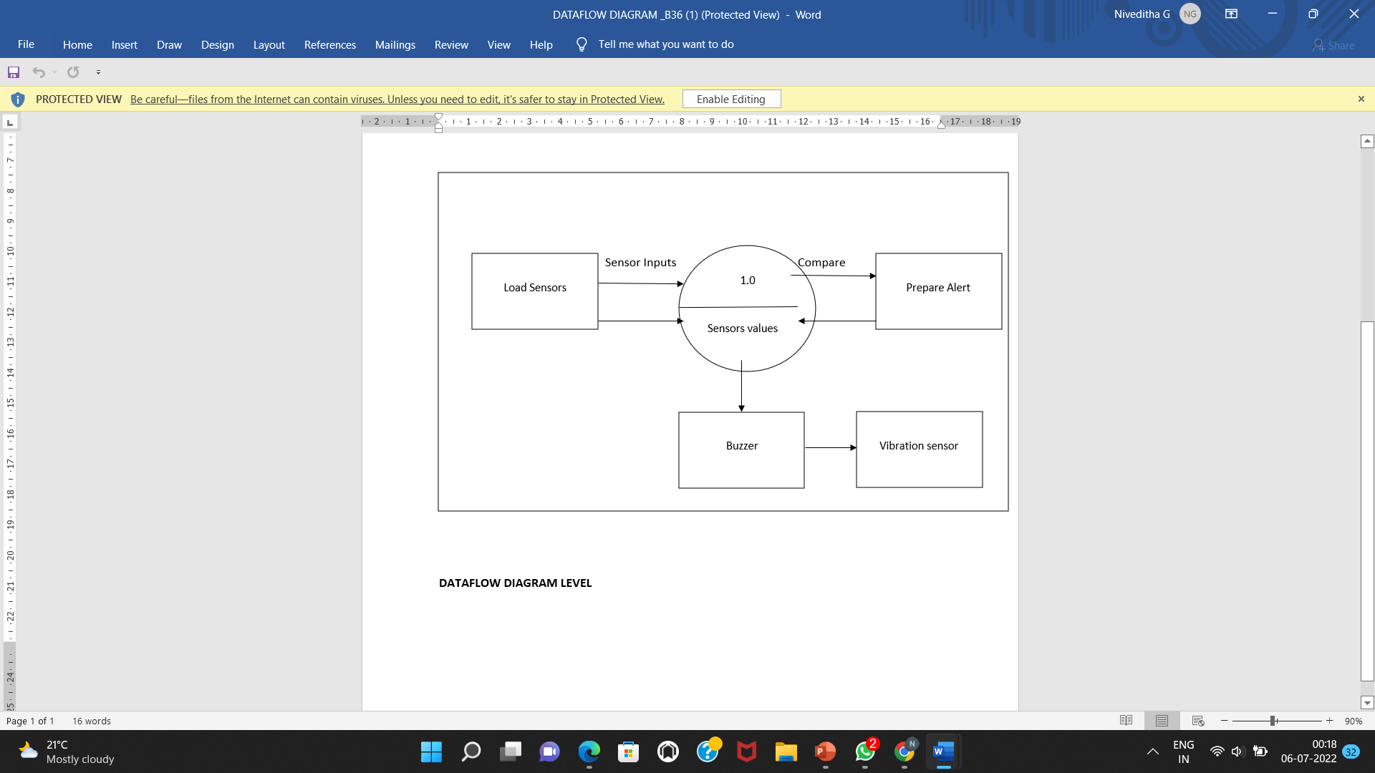

**CHAPTER 5: IMPLEMENTATION**

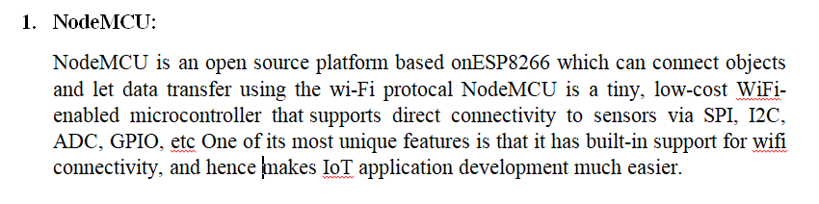

**Fig: Microcontroller (NodeMCU)**

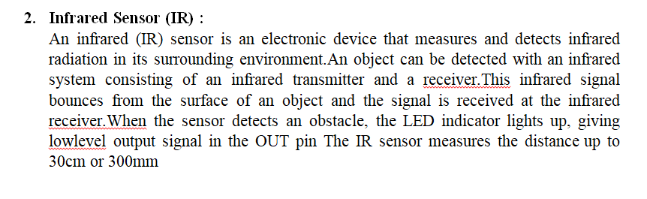

**Fig: IR sensor**

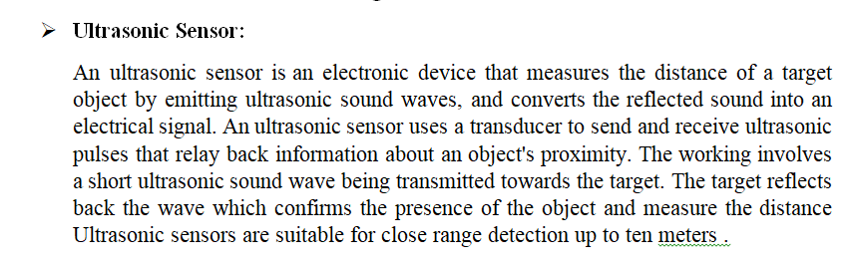

**Fig: Ultrasonic Sensor**

* **Buzzer:**

The **buzzer** is a sounding device that can convert audio signals into sound signals. Its, like a magnetic speaker, it needs voltage with different frequency so that it can make sound accordingly. The pitch becomes louder when the frequency gets higher. Typical uses of buzzers and beepers include alarm devices, timers, train and confirmation of user input such as a mouse click or keystroke.

Fig : Beeper or Buzzer

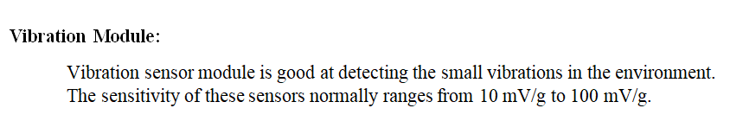

Fig: Vibration Module

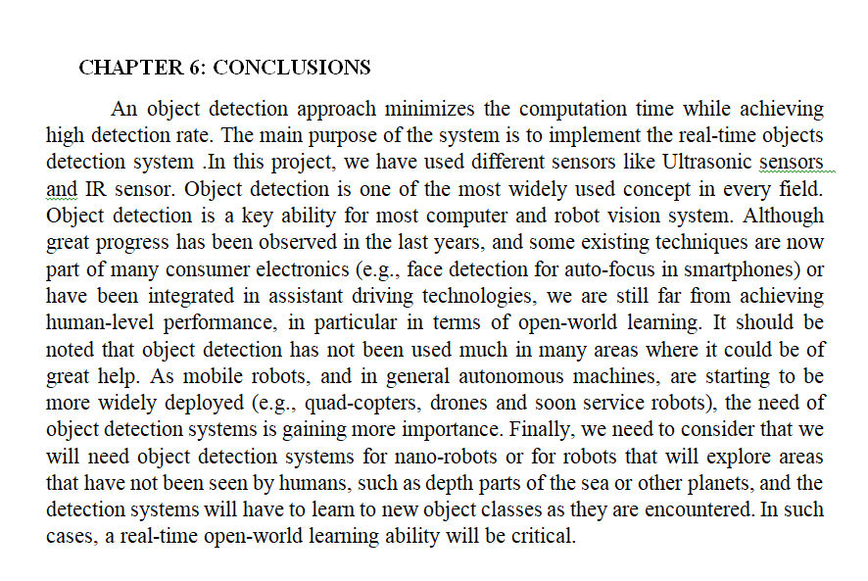

**CHAPTER 7:REFERENCES**

[1] M.P. Arakeri, N.S. Keerthana, M. Madhura, A. Sankar, T. Munnavar, “Assistive Technology for the Visually Impaired Using Computer Vision”, International Conference on Advances in Computing, Communications and Informatics (ICACCI), Bangalore, India, pp. 1725-1730, sept. 2018.

[2] R. Ani, E. Maria, J.J. Joyce, V. Sakkaravarthy, M.A. Raja, “Smart Specs: Voice Assisted Text Reading system for Visually Impaired Persons Using TTS Method”, IEEE International Conference on Innovations in Green Energy and Healthcare Technologies (IGEHT), Coimbatore, India, Mar. 2017.

[3] Sunit Vaidya, Naisha Shah, Niti Shah, Prof. Radha Shankarmani , “Real-Time Object Detection for Visually Challenged People”. Proceedings of the International Conference on Intelligent Computing and Control Systems (ICICCS 2020) .

[4] Md. Tobibul Islam, Mohiuddin Ahmad , Akash Shingha Bappy “Real-Time Family Member Recognition Using Raspberry Pi for Visually Impaired People ”. 2020 IEEE Region 10 Symposium (TENSYMP), 5-7 June 2020, Dhaka, Bangladesh.

[5] Akif Khan, Shan Khusro, “An insight into smartphone-based assistive solutions for visually impaired and blind people: issues, challenges and opportunities”.  
[6] Hugo Fernandes, Paulo Costa, Vitor Filipe, Joa ̃o Barroso. “A review of assistive spatial orientation and navigation technologies for the visually impaired”.