How a program execute-4 phases

1.preprocessing

Input file of preprocessing stage is .c(.c source file)

Output of preprocessing stage is .i(preprocessed file)

Handles the directives like #include,#define,…and it produce c code file with all macros and headers expanded.

2.compiling

Input of compiling stage is .i file

Output of compiling stage is .s (assembly lang file.

Converts the preprocessed c code into assembly lang.

3.Assembling

Input of assembling stage is .s file

Output of assembling stage is .o or .obj file(object file)

Converts the assembly code into machine code.

4.Linking

Input of linking process is .o file

Output of linking is .exe(executable file)

It combines all object file into single executable file.

Comparison of c and c++C

Top-down approach

Function driven

Can not use function inside structure

Data is not secured

Procedural oriented programming

Main() need not return any value

C++

Bottom-up approach

Object driven

Can use function inside structure

Data is hidden

Procedural and object oriented programming

Main() should return a value

Visual studio installation

Visual studio 2022

1. Open Microsoft Edge and visit the Visual Studio, to enter the same click the below link:

[Visual Studio: IDE and Code Editor for Software Developers and Teams](https://visualstudio.microsoft.com/)

1. Scroll down and click the ‘Download Visual Studio’ a drop-down menu appears select the ‘Community 2022’.
2. A setup file downloads named as ‘mingw-get-seup.exe’:
3. Run the setup as usual and place it in a desired folder.
4. Visual Studio 2022 has been successfully installed

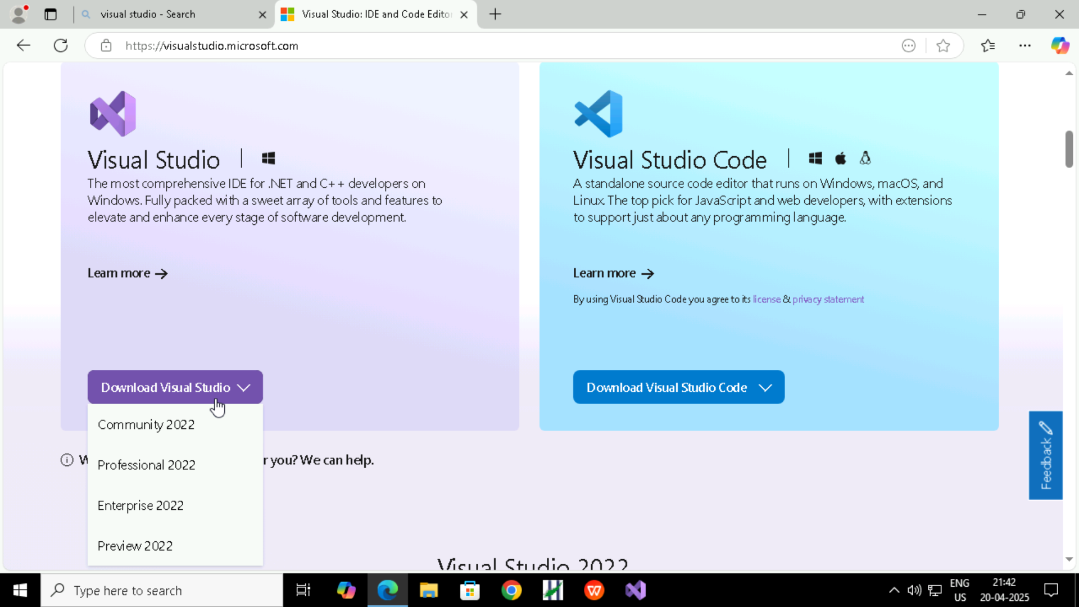

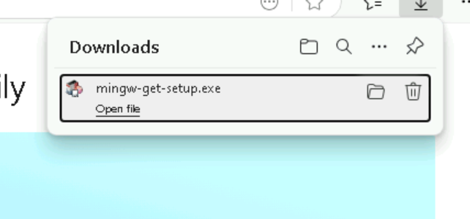

Visual Studios Installer.

1. Open Visual Studios Installer.
2. Click Modify and select ‘Desktop development with C++’
3. Go to Installation details and select the necessary features from the ‘Desk development with C++’ and go to the optional drop-down selection(or refer to the picture):
4. Apart from that go to the tab ‘Individual Components’ and select the following components:
5. C++ CMake tools for Windows.
6. MSVC v143 – VS 2022 C++ ARM build tools(Latest)
7. MSVC v140 – VS 2015 C++ build tools (v 14.00)
8. Select ‘Install while downloading’ and click ‘Modify’.
9. After the Installation and downloading is completed ‘Launch’.
10. Visual Studio 2022 gets launched.

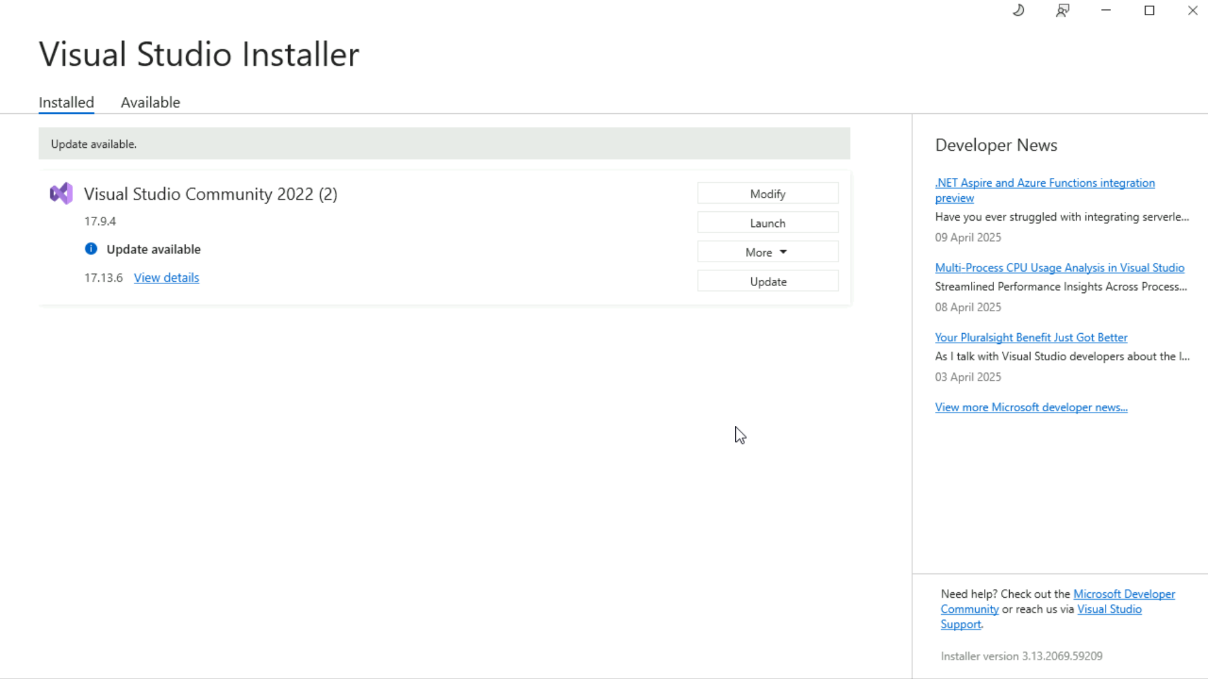

:

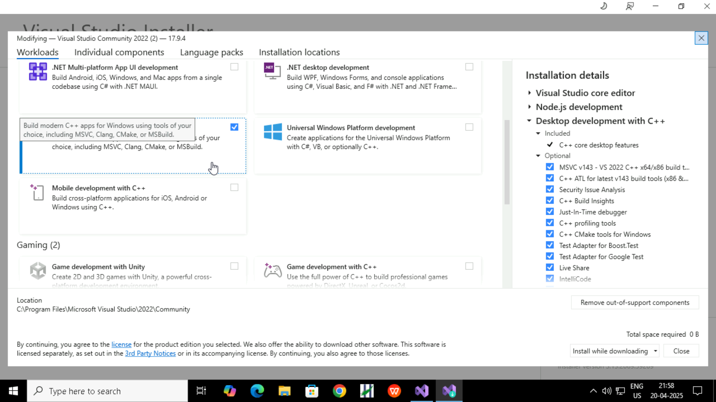

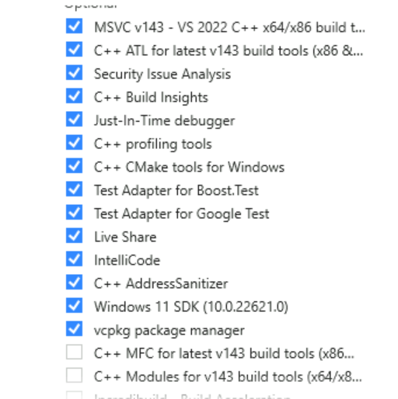 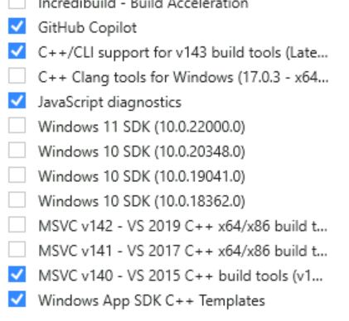

Creating a Project.

1. After Visual Studio 2022 launches select ‘Create a New Project’ from the ‘Get Started’ Menu:
2. Now, select ‘C++’ in the ‘All languages’ drop-down.
3. Then, select ‘Windows’ in the ‘All platforms’ drop-down:
4. Finally, select ‘Console’ from the ‘All project types’:
5. Now, select ‘Empty Project’ (you can also choose ‘Windows Console Application’) and click ‘Next’:

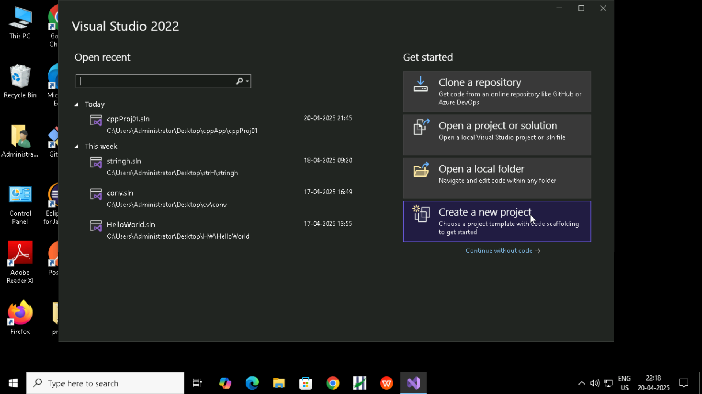

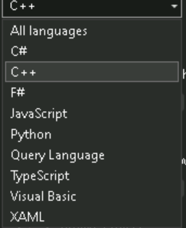

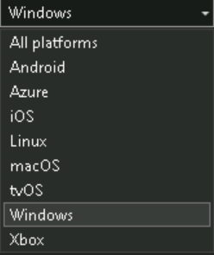

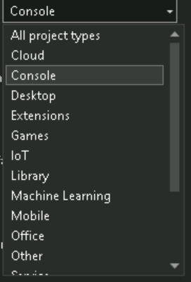

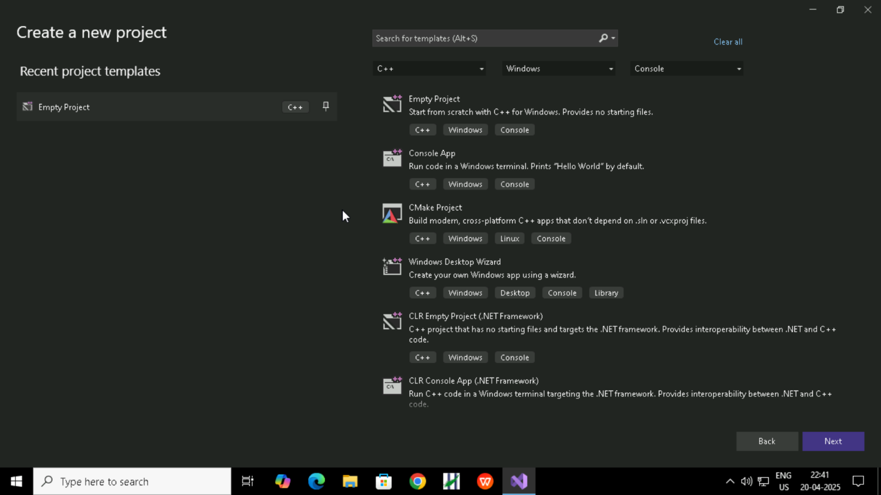

How to execute main function with a function from build in visual studio

1.Right click the file in solution explorer

2.In the properties window find the exclude from build option

3.And set to yes

4.Apply the changes.

