DAT171 Objektorienterad programmeringsteknik i Python 2019-02-09  
Computer Assignment 1  
Martin Vanky, Andreas Gelotte

|  |  |  |  |
| --- | --- | --- | --- |
| **filename** | **start, end** | **cost** | **path** |
| SampleCoordinates | 0, 5 | 0.21934542403665458 | [0, 4, 3, 5] |
| HungaryCities | 311, 702 | 0.1937104201123858 | [311, 19, 460, 629, 269, 236, 740, 519, 571, 313, 218, 161, 158, 791, 615, 44, 395, 123, 580, 114, 253, 836, 73, 35, 424, 503, 789, 200, 702] |
| GermanyCities | 1573, 10584 | 0.4160955644172497 | [1573, 5032, 3182, 2958, 4197, 4448, 2269, 5634, 3467, 6172, 4656, 4390, 3610, 3776, 4850, 6846, 764, 5614, 7656, 6251, 5004, 5932, 6906, 7571, 4712, 3700, 270, 4160, 2522, 2738, 2376, 4399, 3987, 4890, 2266, 5813, 6473, 6062, 6048, 11572, 8765, 8847, 3995, 9989, 9683, 10232, 4325, 7418, 3122, 7115, 10160, 9311, 4084, 10561, 4135, 4806, 629, 4652, 5762, 6162, 9350, 8352, 1112, 4887, 4699, 6987, 4651, 5513, 9104, 4911, 8920, 5357, 5414, 10404, 8228, 9116, 11213, 9467, 11126, 10789, 5970, 7292, 8473, 9856, 11780, 9570, 10476, 10078, 9956, 9998, 738, 10403, 9172, 11716, 10197, 8148, 6807, 9578, 7733, 7197, 7863, 9346, 10784, 8538, 11378, 10872, 5444, 4289, 6980, 6434, 7064, 7841, 9729, 10362, 7958, 10584] |

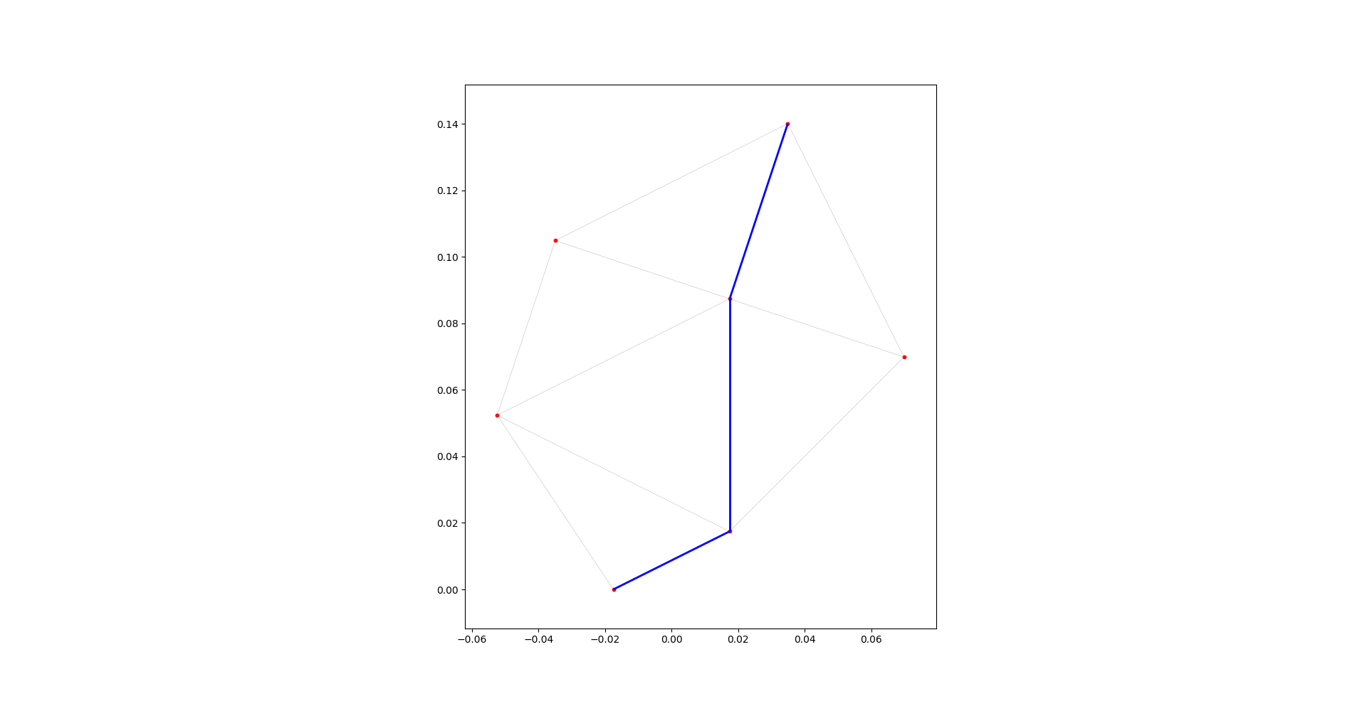

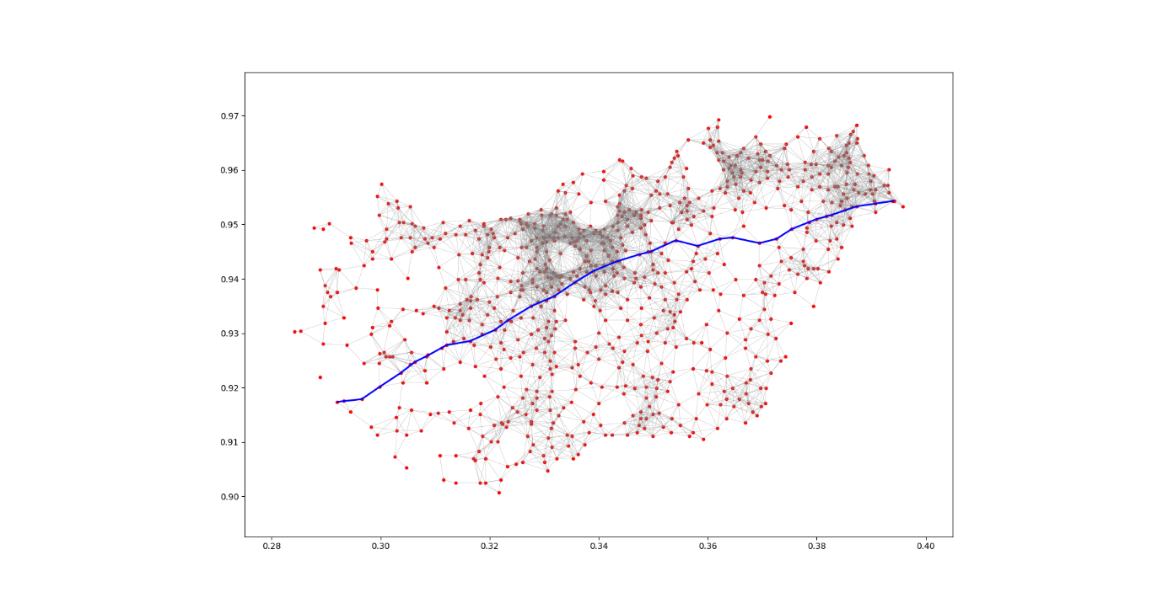

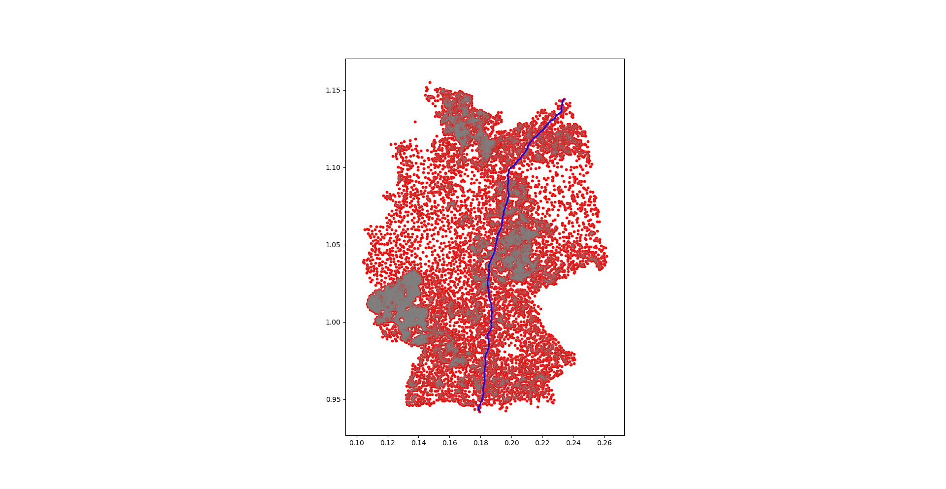

Intel Core i7-8550U, GermanyCities.txt:

|  |  |
| --- | --- |
| **function** | **time (s)** |
| read_coordinate_file | 0.0598 |
| construct_graph_connections | 343 |
| construct_graph | 0.0049 |
| tasks 6+7 | 0.0140 |
| plot_points (from task 8, excluding plt.show) | 1.1300 |
| construct_fast_graph_connections | 0.7350 |
| Running the entire program using the fast version, excluding plotting | 0.8068 |