**Sample**

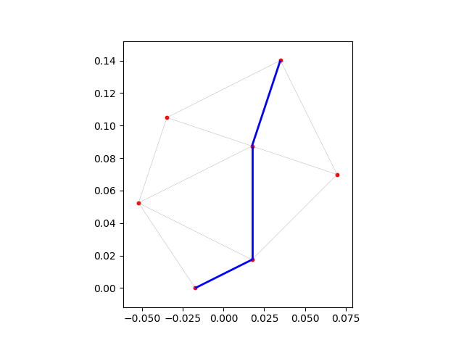

The cheapest path between city 0 and city 5 costs: 0.21934542403665458

[0, 4, 3, 5]

|  |  |
| --- | --- |
| **Function** | **Time** (sec) |
| read_coordinate_file | 0 |
| construct_graph_connections | 0.0156 |
| construct_graph | 0 |
| Calculate shortest path (task 6+7) | 0 |
| Entire program without fast_graph_connections | 0.0156 |
| Entire program *with* fast_graph_connections |  |
|  |  |

**Hungary**

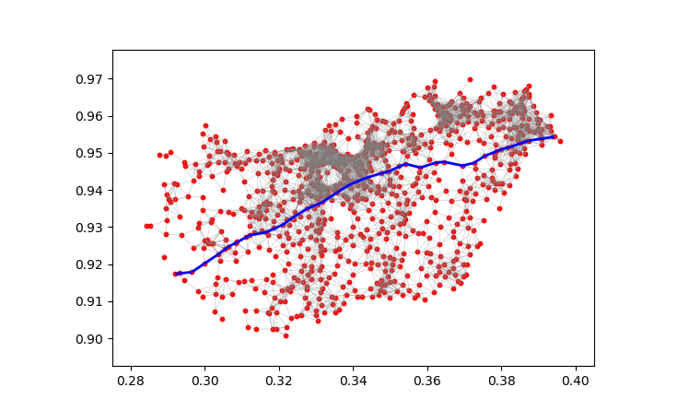

The cheapest path between city 311 and city 702 costs: 0.19371042011238587

[311, 19, 460, 629, 269, 236, 740, 519, 571, 313, 218, 161, 158, 791, 615, 44, 395, 123, 580, 114, 253, 836, 73, 35, 424, 503, 789, 200, 702]

**Germany**