PREDICTING STELLAR CLASS
Kaggle Playground Series — Season 6, Episode 6
Chapter 1 — Introduction & Background

1.1 Introduction to Celestial Object Classification
Data science greatly benefits modern astronomy. Automated sky surveys such as SDSS acquire information about millions of celestial bodies, so they are impossible to inspect manually. This makes the first and most basic operation to classify celestial objects into three classes according to their physical entity.
- Stars: Single, gravitationally bound plasma spheres in the Milky Way galaxy. Since these stars are sufficiently close, they can be considered as unresolved, point-like sources of light.
- Galaxies: Large gravitationally bound systems consisting of billions of stars, gas, and dust. Due to their huge dimensions and relative closeness, they can be seen as extended structures with visible features.
- QSO: Extremely bright active galactic nuclei of remote galaxies containing supermassive black holes. As these objects are similar to galaxies, their huge distance makes them point-like objects.
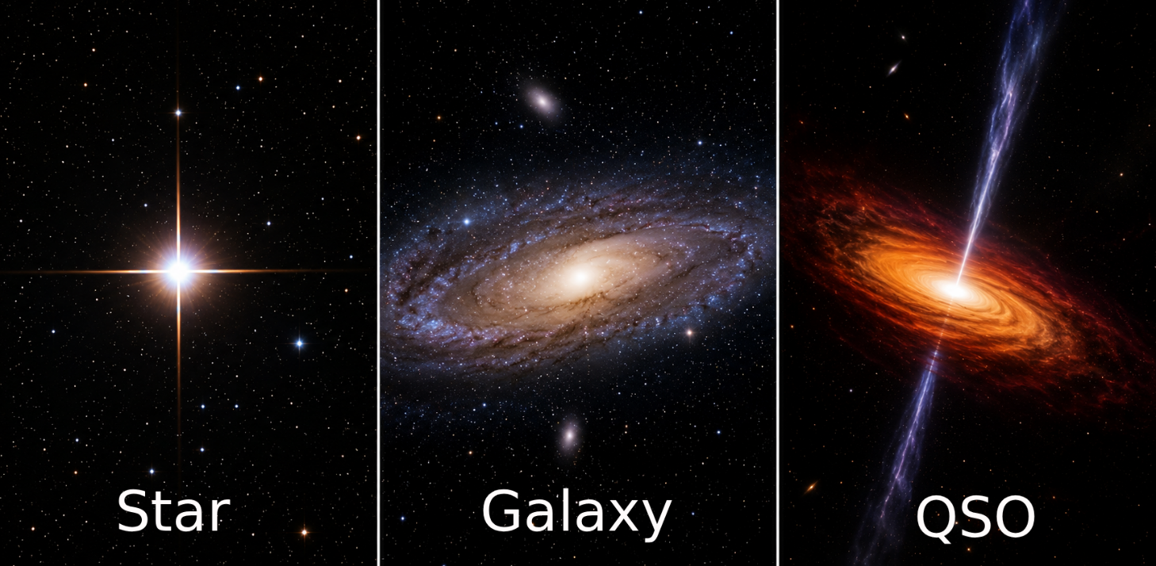
Figure 1 (repeated for reference). STAR, GALAXY and QSO differ physically, but can look deceptively similar in survey imagery and in tabular brightness measurements.

Historically, astronomers manually inspected images and spectra, a process that cannot scale to today's billion-object catalogues.
Today, classification is automated using tabular, structured data combined with machine learning models. This process relies on key numerical features:
- Multi-band magnitudes (brightness across different filters)
- Colour indices (differences between these magnitudes)
- Spectroscopic redshift (indicating distance)
This competition mirrors this real-world workflow: using a table of numerical and categorical features to predict which of the three classes an astronomical object belongs to.

1.2 Problem Statement
The main objective of this project is to address the multi-class classification challenge. The aim is to create a machine learning tool capable of determining three classes in a tabular dataset comprising of numeric and derived features (e.g., colors, magnitudes, and redshifts).
Target Classes
- GALAXY — an extended, multi-star stellar system
- STAR — a single, point-like stellar source within the Milky Way
- QSO — a Quasi-Stellar Object (quasar), a distant active galactic nucleus

The evaluation of model performance employs balanced accuracy, which is defined as the mean of recall computed for each class. In contrast to simple accuracy, this measure treats all classes alike irrespective of the number of samples associated with each class. The choice of this measure is of importance in its own right, and consequently guides many of the subsequent technical decisions described in this document.

2.1 System Architecture Diagram
In this section, the overall framework is described for the stellar classification pipeline (as indicated in Figure 2 regarding its system architecture). This enables us to understand how the data moves in the three primary stages.
Raw Data: The point at which the raw CSV files enter the pipeline
Machine Learning Pipeline: The period of converting features into invested data.
Deployed System: The execution of the machine learning pipeline.
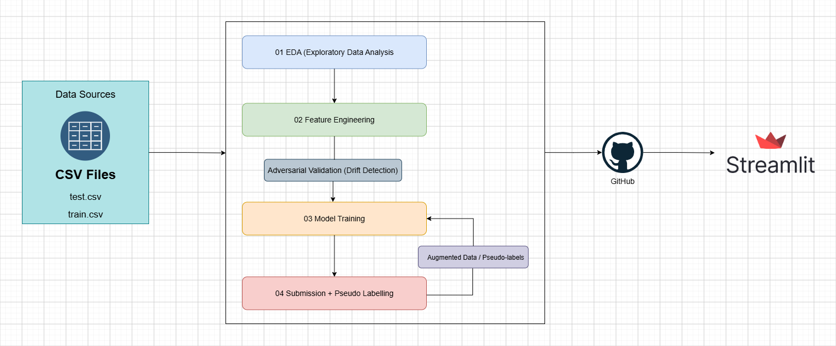
Figure 2. Proposed end-to-end system architecture, from raw data sources through the machine learning pipeline to production deployment.
The pipeline on the left is supplied with two raw CSV files which are train.csv and test.csv from the local storage. These files undergo sequential processing in a bounded machine learning pipeline which consists of 4 sub-processes:
- exploratory data analysis.
- feature engineering and adversarial validation.
- model training.
- pseudo-labelling.
Also, a feedback mechanism enables the model training process to reuse predictions which were made with high certainty by the model. Once the pipeline performed all necessary stages, the code and model go under version control at GitHub and the application is deployed continuously into Streamlit Cloud to allow access to the classifier as a web application.

3. Data Exploration & Insight Generation (EDA)
The chapter outlines the exploratory data analysis (EDA) conducted on the raw files train.csv and test.csv, corresponding to the 01_eda notebook in the repository. The notebook proceeds with the five phases of the approach that involves learning about the data, cleaning, identification of one variable, checking the target variable, and identification of relationships.

3.1 Dataset Characteristics
This dataset is structured in three different functional categories of columns.
- The numeric category of columns includes sky coordinates (alpha, delta) and the photometric measurements (u, g, r, i, z), along with the spectral redshift.
- The categorical category of columns consists of spectral_type and galaxy_population as assigned by astronomers.
- The target column, called class, contains the three target labels accordingly predicted by the project, which are: GALAXY, QSO, and STAR.
Before any analysis is undertaken, the system undertakes the profiling of the data:
- Data type: It automatically determines which columns are numerical or categorical based on pandas's dtypes.
- Cardinality of column: The number of unique values in columns is computed along with the proportion of the unique values to total numbers.
- Duplicate rows: The training and testing datasets are checked for identical rows.
- Missing values: The number of records missing in each column is determined.
This step ensures the data structure is intact and alerts it about any columns which can cause problems in the next stages, particularly if they have too high cardinality or missing values.

3.1.1 Dataset Dimensions and Integrity Checks
The loading process reveals that the training set includes 577,347 rows organized in 12 columns whereas the test set contains 247,435 rows categorized into 11 columns, one less than the training set because the first column with the dependent variable is omitted in the test set being a supervised contest. The row/column information provided makes sense in case the document is in a shape expected of it before any calculations put forth in this chapter.
Check | Result | Why it matters
Train shape | 577,347 rows x 12 cols | Confirms the full file loaded, not a truncated read
Test shape | 247,435 rows x 11 cols | Confirms class is correctly withheld from test
Duplicate rows (train) | 0 (0.000%) | Rules out repeated samples biasing the model
Duplicate rows (test) | 0 | Same check applied to the test file
Missing values (train) | 0 across all 12 columns | Confirms no imputation strategy is required
Missing values (test) | 0 across all 11 columns | Confirms the test file is equally complete

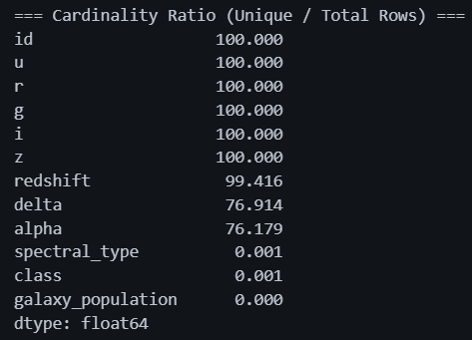
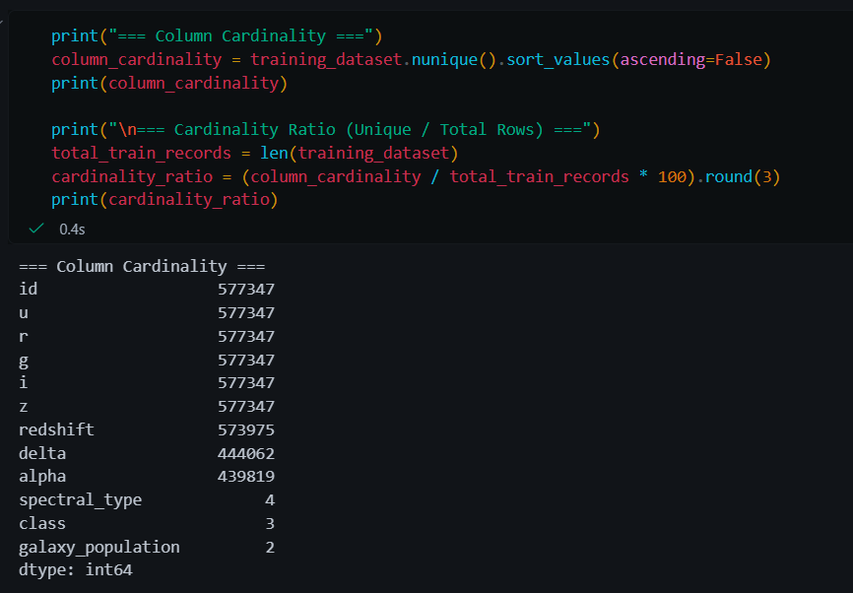
Figure 3. Column cardinality output from the 01_eda notebook: cardinality ratio summary (left) and full code and output (right).
Column cardinality is validated for the same purpose. The id and the five photometric bands (u,g,r,i,z) are unique in 100% of the rows, while the redshift is unique in 99.4% of the rows, proving that the data values are continuous. On the other hand, the attributes spectral_type (4 unique values), class (3), and galaxy_population (2) confirm that these three columns are definitely categorical rather than wrongly typed ones.

3.1.2 Descriptive Statistics in Detail
The precise numerical ranges have been noted here so that it can be required at a later stage when making feature-scaling decisions, and also for the reasons behind highlighting redshift as extraordinary even before the class-wise division.
Feature | Mean | Std | Min | Max
u | 22.44 | 2.02 | -0.14 | 28.25
g | 21.01 | 1.80 | 13.54 | 27.62
r | 19.96 | 1.65 | 12.58 | 25.25
i | 19.38 | 1.58 | 11.96 | 27.91
z | 19.04 | 1.58 | 11.68 | 26.83
redshift | 0.72 | 0.81 | -0.01 | 7.01

Magnitude groupings demonstrate a reliable and predictable spread, with standard deviations occurring around 1.6-2.0. In contrast, redshift shows a higher level of spread with a standard deviation of 0.81 compared to its average of 0.72. This serves as an early quantitative indicator of the non-uniform nature of redshift, a fact that would be established later through graphical means in Section 3.1.4.

3.1.3 Categorical Feature Distributions
Visualizing the counts of each categorical variable next to each other allows one to immediately see which values are dominant in each variable since more comprehensive data will come in section 3.1.8.
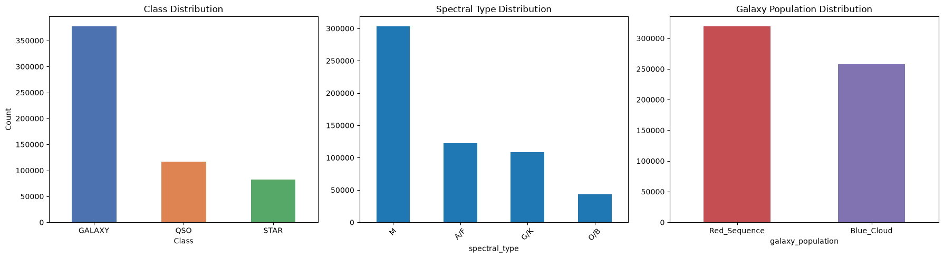
Figure 4. Class, spectral type, and galaxy population frequency counts.
GALAXY rules the class column, the spectral type M rules the spectral type, and the Red Sequence rules the galaxy population. The three statistical imbalances are related when checked using the crosstab against the class count in Section 3.1.8.

3.1.4 Redshift Distribution by Class (Detail)
Class | Mean | Std | Min | Max
GALAXY | 0.509 | 0.309 | -0.01 | 6.860
QSO | 1.876 | 1.070 | 0.00 | 7.011
STAR | 0.068 | 0.064 | -0.01 | 5.445

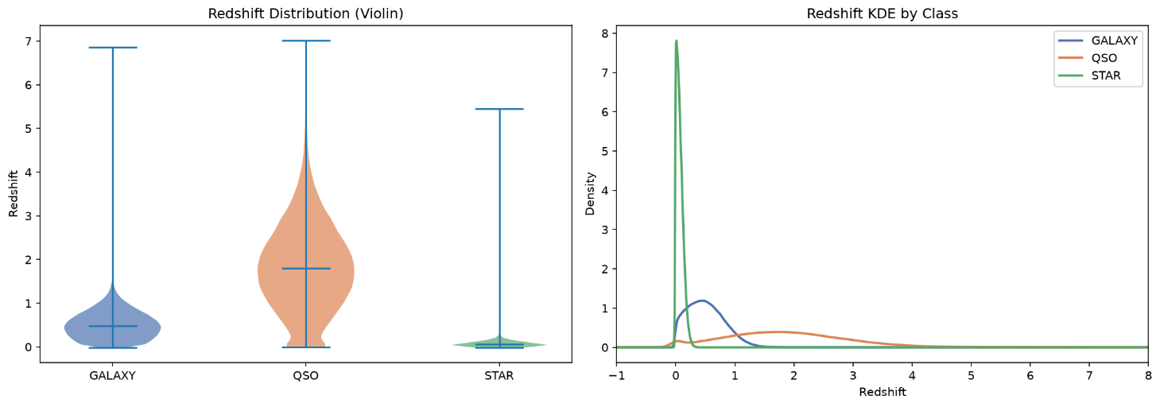
Figure 5. Redshift distribution by class: violin plot (left) and kernel density estimate (right).
The provided numbers illustrate what Section 3.1.2 explains in qualitative terms: STAR is close to 0, QSO has the highest and greatest degree of variability while GALAXY shows a mid-range mean with moderate variability. The ultimate separation of the respective means of the three classes makes it possible to refer to redshift as the most telling indicator in the data set.

3.1.5 Colour Indices by Class
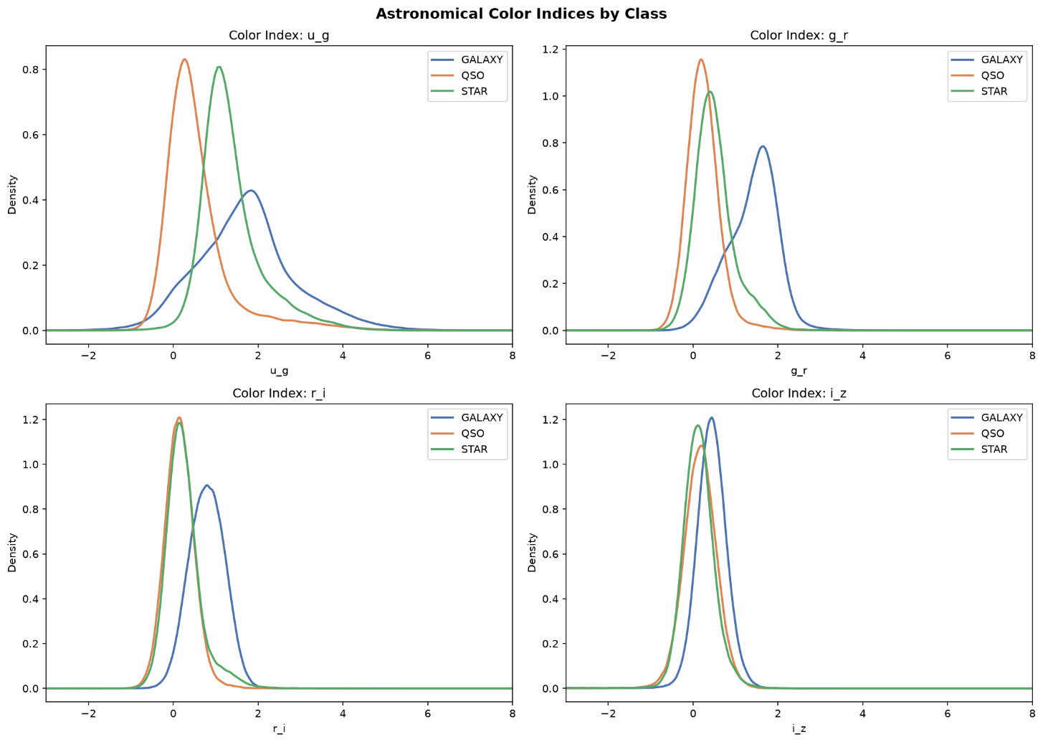
Figure 6. Kernel density plots of four engineered colour indices (u-g, g-r, r-i, i-z), split by class.
In the plot above, four parameters are plotted against each other to test if the simultaneous use of two correlated magnitudes is a better discriminant than a single given raw band. In the case of GALAXY, the curve clearly has a distinct peak in g_r, r_i, and i_z, and the variations in g_u separate QSO and STAR better.

3.1.6 Outlier Detection (IQR Method)
An interquartile range (IQR) scan (1.5 times IQR) detected potential outliers in all of the numerical features so that they don’t overemphasize the results in the distance-based or gradient-based models if not treated.

Feature | Lower bound | Upper bound | Outlier count | Outlier %
alpha | -17.341 | 381.332 | 0 | 0.000%
delta | -49.297 | 88.760 | 0 | 0.000%
u | 16.639 | 28.207 | 315 | 0.055%
g | 16.223 | 25.934 | 2,806 | 0.486%
r | 15.306 | 24.679 | 1,677 | 0.290%
i | 14.855 | 24.060 | 1,277 | 0.221%
z | 14.690 | 23.445 | 1,476 | 0.256%
redshift | -0.869 | 1.932 | 52,590 | 9.109%

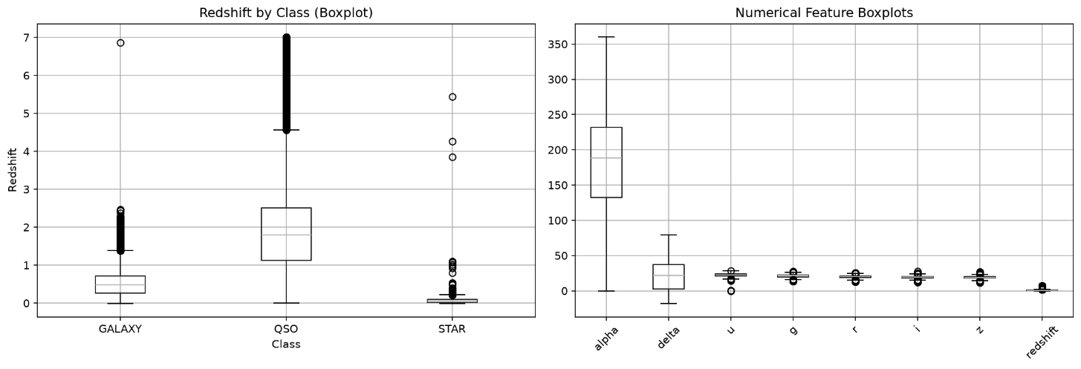
Figure 7. Boxplot of redshift by class (left) and boxplots of the core numerical features (right).
The sky coordinates and five photometric bands reveal an insignificant outlier rate; therefore, no further elaboration is needed. Although the outlier rate of redshift is 9.1%, which seems alarming at a glance, the box-and-whiskers plot speaks to the fact that the QSO interquartile range is considerable, while the cutoff has been selected according to global statistics. Thus, the majority of high-redshift QSOs are correctly flagged as outliers. Forthcoming is the recommendation for class-based (or no) outlier treatment for redshift.

3.1.7 Class Imbalance (Supplementary Chart)
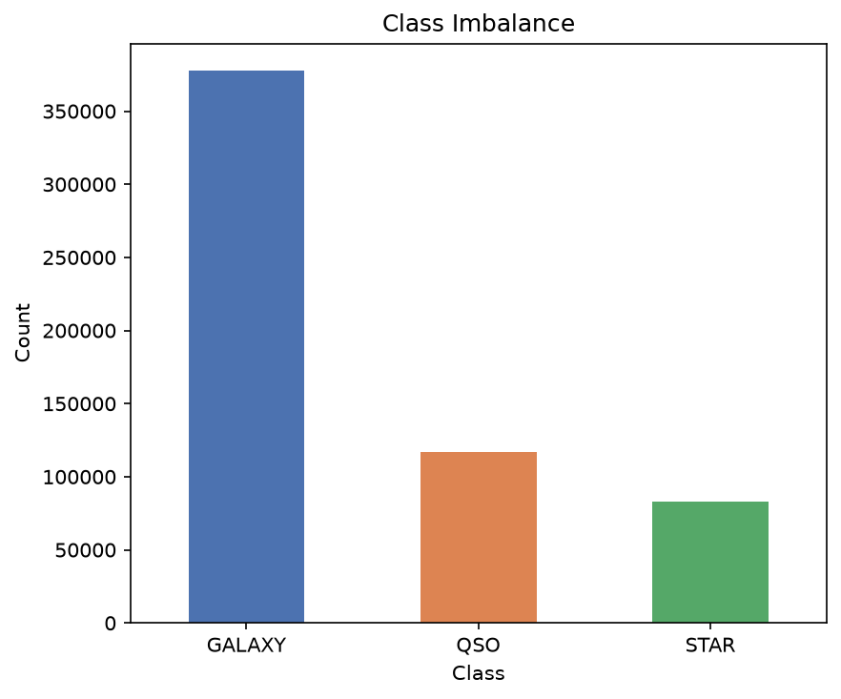
Figure 8. Exact class counts in the training set: GALAXY 377,480 (65.4%), QSO 117,143 (20.3%), STAR 82,724 (14.3%).
The assessment of target column shows the fact that the three categories do not distribute equally in the training dataset. It is due to this bias that the evaluation of submissions is done by taking into account balanced accuracy instead of regular accuracy, in case the model is creating bias towards the most populated class. The conclusion made profoundly influences the application of weights for classes and stratified cross-validation technique during the process of model training.

3.1.8 Bivariate Relationships: Sky Position and Categorical Cross-Tabulations
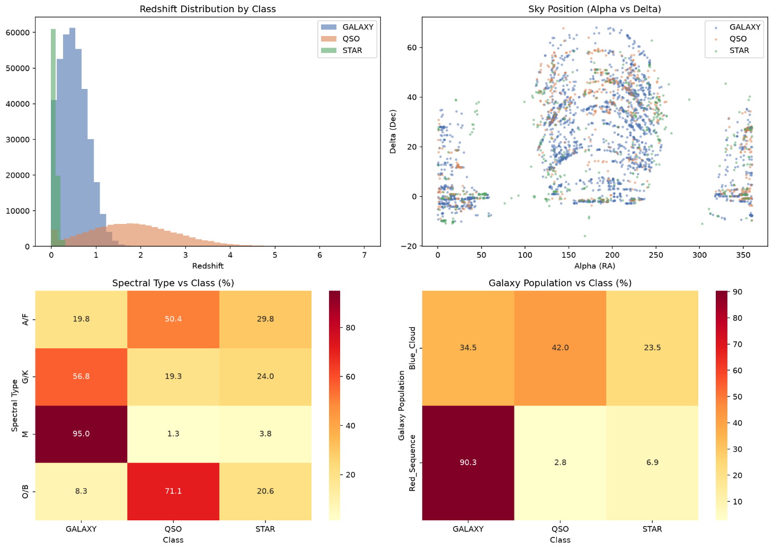
Figure 9. Redshift histogram by class (top-left); sky position by class (top-right); spectral type vs class, row-normalised % (bottom-left); galaxy population vs class, row-normalised % (bottom-right).
In the upper right-hand corner of the figure representing the connection between alpha and delta, there are colours that separate the distinct classes, which helps to minimize the risk of any particular risk, in particular, that the sky position will merge into the class (for instance, if fields contain excessive number of a class in relation to others). There are no signs of the clusters being present, thus confirming that the sky position does seem have any predictive capability and should be omitted from the dataset.
Examining the relationship between spectral_type and class in a cross-tabulation shows a relationship that cannot be captured by just one frequency.
Cross-tabulating spectral_type with class (bottom-left) shows that spectral_type is a good predictor of class.

spectral_type | GALAXY | QSO | STAR
A/F | 24,240 | 61,514 | 36,368
G/K | 61,627 | 20,921 | 25,998
M | 288,023 | 3,889 | 11,411
O/B | 3,590 | 30,819 | 8,947

When we cross-tabulate galaxy_population with class (shown in the lower right), we find a similar but weaker trend: 90.3% of Red_Sequence objects are GALAXY, while there is a more even distribution for Blue_Cloud constituents (34.5% GALAXY, 42% QSO, 23.5% STAR). However, because this trend is not the same as the spectral_type trend, both categorical variables are considered as containing overlapping information that are thus left intact.
galaxy_population | GALAXY | QSO | STAR
Blue_Cloud | 88,962 | 108,274 | 60,546
Red_Sequence | 288,518 | 8,869 | 22,178

3.1.9 Feature Correlation (Exact Coefficients)
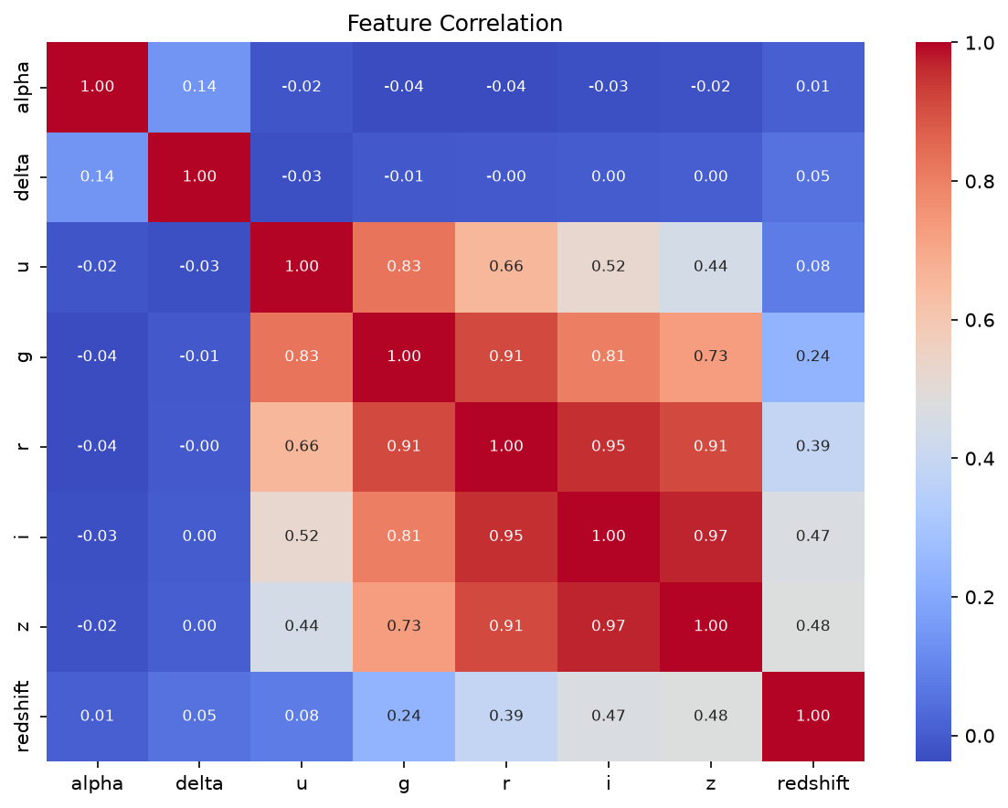
Figure 10. Pairwise Pearson correlation matrix of the eight core numerical features (exact coefficients from the notebook run).
The exact coefficients indicate which pairs are least useful: i-z (r = 0.97), i-r (r = 0.95), r-z (r = 0.91) and g-r (r = 0.91) represent the highest coefficients, which indicates that the photometric systems have enough similarities to prefer engineering colour-index differences (section 3.1.5) over using raw systems separately. The degree of redshift has a medium correlation with the reddest bands (z: r = 0.48, i: r = 0.47) and a low correlation with the bluest band (u: r = 0.08), reflecting a fact that redshift actually shifts light to longer wavelengths. Coordinate position (alpha, delta) shows almost no correlation with other features (|r| < 0.15), re-confirming the observation that they contain no useful information and can be removed from the list of features.

4. Data Preprocessing & Feature Engineering
With the exploratory patterns from Chapter 3 established, this chapter documents how the raw data is turned into a model-ready feature set. It corresponds to the preparation stage of the pipeline shown in Figure 2 the 02_feature_engineering notebook, backed by src/data/preprocessing.py and src/features/engineering.py together with the adversarial-validation quality gate that guards it before anything is written to disk.

4.1 Data Preprocessing & Cleaning
Since Section 3.1.1 (EDA stage) has already confirmed that there are no missing values, duplicate records, or poorly typed columns in train.csv and test.csv, there is no need for remedial cleaning. This means that there are no imputation or duplication issues. Therefore, the preprocess() function acts as an additional confirmation, guaranteeing that each column type is consistent and that the raw columns are prepared for feature engineering through a single entry point (src/data/preprocessing.py). This is important because the same preprocess() function is used offline for training and online for making predictions in the deployed Streamlit app via predict_single().
Categorical encoding is the only cleaning-related transformation performed at this stage. The features spectral_type and galaxy_population, which have four and two unique values, respectively, are transformed into new columns, spectral_type_enc and galaxy_population_enc. Although one-hot encoding seems appropriate for categorical values, ordinal encoding is used because the three models to be used in subsequent stages—LightGBM, XGBoost, and CatBoost—are decision tree ensembles that function by splitting a single number representing a category, with no confusion over the order of different categories.
No rows are lost during this step of the process; both train.csv and test.csv retain all of their original rows during the feature engineering stage. This is an intentional choice based on EDA analysis (Section 3.1.6). The analysis revealed that 9.1% of flagged redshift values are real QSOs with high redshifts and are not data errors. Thus, dropping such rows from the dataset would result in the loss of useful information rather than noise.

4.2 Advanced Feature Engineering
In the pipeline, the build_features() stage (src/features/engineering.py) represents one of the most extensive transformation processes. For preprocessed data, this stage produces a table with 50 columns for the training data and 49 columns for the test data (one fewer because it lacks a class label). Each generated column can be traced back to patterns found in exploratory data analysis, rather than being randomly invented.
Table 2. Engineered Feature Categories
- Categorical encodings (2) — spectral_type_enc, galaxy_population_enc
- Colour indices (11) — u_g, g_r, r_i, i_z, g_i, r_z, u_r, g_z, u_i, u_z, r_g
- Colour ratios (4) — g_div_z, r_div_i, u_div_r, g_div_r
- Colour interactions (2) — gz_x_ri, gr_x_iz
- Band-wise row statistics (10) — band_mean, band_std, band_min, band_max, band_range, band_sum, band_skew, band_median, band_iqr, band_cv
- Redshift transforms (3) — redshift_log1p, redshift_sq, redshift_sqrt
- Redshift threshold flags (4) — is_high_z, is_star_z, is_redshift_zero, is_very_high_z
- Redshift × band interactions (4) — redshift_x_gz, redshift_x_bandstd, redshift_x_bandmean, redshift_over_bandmean

4.2.1 Colour-Based Features
Section 3.1.9 established that the five photometric bands are closely related (r = 0.80–0.97). Therefore, they provide redundant data regarding an object's general brightness. Nevertheless, color indices (differences between band pairs, such as u-g and g-r) eliminate the common brightness factor and focus on the shape of the spectrum. While brightness is distance-dependent, color shape is not. Color ratios (g_div_z, r_div_i, u_div_r, and g_div_r) provide the same information in a multiplicative way. Meanwhile, interaction terms (gz_x_ri and g_r_x_iz) enable the model to use all color pair combinations. The correlation analysis presented in Section 4.2.6 proves that this approach is effective: g-div-z is the most target-related feature in the entire dataset.

4.2.2 Band-Wise Statistical Features
This category considers the five photometric measurements of an object as a minor distribution of these measurements on their own, and it summarizes measurements in terms of band_mean, band_std, band_min, band_max, band_range, band_sum, band_skew, band_median, band_iqr, and band_cv. The reasoning is that galaxies are spatially extended sources with various, mature populations of stars, and as such, they tend to produce more varied distributions of brightness compared to relatively monotone spectra of stars, or almost entirely blue spectra of quasars. band_iqr and band_cv are among the most important predictors of class value, as seen in Section 4.2.6, which means that the distribution of the brightness across bands provides about the same amount of information to identify the object as the measurements of the brightness themselves do.

4.2.3 Redshift-Derived Features
Chapter 3 found that redshift was the most effective single raw class separator. However, it is heavily right-skewed, resulting in STAR being aggregated around 0 and QSOs extending far beyond 7. Three transformations (redshift_log1p, redshift_sq, and redshift_sqrt) provide the model with different scales to analyze the same information hidden in the original raw signal. Log1p compresses the long QSO tail to improve results with scale-sensitive splits. Sq stretches the same tail. Sqrt provides a less extreme view. Rather than letting the tree model determine the thresholds for STAR and QSO from Section 3.1.4, four binary flags (is_high_z, is_star_z, is_redshift_zero, and is_very_high_z) specify these thresholds as yes or no flags for the model. Furthermore, four interaction variables (redshift_x_gz, redshift_x_bandstd, redshift_x_bandmean, and redshift_over_bandmean) include characteristics of redshift and bands from Section 4.2.2 since Section 3.1.9 demonstrated that these two variables contain independent information with only moderate correlations (r ≈ 0.35–0.46).

4.2.4 Feature Validation & Statistical Summary
Before storing data persistently, the pipeline verifies that FEATURE_COLS is receiving all required columns and that none of the 48 model-related features have implicitly turned into null values due to engineering. Both tasks were completed without complications, ensuring that the build_features() function was performed without dropping or corrupting data. Table 3 provides statistics on a small sample of engineered features. As can be seen from band_sum being approximately equal to 102 and band_cv being equal to 0.06, a range of values must be considered at the design stage. This is because tree-based algorithms can be used here, as no additional normalization steps are required.
Feature | Mean | Std | Min | Max
u_g | 1.435 | 1.142 | -23.156 | 7.523
g_i | 1.628 | 1.074 | -10.808 | 9.285
band_std | 1.281 | 0.688 | 0.014 | 8.583
band_iqr | 1.620 | 1.024 | 0.0003 | 9.332
redshift_log1p | 0.465 | 0.374 | 0.000 | 2.081
is_high_z | 0.206 | 0.405 | 0.000 | 1.000
is_star_z | 0.037 | 0.190 | 0.000 | 1.000
spectral_type_enc | 0.813 | 0.989 | 0.000 | 3.000

4.2.5 Engineered Feature Distributions by Class
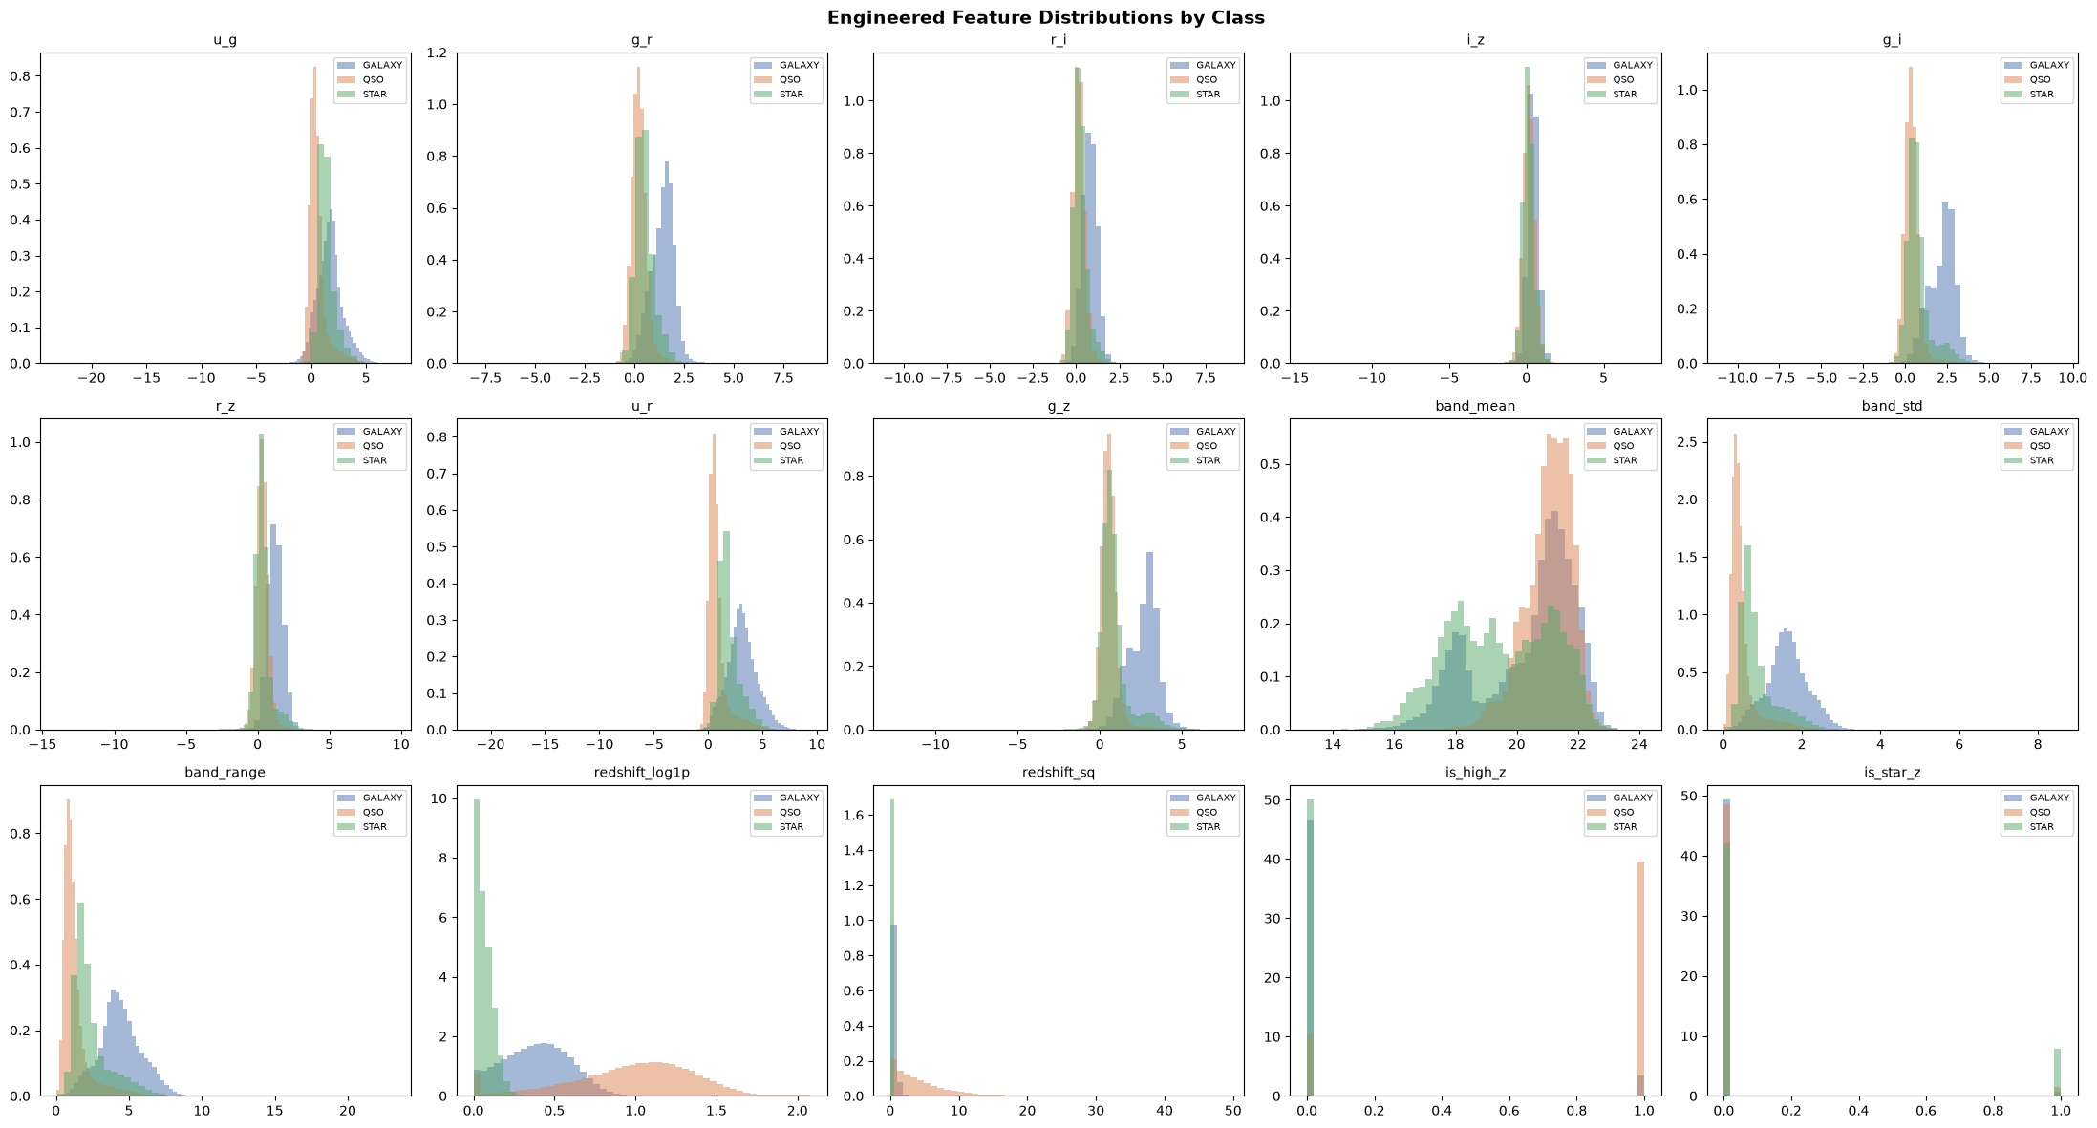
Figure 11. Distribution of fifteen representative engineered features, split by class.
The by-class histogram provides clearer insight into some of the previously mentioned arguments. g_i can clearly differentiate between the GALAXY distribution (approximately 2–3 on the right), the QSO distribution, and the STAR distribution. The latter two distributions are almost at zero and overlap with each other, which is consistent with the color index method discussed in Section 4.2.1. band_std shows an even clearer tendency: while the GALAXY distribution spreads to 4–8, the QSO and STAR distributions remain at zero, confirming that the brightness distribution in different bands is a significant class feature. Most notably, is_high_z and is_star_z behave almost like the class attribute highlighted in the histograms. is_high_z sends spikes almost exclusively to 1 for QSO, and is_star_z spikes almost exclusively at 1 for STAR.

4.2.6 Feature–Target Correlation Ranking
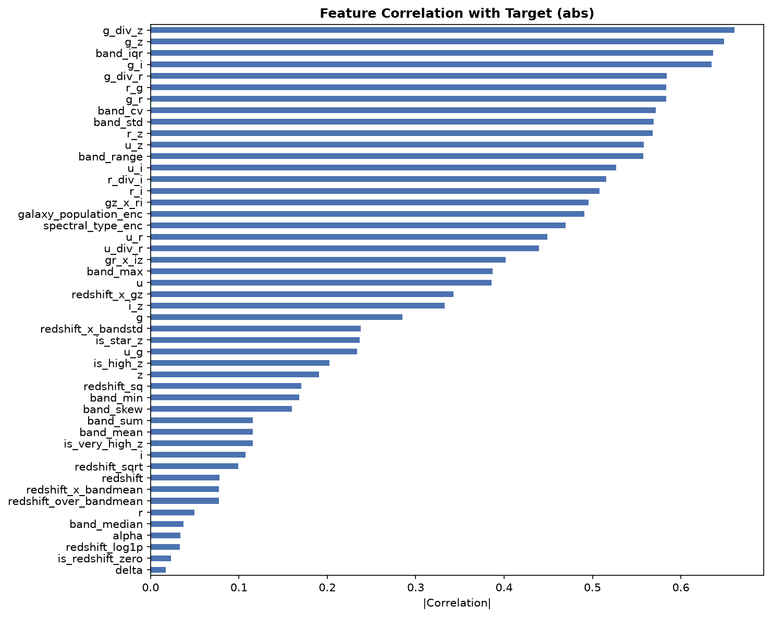
Figure 12. Absolute Pearson correlation of every engineered feature with the label-encoded class target, ranked highest to lowest.
The ranking includes g_div_z (0.660), g_z (0.649), band_iqr (0.637), g_i (0.635), and g_div_r (0.584), which are all engineered features. As stated in Sections 4.2.1 and 4.2.2, the implementation of color-based engineering and band statistics positively impacted recognition abilities. The object’s sky position (alpha, delta) is last on the list, consistent with Section 3.1.8's conclusion that sky position does not carry valuable class information. However, one result should be assessed with caution: Redshift_log1p and Redshift are low on the list, despite being considered the greatest single separator in Chapter 3. This is due to the specifics of the metric rather than the feature itself. Namely, the Pearson correlation is calculated using class_enc, which is an arbitrary 0/1/2 encoding that does not carry any meaningful information. Calculating linear correlation for a categorical target undermines the metric's meaning for features with a non-monotonic relationship to classes. It is easier to estimate the significance of redshift in the model.

4.2.7 Adversarial Validation: Data Drift Quality Gate
Before writing any processed files to the disk, the final stage is to use a quality gate that is not a diagnostic check. The run_adversarial_validation() function creates a five-fold classifier that categorizes the rows in the dataset as either from the training or test set. This is done using the finalized feature set with 48 columns. If the resulting out-of-fold ROC-AUC score is greater than 0.70, an exception called DataDriftException is raised. This stops the pipeline and prevents any writing process because it is inferred that a potential distribution shift occurred if the test and training rows can be easily distinguished.
In this run, no issues were encountered with the gate, as the fold-level AUC fell between 0.4998 and 0.5019, translating to an out-of-fold ROC-AUC of 0.5008. This indicates that it does not differ significantly from 0.50, the result that would be obtained by guessing. In other words, the model does not differentiate between the training and testing data after applying feature engineering techniques, which shows that the two datasets originate from the same underlying distributions. The features found useful by the adversarial classifier to distinguish between the training and testing data were the same sky position columns that were previously identified as insignificant in Section 3.1.8. Since the overall AUC shows a result at the level of chance, these findings are clearly unimportant and are only the result of minor sampling fluctuations. After passing the gate, the pipeline generates the following files: X_train.csv (577,347 × 48), y_train.csv, X_test.csv (247,435 × 48), feature_columns.csv, and adversarial_validation_report.json, which records the validation process and completes it.

5.1 Hyperparameter Tuning (Optuna)
Optuna has been used to optimize LightGBM and XGBoost, which have undergone 5 trials before the cross-validation process started; CatBoost has been trained with a single set of parameters and makes use of its own built-in overfitting detector instead. The number of trials is intentionally small - in this case, each trial takes a bit beneath a minute and a half when trained on over half-a-million rows (Figure 13), thus resulting in several minutes being spent on each model in total, which remains low enough to allow for running many trials in a relatively short amount of time.
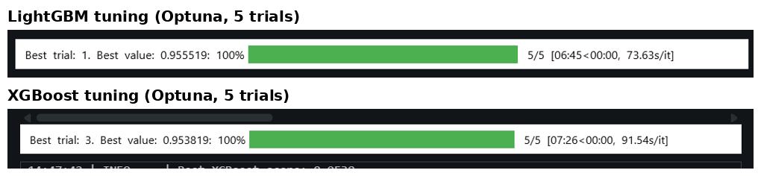
Figure 13. Optuna tuning progress for LightGBM (top) and XGBoost (bottom), 5 trials each.
Parameter | LightGBM (best: 0.9560) | XGBoost (best: 0.9555)
learning_rate | 0.0786 | 0.0255
max_depth | 9 | 10
num_leaves / min_child_weight | 147 | 9
subsample / bagging_fraction | 0.932 | 0.686
colsample / feature_fraction | 0.670 | 0.731
reg_alpha | 0.360 | 0.570
reg_lambda | 0.005 | 0.015

Even before either model undergoes cross-validation, LightGBM's tuned score (0.9560) surpasses XGBoost's (0.9555), foreshadowing the persistent gap between the two models throughout this chapter.

5.2 Stratified 10-Fold Cross-Validation
Once optimized hyperparameters are finalized, function cross_validate_models () re-estimates all three categories of model on 10 stratified groups. Unlike the traditional choice of 5 folds, we choose 10 for this occasion because of class imbalance stress in Chapter 4: STAR category has only 14.3% share in data (82,724 out of 577,347) and this way we will have few STAR instances in each validation fold which will make recall calculation imprecise. In Chapter 4 STAR class imbalance has been accounted.
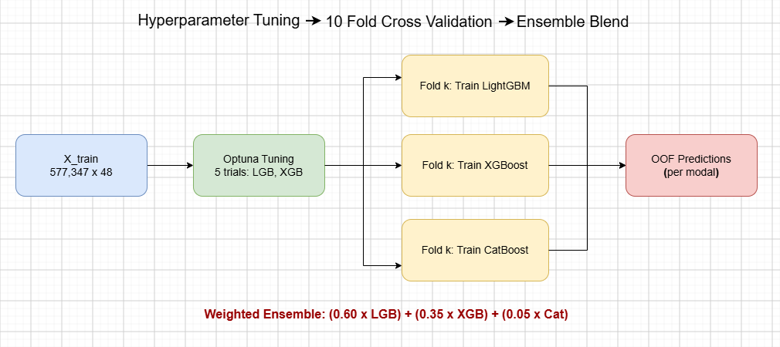
Figure 14. The tuning-to-ensemble training pipeline: each of the 10 folds trains one LightGBM, one XGBoost, and one CatBoost model, and their held-out predictions are combined into out-of-fold (OOF) estimates.
In the logs of the training, one can see directly one of the implementation details which shows that CatBoost is the only model of the three that trains on various lengths. It stops the training at the point when the performance on the validation is unchanged for more than 50 iterations, so the times each fold took are in the range of around 470 iterations up to just under 1,000 iterations depending on which fold it is.
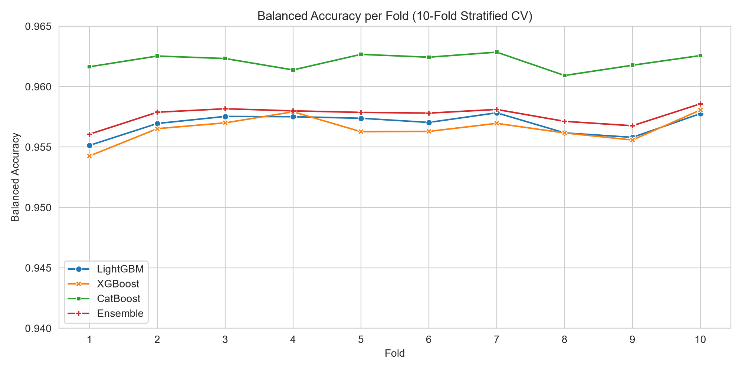
Figure 15. Balanced accuracy on the held-out fold, for each of the 10 folds.
The per-fold view proves beyond doubt that the training is stable and not just lucky, as the LightGBM line is always above the other three across all ten folds. The Ensemble line sits just below LightGBM in every fold, consistently ahead of CatBoost, while XGBoost trails all three models in every fold. It can be seen that none of the models behaved unusually during training, which indicates that it is possible to rely on out-of-fold average as an accurate predictor of real-life performance.

5.3 Final OOF Performance and the Ensemble Trade-off
On average across all ten folds, the out-of-fold balanced accuracy is 0.9647 for LightGBM, 0.9568 for XGBoost, 0.9624 for CatBoost, and 0.9638 for the final weighted ensemble (0.60 × LightGBM + 0.35 × XGBoost + 0.05 × CatBoost).

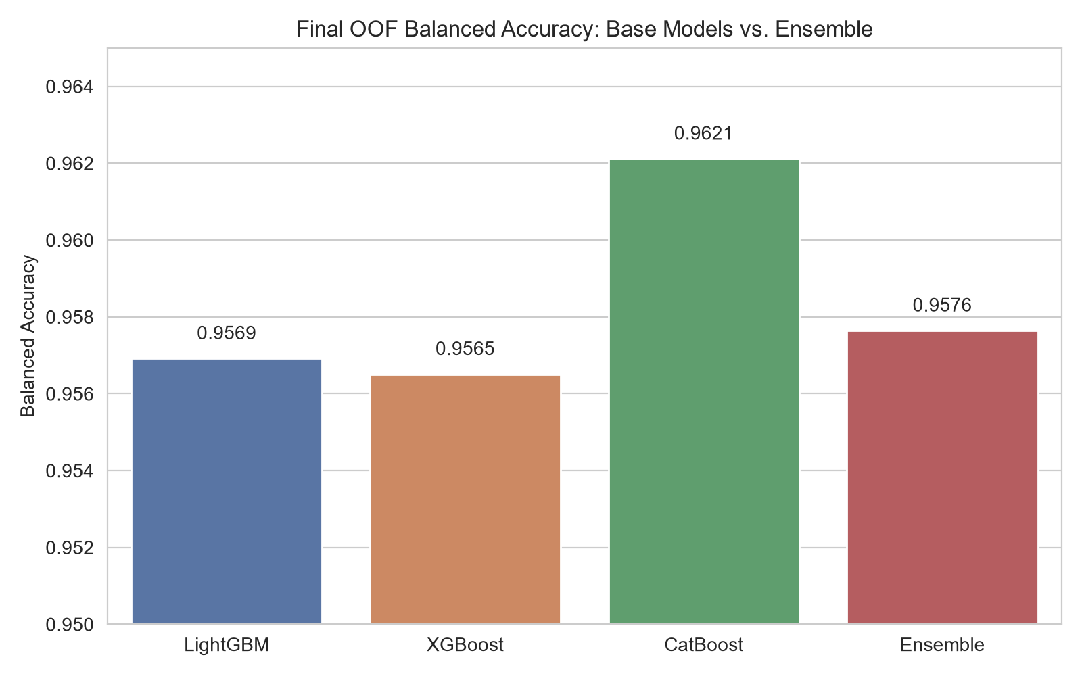
Figure 16. Final out-of-fold balanced accuracy: each base model against the weighted ensemble. The dotted line marks CatBoost's score for reference.
This chapter's key finding is that the Light Gradient Boosting Machine (0.9647) is the best standalone model, followed by the weighted ensemble (0.9638), CatBoost (0.9624), and the XGBoost model (0.9568). Moreover, this ranking applies in all the ten experiments (as illustrated in Figure 15), not only on the average. This finding is remarkable when you consider the weights demonstrated in Figure 14 – CatBoost is the second best base model, but its contribution to the overall prediction is only 5% and the XGBoost model is the weakest, with a 35% contribution.
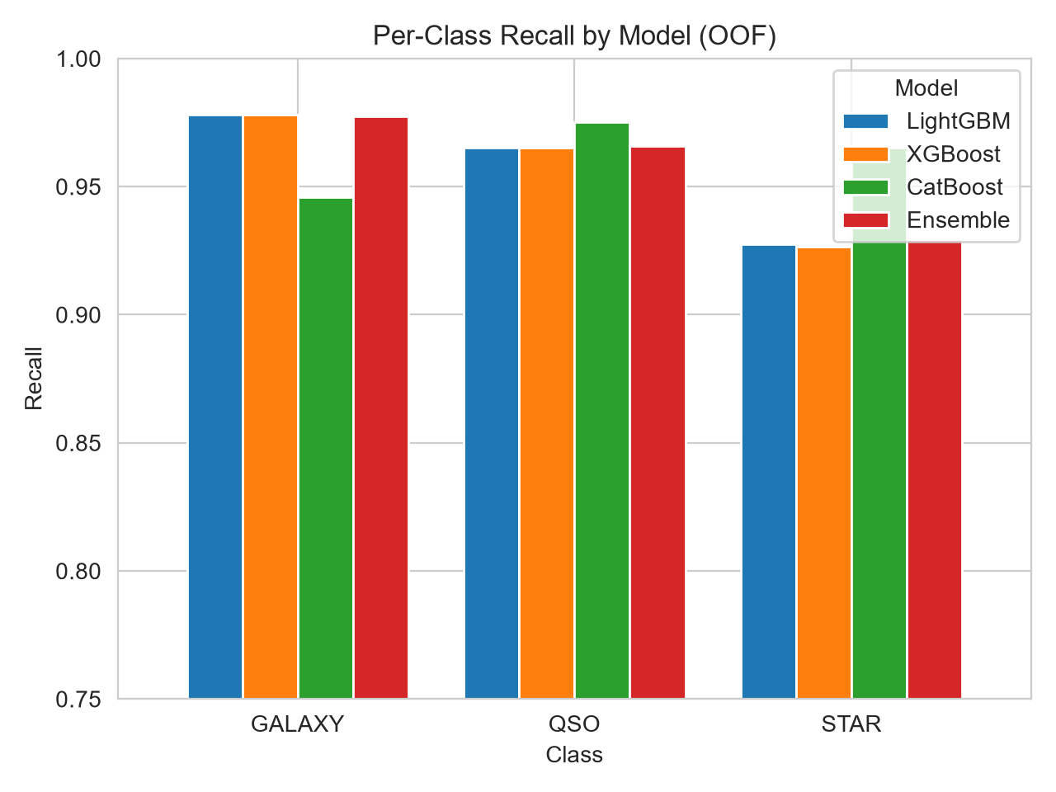
Figure 17. Recall for each class, per model, out-of-fold.
As shown in Figure 17, CatBoost has the least uniform per-class profile of all four: its recall for GALAXY class is 0.95, which is the lowest of all for LightGBM, the figure is 0.96, for XGBoost it is 0.98, and for the ensemble it is 0.97. On the other hand, its STAR recall is the highest at 0.97, which is higher than the respective figures for LightGBM (0.96), the ensemble (0.95), and XGBoost (0.93). CatBoost is also slightly better with respect to QSO recall at 0.98 compared to 0.97 for the other three technologies. As balanced accuracy is calculated as the average of three per-class recalls, and STAR is the smallest class with 14.3 percent of all events, there is a recall trade-off in favor of CatBoost with respect to balanced accuracy making up for the shortcoming in its GALAXY recall which is why it still shows the balanced accuracy of 0.9624, even though it falls short of 0.9647 for LightGBM, which does not face the same tradeoff at all.
Flagging this issue may be advantageous since it is an empirically derived candidate, as opposed to being a design choice. CatBoost (0.9624) outperforms XGBoost (0.9568) in OOF performance, and it is plausible that the proposed split of 60/35/5 favors XGBoost and penalizes CatBoost more than justified by their respective OOF performance. This could be a sign of a practical issue, not a performance-related choice: in fact, CatBoost takes 3-6 times longer to train each fold than LightGBM, which matters if the weights were calculated based on retraining speed and/or inference costs, instead of validation accuracy. It makes sense to use only OOF performance to calculate blend weights – and this is confirmed by the optimized weights search used for the final submission, where XGBoost gets 0% weight and CatBoost has its weight raised to 15%, thus increasing the OOF balance accuracy of the ensemble to 0.9648, just ahead of LightGBM.

5.4 Model Persistence
The function save_models() saves one model from each fold for each family in models/ folder, which includes total 10 LightGBM and 10 CatBoost and 10 XGBoost models. This agrees with the way the models are explained in Figure 5. The usage of these 30 fold-level models and the blending weights will be discussed in the submission stage in the next chapter when the prediction on test set is produced.

6.1 Pseudo-Labeling Pipeline and Rationale
The process outlined in Notebook 04 commences by loading the models developed in Chapter 5 (a combination of 10 each of LightGBM, XGBoost, and CatBoost) in creating predictions. This is done by computing the predictions using the same blend of weights for each model, namely, 0.60 × LightGBM + 0.35 × XGBoost + 0.05 × CatBoost. The resultant predictions with high probabilities are taken as pseudo-labels with some threshold probabilities for each class (GALAXY ≥ 0.995, QSO ≥ 0.995, STAR ≥ 0.95, where the threshold for STAR has been kept lower compared to the other two classes since STAR is considered a less frequent class and the number of high probability cases will be lower). The outcome of this step is that about 159617 rows can be selected out of these 247435 test observations to be considered pseudo-labeled. The labeled data has been augmented to form a combined dataset consisting of 736964 rows (original training data 577347 rows). The class distribution does increase but is still the same in percentage terms (GALAXY 377480 → 474210; QSO 117143 → 153529; STAR 82724 → 109225 rows).
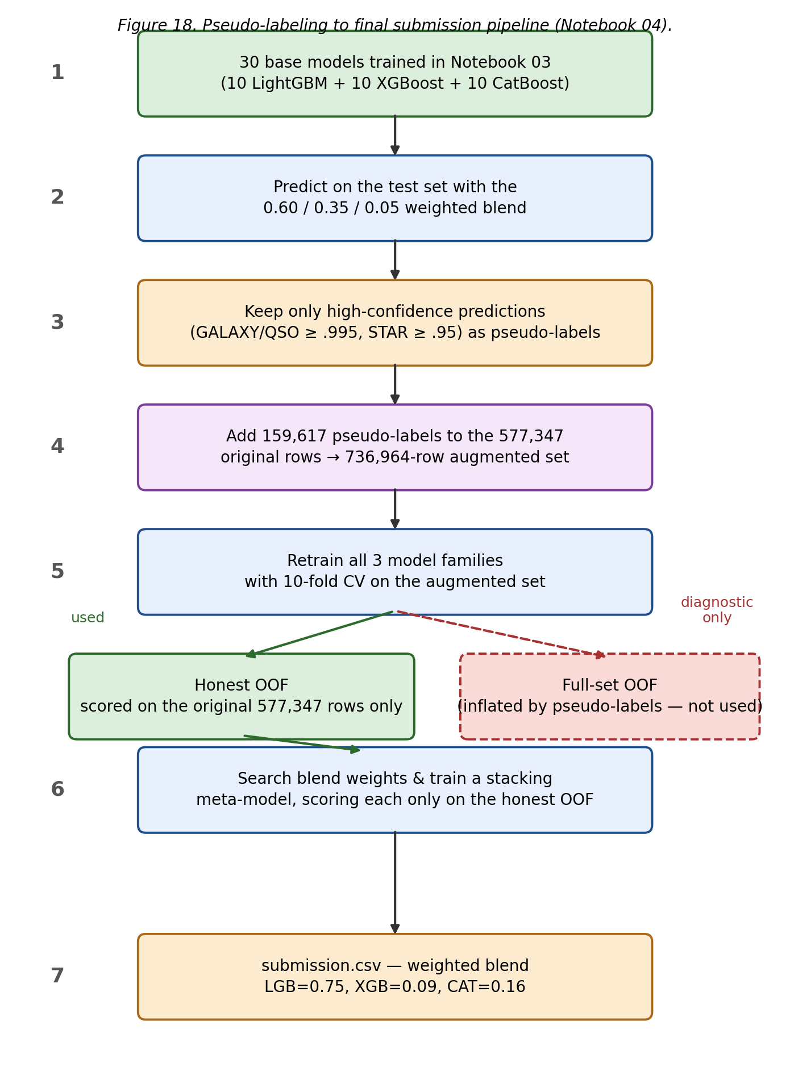
Figure 18. Pseudo-labeling to final submission pipeline (Notebook 04).

6.2 Retraining on the Augmented Dataset
The three base model families are relabeled using a 10-fold cross-validation method similar to what was employed in Chapter 5 but this time with new hyperparameters (LightGBM: learning_rate=0.038, num_leaves=224, max_depth=12, min_child_samples=21, feature_fraction=0.772, bagging_fraction=0.945, bagging_freq=8, reg_alpha=0.321, reg_lambda=0.424; XGBoost: learning_rate=0.068, max_depth=8, subsample=0.921, colsample_bytree=0.805, reg_alpha=0.034, reg_lambda=0.365, min_child_weight=6) instead of using the previously tuned hyperparameters as done in Chapter 5. It is worth mentioning that running the training session on the bigger data set with 736,964 rows takes longer for each fold than in Chapter 5 where only 577,347 rows were involved in the training. The overall out-of-the-box accuracy has been successfully recorded as 0.9728 for LightGBM, 0.9671 for XGBoost, 0.9704 for CatBoost, and 0.9720 for the ensemble recorded on the augmented dataset which is around 0.008–0.010 higher than that in Chapter 5.
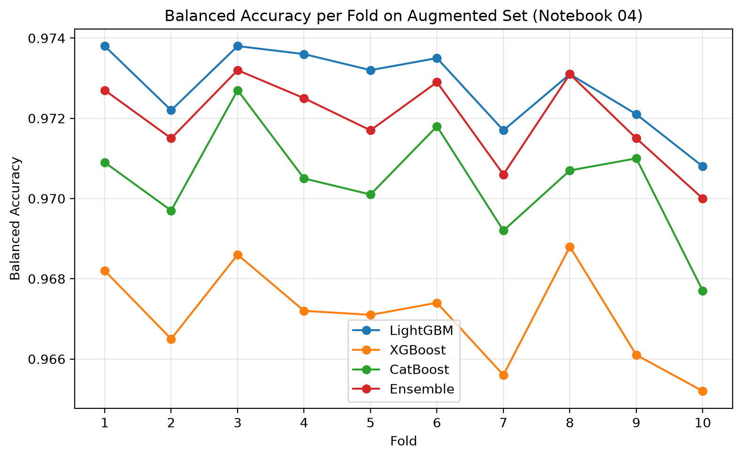
Figure 19. Balanced accuracy per fold on the augmented (pseudo-labeled) training set.

6.3 The Honesty Check: Why the Full-Set OOF Is Misleading
The entire set of figures presented cannot be compared to those found in Chapter 5 since 21.7% of the "ground truth" against which the performance is measured comes from model predictions. The label of a pseudo-labeled data is generated by one of the previous models from the same ensemble, hence getting results means infringing on own conclusions. In order to obtain valid results, this notebook performs OOF computations based on the predictions of the original 577,347 labeled rows together with their OOF performance values. The results of "real" OOF computations for LightGBM equal to 0.9648, for XGBoost is equal to 0.9570, for CatBoost is equal to 0.9619; hence the “fixed” result of 0.60/0.35/0.05 yields the final value of 0.9636 — which is almost the same to those computed in Chapter 5 (0.9647 / 0.9568 /0.9624 / 0.9638 which differ only by 0.0001-0.0005, which is still within the range of fold-to-fold noise).
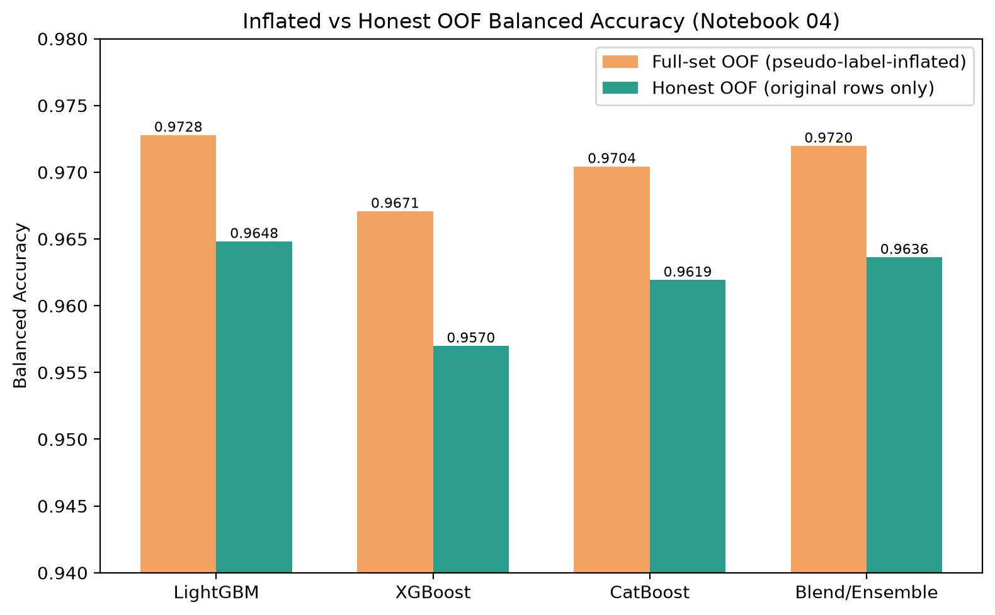
Figure 20. Full-set (pseudo-label-inflated) OOF vs. honest OOF balanced accuracy, per model.

6.4 Blend-Weight Search and the Stacking Meta-Model
A grid search which varied blend weights in steps of 5%, ensuring that each model had at least a 5% weight was conducted, using seed weights obtained from various manually selected combinations including the default weights used in this chapter. The results for the top 15 weight combinations were clustered around values of 0.9645 and 0.9647. The average weights obtained from these methods were LGB=0.750, XGB=0.090, CAT=0.160, giving an expected out-of-fridge balanced accuracy of 0.9646. A stacking model trained with the out-of-fridge probabilities gives a cross-validation mean of 0.9682 ± 0.0008 when evaluated on the compiled dataset. However, this is again done erroneously, using an exaggerated version of the original data. The out-of-fridge accuracy for the actual data came out to be only 0.9585. The analysis in this section reveals the same discrepancy in metrics as in Section 6.3; this is essential since it completely changes our interpretation of model performance.
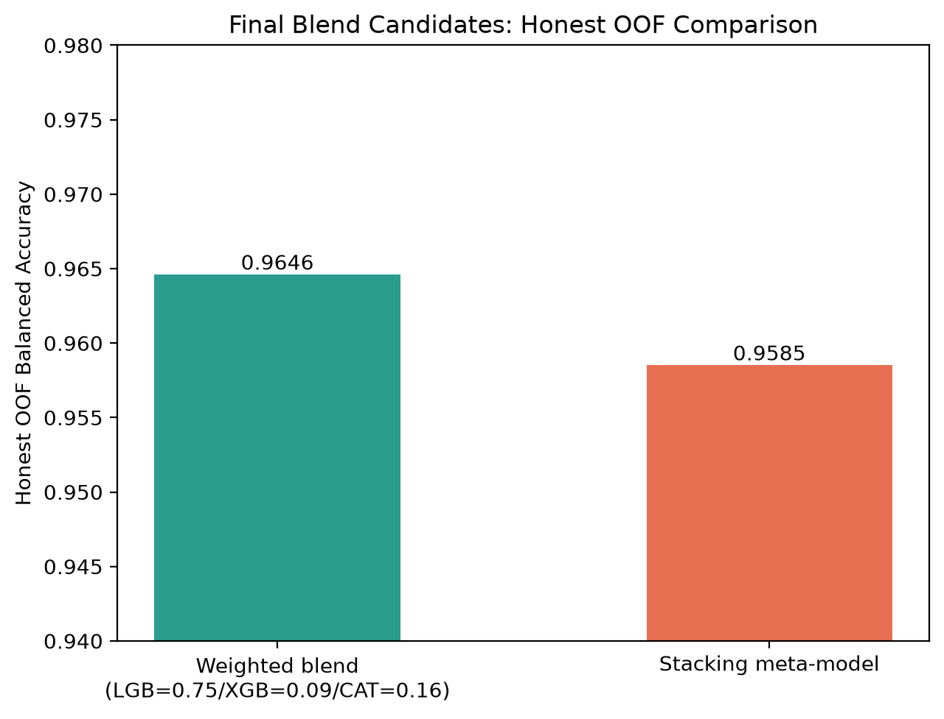
Figure 21. Honest OOF balanced accuracy: weighted blend vs. stacking meta-model.

6.5 Leaderboard Result and Comparison with Notebook 03
The performance of the submission.csv file was rated 0.96494 (for private) and 0.96545 (for public) on the leaderboard. This performance is slightly lower than the notebook 03 submission7.csv which utilizes the combination of non-pseudo labeled models with ratios LGB=0.85/XGB=0.0/CAT=0.15 which scored 0.96520 (for private) and 0.96588 (for public). The difference is minor (0.00026 for private and 0.00043 for public) yet follows the honest OOF comparison trend because, in notebooks 03, the OOF content was rated 0.96476, while notebook 04’s OOF rate was 0.9646. Even though there is more involved in notebook 04, such as pseudo-labeling, hyperparameter re-tuning, stacking that is done at the meta-model level, and test-time augmentation used in the process, the notebook 04 process is still somewhat slower than notebook 03 process in the context of genuine performance.
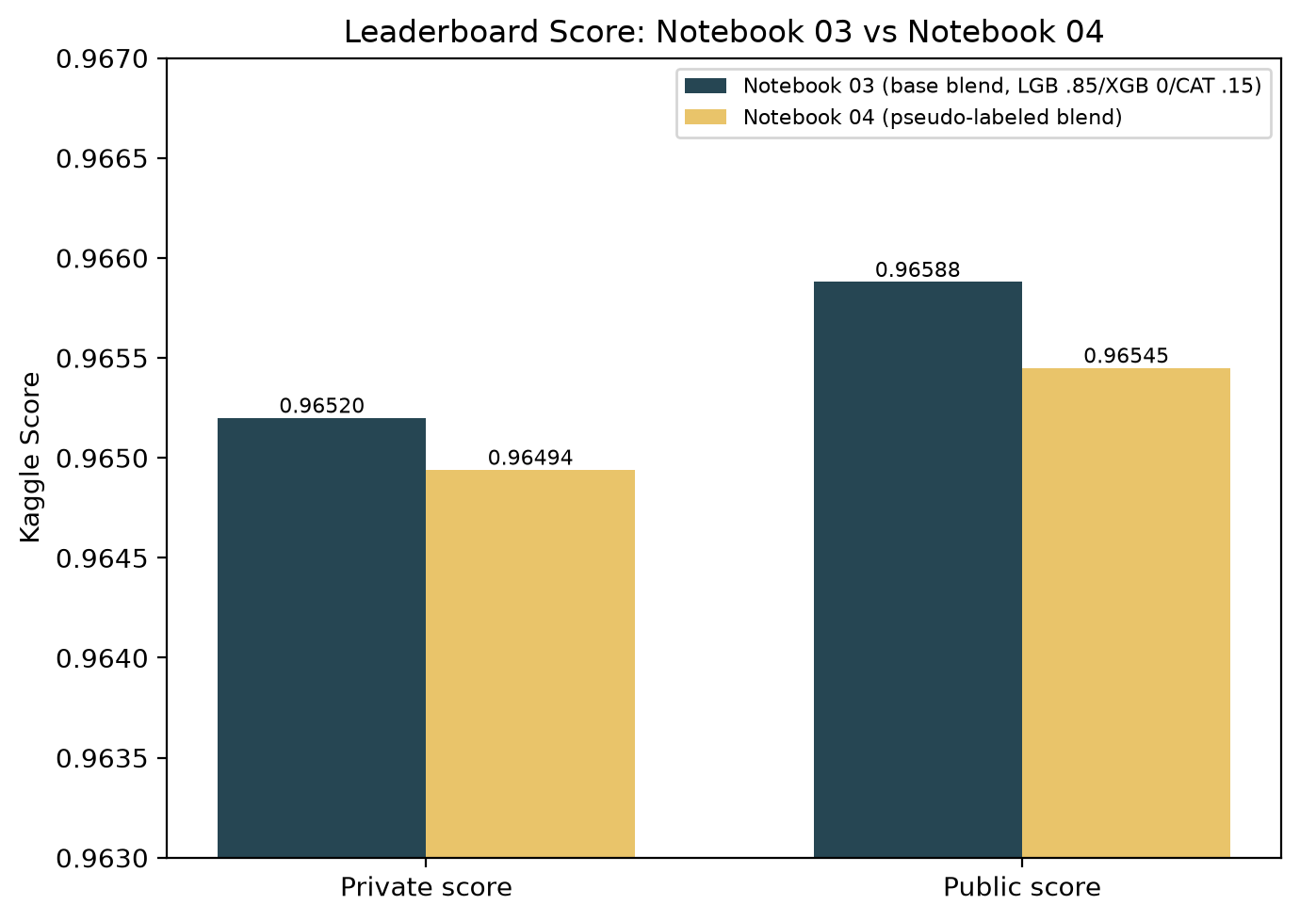
Figure 22. Kaggle leaderboard score: Notebook 03 vs. Notebook 04 final submissions.

6.6 Final Model Selection
Because the mixture of Notebook 03 has a greater OOF score that is not adjusted and has better scores in the leaderboard and it uses one training stage less (there is no pseudo-labeling loop, no meta-model, and no TTA), it is recommended to implement this model. Notebook 04 does contribute in that it serves as a validation study that shows the self-training used did not include any real signals and that it is important to evaluate any pipeline that uses pseudo-labeling and get its “honest” result (without including the augmented input) so that one does not mistake self-confirmation for an improvement.

6.7 Production Model Finalization (Notebook 05)
Section 6.6 selected Notebook 03’s base blend (LGB=0.85/XGB=0.0/CAT=0.15) as the production model, in preference to Notebook 04’s pseudo-labeled pipeline. A short finalization notebook, 05_finalize_production_model.ipynb, turns that decision into a single deployable artifact. It reloads the 10 LightGBM and 10 CatBoost fold models that Notebook 03 already trained and saved (Section 5.4) — XGBoost is deliberately not loaded, since its blend weight is 0.0 and it therefore has no effect on the final prediction. The three components (models, blend weights, feature schema) are bundled with joblib into one file, production_bundle.pkl, together with a fixed 200-row sample of engineered training features used as a background reference for the global SHAP view described below. The Streamlit application deployed via Streamlit Cloud (Section 2.1) loads this single bundle at startup; no separate model files, and no XGBoost artifacts, need to be shipped or loaded.

6.8 Model Explainability with SHAP
Notebook 04 already contains a working SHAP extraction routine for CatBoost (using the native ShapValues output, with the bias/expected-value term sliced off the end of the feature axis rather than the front). However, that routine was run against pseudo_labeled_catboost_models[0] — a CatBoost fold from the retrained, pseudo-labeled pipeline — and not against the CatBoost fold that is actually part of the production blend. Since Notebook 03’s blend was the one selected for deployment in Section 6.6, Notebook 05 re-runs the same, unmodified extraction logic against catboost_models[0] from Notebook 03 instead, so that the explanations below describe the model that is actually shipped.
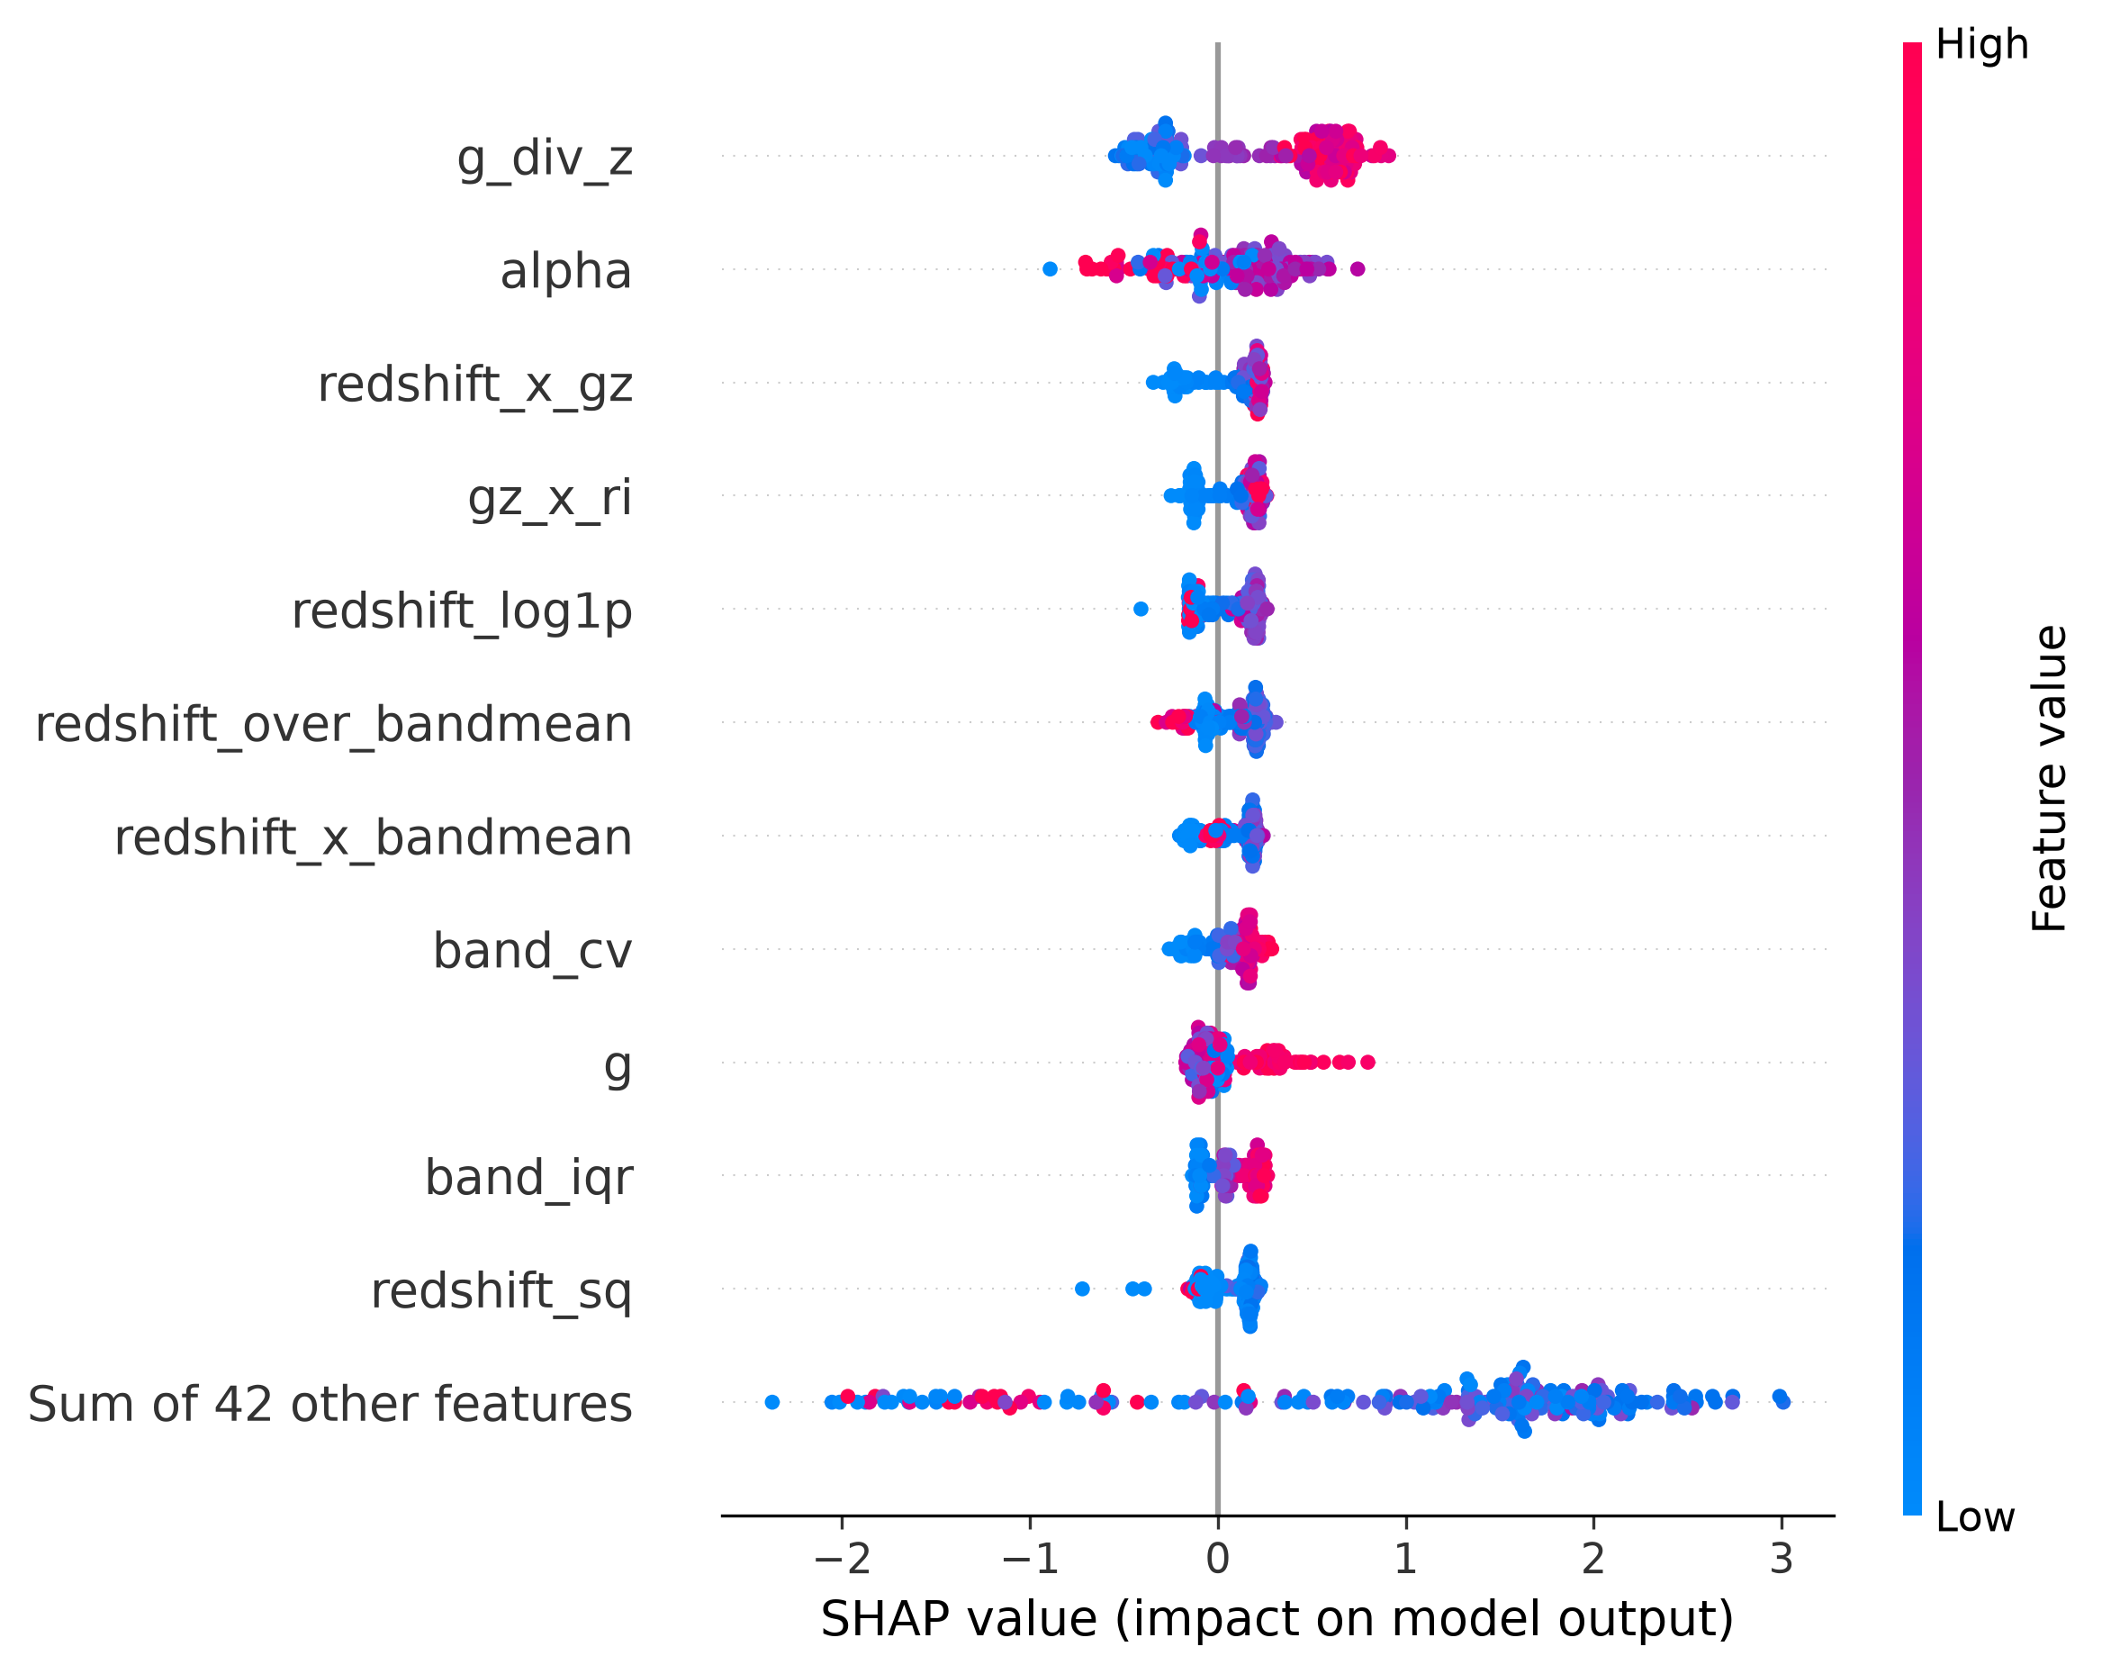
Figure 23. SHAP beeswarm plot for the production CatBoost fold (Notebook 03), dominant predicted class, top 12 features.
g_div_z is the dominant feature by a clear margin, with high values of the feature pushing predictions strongly in one direction and low values pushing the other way — consistent with it also ranking first in the Pearson correlation ranking of Section 4.2.6 (Figure 12). alpha is the second most influential feature in this SHAP view, followed by redshift_x_gz and gz_x_ri, then a cluster of redshift-derived and band-statistic features (redshift_log1p, redshift_over_bandmean, redshift_x_bandmean, band_cv, g, band_iqr, redshift_sq) with more modest and more evenly spread contributions. This ordering is not identical to the correlation ranking in Figure 12 — SHAP values reflect each feature’s contribution within this specific tree ensemble, including interactions with other features, whereas Figure 12 measures each feature’s marginal linear association with the encoded target on its own — but the two views agree on which handful of engineered features carry most of the class signal.
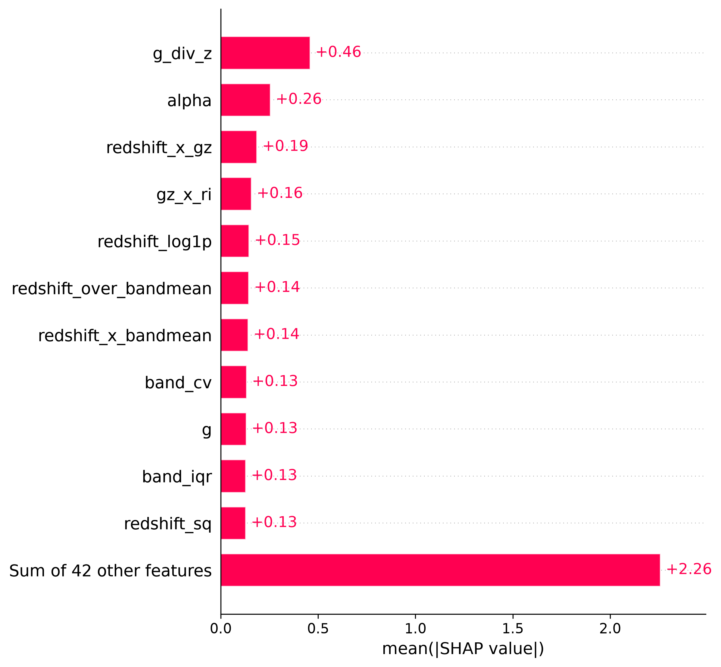
Figure 24. Mean absolute SHAP value per feature for the production CatBoost fold, top 12 features plus the combined contribution of the remaining 42.
In mean absolute terms, g_div_z again leads at +0.46, roughly 1.8× the next feature (alpha, +0.26), followed by redshift_x_gz (+0.19), gz_x_ri (+0.16), redshift_log1p (+0.15), redshift_over_bandmean and redshift_x_bandmean (+0.14 each), and band_cv, g, band_iqr and redshift_sq (+0.13 each). The remaining 42 features together still contribute +2.26 in aggregate, confirming that class separation in the production model comes from the combined effect of many engineered features rather than from one or two dominant signals alone. This is the corrected, production-model version of the explainability analysis: the earlier pseudo-labeled version in Notebook 04 is left in place there as part of that pipeline's own record, but the figures in this section, generated from Notebook 05, are the ones that describe the model actually deployed to the Streamlit app.

