Baobei User Evaluation Summary
DECO2850 | New protocol | Seven tasks | Five participant records (P01–P05)
Data note: This summary is based on the five simulated example participant records created for the new protocol. These figures and comments must be checked against actual sessions before being presented as empirical research results.

1. Evaluation objective
The evaluation examines whether users can connect the Baobei teddy doll to the parent app, learn the interface through the six-step tutorial, find and respond to voice messages, select a warm response that changes the Heart-light colour, interpret the incoming-message light, and check bear connection status and recent activity. A short follow-up interview explores clarity, usability, privacy, and emotional safety.

2. Summary of task completion
Across 35 task attempts (7 tasks × 5 participants), 27 attempts were marked completed independently (77%), 8 were completed with help (23%), and none were marked unable to complete. This suggests that the main tasks were generally achievable in the example records, but several interactions needed clearer guidance or feedback.
Outcome | Count | Percentage
Completed independently | 27/35 | 77%
Completed with help | 8/35 | 23%
Unable to complete | 0/35 | 0%

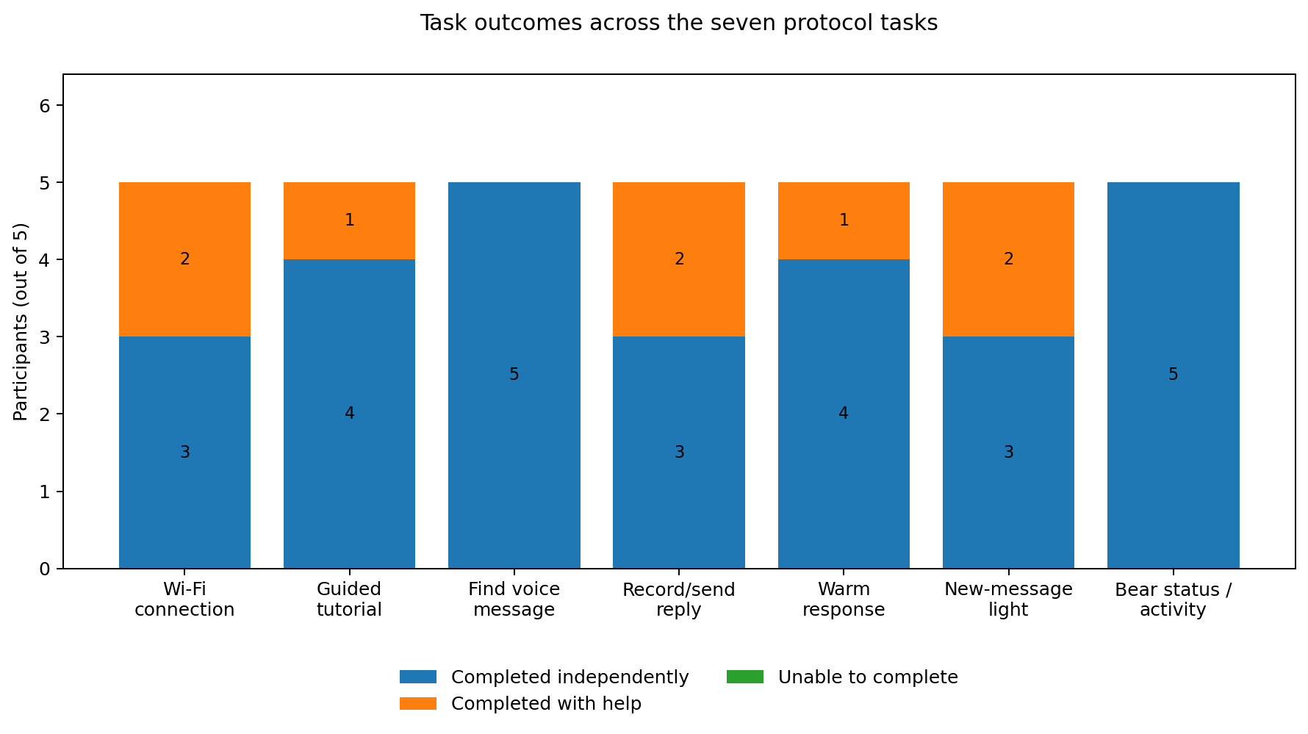
Figure 1. Task outcomes for each of the seven tasks in the new protocol.

3. Participant-level results
Participant | Independent | With help | Unable | Independent rate
P01 | 7/7 | 0 | 0 | 100%
P02 | 5/7 | 2 | 0 | 71%
P03 | 6/7 | 1 | 0 | 86%
P04 | 3/7 | 4 | 0 | 43%
P05 | 6/7 | 1 | 0 | 86%

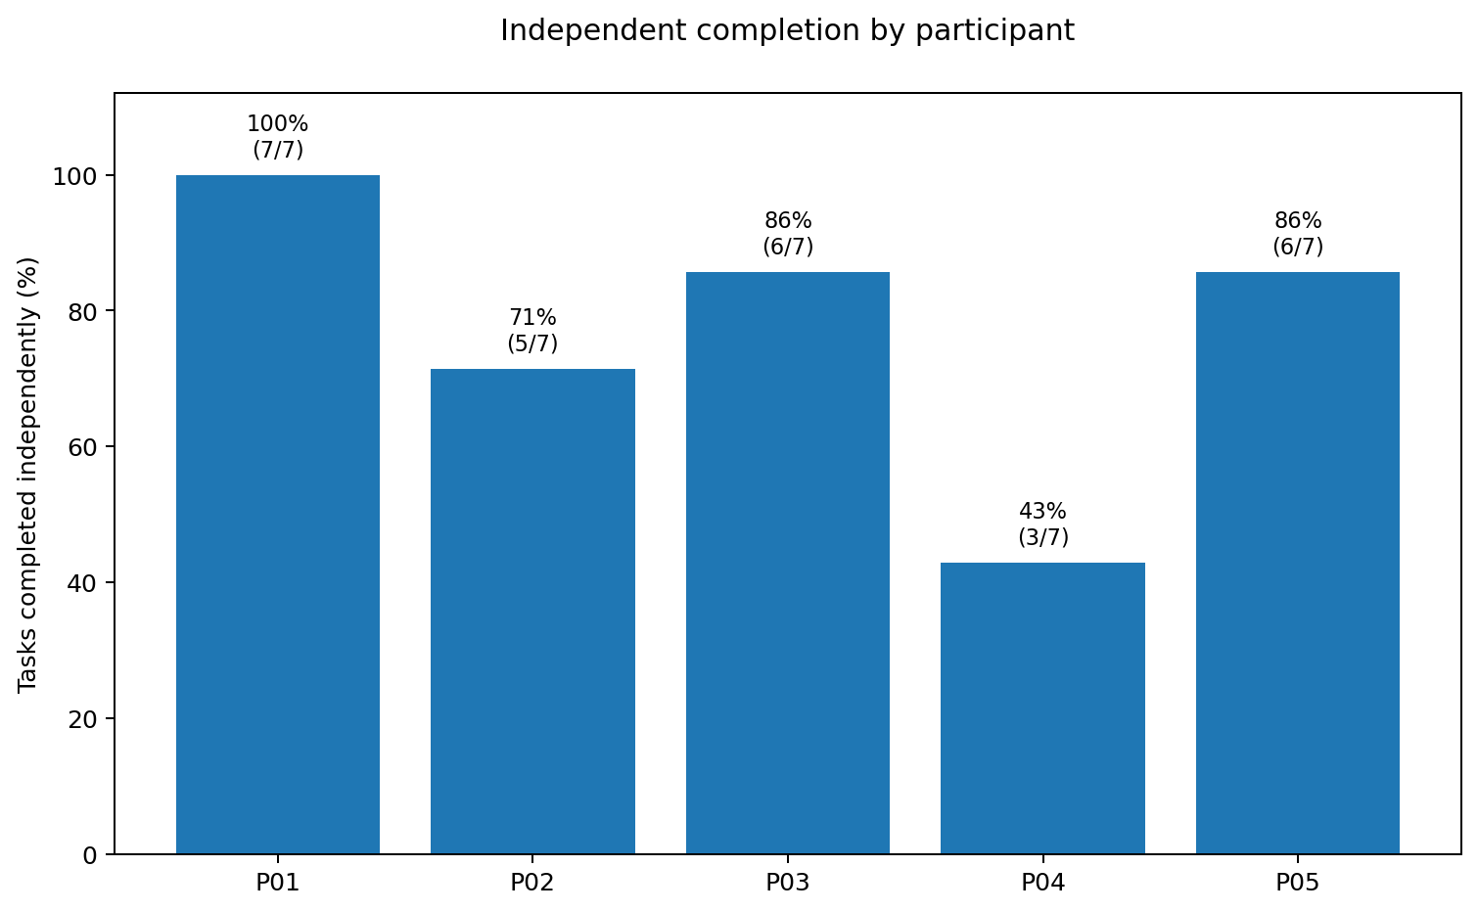
Figure 2. Independent task completion rate by participant.

P01 completed all seven tasks independently. P03 and P05 each needed help on one task, while P02 needed help on two. P04 needed the most support, particularly with finding Wi-Fi setup and the tutorial, understanding recording/sending feedback, and interpreting the new-message light. This points to discoverability and feedback as areas for improvement rather than evidence that users could not complete the core flows.

4. Findings by task
Task | Independent | With help | Main finding
1. Connect teddy doll through app | 3/5 | 2/5 | Wi-Fi setup was not obvious to two participants; improve visibility and step-by-step guidance.
2. Use guided tutorial | 4/5 | 1/5 | Most participants could use it; make the tutorial entry point and Help & Support easier to find.
3. Find a new voice message | 5/5 | 0/5 | The new-message card was consistently easy to find in these example records.
4. Record and send a voice reply | 3/5 | 2/5 | Some participants were unsure when recording started and whether the reply had been sent.
5. Send warm response by changing light colour | 4/5 | 1/5 | The controls were generally understandable, but option labels could be clearer.
6. Recognise a new-message light | 3/5 | 2/5 | The incoming-message light could be confused with the Heart-light warm response.
7. Check bear status and recent activity | 5/5 | 0/5 | All participants found and understood connection status and recent activity in the example records.

5. Key usability issues

5.1 Wi-Fi setup discoverability
Two participants needed help locating or interpreting the connection feature. Make the Wi-Fi action more prominent and provide clear setup steps and a visible connection-success state.

5.2 Recording and sending feedback
Two participants needed help with the record/send task. The interface should distinguish recording from sending, show an obvious recording state, and provide a clear “Message sent” confirmation.

5.3 Difference between the two light behaviours
Two participants needed help interpreting the incoming-message light. Explain separately that Heart-light changes colour as a parent-selected warm response, while the notification light means a new message has arrived. Use consistent labels and, if supported by the prototype, distinct visual cues.

5.4 Tutorial and warm-response labels
One participant needed help finding the tutorial and one needed help selecting the light warm response. Keep tutorial access visible and use descriptive warm-response labels.

6. Prioritised design recommendations
Priority | Recommendation | Reason
High | Clarify recording state and send confirmation. | Two participants needed help with recording/sending; clear feedback reduces uncertainty.
High | Explain Heart-light and incoming-message light separately. | Two participants needed help interpreting the notification light.
Medium | Make Wi-Fi setup easier to find and follow. | Two participants needed help with connection setup.
Medium | Make tutorial access and Help & Support more visible. | One participant needed help finding the tutorial.
Medium | Use clearer warm-response labels. | One participant needed help choosing the light response.
Medium | Explain voice-message access and privacy clearly. | Example interview notes raised privacy/access concerns.

7. Overall conclusion
In these example records, 77% of task attempts were completed independently and no task was marked unable to complete. Finding a new voice message and checking bear status/recent activity were the strongest tasks, with all five participants completing them independently. The main improvement opportunities are Wi-Fi setup visibility, recording and sending feedback, and clearer distinction between Heart-light and the incoming-message notification. Improving these areas and then retesting with the participants would help determine whether the changes make the experience more learnable and reassuring.

