Master's thesis planning report

Accessibility of teaching materials
Exploring obtainability and testing usability in design of shareable teaching materials

Table of Contents
1 Introduction 2
1.1 Background 2
1.2 Purpose 2
1.3 Goals and limitations 3
1.4 Ethical implications 5
2 Strategy, method and time plan 6
2.1 Schedule 7
2.2 Method 8
2.3 Risks and countermeasures 12
2.4 Test subject anonymity 14
3 References 15

Introduction
This thesis studies how to design teaching materials in an accessible way. More specifically, it's about testing the accessibility of a teaching material from a teacher's perspective. Teaching materials, accessibility, purpose and goals, as well as ethical implications are described and discussed in the following introductory chapter.
This study has a particular focus on the Swedish upper secondary school and its main task, as defined by Skolverket (Swedish National Agency for Education).
”The main tasks of the upper secondary school are to impart knowledge and to create the preconditions for students to acquire and develop their knowledge.”
(Curriculum for the upper secondary school, 2013)
This study aims to improve upon the task of imparting knowledge (Satisfactory? Effectively? Efficiently? Neither?) by taking a teacher's perspective into consideration when designing teaching materials.

Background
Teaching materials encompass many different things. In the context of this study, they are materials that are used in a teaching situation with students, but chosen by the teacher, and that are shareable and reusable by many teachers. It's essentially a limitation of the concept of OER, or Open Educational Resources.
“Open Educational Resources (OERs) are any type of educational materials that are in the public domain or introduced with an open license. The nature of these open materials means that anyone can legally and freely copy, use, adapt and re-share them. OERs range from textbooks to curricula, syllabi, lecture notes, assignments, tests, projects, audio, video and animation.” (Unesco.org. 2012)
While OER can be used by students independently, this thesis limits its focus by defining teaching materials as such that are chosen and used directly by teachers. The reason for choosing this focus is because of the complex role a teacher plays in education. Although the Swedish education system consists of many other actors, such as students, principals, administrators, school curriculum writers, parents, and more, the teacher is often one who has to take into consideration the many different interests of these actors (Bengtsson and Selimovic, 2009). Thus, studying materials from a teacher's perspective brings many important organisational and leadership aspects, compared to only studying students' learning.

Purpose
The aim of the thesis is to study how design of teaching materials affect their accessibility from a teacher's perspective. Accessibility in this study is defined as the following description in the Oxford dictionary (Oxford Dictionaries | English, 2018)
“The quality of being easy to obtain or use.”
With this definition, there is both a use aspect and an obtainability aspect to accessibility. Since this thesis aims to study the design of teaching materials, the use aspect is prioritized over the obtainability aspect. However, obtainability is predicted to be relevant enough for the purpose of this thesis, and will thus be studied adequately.
Studying accessibility of a teaching material from a teacher's perspective means to study how a teaching material's design affects its accessibility for a teacher, not for a teacher's students or others actor involved in the teaching process. The reason for picking this focus is because the teacher is in a position where accessibility is very important: They need to take into consideration factors such as the students' previous knowledge, the school curriculum, time management, classroom leadership, and more. This also means that the material's accessibility is, hypothetically, tested against several factors at once.
Summarized:
- The aim of the thesis is to study how the design of teaching materials affect their accessibility from a teacher's perspective, where accessibility is defined as being easy to obtain and use.

Goals and limitations
The goals of the thesis are described in the form of multiple deliverables which connect to an overall goal. The deliverables are as follows.

Target groups and how to share the deliverables
While the final report and presentation are technically open to the public, many of our target groups will not likely take part of these resources. To make our results more accessible to the public we propose a few ways to share them with the following audiences:
- Swedish school teachers: There are multiple social media groups where resources like ours are shared, where it’s easy to upload files and show a summary of our findings to teachers who might be interested. The schools and teachers that we cooperate with might also want to take part of our results and should therefore be handed the deliverables in an accessible format.
- Students and alumni at Chalmers’ masters program Lärande och Ledarskap (Learning and Leadership). These may partake in the presentation, and they have multiple social media groups and similar places where we can share the deliverables that they might be interested in.
- Kleindagarna is a yearly event that will take place in June and August, with the purpose of bridging the gap between Swedish secondary school (gymnasium) and higher educational institutions (högskolan), with focus on mathematics. The people participating in this event are a relevant target group, and can possibly be reached both by sharing results of the study digitally, or participating in the event itself.

Testing methods
With our testing methods we hope to develop a simple yet effective way of studying the accessibility of teaching materials. Inspired by Steve Krug’s usability testing script, we want to make our methods similarly accessible to those who are interested in making effective teaching materials. (Krug, 2009)
- A Steve Krug-like script for doing usability testing of teaching materials.
- An evaluation of the testing methods from several perspectives: Its time and resource requirements, its reliability and validity, what kind of information it gives, and eventual other things that we discover with it.

Models that facilitate the making of teaching materials
During our testing we expect to create and think about new models that describe the process of making teaching materials. We hope that some of these will be useful for understanding the process and for finding new ways of improving one’s ways of creating materials. In that case, making them accessible to the public might be advantageous.
- A description of each model and how it’s thought to be used.
- And evaluation of each model that describes eventual areas of improvement and what the model might be useful for.

Teaching materials
While we expect to use a lot of existing teaching materials for testing instead of spending a lot of time making it from scratch, there’s also the possibility of improving these materials as part of the testing process. For example, we might try to “patch” one of the shortcomings of one material, and test how this patch changes its quality. Similarly, we might create instructions to increase the accessibility of some materials to the test subjects. In such cases, sharing the improved materials might give something of value to teachers that may be relevant to them.
- The materials themselves in the form of digital copies or blueprints.
- A summarized evaluation of each material, according to the test results, in the final report.
- Instructions for how each material can be used, and how one can take part of its benefits.

Ethical implications
While it's easy to assume that the gained knowledge from the study will be used to improve how teaching materials are designed, there are a couple of other possible outcomes to consider. For example, do shared teaching materials increase or decrease teacher workload, and how does access to these materials affect segregation in schools? While the thesis doesn't aim to answer these questions directly, they are important to consider in design decisions around teaching materials, and therefore become an important part of the study.

Possible effects on teachers' work load
Teaching materials may hypothetically be used to decrease teachers' work load by shifting the responsibility for lesson design somewhere else. Decisions such as how to divide the students into groups can be delegated to the material designer, who can share the material practically infinite times through the use of digital tools. Compared to letting every teacher create their own material without sharing it, shareable materials would decrease the work load overall. However, this assumes optimal conditions, such as the material not needing any adaptation that depend on specific needs. Furthermore, long-term effects such as the teacher-per-student ratio changing might leave the workload of every teacher unaffected.

Possible effects on segregation
Shared teaching materials can hypothetically be used to decrease segregation, by providing access to knowledge and resources to schools that lacked them before. For example, teachers who have less time to spend on designing materials might delegate the design process to teachers who have more time. This might help increase the quality of teachers' work in disadvantaged schools, a proposed strategy to battle segregation in schools in an OECD study (OECD, 2012), by letting skilled teachers share their knowledge where it is most needed. However, this also assumes that the material is easily shared between teachers without too much work required on adapting it. It also assumes that teachers in schools that need the materials actually gain access to it. Even if it would be possible for every teacher to download a material from a public website, it's possible that not every teacher knows about the website and the material, which is especially important to consider in this study when analyzing how obtainable certain teaching materials are.

Teaching materials as a technology
Since it's not obvious what the implications of shared teaching materials could be, it's important to stay critical and discuss the effects of certain material designs during the study. A certain perspective that can be used is one by U. Franklin, in the book and lecture series The Real World of Technology (Franklin, 1990). In it, she discusses technology as a complex system:
“Technology is not the sum of the artifacts, of the wheels and gears, of the rails and electronic transmitters. Technology is a system. It entails far more than its individual material components. Technology involves organization, procedures, symbols, new words, equations, and, most of all, a mindset. […] Personally, I much prefer to think in terms not of systems but of a web of interactions. This allows me to see how stresses on one thread affect all others. The image also acknowledges the inherent strength of a web and recognizes the existence of patterns and designs.” - Franklin, 1990, pages 16 and 95.
Since teaching materials encompass both a way of working and artifacts, they can be viewed as a technology, as defined by Franklin. As such, they affect how a teacher does their work in complex ways. For example, as Franklin also notes, materials can be used both to assist teachers in their lesson design, or to make them comply to certain standards and control structures. Therefore, it becomes important to consider effects on the teacher's work as a whole, instead of limiting the analysis to a specific lesson.
Applied to our study, seeing teaching materials as a technology means considering the teacher's work holistically when discussing design decisions and test results. Here are some examples of considerations to include:
- How the design of the material limits as well as enables the teacher to work in certain ways,
- What kinds of schools and institutions the material will be available to,
- How the material affects the teacher's workload,
- If the material affects how the teacher's institution works, for example if it involves other teachers.

Strategy, method and time plan
Some important decisions have been made about the strategy, methodology and time plan of this study. Developing teaching materials incrementally has been viewed as the most reasonable method, as usability testing a material contributes with data that, when used to revise the material, enables future usability testing and revisions. Other methods of this study, such as collecting data answering questions about obtainability will mainly be made through non-iterative processes, such as literature studies.

Schedule
Summary of time plan:
- Planning (6 weeks) – Working out and agreeing on a set of methods and a preliminary plan for the project. Finding test subjects and planning the usability tests they will partake in. Compiling a list of sample teaching materials.
- Planning and Testing (3 weeks) – Starting the tests, where we do several iterations of the testing phase on a very limited amount of test subjects, then summarizing and analyzing the data. Completing the list of sample teaching materials, after we know what seems to yield the most useful data from our tests. Researching obtainability through literature studies and usability testing results.
- Testing and Documenting (7 weeks) – Involving a larger amount of test subjects, probably collecting more comparable and higher quality data than before. Summarizing, analyzing and documenting the results. Continue researching obtainability through literature studies and usability testing results.
- Documenting (9 weeks) – Finish writing, defending and revising the final report.
Summary of milestones:
- Start of test (week 17) – This is where we start the first iteration of the testing phase. The selection of test subject will be relatively small in these cycles.
- “Np” starts (week 18) – “Nationella proven” starts. These are standardized, national tests in mathematics. During this period many math teachers will not feel inclined to partake in usability testing teacher materials. Focus will instead be put into summarizing and analyzing previous data and revising material. This may also be a good time to put extra time on finding more literature to help revising the teaching materials in a systematic and scientific way, when we now have conducted some tests and have a better picture of what to expect from future data.
- “Np” ends (week 22) – “Nationella proven” ends. Although we may be able to include some teachers earlier than week 22, this week should be when teachers are done correcting “Nationella proven” and should therefore be more willing to partake in the study. There’s not much time left until schools close and most teachers go on summer vacation, therefore teachers should be asked to continue participating in this study during the summer.
- Data discussion (week 27) – This marks the planned end point for collecting data. A decision need to be made whether collected data is sufficient or if testing should continue. If testing is decided to end, this is where the collected data is analyzed as a whole and general conclusions from that data are drawn.
- Defend final report (week 33) – This is the earliest possible week for defending a final report in the fall, as scheduled by Chalmers University of Technology. A preliminary (and substantially complete) version of the final report will be sent to the opponents and submitted to the learning platform PingPong at least seven days before defending the final report.
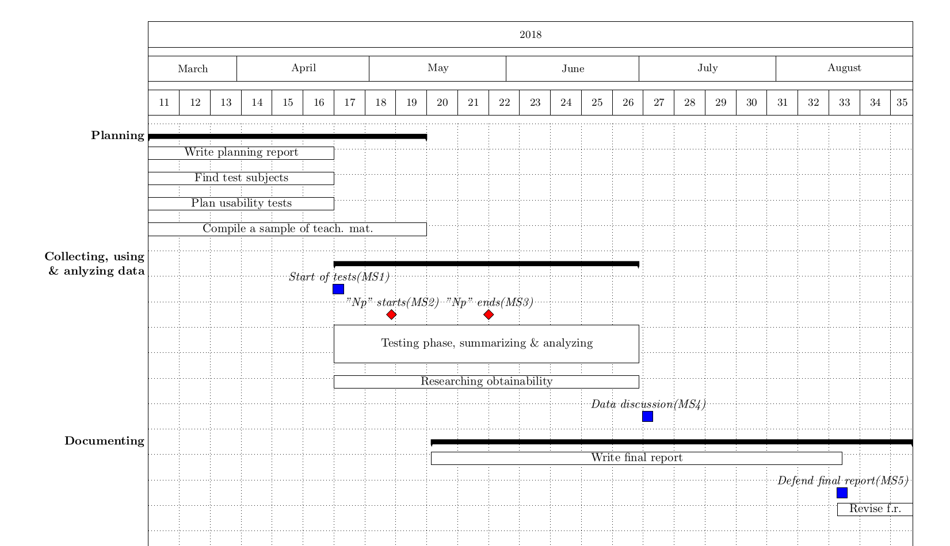
Figure 1: Gantt schedule describing what work is expected when. The “Testing phase, summarizing & analyzing” is an iterative process, which is described more in depth in the method chapter.

Method
When discussing Accessibility of a teaching material, in this study, it has been separated into two aspects: Obtainability and Usability. Collecting data for these aspects will be done separately and with different methods.

Obtainability
Obtainability describes how easy it is for a teacher to obtain a teaching material, and the data for this aspect of accessibility will mainly be acquired through studying literature. There is also a possibility of acquiring data connected to obtainability while testing for usability, as these aspect can oftentimes be hard to distinguish.
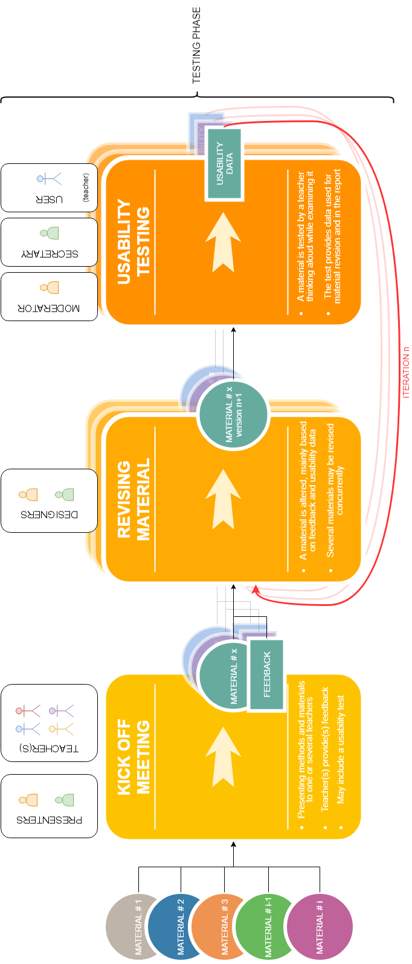
Words like obtainable and teaching materials are broad by definition, and school as an institution is complex by nature. The discussion on obtainability in this thesis can therefore be expected to fail at giving a complete explanation to how these words fit together, but it will try to answer some of the difficulties teachers are facing in obtaining teaching materials.
Figure 3: As with ASD, this custom designed method includes a learning loo and will be used for collecting data on usability of teaching materials. This method also describes the roles of the different actors, based on the current stage of the testing phase.

Usability
Our main method of collecting data consists of a process inspired by Adaptive Software Development (ASD). This method involves iterative development with strengths that fit this project, such as being flexible and low risk. This can for example mean that new information can be easily adopted in future tests and that results can be delivered even if test subjects decide to terminate involvement in this study early. (Sommerville, 2016)
ASD is an antecedent to Agile Software Development, paving the way for popular project management methodologies such as Scrum and Kanban. The methodology for this study has no need of being as complex as Scrum or Kanban, one of the main reasons being the relative small size of the development team (i.e. the two authors of this paper), whereas for example the Scrum model is generally used by splitting a larger workforce in teams of 3 to 9. (Schwaber, 2004)
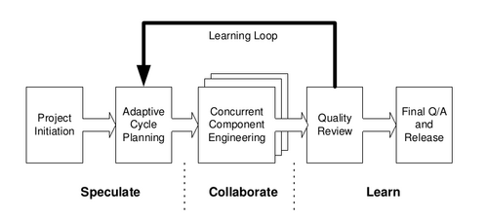

Figure 2: Adaptive Software Development (ASD) consists of three stages with a feedback loop, enabling developers to perform multiple iterations of improvement based on what they learn from users. This model is similar to the methodology that will be used in this study to collect data on usability of teaching materials. (Highsmith, 2000, p.84)
Comparing this study’s methodology with the ASD model, the Kick Off Meeting used to introduce one or more teachers to the study, as well as deciding on a teaching material to work on and a date for the first usability test, is comparable to the Project Initiation of ASD, being prior to the parts contained inside the Learning Loop.
What in the ASD methodology is called Adaptive Cycle Planning will be the initial step of the Revising Material stage, deciding on how to rework the teaching material based on the data collected from a Kick Off Meeting or previous Usability Test. This is inevitably one of the stages where collected data is Summarized and Analyzed.
The Concurrent Component Engineering part of ASD is practically the same as the Revising Material stage, this is where a coder would revise the code of the program and this is likewise where the product, the teaching material, is being worked on with the intent of improving its usability.
What is called Quality Review in ASD is the Usability Testing part of this study. This is where the teaching material is tested on a teacher and the data needed to improve the usability of the teaching material is collected. The method used to test usability is based on Steve Krug’s script for usability testing websites. Because a teaching material is quite different from a website, oftentimes focusing on interactivity, the script can not be used without some changes. There is however some important aspects of Steve Krug’s script, e.g. not asking leading questions, that is of great importance to the quality of the data and thereby the quality of future revisions of the teaching material. (Krug, 2009)
The end goal of ASD is Final QA and Release. In the case of this thesis, this would be replaced with Final report.

During the Kick Off Meeting of each teacher involved in the study, the teacher will be able to choose what teaching material they want to use for their usability testing. There will be a sample of teaching materials to choose from, but the possibility of the teacher choosing a material of their own liking is also a possibility. This will be done so that the teaching material will feel as relevant as possible to the teacher.
When revising material, the decisions of how the revisions will be conducted is determined from a combination of data from Usability Tests and by studying literature. There can be instances where a teacher’s assumptions of how the next revision will look may be unmet. These cases need to be analyzed and mentioned in the final report, as they may lead to interesting discussions. If for example a revision is made following a certain pedagogic template, and the resulting material makes the test subject less inclined to use it on a lesson, new conclusions can possibly be drawn about accessibility of designing teaching materials.

Risks and countermeasures
Risk | Countermeasure
Teachers stop working in the middle of the project due to the summer holidays. This creates several challenges. It gives us limited time to contact the teachers and plan the tests together with them. It might also make it more difficult to convince them to participate. | We simplify the testing method early to avoid logistical problems that are time consuming both for us and the teachers, making it easier to book meeting and testing sessions with teachers. Furthermore we make the tests executable outside an active lesson, thus making it possible to do some of them during the school summer holidays.  In case it still becomes difficult to execute tests during the summer, it's also possible to continue working on materials according to the analysis and results of the tests, and to refine the knowledge gained through various other sources, such as literature studies.
Too few teachers are willing to participate, for the thesis to become scientifically feasible. | Due to a large part of the project running during the summer, this risk is very likely, at least during part of the project. Some approaches if this happens include:  - Having more data than appropriate represented by teacher students or very few teachers, reducing the scientific accuracy of the study.  - Putting more time than planned into finding new test subjects, as some schools have teachers working during the summer. With the risk of gaining no to little returns, reducing the efficiency of the study.  - Extending the study, collecting and analyzing data during the fall of 2018. Postponing graduation and reducing possible personal income.  - Changing methods and methodology in some other way than the suggestions above and still answering the same thesis statement or research question.  - Adapting the thesis in accordance to existing conditions, answering a different research question or proving a different thesis statement. Possibly changing methods and methodology to fit the new goals and purposes of the thesis.
The tests are done independently by different people, resulting in different interpretations of the testing method. | The plan is primarily to do tests in pairs, and thus the different interpretations will likely be noticed and dealt with on the spot. The tests are also done via manuscripts and templates, which standardizes them somewhat.
Data won’t be comparable. For example, multiple test subjects might deliver vastly different data to the same teaching material without a logical explanation to this deviation. | We treat a lack of comparable data as data itself. Since our testing method itself is part of our deliverable goals, finding out its flaws is also a good result for improving it or for finding out that it's not a reliable method.
We are unable to find generally applicable guidelines for designing accessible teaching materials, possibly due to teachers having different needs and desires, therefore wanting very different material. | This is expected because of how much variation exists in teaching, especially when it comes to local needs. One of the ways to deal with this is to create a testing method that is easy to use for anyone who wants to design teaching materials. If the tests are generally applicable, they can be used to design better teaching materials for specific needs.  Another possible solution to this problem is that finding out that teachers' needs are very different and specific can be a good result in itself. For example, this can be taken into consideration when discussing design methods for teaching materials, such as if it's better to focus on a specific need for a few teachers, or to “go wide” and design for many kinds of needs.
The test results are not transferable to a real situation, such as a classroom or when a teacher actually plans a lesson. | It's difficult, if not impossible, to avoid this problem completely. If possible, some tests might be done with a real lesson, although this is difficult to do logistically. Another way to deal with it is to make sure that the testing methods don't consist of leading questions. For example,
Our scope changes, for example by trying to answer questions not thought of in the beginning of the project. | A certain level of scope change is inevitable as the project progresses, since it's a research project that explores new methods. However, it becomes a problem when scope change develops into scope creep. In that case, more time and resources are required as more features and questions are added to the goals of the project.  An important part of dealing with the scope creep is to spend time clarifying the project goals and communicate them clearly within the team. If a change of scope is needed, care should be taken so that the whole team is aware of what changes need to be done. Suggested countermeasures for this are for example holding weekly meetings where scope is discussed in some form, making sure all documents are accessible to everyone in the team, and working in the same place at the same time.
Focus on accessibility for teachers lower quality of student learning | Although this aspect is outside the realm of the current thesis statement, it is a possible point for discussion that can be presented in the final report.

Test subject anonymity
There are several ways of presenting the personal details of test subjects in scientific studies. In this study some personal details will be disclosed and some will be held anonymous. What is disclosed and examples of what is held anonymous are listed below.

Disclosed information
Age – rounded to nearest 5 years.
Current status – if the test subject is currently working as a teacher and if so in what grades, or if they are e.g. studying to become a teacher.
Years in teaching – nearest year if under 10 years, can otherwise be rounded to nearest 5 years. No regard to the age of students taught. No regard to full-time or part-time employment.
Subjects – what school subjects is the test subject certified to teach?

Anonymous information
Sex/Gender – the risk of a reader finding false correlations from the data is assumed to be greater if the test subject’s sex and/or gender is disclosed.
Name – the name of the test subjects will not be disclosed, and because the sex/gender will not either, the label of the test subjects will also be as gender free as possible.
Name of school – with this information, it would be too easy to identify the test subject.
Place of school – all subjects studied will live and work in close proximity to Gothenburg, Sweden, as the tests are dependent on personal meetings.

References
Krug, S. (2010). Rocket surgery made easy. Berkeley, CA: New Riders.
Curriculum for the upper secondary school. (2013). Stockholm: Skolverket.
Highsmith, J. (2000). Adaptive software development. New York: Dorset House.
Schwaber, K. (2004). Agile project management with Scrum. Redmond, Wash.: Microsoft Press.
Sommerville, I. (2016). Software engineering. Harlow: Pearson.
Unesco.org. (2012). What are Open Educational Resources (OERs)? | United Nations Educational, Scientific and Cultural Organization. [online] Available at: http://www.unesco.org/new/en/communication-and-information/access-to-knowledge/open-educational-resources/what-are-open-educational-resources-oers/ [Accessed 26 Apr. 2018].
Oxford Dictionaries | English. (2018). accessibility | Definition of accessibility in English by Oxford Dictionaries. [online] Available at: https://en.oxforddictionaries.com/definition/accessibility [Accessed 26 Apr. 2018].
Franklin, U. M. (1990). The Real World of Technology. Toronto: House of Anansi Press Inc.
OECD (2012), Equity and Quality in Education: Supporting Disadvantaged Students and Schools. OECD Publishing.
M. Bengtsson and A. Selimovic (2009). Vad har läraren för roller idag?. Malmö: Malmö högskola.

