Exploring efficient design of teaching materials / Usability-testing teacher accessibility (in design) of shareable teaching materials // Håkan
Master's thesis planning report

Introduction // Seb

Background
While many studies focus on how teaching materials can be designed to improve student learning, few have tackled how teaching materials can be designed for teachers to find them accessible. Teacher accessibility is a cornerstone of effective education, in that student learning suffers if a teacher can’t create efficient lessons from the given or chosen material. In a world where content creation is thriving, accessibility becomes more crucial as availability becomes more trivial.
// Check the background that I saved in a side document when I cleaned up. There are several sources there that can be used in the background to describe and motivate the study. For example, I know there is one source that explains that teachers lack knowledge of where to find materials. If unclear, we should write the background last, since it's very dependent on what we write below it. /Seb

Purpose

Goals and limitations
The aim of the thesis is to study how design of teaching materials affect their accessibility from a teacher's perspective. Accessibility in this study is defined as the following description in the Oxford dictionary [KÄLLA: https://en.oxforddictionaries.com/definition/accessibility]
“The quality of being easy to obtain or use.”
With this definition, there is both a use aspect and an obtainability aspect to accessibility. Since this thesis aims to study the design of teaching materials, the use aspect is prioritized over the obtainability aspect. However, if relevant for certain cases, obtainability of a material might be studied as well.
Studying accessibility from a teacher's perspective means to study how a teaching material's design affects its accessibility for a teacher, not for the teacher's students or any other actor involved in the teaching process. The reason behind this is because the teacher is in a position where accessibility is very important: They need to take into consideration factors such as the students' previous knowledge, the school curriculum, time management, classroom leadership, and more. The material's accessibility is therefore, hypothetically, tested against several factors at once.
Summarized:
- The aim of the thesis is to study how the design of teaching materials affect their accessibility from a teacher's perspective, where accessibility is defined as the quality of being easy to obtain or use.

This study aims to find which aspects of teaching materials contributes to making said material accessible to teachers.
In broad terms, teaching materials can be anything from math books to PowerPoints or Youtube-videos. The teaching materials in this study will be designed by the authors of this study to initially emulate the typical shareable material that can be found on the internet, iteratively evolving to determine how it can be more accessible to teachers.
“Accessible” will be viewed as a complex term, primarily being synonymous with “usable”. Secondary meanings include “convenient”, “inspirational”, “useful”, “effective”, “flexible” and “suitable”.
The question the study is trying to answer is:
- Can we from
// Define what materials are and what materials we are going to use as concretely as possible, without sacrificing flexibility that will be needed when negotiating tests withh teachers.
// Scope: Research question, purpose, and such. Again make it as concrete as possible without sacrificing too much flexibility. Use Beginner's Mind.
// How do teachers use documented education, and how can documentation be formed to maximize gains for the teachers that use it? Gains mean, for example:
- Time, compared to if the teacher had planned their education from scratch
- Knowledge, in that the teacher could use another person’s expertise in an area
- Perspective, in that different teachers contribute to the same documentation

Ethical implications
- Segregation in schools and how the study affects it: obtainability, usability
// Duality: availability of the knowledge gained from the thesis vs. positive effects of sharing materials.
- Teacher stress and materials
// Duality: more or less work for teachers?

Strategy, method and time plan

Risks and bottlenecks // Seb
- We are unable to find generally applicable guidelines for designing accessible teaching materials, possibly due to teachers having different needs and desires, therefore wanting very different material.
- A simple question we are trying to answer turns out to be more complex than thought. If for example teaching material accessibility turns out to be extremely depend on its medium (PowerPoint, text document, video etc.) or the receiver (if different teachers interpret the material differently etc.).
- Our scope changes, possibly due to personal desires of answering questions not thought of in the beginning of the project.
- General lack of test subjects… (see examples below)
- Lack of test subjects for particular kinds of tests, forcing the project to change methods and possibly answering a different question than.
- Results vary depending on who conducts the testing.
- Data won’t be comparable. If for example multiple test subjects deliver vastly different data to the same teaching material and there is no logical explanation to this deviation.
- Our focus on accessibility for teachers may lower the overall quality when it comes to student learning. Although this aspect is outside the realm of this study, it’s a possible point for discussion.

- Teachers stop working in the middle of the project due to the summer holidays. This creates several challenges. It gives us limited time to contact the teachers and plan the tests together with them. It might also make it more difficult to convince them to participate. Our main method for dealing with this is to focus on one whole school at a time, meaning we don't have to adapt to too many teachers' structures and methods, especially if the teachers cooperate in teams. We'll also work actively on contacting schools and teachers even while the planning report is being written.
- After schools close for summer, we can't do any more testing. This means we need to find a way to contribute to the project without the schools. Suggestions are to continue developing the teaching materials without tests, working on sharing/discussing the results online, or finding a summer school or study circle to do tests with.
- [Lärarna har inte tid?]
- [Vi tolkar testmetoderna olika?]
- [Risk: Vi gör materialet bra på usability test, men inte bra på lektionen!]

Schedule // Håkan
Summary of timeplan:
- Planning (6 weeks) – Working out and agreeing on a set of methods and a preliminary plan for the project. Finding test subjects and planning the usability tests they will partake in. Compiling a list of sample teaching materials.
- Planning and Testing (3 weeks) – Starting the tests, where we do several iterations of the testing phase on a very limited amount of test subjects, then summarizing and analyzing the data. Completing the list of sample teaching materials, after we know what seems to yield the most useful data from our tests.
- Testing and Documenting (7 weeks) – Involving a larger amount of test subjects, probably collecting more comparable and higher quality data than before. Summarizing, analyzing and documenting the results.
- Documenting (9 weeks) – Finish writing, defending and revising the final report.
Summary of milestones:
- Start of test (week 17) – This is where we start the first iteration of the testing phase. The selection of test subject will be relatively small in these cycles.
- “Np” starts (week 18) – “Nationella proven” starts. These are standardized, national tests in mathematics. During this period many math teachers will not feel inclined to partake in usability testing teacher materials. Focus will instead be put into summarizing and analyzing previous data and revising material. This may also be a good time to put extra time on finding more literature to help revising the teaching materials in a systematic and scientific way, when we now have conducted some tests and have a better picture of what to expect from future data.
- “Np” ends (week 22) – “Nationella proven” ends. Although we may be able to include some teachers earlier than week 22, this week should be when teachers are done correcting “Nationella proven” and should therefore be more willing to partake in the study. There’s not much time left until schools close and most teachers go on summer vacation, therefore teachers should be asked to continue participating in this study during the summer.
- Data discussion (week 27) – This marks the planned end point for collecting data. A decision need to be made whether collected data is sufficient or if testing should continue. If testing is decided to end, this is where the collected data is analyzed as a whole and general conclusions from that data are drawn.
- Defend final report (week 33) – This is the earliest possible week for defending a final report in the fall, as scheduled by Chalmers University of Technology. A preliminary (and substantially complete) version of the final report will be sent to the opponents and submitted to the learning platform PingPong at least seven days before defending the final report.

//Should we also set aside time on for example opposing another master thesis or making changes after defending the thesis? Or is this time expected to be in excess of 800 hrs?
// Schedule. Gantt n stuff. More detailed than the small project plan, obviously.
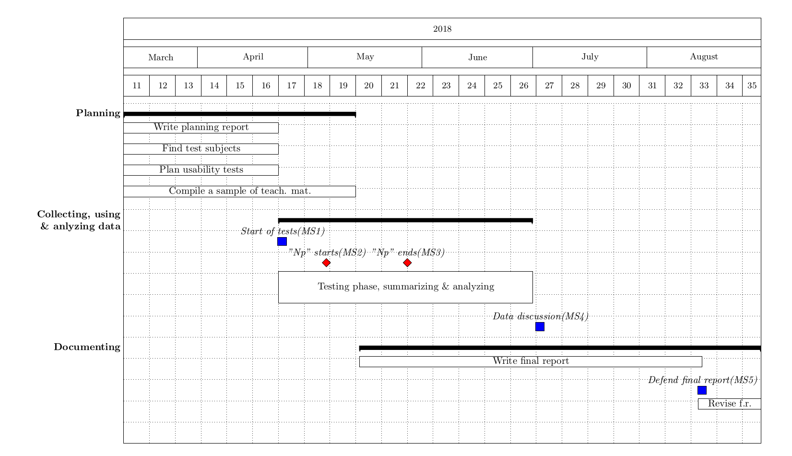
The “Testing phase, summarizing & analyzing” is an iterative process, which is described more in depth in the method chapter.
//defend report sometime in August...
// 30 hp motsvarar 800 h per person

Method // Håkan
When discussing Accessibility of a teaching material, in this study, it has been separated into two aspects: Obtainability and Usability. Collecting data for these aspects will be done separately and with different methods.

Obtainability
Obtainability describes how easy it is for a teacher to obtain a teaching material, and the data answering this question will be acquired through literature and interviews with teachers. Because of the comprehensive nature of words like obtainable and teaching materials, as well as the complex nature of school as an institution, the discussion of this aspect will most likely be extensive.

Usability
Our main method of collecting data consists of a process inspired by Adaptive Software Development (ASD). This method involves iterative development with strengths that fit this project, such as being flexible and low risk. This can for example mean that new information can be easily adopted in future tests and that results can be delivered even if test subjects decide to terminate involvement in this study early. [Källa]
ASD is a predecessor of the more common approach to software development, called Agile Software Development, where Scrum and Kanban are the most popular agile project management methodologies. The methodology for this study has no need of being as complex as Scrum or Kanban, one of the main reasons being the relative small size of the development team (i.e. the two authors of this paper), whereas for example the Scrum model is generally used by splitting a larger workforce in teams of 3 to 9.
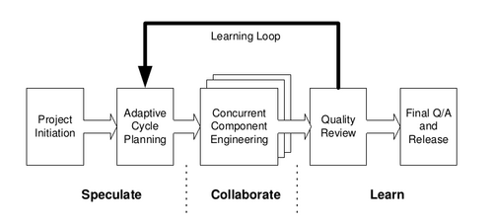

Figure 2: Adaptive Software Development (ASD) consists of three stages with a feedback loop, enabling developers to perform multiple iterations of improvement based on what they learn from users. This model is similar to the methodology that will be used in this study to collect data on usability of teaching materials. [Highsmith, 2000 p.84]
//Describe our strategy: Create a suggestion for every school that is interested in doing and participating in tests. Also describe our two test types, the usability test and the lesson observation, or whatever we want to call them. Check the separate suggestion document for details.
// Also describe how we will test the obtainability aspect of accessibility.
Comparing this study’s methodology with the ASD model, the Kick Off Meeting used to introduce one or more teachers to the study, as well as deciding on a teaching material to work on and a date for the first usability test, is comparable to the Project Initiation of ASD, being prior to the parts contained inside the Learning Loop.
What in the ASD methodology is called Adaptive Cycle Planning will be the initial step of the Revising Material stage, deciding on how to rework the teaching material based on the data collected from a Kick Off Meeting or previous Usability Test. This is inevitably one of the stages where collected data is Summarized and Analyzed.
The Concurrent Component Engineering part of ASD is practically the same as the Revising Material stage, this is where a coder would revise the code of the program and this is likewise where the product, the teaching material, is being worked on with the intent of improving its usability.
What is called Quality Review in ASD is the Usability Testing part of this study. This is where the teaching material is tested on a teacher and the data needed to improve the usability of the teaching material is collected. The method used to test usability is based on Steve Krug’s script for usability testing websites. Because a teaching material is quite different from a website, oftentimes focusing on interactivity, the script can’t be used without some changes. There is however some important aspects of Steve Krug’s script, e.g. not asking leading questions, that is of great importance to the quality of the data and thereby the quality of future revisions of the teaching material [Källa].
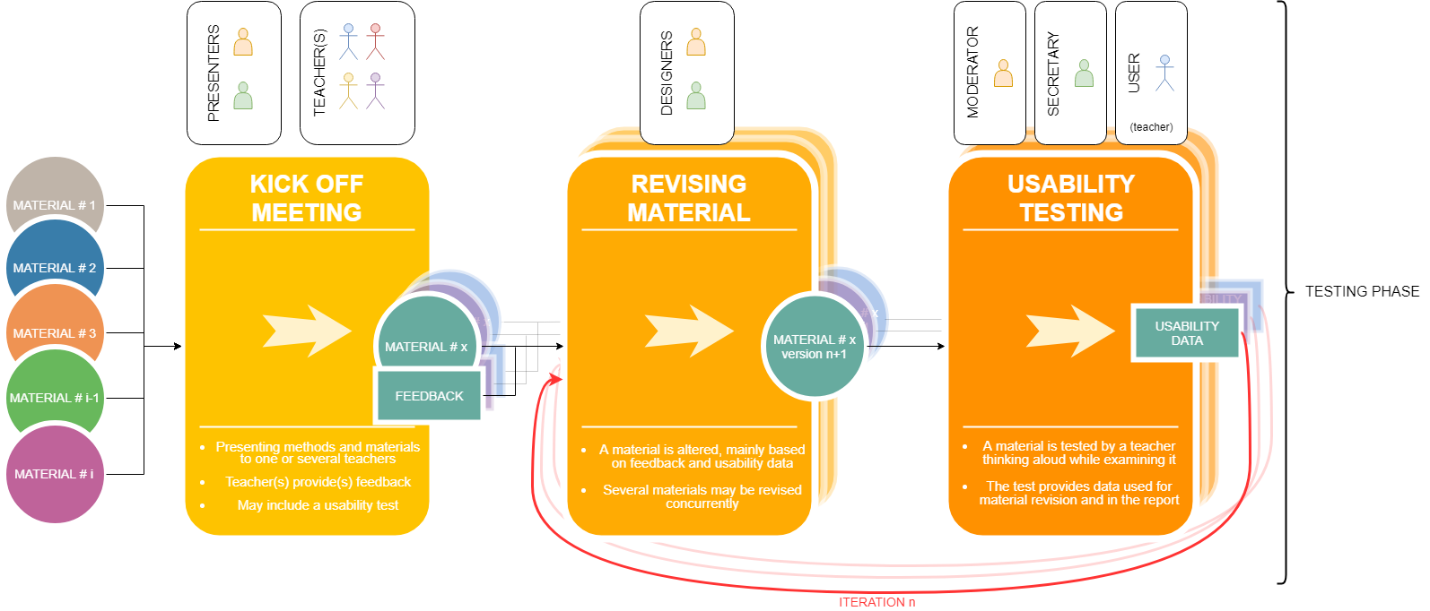
Figure 3: As with ASD, this custom designed method includes a learning loo and will be used for collecting data on usability of teaching materials. This method also describes the roles of the different actors, based on the current stage of the testing phase.
During the Kick Off Meeting of each teacher involved in the study, the teacher will be able to choose what teaching material they want to use for their usability testing. There will be a sample of teaching materials to choose from, but the possibility of the teacher choosing a material of their own liking is also a possibility. This will be done so that the teaching material will feel as relevant as possible to the teacher.
When revising material, the decisions of how the revisions will be conducted is determined from a combination of data from Usability Tests and by studying literature. There can be instances where a teacher’s assumptions of how the next revision will look may be unmet. These cases need to be analyzed and mentioned in the final report, as they may lead to interesting discussions. If for example a revision is made following a certain pedagogic template, and the resulting material makes the test subject less inclined to use it on a lesson, new conclusions can possibly be drawn about accessibility of designing teaching materials.

Test subject anonymity // Håkan
There are several ways of presenting the personal details of test subjects in scientific studies. In this study some personal details will be disclosed and some will be held anonymous. What is disclosed and examples of what is held anonymous are listed below.

Disclosed information
Age – rounded to nearest 5 years.
Current status – is the test subject currently working as a teacher and if so in what grades, or are they e.g. studying to become a teacher.
Years in teaching – nearest year if under 10 years, can otherwise be rounded to nearest 5 years. No regard to the age of students taught.
Subjects – what school subjects is the test subject certified to teach?

Anonymous information
Sex/Gender – the risk of a reader finding false correlations from the data is assumed to be greater if the test subject’s sex and/or gender is disclosed.
Name – the name of the test subjects will not be disclosed, and because the sex/gender will not either, the label of the test subjects will also be as gender free as possible.
Name of school – with this information, it would be too easy to identify the test subject.
Place of school – all subjects studied will live and work in close proximity to Gothenburg, Sweden, as the tests are dependent on personal meetings.

Deliverables // Seb
A collection of shareable resources that result from the master’s thesis aside from what is shared in the final report. All resources are part of the final report in some way, but here are some other ways to share the knowledge gained from the thesis outside the project.

Target groups and how to share the deliverables
While the final report and presentation are technically open to the public, many of our target groups will not likely take part of these resources. To make our results more accessible to the public we propose a few ways to share them with the following audiences:
- Swedish school teachers: There are multiple social media groups where resources like ours are shared, where it’s easy to upload files and show a summary of our findings to teachers who might be interested. The schools and teachers that we cooperate with might also want to take part of our results and should therefore be handed the deliverables in an accessible format.
- Students and alumni at Lärande och Ledarskap. These may partake in the presentation, and they have multiple social media groups and similar places where we can share the deliverables that they might be interested in.
- Engineers that work with Knowledge Management or similar subjects: [uh, actually, how do we reach these?]
- [Kleindagarna? Studion? Chalmers-institutioner?]

Testing methods
With our testing methods we hope to develop a simple yet effective way of studying the accessibility of teaching materials. Inspired by Steve Krug’s usability testing script, we want to make our methods similarly accessible to those who are interested in making effective teaching materials.
- A Steve Krug-like script for doing usability testing of teaching materials.
- An evaluation of the testing methods from several perspectives: Its time and resource requirements, its reliability and validity, what kind of information it gives, and eventual other things that we discover with it.

Models that facilitate the making of teaching materials
During our testing we expect to create and think about new models that describe the process of making teaching materials. We hope that some of these will be useful for understanding the process and for finding new ways of improving one’s ways of creating materials. In that case, making them accessible to the public might be advantageous.
- A description of each model and how it’s thought to be used.
- And evaluation of each model that describes eventual areas of improvement and what the model might be useful for.

Teaching materials
While we expect to use a lot of existing teaching materials for testing instead of spending a lot of time making it from scratch, there’s also the possibility of improving these materials as part of the testing process. For example, we might try to “patch” one of the shortcomings of one material, and test how this patch changes its quality. Similarly, we might create instructions to increase the accessibility of some materials to the test subjects. In such cases, sharing the improved materials might give something of value to teachers that they may be relevant to.
- The materials themselves in the form of digital copies or blueprints.
- A summarized evaluation of each material according to the test results in the final report.
- Instructions for how each material can be used, and how one can take part of its benefits.

Testing results
[The testing results are practically our final report, and I was unsure whether this deliverables chapter would be a “non-final report chapter” or “everything we will deliver chapter.” I’m leaning toward the latter.]

